ASSIGNMENT 8.3
V.HRK SRI HARSHA VIGNESH
BATCH – 42
2303A52300
Task 1: Email Validation using TDD
Prompt:
Design and implement an interactive Python-based Email Validation System.The system must: Accept user input dynamically. Validate the email according to the following constraints: Exactly one @ symbol. At least one dot (.) in the domain part. Return True or False based on validation logic. Continue execution until the user chooses to exit.
CODE:
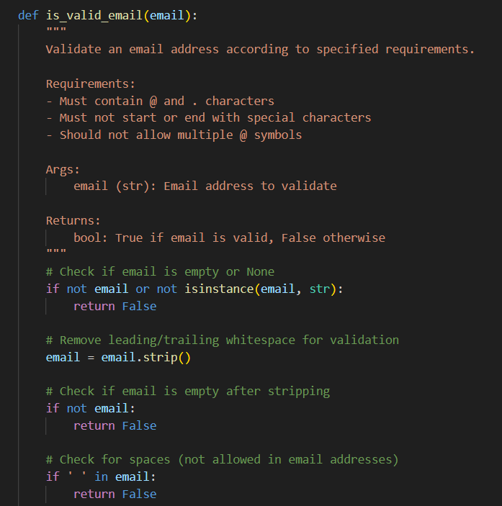
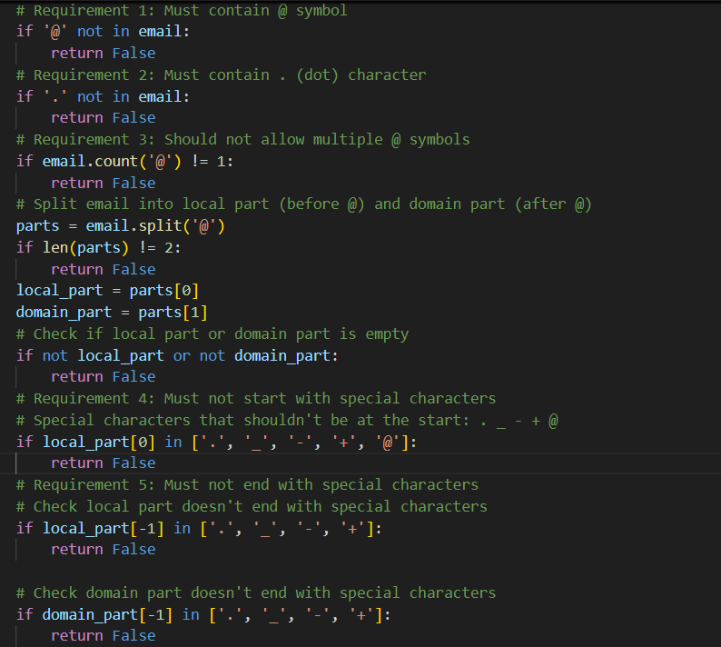
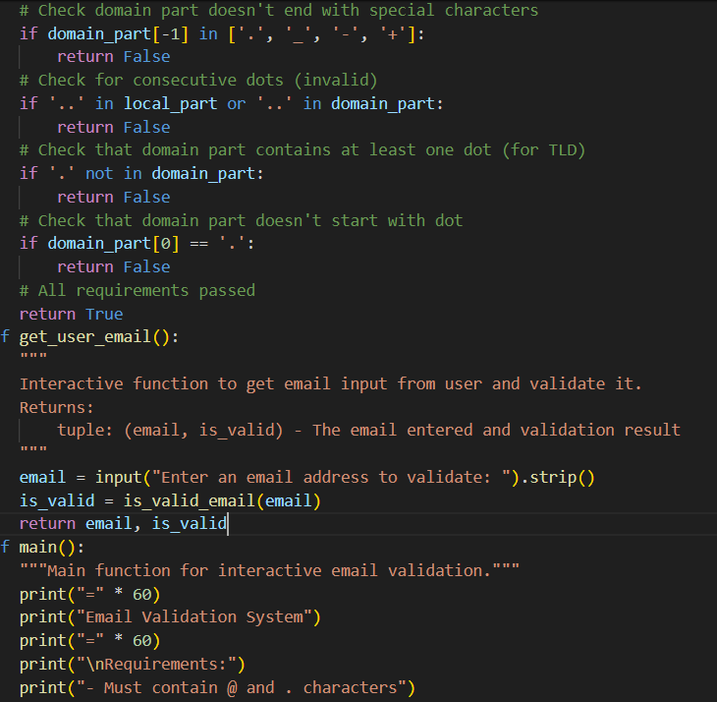
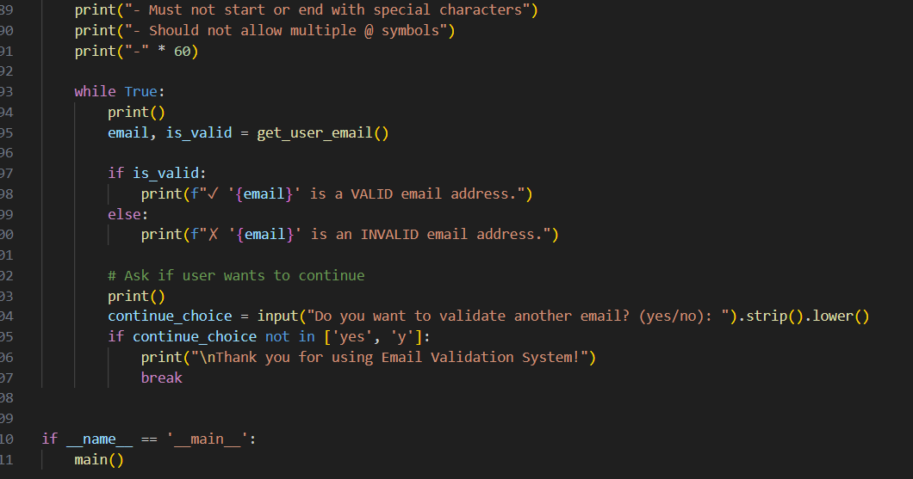
OUTPUT:
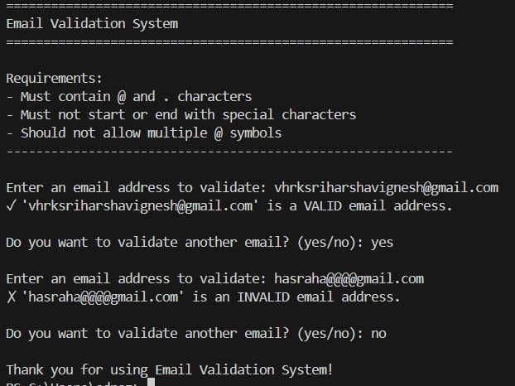
JUSTIFICATION
This code checks whether the email entered by the user is correct or not. It helps to avoid wrong email formats and improves accuracy. It also shows how to use conditions and string checking in Python.
Task 2: Grade Assignment using Loops
PROMPT:
Write a Python assign_grade(score) function that validates input, returns appropriate A–F grades, and successfully passes all unittest tests including boundary conditions and invalid input scenarios.
CODE: 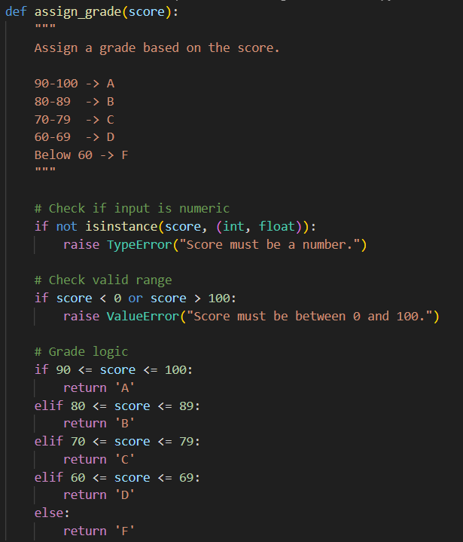

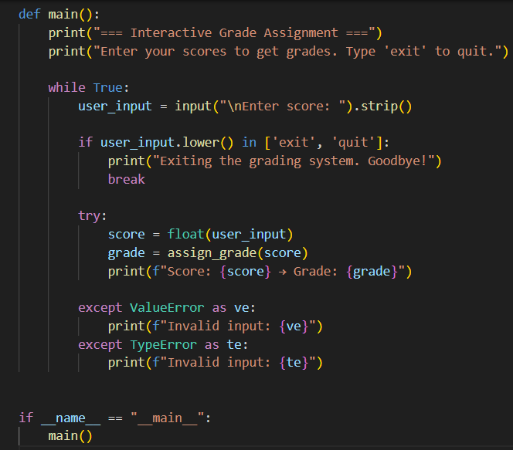
OUTPUT:
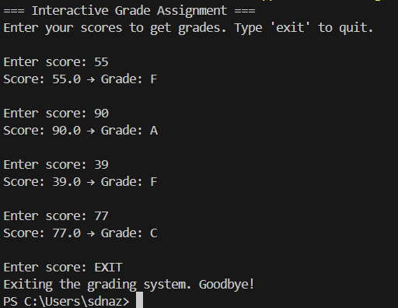
Justification:
This implementation follows clean coding practices with modular design. The assign_grade function handles core logic, while the main function manages user interaction. Error handling ensures the system behaves predictably under edge cases, making it suitable for real-world grading applications.
Task 3: Sentence Palindrome Checker
Prompt:
Develop a Python function is_sentence_palindrome(sentence) that returns True if the sentence is a palindrome and False otherwise. The function must ignore case sensitivity, spaces, and special characters. Create comprehensive unittest test cases covering valid palindromes, non-palindromes, and edge cases.
CODE:
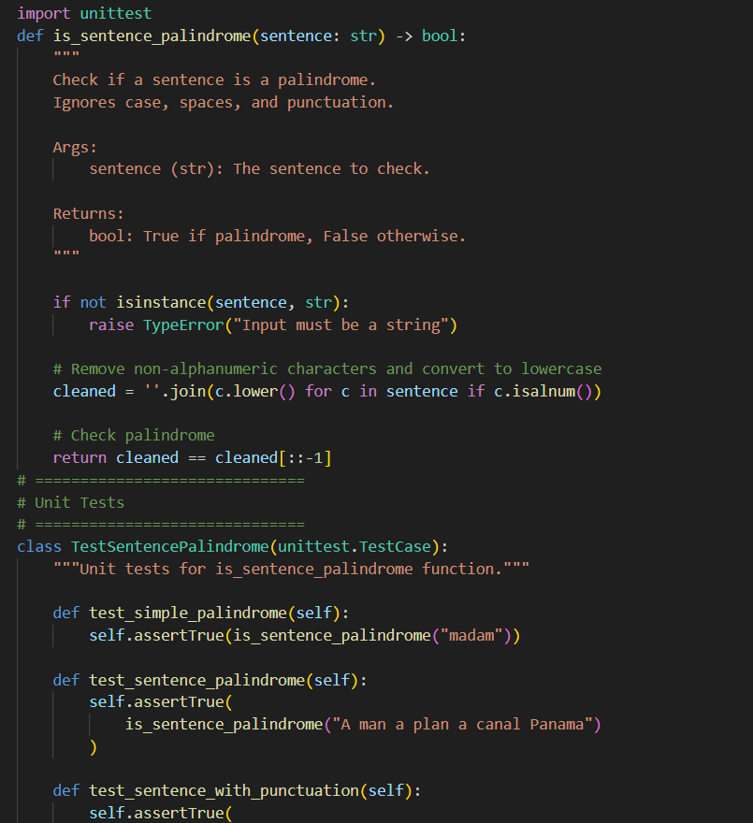
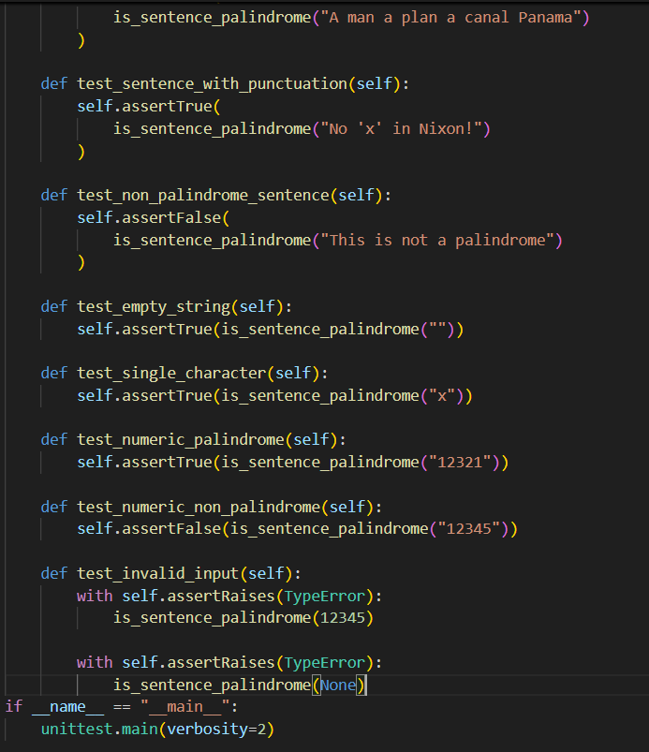
OUTPUT:
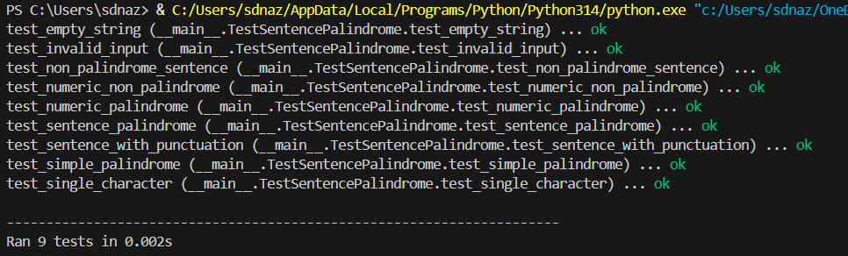
JUSTIFICATION:
The is_sentence_palindrome function checks if a sentence reads the same forwards and backwards, ignoring spaces, punctuation, and case. It first cleans the sentence by keeping only letters and numbers in lowercase, then compares it with its reverse. The unit tests cover normal palindromes, sentences with punctuation, numbers, non-palindromes, empty strings, single characters, and invalid inputs to ensure the function works correctly.
Task 4: ShoppingCart Class
Prompt:
Write a Python script that simulates a basic e-commerce shopping cart. Implement a class to store items in a dictionary and calculate the total bill dynamically. Include a loop-driven user interface with options (add, remove, show, total, quit) and apply error handling for invalid numeric inputs.
CODE:
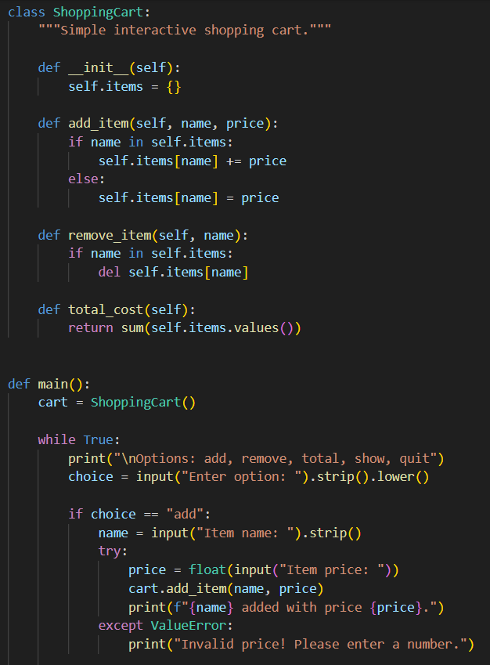
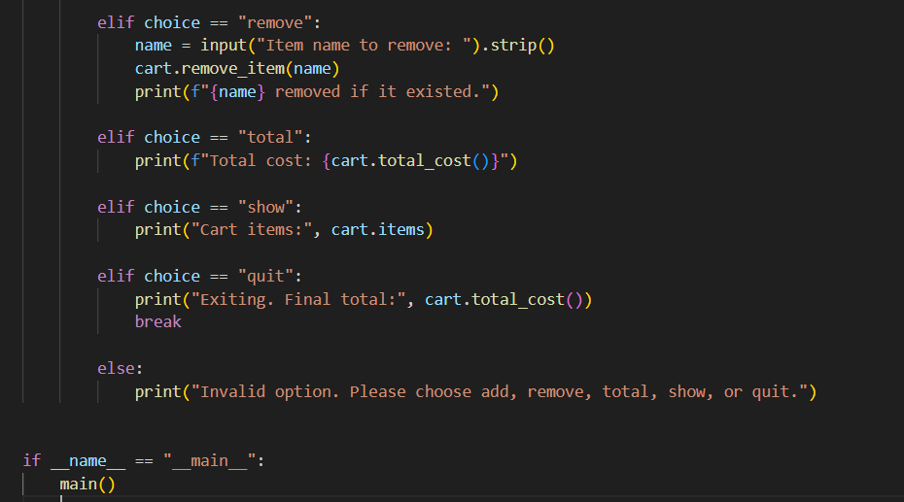
OUTPUT:
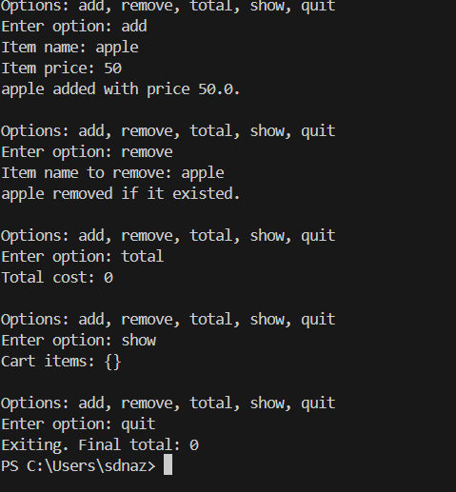
JUSTIFICATION:
This solution demonstrates clean architecture, interactive CLI design, and defensive programming. The class-based structure enhances scalability and maintainability, while proper error handling ensures system reliability. The program simulates a real-world shopping cart workflow and can be extended to include features like quantity management or persistent storage.
Task 5: Date Format Conversion
PROMPT:
Develop a Python program that reformats dates from YYYY-MM-DD to DD-MM-YYYY with proper type checking and format validation.
CODE:
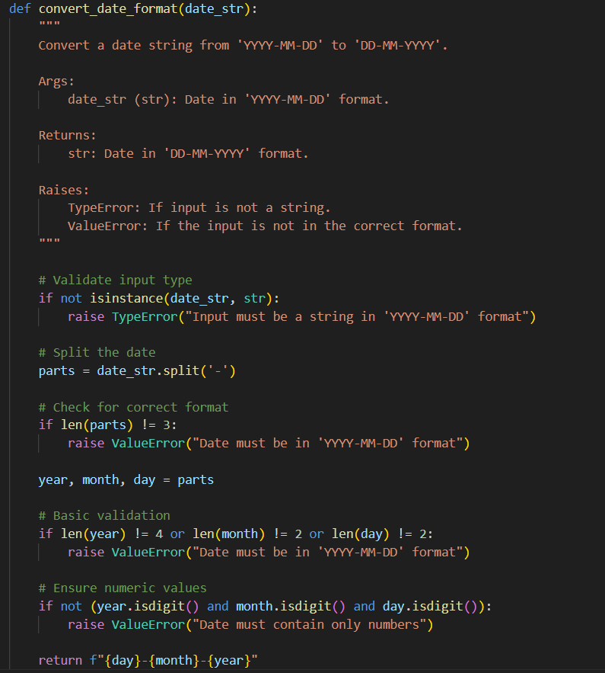

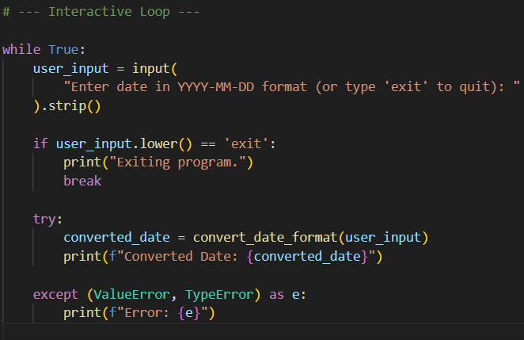
OUTPUT:
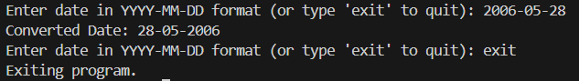
JUSTIFICATION:
The program follows defensive programming by checking structure and numeric values.
It raises appropriate errors for invalid inputs.
This improves robustness and maintains data integrity.

