AI-ASSISTANT-CODING-LAB-15.4
Name: V.HRK SRI HARSHA VIGNESH
Batch: 42
Roll No: 2303A52304
TASK 1 – Initial API Setup
Prompt:
Generate a basic Flask API with a /status endpoint returning JSON response.
Code:
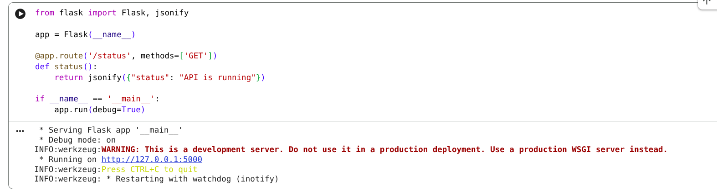
Output:
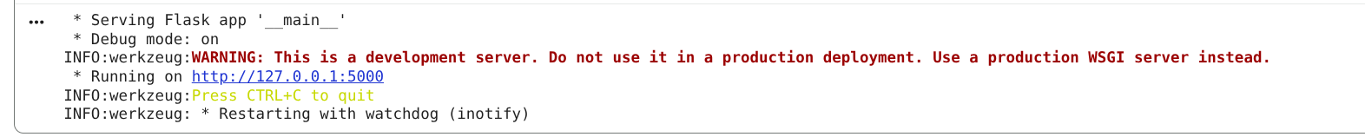

Justification
- Confirms backend availability
- Baseline endpoint for health check

TASK 2 – Add & View Requests

Prompt
Add GET and POST endpoints to manage service requests with title and priority using Flask.
Code:
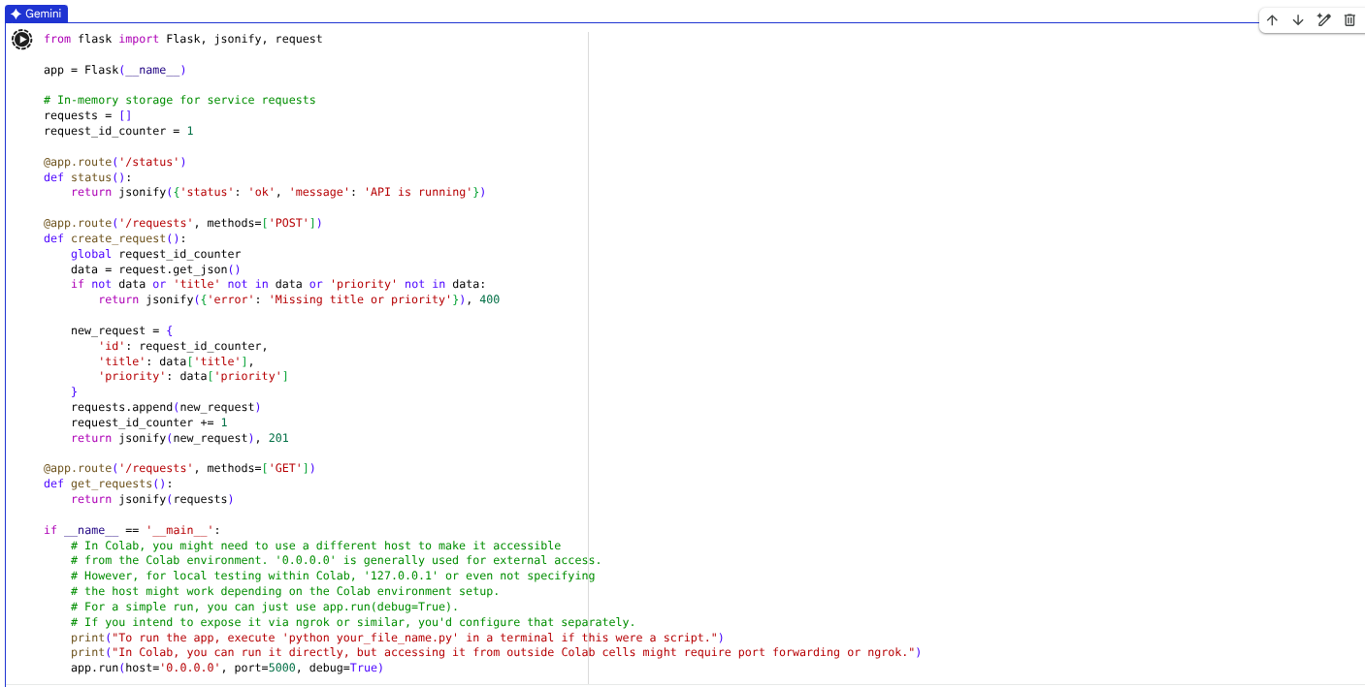
Output:
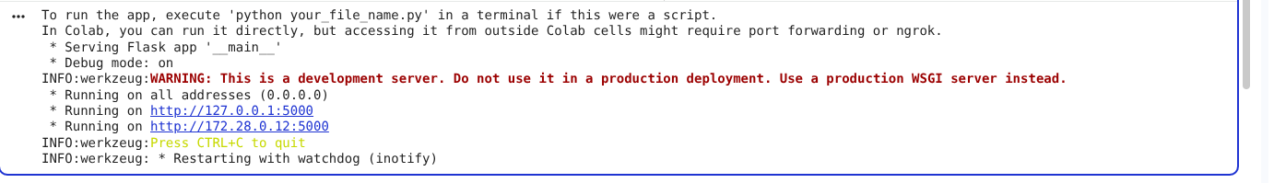

Justification
Implements basic CRUD (Create + Read)
Uses in-memory storage (simple for lab)

TASK 3 – Update Resource (PUT)

Prompt
Add PUT endpoint to update a request by index with proper error handling in Flask.
Code:
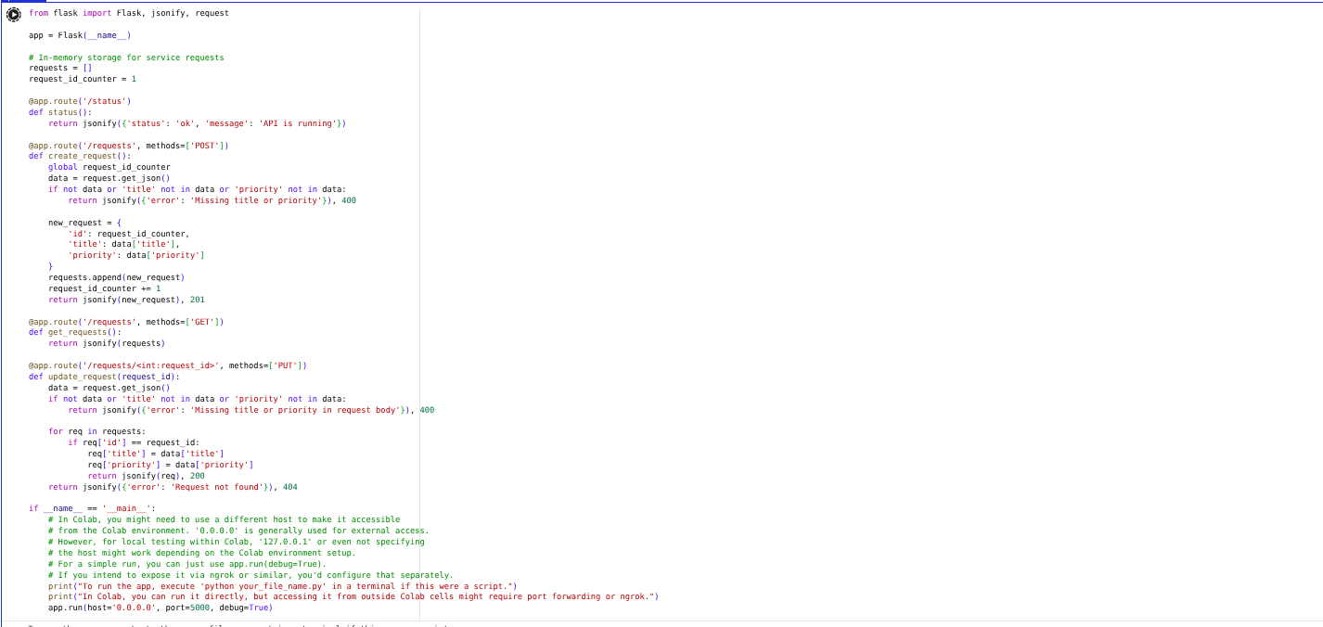
Output:
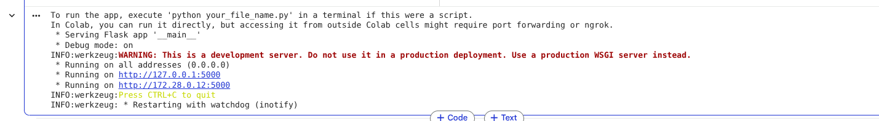
Justification:
Enables update operation
Error handling prevents crashes

TASK 4 – Delete Resource

Prompt
Add DELETE endpoint to remove a request by index with safe error handling.
Code:
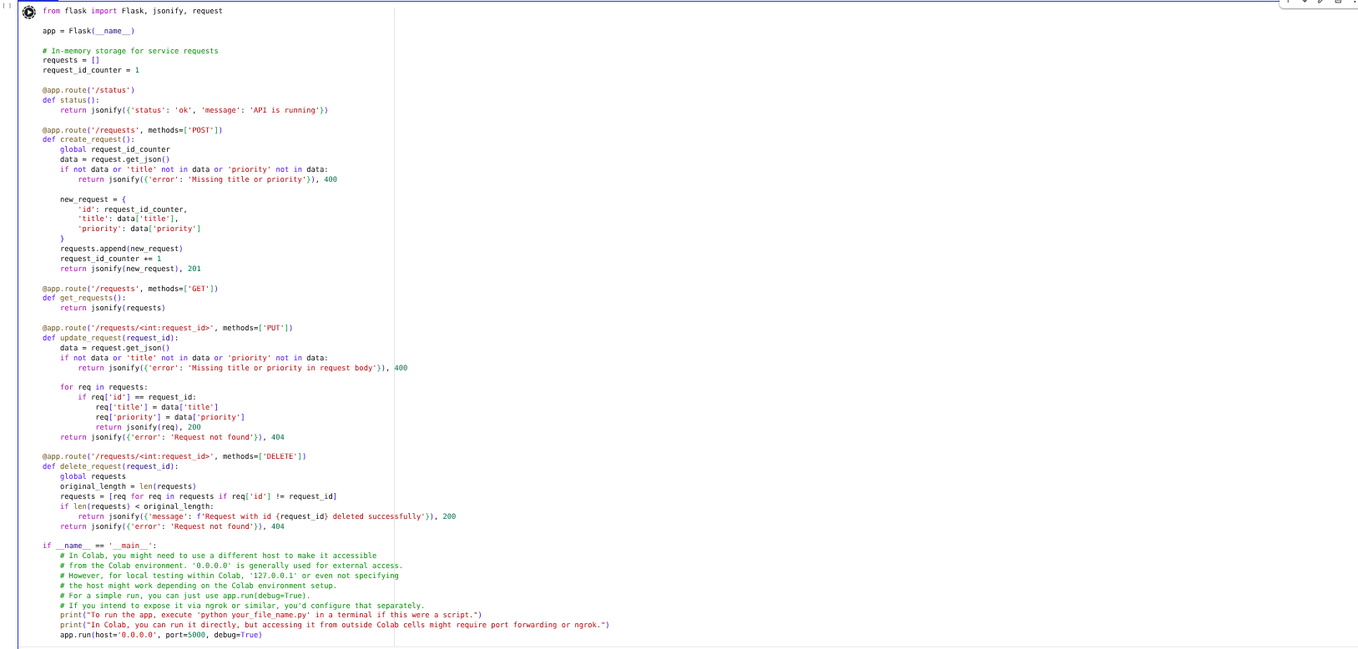
Output:
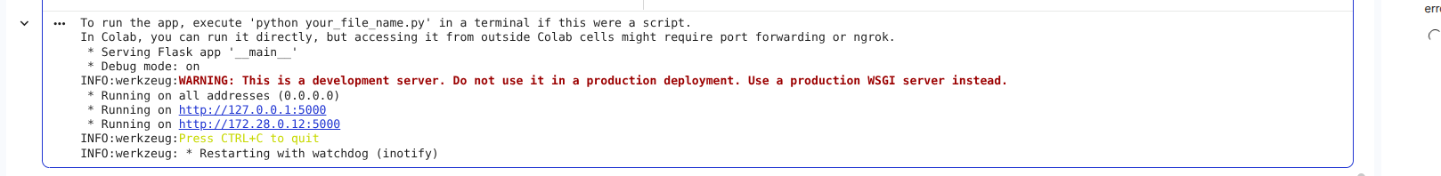

Justification
- Completes CRUD (Delete)
- Safe removal with validation

TASK 5 – Documentation (AI Assisted)

Prompt
Add docstrings and comments to Flask API endpoints and optionally integrate Swagger documentation.
Code:
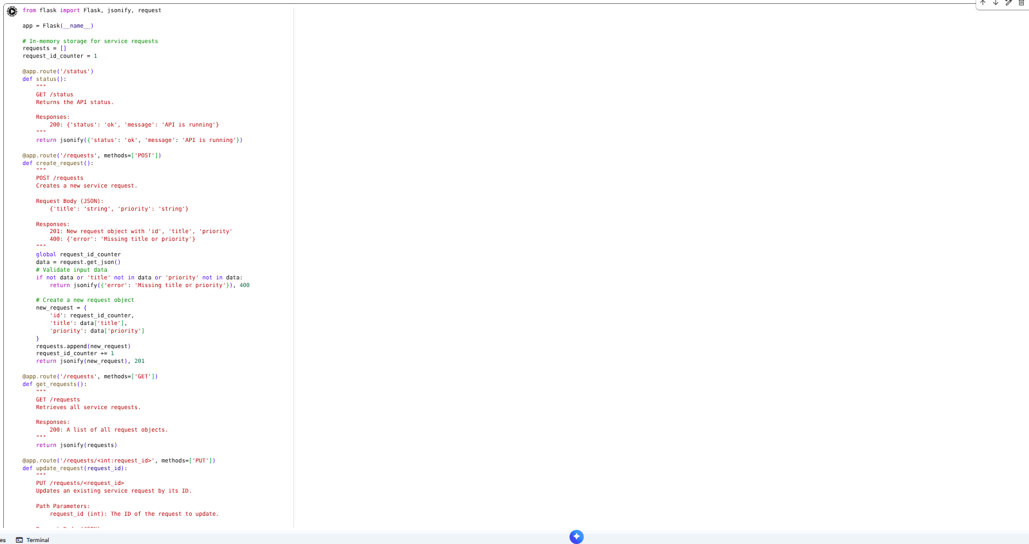
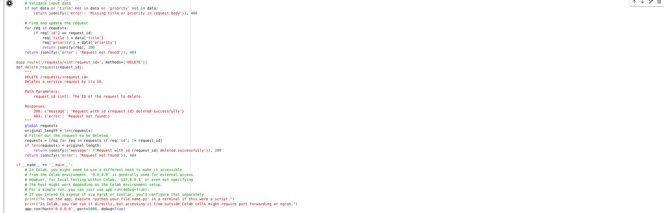
Output:

Justification
- Docstrings → improve readability
- Swagger → auto API documentation
- Helps other developers integrate faster

