ASSIGNMENT-10.3
V.HRK SRI HARSHA VIGNESH
2303A52304
BATCH-42
QUESTION-1:
Problem Statement 1: AI-Assisted Bug Detection
Scenario: A junior developer wrote the following Python function to calculate factorials: def factorial(n):
result = 1 for i in range(1, n): result = result * i return result
1.original code

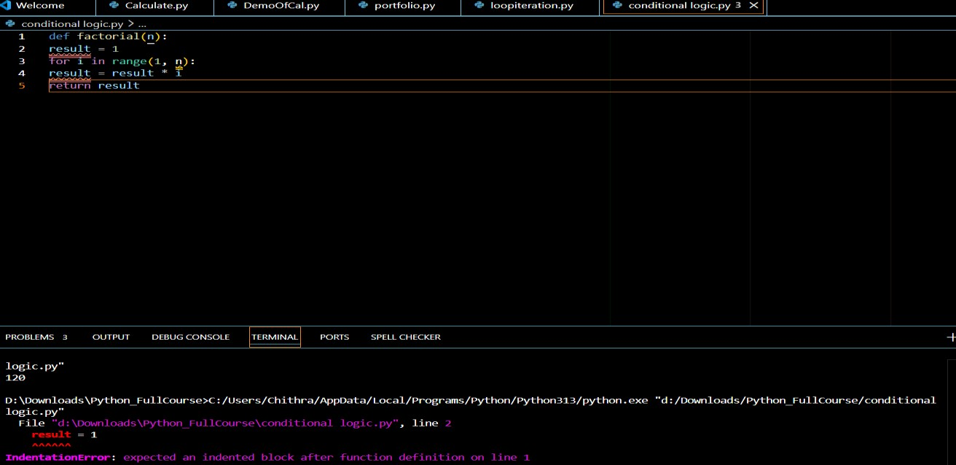
2. The logical bug in the original code is an off-by-one error in the loop. Original code:
for i in range(1, n):
This loop does not include the value n.

Explain Why the Bug Occurs
In Python, range(start, stop) generates numbers from start up to stop-1.
So:
range(1, 5) produces:
1, 2, 3, 4
It does NOT include 5. Therefore, when calling:
factorial(5)
The loop multiplies:
1 × 2 × 3 × 4
Which gives:
24
But factorial of 5 should be:
1 × 2 × 3 × 4 × 5 = 120
So the last number is skipped — this is called an off-by-one error.

Corrected Version
To fix the error, include n in the range by writing n + 1.
Corrected code:
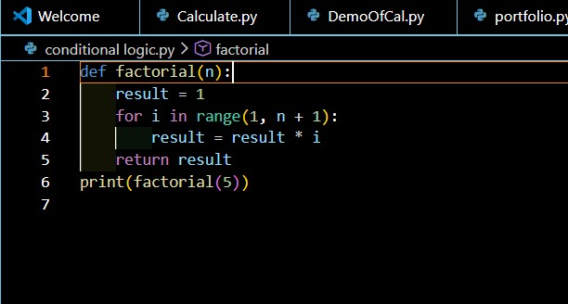

3. Comparison: AI’s Corrected Code vs My Manual Fix
My Manual Fix
I corrected the loop by changing:
range(1, n) to range(1, n+1)
Manual corrected code:
def factorial(n):
result = 1 for i in range(1, n+1): result = result * i return result
This correctly calculates factorial(5) as 120.

AI’s Corrected Code
The AI also changed the loop to: range(1, n+1)
Additionally, the AI suggested improving the function by:
- Handling negative numbers
- Raising errors for invalid input
- Making the code slightly more optimized Example improved AI version: def factorial(n): if n < 0:
raise ValueError("Factorial is not defined for negative numbers")

result = 1 for i in range(1, n+1):
result *= i

return result
4. Brief Comparison: Edge Cases
The AI correctly fixed the off-by-one error and ensured that the function returns 120 for factorial(5). It also handled the case of negative numbers by suggesting an error check.
However, in its basic corrected version, the AI did not explicitly handle non-integer inputs (such as decimal numbers or strings). The function works correctly for zero, since factorial(0) correctly returns 1.
Overall, the AI handled the major logical error and most important edge cases, but additional validation for input type could further improve the solution.
Output:
Question 2:
Improving Readability &
Documentation
Scenario:The following code works but is poorly written:
. def calc(a, b, c): if c == "add": return a + b elif c == "sub": return a - b elif c == "mul": return a * b
elif c == "div":
5. AI Critique of the Original Function
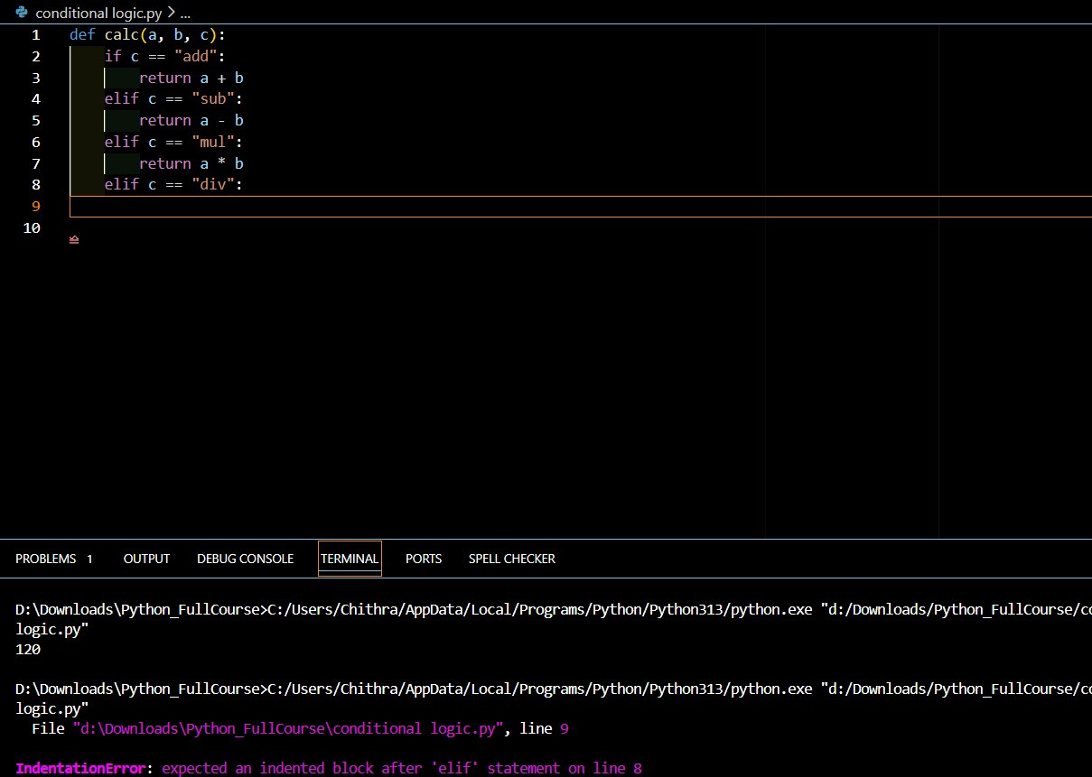
Rewritten Improved Version
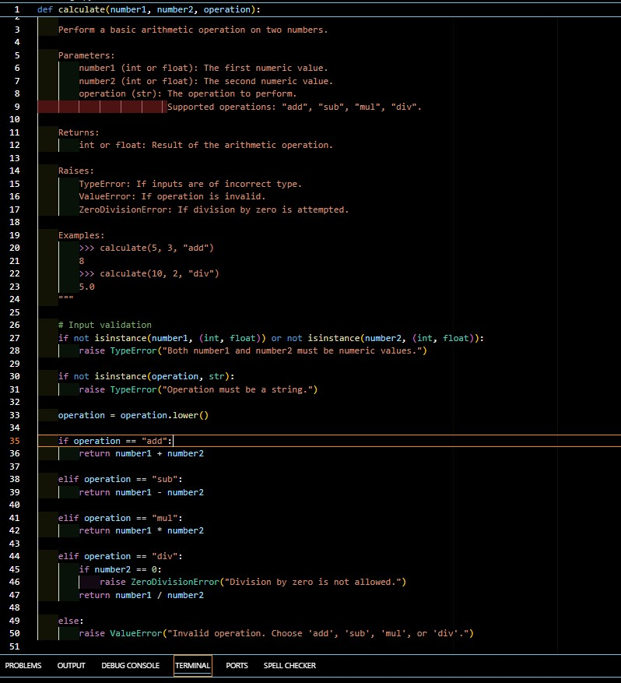
6.Comparison: Original vs AI-Improved Version
Function Name Original:
def calc(a, b, c):
- The name calc is vague.
- It does not clearly describe the purpose.
AI-Improved:
def calculate(number1, number2, operation):
- The name calculate is descriptive.
- Clearly indicates what the function does.
Improvement: Better readability and clarity.

Parameter Naming
Original:
- a, b, c are unclear.
- Reader must check the code to understand their meaning.
AI-Improved:
- number1, number2, operation clearly describe their roles.
Improvement: Self-explanatory parameters make the code easier to understand.

Documentation
Original:
- No docstring.
- No explanation of parameters or return value.
- No examples.
AI-Improved:
- Includes a complete docstring.
- Describes purpose, parameters, return value.
- Includes example usage.
- Lists possible exceptions.
Improvement: More professional and maintainable.

Error Handling Original:
- No check for division by zero.
- No handling of invalid operation.
- No input validation.
AI-Improved:
- Handles division by zero.
- Raises error for invalid operation.
- Validates numeric inputs.
- Validates operation type.
Improvement: Safer and more robust.

Readability & Maintainability Original Version:
- Hard to understand quickly.
- Less structured.
- Not suitable for production use.
AI-Improved Version:
- Clear structure.
- Professional formatting.
- Easier to maintain and extend.

7.Testing the Original Version
- Original Code (Basic Version)
- def calc(a, b, c):
- if c == "add":
- return a + b
- elif c == "sub":
- return a - b
- elif c == "mul":
- return a * b • elif c == "div":
- return a / b

• Valid Inputs
- print(calc(10, 5, "add")) # 15
- print(calc(10, 5, "div")) # 2.0
- Works correctly for valid inputs.

• Invalid Input: Division by Zero
- print(calc(10, 0, "div"))
- Output:
- ZeroDivisionError: division by zero
- ⚠ The program crashes (no custom handling).

• Invalid Input: Non-String Operation
- print(calc(10, 5, 123))
- Output:
- None
- ⚠ No error message. Function silently fails.

Testing the AI-Improved Version
- Improved Code
- def calculate(number1, number2, operation):
- if not isinstance(number1, (int, float)) or not isinstance(number2, (int, float)):
- raise TypeError("Both inputs must be numbers.")
•
- if not isinstance(operation, str):
- raise TypeError("Operation must be a string.")
•
- operation = operation.lower()
•
- if operation == "add":
- return number1 + number2
- elif operation == "sub":
- return number1 - number2
- elif operation == "mul":
- return number1 * number2
- elif operation == "div":
- if number2 == 0:
- raise ZeroDivisionError("Division by zero is not allowed.")
- return number1 / number2
- else:
- raise ValueError("Invalid operation.")
Valid Inputs  print(calculate(10, 5, "add")) | # 15
print(calculate(10, 5, "div")) ✔Works correctly. | # 2.0
Division by Zero  calculate(10, 0, "div") Output:  ZeroDivisionError: Division by Properly handled with clear message. | zero is not allowed.
•
•
- •
•
•
•
•
- •
•
•

• Non-String Operation
- calculate(10, 5, 123)
- Output:
- TypeError: Operation must be a string.

Output:
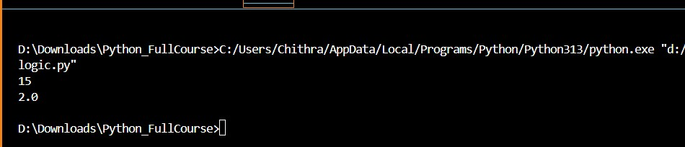
Question 3:
Enforcing Coding Standards
Scenario: A team project requires PEP8 compliance. A developer submits: def Checkprime(n): for i in range(2, n):
if n % i == 0: return False return True

Step 8: Verify the Function Works
Original Code
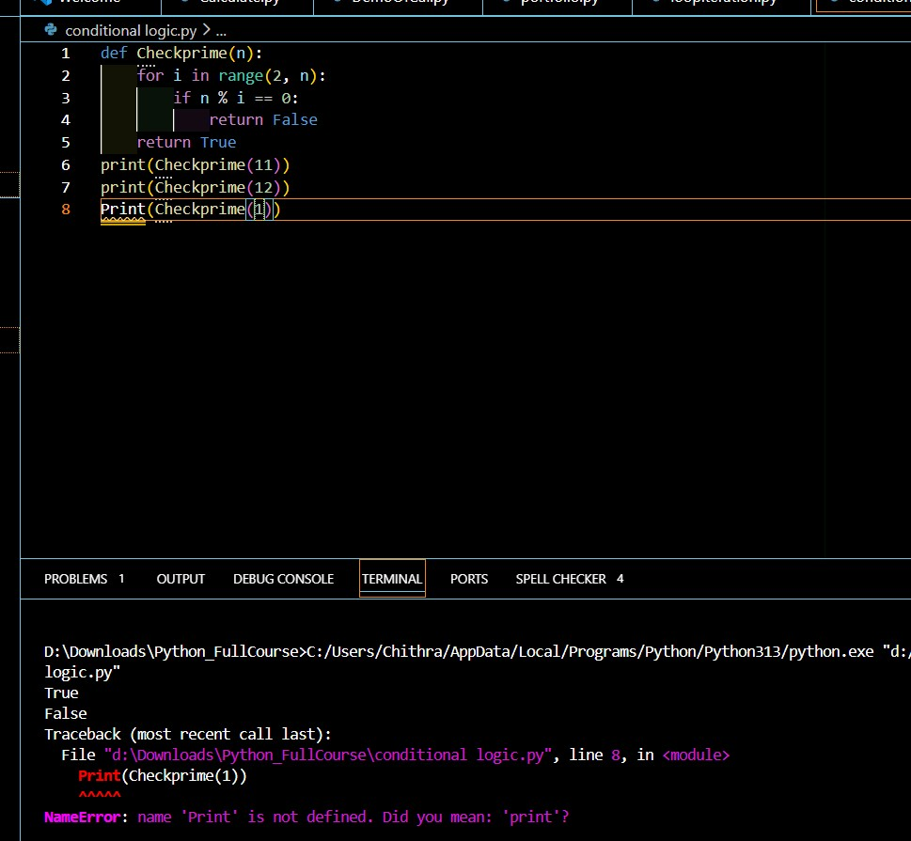
Step 9: PEP8 Violations Identified
PEP8 Issues in Original Code
Function Name
- Checkprime violates naming convention.
- PEP8 requires lowercase with underscores.
- Correct style: check_prime
Missing Blank Lines
- PEP8 requires 2 blank lines before top-level function definitions.
No Docstring
- Function lacks documentation.
No Input Validation
- Does not handle negative numbers or non-integers.
Logical Issue
- Does not correctly handle n <= 1.
Optimization Suggestion
- Can improve efficiency by checking up to sqrt(n) instead of n.

Step 9: Refactored PEP8-Compliant Version
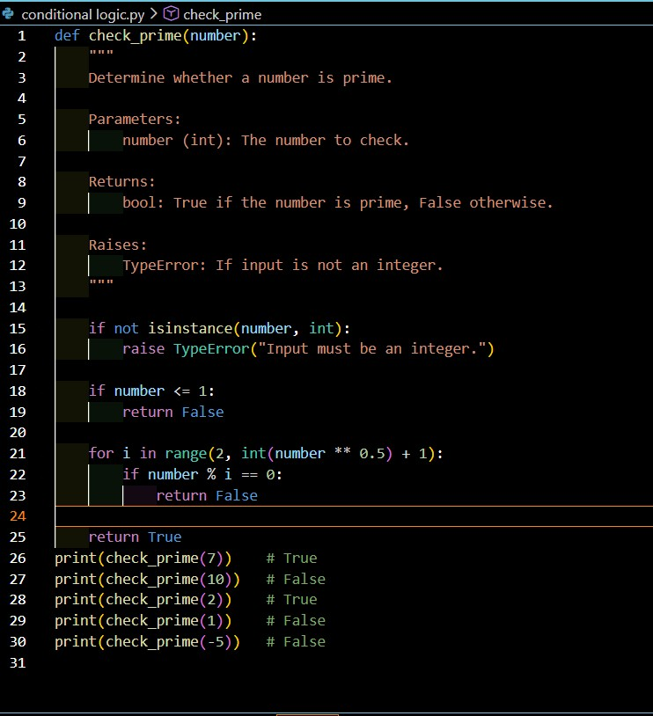
Short Note: How Automated AI Reviews Streamline Code Reviews
Automated AI-powered code reviews can significantly streamline the development process in large teams. AI tools can quickly detect syntax errors, logical mistakes, PEP8 violations, security vulnerabilities, and performance issues before human reviewers even see the code. This reduces the workload on senior developers and allows them to focus on higher-level design decisions instead of minor formatting or style corrections.
AI reviews also ensure consistency across the codebase by enforcing coding standards automatically. They provide instant feedback to developers, which speeds up debugging and learning. In large teams where multiple developers contribute simultaneously, AI tools improve efficiency, reduce review time, and help maintain high code quality.
Overall, automated AI reviews make code review processes faster, more consistent, and more scalable.
Output:
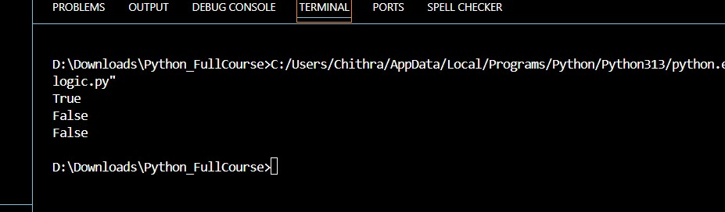
Question-4:
AI as a Code Reviewer in Real Projects Scenario:
In a GitHub project, a teammate submits: def processData(d):
return [x * 2 for x in d if x % 2 == 0]
Manual Review of the Original Function Original Code def processData(d):
return [x * 2 for x in d if x % 2 == 0]
Manual Review
Readability & Naming
processData is vague — does not clearly describe what the function does.

Parameter d is unclear.

It is not immediately obvious that the function doubles even numbers.

Reusability & Modularity
Multiplier is fixed at 2 (not configurable).

Only works for even numbers.

No documentation or explanation.

Edge Cases
No validation if input is not a list.

No handling for empty list (though it works implicitly).

Crashes if elements are non-numeric (e.g., strings).

No type hints.
AI Code Review Suggestions
a. Better Naming
Rename to something descriptive like:
- double_even_numbers Rename parameter:
- numbers

b. Add Type Hints & Input Validation
- Use List and Union from typing.
- Check input type.
- Ensure elements are numeric.

c. Generalization Suggestion • Add configurable multiplier.
• Allow flexibility in scaling.
Refactored Version (AI-Improved)
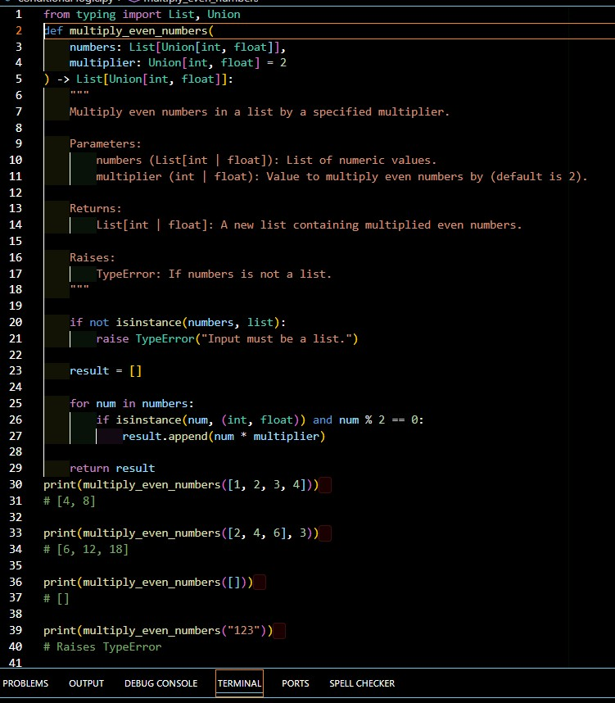
Short Reflection
AI should not be a standalone reviewer but rather an assistant to human reviewers. While AI can quickly detect naming issues, missing validations, style violations, and suggest improvements, it may not fully understand business logic or project-specific requirements. Human reviewers are still essential for architectural decisions and contextual understanding. Therefore, AI works best as a productivity-enhancing assistant rather than a replacement for human code review.
Output:
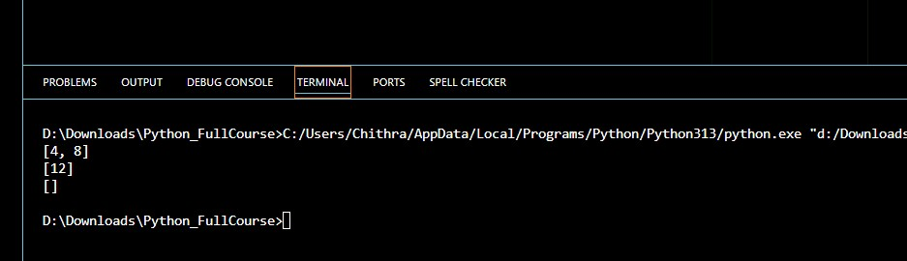
Question -5
AI-Assisted Performance Optimization
Scenario: You are given a function that processes a list of integers, but it runs slowly on large datasets: def sum_of_squares(numbers): total = 0 for num in numbers: total += num ** 2 return total
Original Function
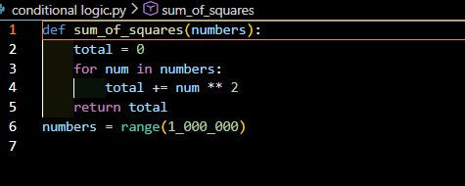
2. Time Complexity Analysis
Time Complexity
- The function loops once through the list.
- Each operation inside loop is O(1).
Overall Time Complexity: O(n) Space Complexity: O(1)
This is already optimal in Big-O terms.
But we can improve constant performance factors.

3. AI Suggested Optimization
Option 1 — Use Built-in sum() with Generator (Cleaner & Faster) def sum_of_squares_optimized(numbers):
return sum(x * x for x in numbers)
More Pythonic
Faster due to C-level optimization in sum()
More readable

Option 2 — Using NumPy (Best for Very Large Data) import numpy as np

def sum_of_squares_numpy(numbers):
arr = np.array(numbers) return np.sum(arr * arr) Much faster for very large datasets
Uses vectorized operations
Requires external library

Compare Execution Time Use time module:
import time

numbers = range(1_000_000)

start = time.time() sum_of_squares(numbers)
print("Original:", time.time() - start)

start = time.time()
sum_of_squares_optimized(numbers) print("Optimized:", time.time() - start)

Expected Result
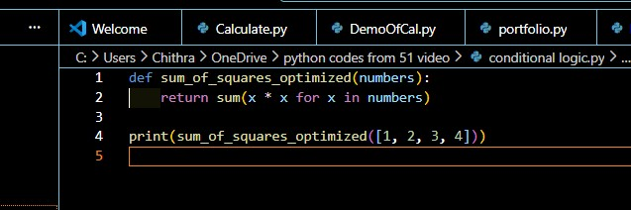
Output:
