LAB ASSIGNMENT-14.4
V.HRK SRI HARSHA VIGNESH
2303A52304
BATCH-42

Task 1: Responsive Homepage Layout for a Startup Website
Prompt:
you are developing a homepage for a stratup company that needs to look good on
desktops,tablets,and mobile devices. create a webpage structure using HTML that includes: a header with navigation links,a main content section, a footer with basic information. generate responsive CSS using media queries. ensures the layout adjusts smoothly across dfferent screen sizes. and i need output as a responsive web page where header,contentand footage are clearly separated. make it userfriendly and good looking
Code:
<!doctype html>
<html lang="en">
<head>
<meta charset="utf-8" />
<meta name="viewport" content="width=device-width,initial-scale=1" />
<title>Startup — Innovative Solutions</title>
<link
href="https://fonts.googleapis.com/css2?family=Inter:wght@300;400;600;700&display=swa p" rel="stylesheet">
<style>
/* =========================
Variables & Reset
========================= */
:root{
--bg: #f7f9fb;
--card: #ffffff;
--muted: #6b7280;
--accent: #0ea5a4;
--accent-2: #0369a1;
--shadow: 0 6px 18px rgba(8,15,31,0.08);
--radius: 12px;
--container: 1100px;
}
*{box-sizing:border-box;margin:0;padding:0} html,body{height:100%} body{
font-family: 'Inter', system-ui, -apple-system, "Segoe UI", Roboto, "Helvetica Neue", Arial; background:var(--bg); color:#0f172a;
-webkit-font-smoothing:antialiased; -moz-osx-font-smoothing:grayscale; line-height:1.5; padding:0 16px;
}

/* =========================
Layout helpers
========================= */
.wrap{ max-width:var(--container); margin:0 auto; width:100%;
}
.row{display:flex;gap:24px}
.visually-hidden{position:absolute;width:1px;height:1px;padding:0;margin:1px;overflow:hidden;clip:rect(0 0 0 0);white-space:nowrap;border:0}

/* =========================
Header
========================= */
header.site-header{ background:linear-gradient(90deg,var(--accent),var(--accent-2)); color:white; border-radius: var(--radius); margin-top:20px; padding:18px; box-shadow: var(--shadow);
}
.site-header .wrap{ display:flex; align-items:center; justify-content:space-between; gap:16px;
}
.brand{ display:flex; gap:12px; align-items:center; text-decoration:none; color:white;
} .logo { width:44px;height:44px;border-radius:10px; background:rgba(255,255,255,0.18); display:inline-grid;place-items:center;font-weight:700; box-shadow: inset 0 -6px 18px rgba(255,255,255,0.04); font-size:18px;
}
.brand h1{font-size:18px;letter-spacing:-0.2px}
.brand p{font-size:12px;color:rgba(255,255,255,0.9);margin-top:2px}

/* Navigation */ nav.main-nav{display:flex;align-items:center;gap:18px}
.nav-links{ display:flex;gap:12px;align-items:center; list-style:none;
}
.nav-links a{ color:white;text-decoration:none;padding:8px 10px;border-radius:8px;font-weight:600; transition:background .18s, transform .12s;
}
.nav-links a:hover{background:rgba(255,255,255,0.08);transform:translateY(-1px)}
.cta{
background:white;color:var(--accent-2);padding:8px 12px;border-radius:10px;fontweight:700; box-shadow:0 6px 18px rgba(2,6,23,0.08);
}

/* Mobile nav toggle */
.nav-toggle{ display:none; background:transparent;border:0;color:white; padding:8px;border-radius:8px;
}

/* =========================
Hero
========================= */ main{margin:22px 0 48px}
.hero{ background:linear-gradient(180deg, rgba(255,255,255,0.6), transparent); border-radius:12px;padding:28px;margin-bottom:20px; display:flex;flex-direction:column;gap:18px;box-shadow:var(--shadow); background-image: linear-gradient(180deg, rgba(14,165,164,0.06), transparent);
}
.hero .hero-inner{display:flex;align-items:center;justify-content:spacebetween;gap:24px;flex-wrap:wrap}
.hero h2{font-size:28px;margin-bottom:6px}
.hero p{color:var(--muted);max-width:640px}
.hero-actions{display:flex;gap:12px;align-items:center}
.btn{
display:inline-block;padding:10px 16px;border-radius:10px;text-decoration:none;fontweight:700;
}
.btn-primary{background:var(--accent);color:white}
.btn-secondary{background:transparent;border:2px solid rgba(2,6,23,0.06);color:var(-accent-2)}

/* =========================
Feature grid / Content cards
========================= */
.grid{ display:grid; gap:18px; grid-template-columns: repeat(3, 1fr); margin-top:10px;
}
.card{ background:var(--card);padding:18px;border-radius:12px; box-shadow:var(--shadow);min-height:120px;
}
.card h3{margin-bottom:8px;font-size:16px}
.card p{color:var(--muted);font-size:14px}

/* About / Two-column section */
.about{ display:grid; grid-template-columns: 1fr 360px; gap:18px;margin-top:20px;
}
.about .panel{background:var(--card);padding:18px;border-radius:12px;box-shadow:var(-shadow)}

/* =========================
Footer
========================= */
footer.site-footer{
background:#0b1220;color:#e6eef6;border-radius:12px;padding:18px;marginbottom:30px; box-shadow:var(--shadow);
}
.footer-grid{display:flex;gap:18px;flex-wrap:wrap;align-items:flex-start;justifycontent:space-between}
.footer-grid p{color:#cbd5e1;font-size:14px}
.social a{margin-right:10px;color:#cbd5e1;text-decoration:none}

/* =========================
Responsive breakpoints
========================= */
@media (max-width: 1000px) {
.grid{grid-template-columns: repeat(2, 1fr)}
.about{grid-template-columns: 1fr}
.hero h2{font-size:24px}
}

@media (max-width: 720px) {
.nav-links{display:none}
.nav-toggle{display:inline-flex}
.hero-inner{flex-direction:column;align-items:flex-start}
.grid{grid-template-columns:1fr}
.brand p{display:none}
}

@media (max-width: 420px) {
.hero h2{font-size:20px}
.logo{width:40px;height:40px;font-size:16px}
.brand h1{font-size:16px} body{padding:0 12px} header.site-header{padding:14px} footer.site-footer{padding:14px}
}

/* nav drawer when open (mobile) */
.mobile-nav{ display:none; margin-top:12px; background:linear-gradient(180deg, rgba(255,255,255,0.03), transparent); padding:12px;border-radius:10px;
}
.mobile-nav.open{display:block}
.mobile-nav a{ display:block;padding:10px;border-radius:8px;color:white;text-decoration:none;marginbottom:6px;
}
</style>
</head>
<body>
<header class="site-header" role="banner">
<div class="wrap">
<a class="brand" href="#" aria-label="Startup homepage">
<div class="logo" aria-hidden="true">S</div>
<div>
<h1>Startup</h1>
<p>Innovate • Build • Scale</p>
</div>
</a>

<nav class="main-nav" role="navigation" aria-label="Main navigation">
<ul class="nav-links" id="navLinks">
<li><a href="#home">Home</a></li>
<li><a href="#about">About</a></li>
<li><a href="#services">Services</a></li>
<li><a href="#contact">Contact</a></li>
</ul>

<button class="nav-toggle" id="navToggle" aria-controls="mobileNav" ariaexpanded="false" title="Toggle menu">
<svg width="22" height="22" viewBox="0 0 24 24" fill="none" stroke="currentColor" stroke-width="2">
<path d="M3 6h18M3 12h18M3 18h18" stroke-linecap="round" strokelinejoin="round"></path>
</svg>
</button>

<a href="#get-started" class="cta">Get Started</a>
</nav>
</div>

<!-- Mobile nav (revealed by toggle) -->
<div class="wrap">
<div id="mobileNav" class="mobile-nav" aria-hidden="true">
<a href="#home">Home</a>
<a href="#about">About</a>
<a href="#services">Services</a>
<a href="#contact">Contact</a>
</div>
</div>
</header>

<main class="wrap" id="home" role="main">
<section class="hero" aria-labelledby="heroTitle">
<div class="hero-inner">
<div style="flex:1;min-width:220px">
<h2 id="heroTitle">Build products users love — faster.</h2>
<p>We combine design, engineering, and go-to-market expertise to help startups and enterprises ship delightful digital products. Let’s turn your idea into impact.</p>
<div class="hero-actions" style="margin-top:12px">
<a href="#get-started" class="btn btn-primary">Start a Project</a>
<a href="#services" class="btn btn-secondary">View Services</a>
</div>
</div>

<div style="width:320px;min-width:220px">
<div style="background:linear-gradient(180deg,#fff,#f2fbfb);padding:18px;borderradius:12px;box-shadow:var(--shadow)">
<strong style="display:block;margin-bottom:8px">Quick facts</strong>
<p style="color:var(--muted);font-size:14px">Trusted by teams building web & mobile apps. Fast iterations, clear roadmaps, measurable results.</p>
</div>
</div>
</div>

<!-- Features grid -->
<div class="grid" aria-label="Key features">
<article class="card" aria-labelledby="f1">
<h3 id="f1">Product Strategy</h3>
<p>Roadmapping, user research, and prototype validation to ensure you build the right product.</p>
</article>
<article class="card" aria-labelledby="f2">
<h3 id="f2">Engineering</h3>
<p>Robust, maintainable codebases and scalable architectures using modern tools and best practices.</p>
</article>
<article class="card" aria-labelledby="f3">
<h3 id="f3">Design & UX</h3>
<p>Human-centered design focused on clarity, accessibility, and conversion-friendly interfaces.</p>
</article>
</div>
</section>

<section id="services" class="about" aria-labelledby="servicesTitle">
<div class="panel" style="min-height:160px">
<h2 id="servicesTitle">Services we offer</h2>
<p style="color:var(--muted);margin-top:8px">
End-to-end delivery: discovery, design, development, and launch. We tailor engagements to match your stage — MVP, growth, or enterprise scale.
</p>
<ul style="margin-top:12px;color:var(--muted);list-style:disc;margin-left:20px">
<li>Startup MVPs & prototyping</li>
<li>Full-stack product engineering</li>
<li>Design systems & accessibility audits</li>
</ul>
</div>

<aside class="panel" aria-labelledby="contactTitle">
<h3 id="contactTitle">Contact</h3>
<p style="color:var(--muted);margin-bottom:12px">Email: <a href="mailto:hello@startup.com">hello@startup.com</a></p>
<p style="color:var(--muted)">Phone: +1 (555) 123-4567</p>
<div style="margin-top:12px">
<a class="btn btn-primary" href="mailto:hello@startup.com">Get In Touch</a>
</div>
</aside>
</section>
</main>

<footer class="site-footer wrap" role="contentinfo">
<div class="footer-grid">
<div>
<strong>Startup</strong>
<p style="margin-top:6px">© <span id="year"></span> Startup. All rights reserved.</p>
</div>
<div>
<p style="margin-bottom:8px;color:#cbd5e1">Office</p>
<p style="color:#cbd5e1">123 Innovation Drive, City, Country</p>
</div>
<div class="social" aria-label="Social links">
<p style="color:#cbd5e1;margin-bottom:6px">Follow</p>
<a href="#" aria-label="Twitter">Twitter</a>
<a href="#" aria-label="LinkedIn">LinkedIn</a>
</div>
</div>
</footer>

<script>
// Small JS to toggle mobile navigation and update footer year
(function(){ const toggle = document.getElementById('navToggle'); const mobileNav = document.getElementById('mobileNav'); const yearSpan = document.getElementById('year'); yearSpan.textContent = new Date().getFullYear();

toggle.addEventListener('click', function(){ const open = mobileNav.classList.toggle('open'); toggle.setAttribute('aria-expanded', String(open)); mobileNav.setAttribute('aria-hidden', String(!open));
});

// Close mobile nav when clicking a link mobileNav.addEventListener('click', function(e){ if(e.target.tagName === 'A'){ mobileNav.classList.remove('open'); toggle.setAttribute('aria-expanded', 'false'); mobileNav.setAttribute('aria-hidden', 'true');
}
});

// Ensure nav state resets on resize window.addEventListener('resize', function(){ if(window.innerWidth > 720){ mobileNav.classList.remove('open'); toggle.setAttribute('aria-expanded', 'false'); mobileNav.setAttribute('aria-hidden', 'true');
}
});
})();
</script>
</body>
</html>
OUTPUT:
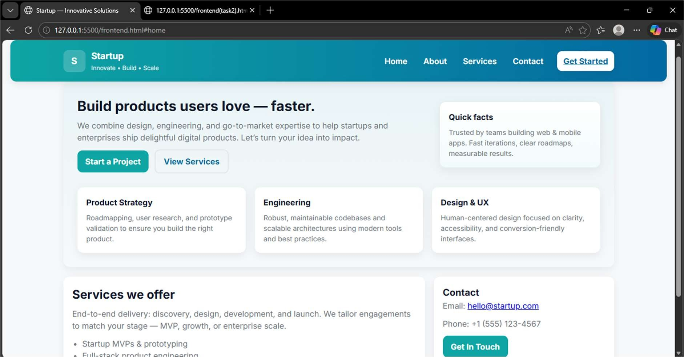

EXPLANATION:
The task is to build a clean homepage for a startup using HTML and CSS. It must include a header with logo and navigation, a main section with welcome content, and a footer with contact details. Use responsive CSS and media queries with breakpoints so the page adapts for mobile, tablet, and desktop. Make sure header, content, and footer are clearly separated and the navigation remains readable on small screens. Aim for a professional, user-friendly design and test it across different screen sizes to ensure it works..

Task 2: Interactive Call-to-Action Button

Prompt:
Generate a code for Interactive Call-to-Action Button. Design a marketing page that requires call-toaction button that responds when users interact with it. Add a button to web page using HTML. Generate a javascript that responds to the button click by displaying a message or alert. Add meaningful comments explaining the javascript logic. Generate a readable and commented code.
Occursion of page reload shouldn't occur.
CODE:
<!doctype html>
<html lang="en">
<head>
<meta charset="UTF-8" />
<meta name="viewport" content="width=device-width, initial-scale=1.0" /> <title>NovaLabs | Build Faster</title>

<!-- Font -->
<link rel="preconnect" href="https://fonts.googleapis.com">
<link rel="preconnect" href="https://fonts.gstatic.com" crossorigin>
<link href="https://fonts.googleapis.com/css2?family=Space+Grotesk:wght@400;500;700&display =swap" rel="stylesheet">

<style>
:root{
--bg:#f4f8ff;
--surface:#ffffff;
--text:#10223d;
--muted:#5f6f86;
--brand:#0ea5e9;
--brand-dark:#0369a1;
--accent:#22c55e;
--ring:rgba(14,165,233,.25);
--shadow:0 10px 28px rgba(16,34,61,.12);
--radius:16px;
--max:1120px;
}

*{ margin:0; padding:0; box-sizing:border-box;
}

body{ font-family:"Space Grotesk", sans-serif; color:var(--text); background:
radial-gradient(circle at 10% 20%, #dff3ff 0%, transparent 40%), radial-gradient(circle at 90% 10%, #dcffe8 0%, transparent 35%),
var(--bg); line-height:1.6;
}

.container{ width:min(92%, var(--max)); margin-inline:auto;
}

/* Header */ header{ position:sticky; top:0; z-index:50; background:rgba(255,255,255,.86); backdrop-filter: blur(8px); border-bottom:1px solid #e6eef8;
}

.nav{ display:flex; justify-content:space-between; align-items:center; padding:14px 0;
}

.logo{ font-weight:700; font-size:1.2rem; letter-spacing:.2px; color:var(--text); text-decoration:none;
}

.logo span{ color:var(--brand-dark); }

.nav-links{
display:flex; gap:1.1rem; list-style:none; flex-wrap:wrap;
}

.nav-links a{ text-decoration:none; color:var(--text); font-weight:500; padding:8px 10px; border-radius:10px; transition:.2s ease;
}

.nav-links a:hover{ background:#eaf6ff; color:var(--brand-dark);
}

/* Main */ main{ padding:48px 0 36px;
}

.hero{ display:grid; grid-template-columns:1.15fr .85fr; gap:24px; align-items:stretch;
}

.hero-left, .hero-right{ background:var(--surface); border-radius:var(--radius); box-shadow:var(--shadow);
}

.hero-left{ padding:32px;
}

.hero-left h1{ font-size:clamp(1.8rem, 3.6vw, 3rem); line-height:1.12; margin-bottom:14px;
}

.hero-left p{ color:var(--muted); margin-bottom:20px; max-width:58ch;
}

.cta-wrap{ display:flex; gap:12px; flex-wrap:wrap; align-items:center; }

.cta-btn{ border:none; background:linear-gradient(135deg,var(--brand),var(--brand-dark));
color:#fff; font-weight:700; padding:12px 18px; border-radius:12px; cursor:pointer; transition:transform .15s ease, box-shadow .15s ease; box-shadow:0 8px 18px rgba(3,105,161,.3);
}

.cta-btn:hover{ transform:translateY(-1px);
}

.cta-btn:focus{ outline:3px solid var(--ring); outline-offset:2px;
}

.ghost{ text-decoration:none; color:var(--brand-dark); font-weight:600; padding:11px 16px; border-radius:12px; border:1px solid #cfe9ff; background:#f5fbff;
}

.hero-right{ padding:24px; display:grid; gap:14px; align-content:start;
}

.stat{ background:#f7fbff; border:1px solid #e4f2ff; border-radius:14px; padding:14px;
}

.stat h3{ font-size:1.45rem; margin-bottom:4px; color:var(--brand-dark);
}

.stat p{ color:var(--muted); font-size:.96rem;
}

.features{ margin-top:24px; display:grid; grid-template-columns:repeat(3,1fr); gap:16px;
}

.card{ background:var(--surface); border-radius:14px; box-shadow:var(--shadow); padding:18px;
}

.card h4{ margin-bottom:8px; font-size:1.05rem;
}

.card p{ color:var(--muted); font-size:.96rem;
}

/* Message output area (JS updates this) */
.message{ margin-top:14px; padding:10px 12px; border-radius:10px; font-size:.95rem; display:none;
}

.message.show{ display:block;
}

.message.success{ background:#e8fff0; color:#146c3b; border:1px solid #b8efcb;
}

/* Footer */ footer{ margin-top:34px; background:#0f2138; color:#dce8f8; padding:22px 0; border-top:3px solid #16385f;
}

.footer-inner{ display:flex; justify-content:space-between; gap:12px; flex-wrap:wrap;
}

.footer-inner p{ font-size:.95rem;
}

/* Tablet */
@media (max-width: 900px){
.hero{ grid-template-columns:1fr;
}

.features{ grid-template-columns:repeat(2,1fr);
}

.nav-links{ gap:.6rem;
}
}

/* Mobile */
@media (max-width: 600px){
.nav{ flex-direction:column; align-items:flex-start; gap:8px;
}

.hero-left{ padding:24px;
}

.features{ grid-template-columns:1fr; }

.cta-wrap{ flex-direction:column; align-items:flex-start;
}

.cta-btn, .ghost{ width:100%; text-align:center;
}
}
</style>
</head>
<body>
<!-- Header with navigation -->
<header>
<div class="container nav">
<a href="#" class="logo">Nova<span>Labs</span></a>
<ul class="nav-links">
<li><a href="#">Home</a></li>
<li><a href="#">About</a></li>
<li><a href="#">Services</a></li>
<li><a href="#">Contact</a></li>
</ul>
</div>
</header>

<!-- Main content -->
<main class="container"> <section class="hero">
<div class="hero-left">
<h1>Launch Your Startup with Confidence</h1>
<p>
We help founders build modern digital products faster with design, development, and growth-ready strategy under one roof.
</p>

<div class="cta-wrap">
<button id="ctaButton" class="cta-btn" type="button">Start Free
Consultation</button>
<a href="#" class="ghost">See Success Stories</a>
</div>

<!-- JS writes click response here -->
<div id="ctaMessage" class="message" aria-live="polite"></div>
</div>

<aside class="hero-right">
<div class="stat">
<h3>120+</h3>
<p>Products shipped for startups and growing teams.</p>
</div>
<div class="stat">
<h3>98%</h3>
<p>Client satisfaction with delivery speed and quality.</p>
</div>
<div class="stat">
<h3>24/7</h3>
<p>Reliable support and transparent communication.</p>
</div>
</aside>
</section>

<section class="features">
<article class="card">
<h4>Strategy First</h4>
<p>Clear planning and roadmap so every feature solves a real user need.</p> </article>
<article class="card">
<h4>Modern Development</h4>
<p>Fast, clean, scalable code that performs smoothly on all devices.</p>
</article>
<article class="card">
<h4>Growth Focused</h4>
<p>Data-driven improvements that increase retention and conversion.</p>
</article>
</section>
</main>

<!-- Footer -->
<footer>
<div class="container footer-inner">
<p>© 2026 NovaLabs. All rights reserved.</p>
<p>Email: hello@novalabs.com | Phone: +1 (555) 210-7788</p>
</div>
</footer>

<script>
// Select the CTA button and the message container
const ctaButton = document.getElementById("ctaButton"); const ctaMessage = document.getElementById("ctaMessage");

// Listen for button click and show feedback without reloading the page ctaButton.addEventListener("click", function (event) {
// This prevents default behavior (safe even though button type is "button") event.preventDefault();

// Update message text and style to show success feedback
ctaMessage.textContent = "Thanks! Your consultation request was received. Our team will contact you soon."; ctaMessage.className = "message show success";

// Optional alert for immediate feedback (also no page reload) alert("Request submitted successfully!");
});
</script>
</body>
</html>
OUTPUT:
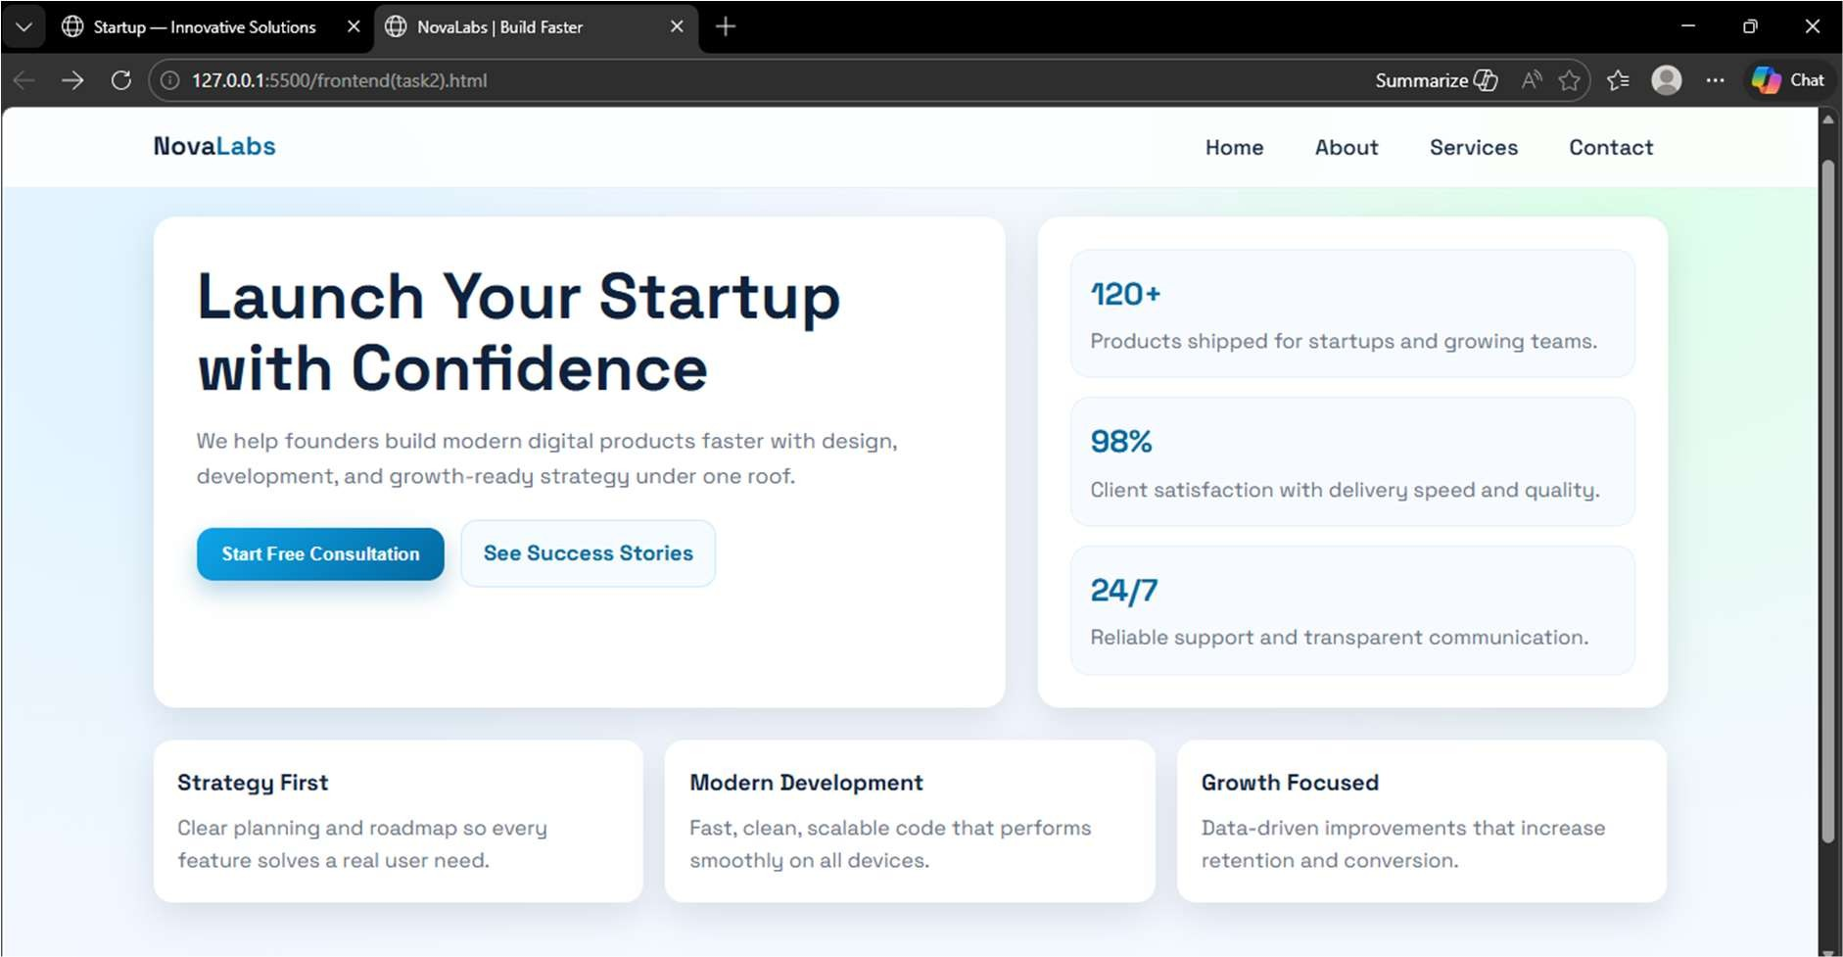

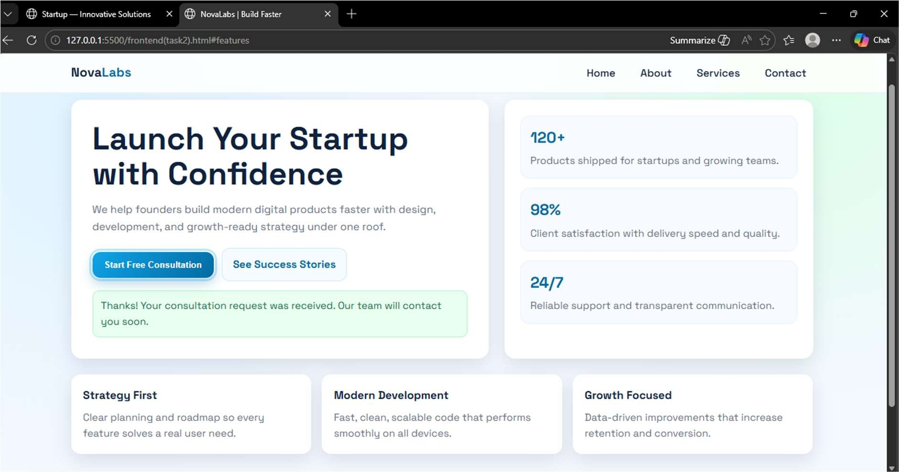
EXPLANATION:
This task asks us to create a simple marketing web page with an interactive Call-to-Action button. We use HTML to build the page parts like header, content section, button, and footer in a clear structure.Then we use CSS and media queries so the layout looks good on desktop, tablet, and mobile screens. With JavaScript, when the user clicks the button, a message or alert appears without reloading the page. Overall, the goal is to make the page user-friendly, responsive, and easy to understand with proper comments.
Task 3: Contact Form with Client-Side Validation
PROMPT:
Develop a contact form for a company website that collects user queries safely and correctly. The form should include input fields for Name, Email, and Message. Implement client-side validation using JavaScript to ensure that users cannot submit the form with empty fields and that the email entered follows a valid format. If the user provides invalid input, the form should display clear inline error messages next to the relevant fields. When all inputs are valid, the form should display a success message confirming the submission. The validation must occur entirely on the client side using JavaScript.

CODE:
<!doctype html>
<html lang="en">
<head>
<meta charset="UTF-8" />
<meta name="viewport" content="width=device-width, initial-scale=1.0" />
<title>Smart Product List</title>
<style>
:root {
--bg: #f3f7ff;
--card: #ffffff;
--text: #13233f;
--muted: #5f6f86;
--brand: #0ea5e9;
--brand-dark: #0369a1;
--danger: #dc2626;
--border: #d7e3f3;
--success-bg: #eafbf0;
--success-text: #17663c;
--radius: 14px;
--shadow: 0 12px 28px rgba(19, 35, 63, 0.08);
}

* { margin: 0; padding: 0; box-sizing: border-box;
}

body { font-family: "Segoe UI", Arial, Helvetica, sans-serif; background:
radial-gradient(circle at 15% 10%, #e1f4ff 0, transparent 35%), radial-gradient(circle at 85% 0%, #e8fff3 0, transparent 30%), var(--bg);
color: var(--text); min-height: 100vh; padding: 24px;
}

.container { max-width: 760px; margin: 0 auto; background: var(--card); border: 1px solid var(--border); border-radius: var(--radius); box-shadow: var(--shadow); overflow: hidden;
}

.topbar { padding: 20px 22px; background: linear-gradient(135deg, var(--brand), var(--brand-dark));
color: #fff;
}

.topbar h1 { font-size: 1.5rem; margin-bottom: 6px;
}

.topbar p { opacity: 0.95; font-size: 0.95rem;
}

.content { padding: 22px;
}

.controls { display: grid; grid-template-columns: 1fr auto auto; gap: 10px; margin-bottom: 14px;
}

.controls input { border: 1px solid var(--border); border-radius: 10px; padding: 11px 12px; font-size: 1rem; outline: none;
}

.controls input:focus { border-color: var(--brand); box-shadow: 0 0 0 3px rgba(14, 165, 233, 0.18);
}

button { border: 0; border-radius: 10px; color: #fff; font-weight: 700; padding: 11px 14px; cursor: pointer; transition: transform 0.12s ease, opacity 0.12s ease;
}

button:hover { transform: translateY(-1px);
}

button:disabled { opacity: 0.55; cursor: not-allowed; transform: none;
}

#addBtn { background: linear-gradient(135deg, #0ea5e9, #0369a1);
}

#removeBtn { background: linear-gradient(135deg, #ef4444, #b91c1c);
}

.hint { color: var(--muted); font-size: 0.9rem; margin-bottom: 12px;
}

.error-text {
color: var(--danger); min-height: 20px; font-size: 0.9rem; margin-bottom: 8px;
}
ul { list-style: none; border: 1px solid var(--border); border-radius: 10px; overflow: hidden; background: #fff;
} li {
padding: 12px 14px; border-bottom: 1px solid var(--border); display: flex; align-items: center; gap: 8px;
}

li:last-child { border-bottom: none;
}

.dot { width: 8px; height: 8px; border-radius: 50%; background: var(--brand); flex-shrink: 0;
}

.status { margin-top: 12px; font-size: 0.95rem; color: var(--muted);
}

.success { margin-top: 10px; background: var(--success-bg); color: var(--success-text); border: 1px solid #bfe8cd; border-radius: 10px; padding: 10px 12px; display: none;
}

.success.show { display: block;
}

@media (max-width: 640px) {
body { padding: 14px;
}

.content {
padding: 16px;
}

.controls { grid-template-columns: 1fr;
}

button { width: 100%;
}
}
</style>
</head>
<body>
<main class="container">
<header class="topbar">
<h1>Product List Manager</h1>
<p>Add and remove products instantly with no page refresh.</p>
</header>

<section class="content">
<div class="controls">
<input id="productInput" type="text" placeholder="Enter product name (example: Wireless Mouse)" />
<button id="addBtn" type="button">Add</button>
<button id="removeBtn" type="button">Remove Last</button>
</div>

<p class="hint">Tip: Press Enter in the input box to add quickly.</p> <p id="errorText" class="error-text" aria-live="polite"></p>

<ul id="productList" aria-live="polite">
<li><span class="dot"></span>Product 1</li>
<li><span class="dot"></span>Product 2</li> <li><span class="dot"></span>Product 3</li>
</ul>

<p id="statusText" class="status">Total products: 3</p>
<p id="successText" class="success" aria-live="polite"></p>
</section>
</main>

<script>
// Cache important DOM elements once. const productInput = document.getElementById("productInput"); const addBtn = document.getElementById("addBtn"); const removeBtn = document.getElementById("removeBtn"); const productList = document.getElementById("productList"); const statusText = document.getElementById("statusText"); const errorText = document.getElementById("errorText"); const successText = document.getElementById("successText");

// Track numeric fallback names when user does not provide custom text. let productCount = productList.children.length;

// Reusable UI updates after every list change. function updateUI() { const total = productList.children.length; statusText.textContent = `Total products: ${total}`; removeBtn.disabled = total === 0;
}

// Show a temporary success message for better user feedback.
function showSuccess(message) { successText.textContent = message; successText.classList.add("show"); setTimeout(() => successText.classList.remove("show"), 1500);
}

// Clear error message when input becomes valid. function clearError() { errorText.textContent = "";
}

// Add new item dynamically without page reload. function addProduct() { const typedName = productInput.value.trim(); let label = typedName;

// If input is empty, use auto-generated product name.
if (!label) { productCount += 1; label = `Product ${productCount}`;
}

const li = document.createElement("li"); li.innerHTML = `<span class="dot"></span>${label}`; productList.appendChild(li);

productInput.value = ""; clearError();
updateUI(); showSuccess(`Added: ${label}`);
}
// Remove only the last item. Show friendly error when list is empty. function removeLastProduct() { if (productList.children.length === 0) { errorText.textContent = "No items left to remove.";
return;
}

const removedText = productList.lastElementChild.textContent.trim(); productList.removeChild(productList.lastElementChild);

clearError(); updateUI(); showSuccess(`Removed: ${removedText}`);
}

// Event bindings addBtn.addEventListener("click", addProduct); removeBtn.addEventListener("click", removeLastProduct);

// Enter key support for quicker add action.
productInput.addEventListener("keydown", (event) => { if (event.key === "Enter") { event.preventDefault(); addProduct();
}
});

// Remove stale errors while user types.
productInput.addEventListener("input", clearError);

// Initial sync on load.
updateUI();
</script>
</body>
</html>

OUTPUT:

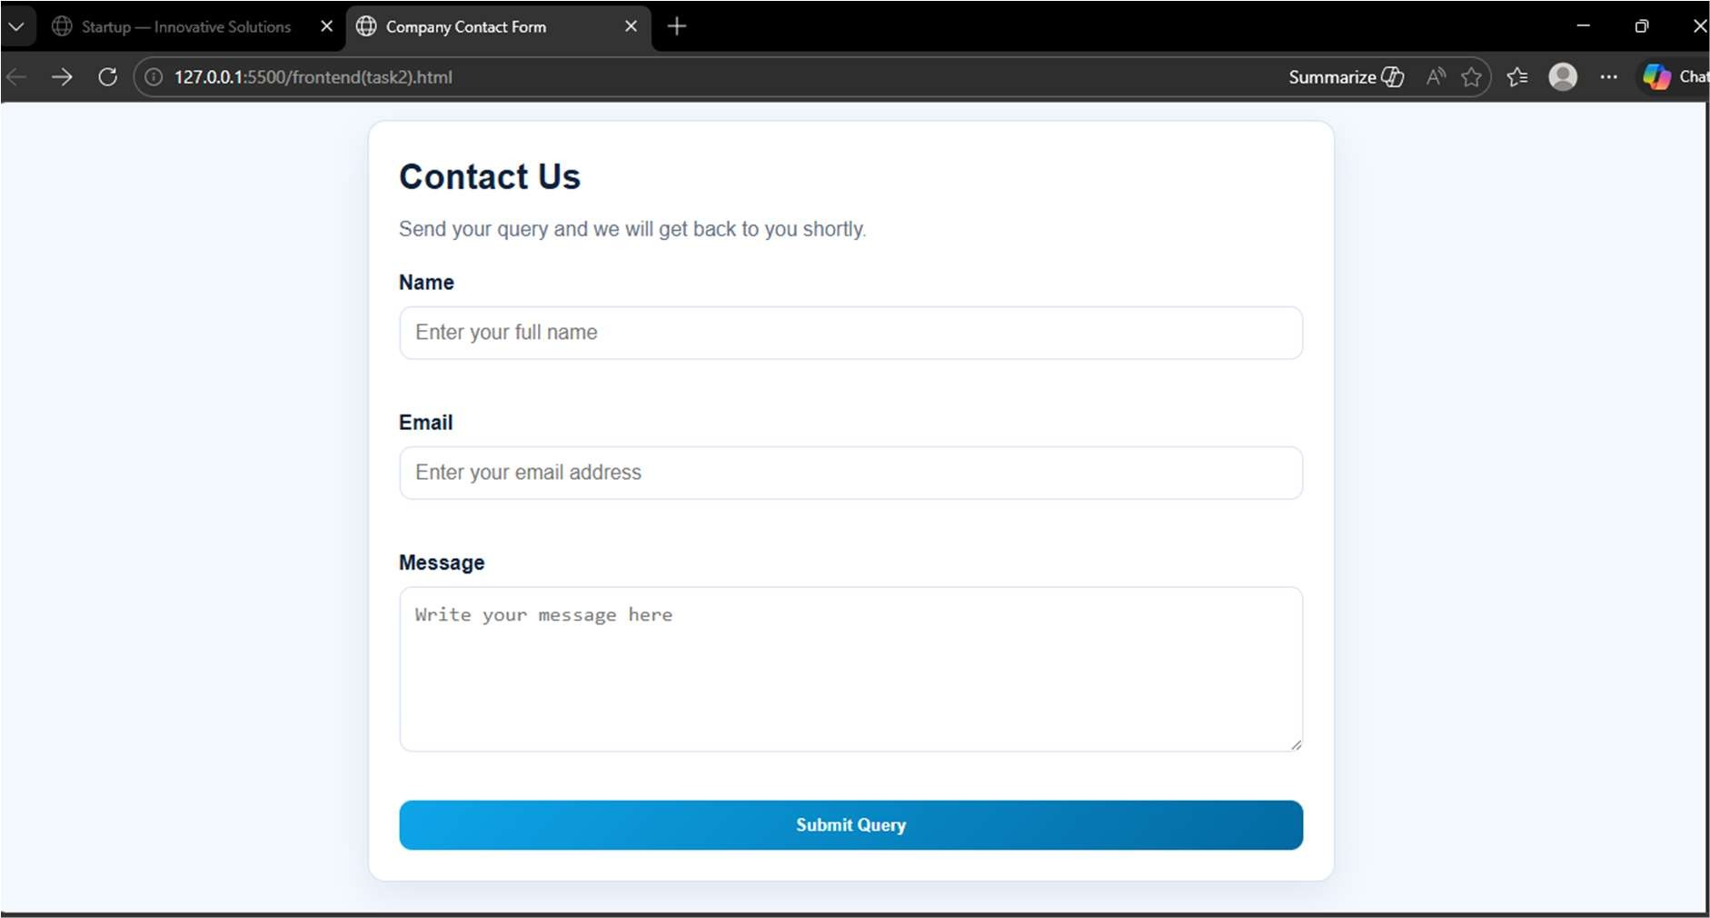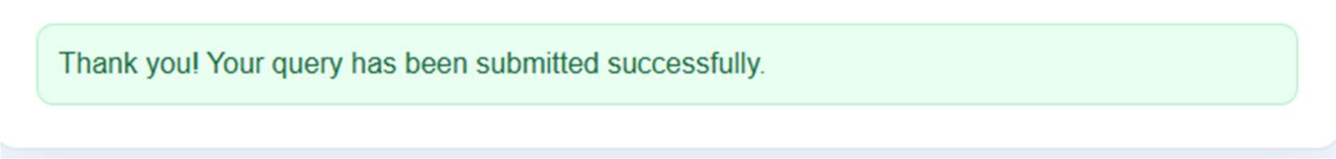
JUSTIFICATION:
This task is about creating a contact form for a company website using Name, Email, and Message fields.
We use JavaScript on the client side to check that no field is left empty before submission.
The email is also validated to make sure it follows a correct format like user@example.com.
If any input is wrong, clear inline error messages are shown next to the related field so users can fix it easily.
When all details are correct, the form shows a success message without reloading the page.
•

Task 4: Dynamic List Management for a Product Page
PROMPT:
Generate code for Dynamic List Management for a Product Page. Design a product listing page that needs to add or remove items dynamically without refreshing the page. Create a simple HTML list to display items. Generate javascript that adds a new item when an "Add" Button is clicked, remove the last item when a "Remove" button is clicked. Ensure the DOM updates dynamically. Changes should appeae instantly without page reload. Javascript logic should be clear and maintainable.
CODE:
<!doctype html>
<html lang="en">
<head>
<meta charset="UTF-8" />
<meta name="viewport" content="width=device-width, initial-scale=1.0" />
<title>Smart Product List</title>
<style>
:root {
--bg: #f3f7ff;
--card: #ffffff;
--text: #13233f;
--muted: #5f6f86;
--brand: #0ea5e9;
--brand-dark: #0369a1;
--danger: #dc2626;
--border: #d7e3f3;
--success-bg: #eafbf0;
--success-text: #17663c;
--radius: 14px;
--shadow: 0 12px 28px rgba(19, 35, 63, 0.08);
}

* { margin: 0; padding: 0; box-sizing: border-box;
}

body { font-family: "Segoe UI", Arial, Helvetica, sans-serif; background:
radial-gradient(circle at 15% 10%, #e1f4ff 0, transparent 35%), radial-gradient(circle at 85% 0%, #e8fff3 0, transparent 30%), var(--bg); color: var(--text); min-height: 100vh; padding: 24px;
}

.container { max-width: 760px; margin: 0 auto; background: var(--card); border: 1px solid var(--border); border-radius: var(--radius); box-shadow: var(--shadow); overflow: hidden;
}

.topbar { padding: 20px 22px; background: linear-gradient(135deg, var(--brand), var(--brand-dark));
color: #fff;
}

.topbar h1 { font-size: 1.5rem; margin-bottom: 6px;
}

.topbar p { opacity: 0.95; font-size: 0.95rem;
}

.content { padding: 22px;
}

.controls { display: grid; grid-template-columns: 1fr auto auto; gap: 10px; margin-bottom: 14px;
}

.controls input { border: 1px solid var(--border); border-radius: 10px; padding: 11px 12px; font-size: 1rem; outline: none;
}

.controls input:focus { border-color: var(--brand); box-shadow: 0 0 0 3px rgba(14, 165, 233, 0.18);
}

button { border: 0; border-radius: 10px; color: #fff; font-weight: 700; padding: 11px 14px; cursor: pointer; transition: transform 0.12s ease, opacity 0.12s ease;
}

button:hover { transform: translateY(-1px);
}

button:disabled { opacity: 0.55; cursor: not-allowed; transform: none;
}

#addBtn { background: linear-gradient(135deg, #0ea5e9, #0369a1);
}

#removeBtn {
background: linear-gradient(135deg, #ef4444, #b91c1c);
}

.hint { color: var(--muted); font-size: 0.9rem; margin-bottom: 12px;
}

.error-text { color: var(--danger); min-height: 20px; font-size: 0.9rem; margin-bottom: 8px;
}
ul { list-style: none; border: 1px solid var(--border); border-radius: 10px; overflow: hidden; background: #fff;
} li { padding: 12px 14px; border-bottom: 1px solid var(--border); display: flex; align-items: center; gap: 8px;
}

li:last-child { border-bottom: none;
}

.dot { width: 8px; height: 8px; border-radius: 50%; background: var(--brand); flex-shrink: 0;
}

.status { margin-top: 12px; font-size: 0.95rem; color: var(--muted);
}

.success { margin-top: 10px; background: var(--success-bg); color: var(--success-text); border: 1px solid #bfe8cd; border-radius: 10px; padding: 10px 12px; display: none;
}

.success.show { display: block;
}

@media (max-width: 640px) {
body { padding: 14px;
}

.content { padding: 16px;
}

.controls { grid-template-columns: 1fr; }

button { width: 100%;
}
}
</style>
</head>
<body>
<main class="container">
<header class="topbar">
<h1>Product List Manager</h1>
<p>Add and remove products instantly with no page refresh.</p>
</header>

<section class="content">
<div class="controls">
<input id="productInput" type="text" placeholder="Enter product name (example: Wireless Mouse)" />
<button id="addBtn" type="button">Add</button>
<button id="removeBtn" type="button">Remove Last</button>
</div>

<p class="hint">Tip: Press Enter in the input box to add quickly.</p> <p id="errorText" class="error-text" aria-live="polite"></p>

<ul id="productList" aria-live="polite">
<li><span class="dot"></span>Product 1</li>
<li><span class="dot"></span>Product 2</li> <li><span class="dot"></span>Product 3</li>
</ul>

<p id="statusText" class="status">Total products: 3</p>
<p id="successText" class="success" aria-live="polite"></p>
</section>
</main>

<script>
// Cache important DOM elements once.
const productInput = document.getElementById("productInput"); const addBtn = document.getElementById("addBtn"); const removeBtn = document.getElementById("removeBtn"); const productList = document.getElementById("productList"); const statusText = document.getElementById("statusText"); const errorText = document.getElementById("errorText"); const successText = document.getElementById("successText");

// Track numeric fallback names when user does not provide custom text. let productCount = productList.children.length;

// Reusable UI updates after every list change.
function updateUI() { const total = productList.children.length; statusText.textContent = `Total products: ${total}`; removeBtn.disabled = total === 0;
}
// Show a temporary success message for better user feedback.
function showSuccess(message) { successText.textContent = message; successText.classList.add("show"); setTimeout(() => successText.classList.remove("show"), 1500);
}

// Clear error message when input becomes valid.
function clearError() { errorText.textContent = "";
}

// Add new item dynamically without page reload. function addProduct() { const typedName = productInput.value.trim(); let label = typedName;

// If input is empty, use auto-generated product name.
if (!label) {
productCount += 1; label = `Product ${productCount}`;
}

const li = document.createElement("li"); li.innerHTML = `<span class="dot"></span>${label}`; productList.appendChild(li);

productInput.value = ""; clearError(); updateUI(); showSuccess(`Added: ${label}`);
}
// Remove only the last item. Show friendly error when list is empty.
function removeLastProduct() { if (productList.children.length === 0) { errorText.textContent = "No items left to remove.";
return;
}

const removedText = productList.lastElementChild.textContent.trim(); productList.removeChild(productList.lastElementChild);

clearError();
updateUI(); showSuccess(`Removed: ${removedText}`);
}

// Event bindings addBtn.addEventListener("click", addProduct); removeBtn.addEventListener("click", removeLastProduct);

// Enter key support for quicker add action.
productInput.addEventListener("keydown", (event) => { if (event.key === "Enter") { event.preventDefault(); addProduct();
}
});

// Remove stale errors while user types.
productInput.addEventListener("input", clearError);

// Initial sync on load.
updateUI(); </script>
</body>
</html>

OUTPUT:
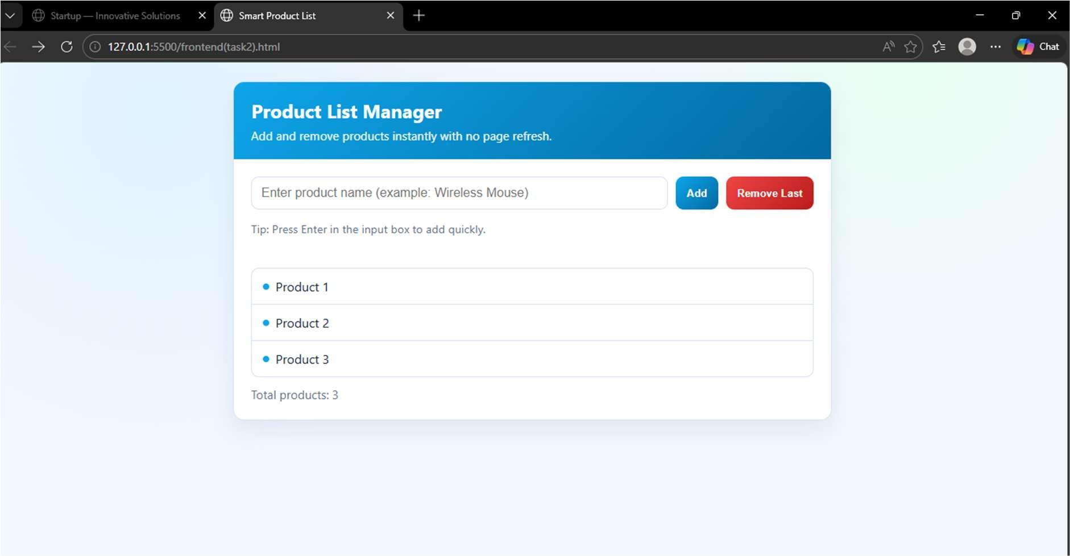

JUSTIFICATION:
This task is to create a product list page where items can be managed without reloading the website. Using HTML, we make a simple list and add two buttons: one for adding items and one for removing the last item. With JavaScript, clicking Add creates a new product entry in the list instantly using DOM updates.Clicking Remove deletes the last product item immediately, and the page stays on the same screen.The code should be clear, readable, and user-friendly so anyone can understand and maintain it easily.
Task 5: Modal Popup for User Notifications
PROMPT:
Develop a modal popup for user notifications that can be used for announcements or alerts on a website. Create the HTML structure for the modal popup, including a button labeled “Open Modal” that triggers the popup. Design the CSS styling with a semi-transparent background overlay so the popup appears clearly above the page content. Implement JavaScript functionality to open and close the modal. The modal should open when the user clicks “Open Modal” and close smoothly when instructed, such as by clicking a close button, clicking outside the modal, or using another close option. Ensure the popup clearly overlays the page content and provides a clean user notification experience.
CODE:
<!doctype html>
<html lang="en">
<head>
<meta charset="UTF-8" />
<meta name="viewport" content="width=device-width, initial-scale=1.0" />
<title>Premium Notification Modal</title>
<style>
:root {
--bg-1: #eef6ff;
--bg-2: #f7fffb;
--text: #12243f;
--muted: #5f6f86;
--primary: #0ea5e9;
--primary-dark: #0369a1;
--danger: #ef4444;
--overlay: rgba(8, 15, 31, 0.58);
--card: #ffffff;
--radius: 16px;
--shadow: 0 22px 55px rgba(10, 20, 40, 0.28);
--ring: 0 0 0 3px rgba(14, 165, 233, 0.25);
}

* { box-sizing: border-box; margin: 0; padding: 0;
}

body { font-family: "Segoe UI", Roboto, Arial, sans-serif; min-height: 100vh; background:
radial-gradient(circle at 10% 10%, #dcf2ff 0%, transparent 35%), radial-gradient(circle at 90% 0%, #e7fff2 0%, transparent 32%), linear-gradient(135deg, var(--bg-1), var(--bg-2)); color: var(--text); display: grid; place-items: center; padding: 24px;
}

.page { width: min(900px, 100%); background: rgba(255, 255, 255, 0.88); backdrop-filter: blur(8px); border: 1px solid #e8f0fb; border-radius: 20px; padding: 34px; box-shadow: 0 15px 40px rgba(18, 36, 63, 0.12); text-align: center;
}

.badge { display: inline-block; background: #e7f6ff; color: #0b5b8f; font-weight: 700; font-size: 0.8rem; letter-spacing: 0.2px; border-radius: 999px; padding: 6px 12px; margin-bottom: 14px;
}

h1 { font-size: clamp(1.6rem, 3vw, 2.3rem); margin-bottom: 10px;
}

.subtitle { color: var(--muted); max-width: 60ch; margin: 0 auto 24px; line-height: 1.6;
}

.open-btn { border: none; color: #fff; font-weight: 700; font-size: 1rem; padding: 12px 18px; border-radius: 12px; cursor: pointer; background: linear-gradient(135deg, var(--primary), var(--primary-dark)); box-shadow: 0 10px 22px rgba(3, 105, 161, 0.3); transition: transform 0.14s ease, box-shadow 0.14s ease;
}

.open-btn:hover { transform: translateY(-1px); box-shadow: 0 14px 26px rgba(3, 105, 161, 0.35);
}

.open-btn:focus-visible { outline: none; box-shadow: var(--ring);
}

/* ===== Modal Layer ===== */ .modal-overlay { position: fixed; inset: 0; background: var(--overlay); display: grid; place-items: center; padding: 18px; z-index: 999; opacity: 0; visibility: hidden; transition: opacity 0.28s ease, visibility 0.28s ease;
}

.modal-overlay.show { opacity: 1; visibility: visible;
}

.modal { width: min(560px, 100%); border-radius: var(--radius); background: var(--card); box-shadow: var(--shadow); border: 1px solid #e7edf8; transform: translateY(18px) scale(0.97); opacity: 0; transition: transform 0.28s ease, opacity 0.28s ease; overflow: hidden;
}

.modal-overlay.show .modal { transform: translateY(0) scale(1); opacity: 1;
}

.modal-head { display: flex; align-items: center; justify-content: space-between; padding: 16px 18px; border-bottom: 1px solid #edf2fa; background: linear-gradient(180deg, #f9fcff, #ffffff);
}

.modal-title-wrap { display: flex; align-items: center; gap: 10px;
}

.icon { width: 34px; height: 34px; border-radius: 10px; background: #e8f7ff; color: #0b5b8f; display: grid; place-items: center; font-weight: 900;
}

.modal h2 { font-size: 1.08rem; margin: 0;
}

.icon-close { border: none; background: transparent; width: 34px; height: 34px; border-radius: 8px; font-size: 1.4rem; line-height: 1; color: #6b7280; cursor: pointer;
}

.icon-close:hover { background: #f1f5f9; color: #111827;
}

.icon-close:focus-visible { outline: none; box-shadow: var(--ring);
}

.modal-body { padding: 20px 18px 10px;
}

.modal-body p { color: #52627b; line-height: 1.6; margin-bottom: 14px;
}

.notice { background: #fff8e8; color: #8a5b00; border: 1px solid #ffe0a3; border-radius: 10px; padding: 10px 12px; font-size: 0.93rem;
}

.modal-actions { display: flex; justify-content: flex-end; gap: 10px; padding: 16px 18px 18px;
}

.btn { border: none; border-radius: 10px; padding: 10px 14px; font-weight: 700; cursor: pointer;
}

.btn.secondary { background: #eef5ff; color: #0a4f80;
}

.btn.close { background: linear-gradient(135deg, #ef4444, #b91c1c);
color: #fff;
}

.btn:focus-visible { outline: none; box-shadow: var(--ring);
}

@media (max-width: 640px) {
.page { padding: 22px; } .modal-actions { flex-direction: column;
}
.btn {
width: 100%;
}
}
</style>
</head>
<body>
<main class="page">
<span class="badge">User Notification</span>
<h1>Announcement Center</h1>
<p class="subtitle">
Use this modal for alerts, updates, offers, or maintenance messages.
It is smooth, readable, and works with mouse and keyboard.
</p>
<button id="openModalBtn" class="open-btn" type="button">Open Modal</button> </main>

<div id="modalOverlay" class="modal-overlay" aria-hidden="true">
<section class="modal" role="dialog" aria-modal="true" aria-labelledby="modalTitle" aria-describedby="modalDesc"
>
<header class="modal-head">
<div class="modal-title-wrap">
<div class="icon">i</div>
<h2 id="modalTitle">Important Website Notice</h2>
</div>
<button id="iconCloseBtn" class="icon-close" type="button" aria-label="Close modal">&times;</button>
</header>

<div class="modal-body">
<p id="modalDesc">
We are releasing a new dashboard tonight. Some sections may be temporarily unavailable from 11:30 PM to 12:30 AM.
</p>
<div class="notice">
Please save your work before maintenance starts.
</div>
</div>

<div class="modal-actions">
<button id="ackBtn" class="btn secondary" type="button">Got It</button>
<button id="closeBtn" class="btn close" type="button">Close</button>
</div>
</section>
</div>

<script>
// Cache elements for clarity and maintainability.
const openModalBtn = document.getElementById("openModalBtn"); const modalOverlay = document.getElementById("modalOverlay"); const closeBtn = document.getElementById("closeBtn"); const iconCloseBtn = document.getElementById("iconCloseBtn"); const ackBtn = document.getElementById("ackBtn");

// Keep track of the element focused before opening the modal,
// so focus can return there when the modal closes.
let previousFocus = null;

function openModal() { previousFocus = document.activeElement; modalOverlay.classList.add("show"); modalOverlay.setAttribute("aria-hidden", "false"); document.body.style.overflow = "hidden"; // Prevent background scroll iconCloseBtn.focus(); // Move keyboard focus into modal
}

function closeModal() { modalOverlay.classList.remove("show"); modalOverlay.setAttribute("aria-hidden", "true"); document.body.style.overflow = ""; // Restore scroll if (previousFocus) previousFocus.focus();
}

// Open modal on trigger button.
openModalBtn.addEventListener("click", openModal);

// Close modal from all explicit close controls. closeBtn.addEventListener("click", closeModal); iconCloseBtn.addEventListener("click", closeModal); ackBtn.addEventListener("click", closeModal);

// Close when user clicks outside the modal card. modalOverlay.addEventListener("click", (event) => { if (event.target === modalOverlay) closeModal();
});

// Close with Escape key for better accessibility. document.addEventListener("keydown", (event) => { if (event.key === "Escape" && modalOverlay.classList.contains("show")) { closeModal();
}
});
</script>
</body>
</html>

OUTPUT:

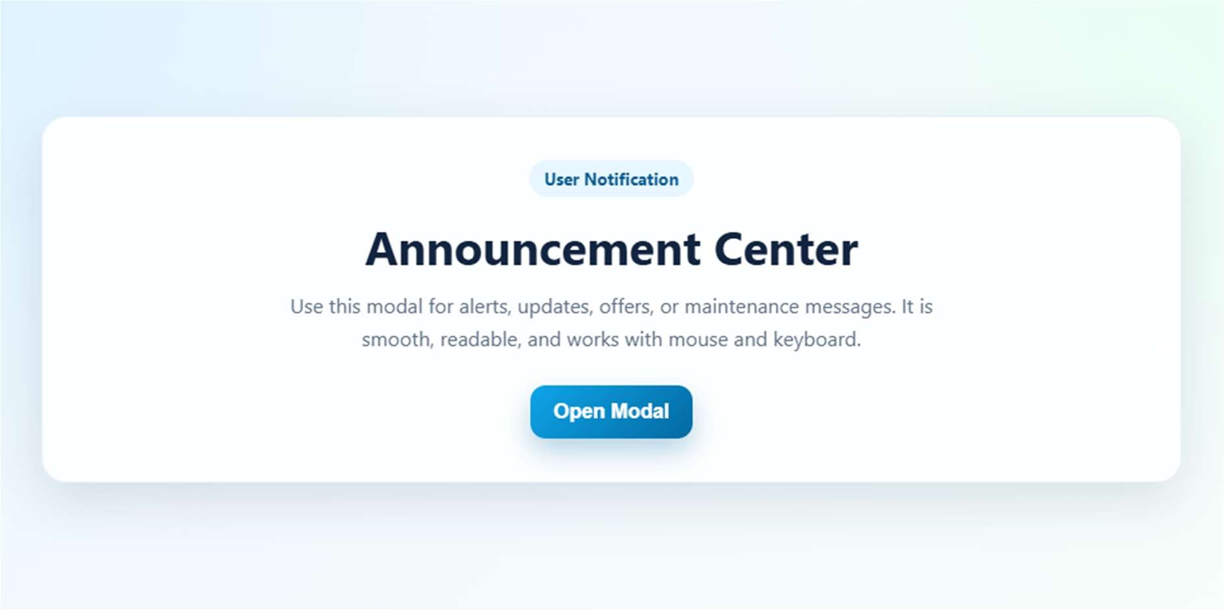

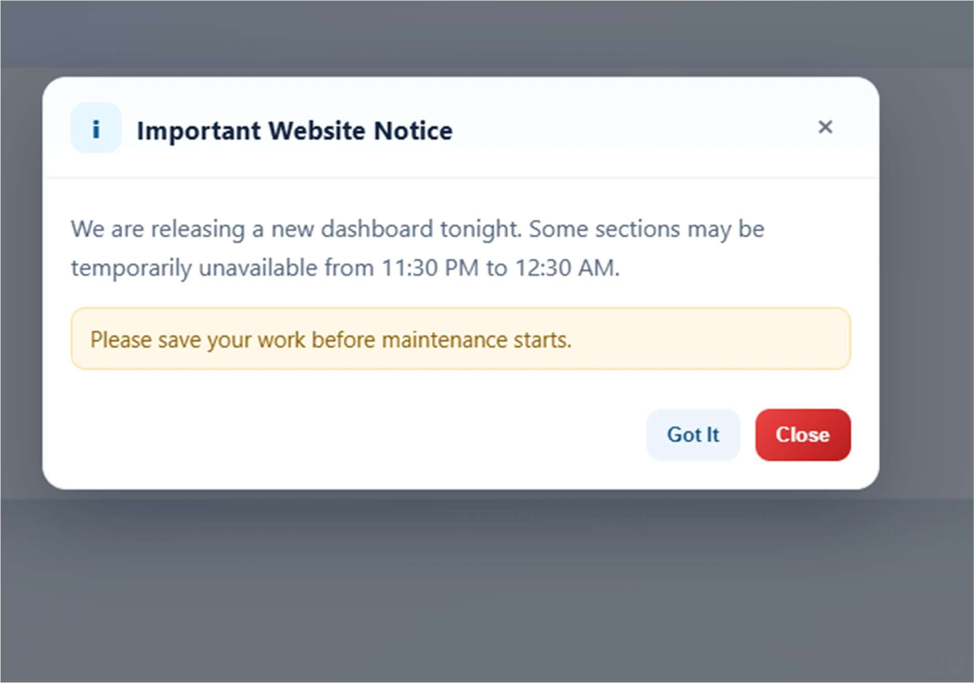
JUSTIFICATION:
This task is about creating a modal popup to show website notifications like announcements or alerts. First, we make the HTML structure with an “Open Modal” button, modal box, and close options. Then we style it using CSS with a semi-transparent overlay so the popup stands out above page content.Using JavaScript, the modal opens on button click and closes with close button, outside click, or Escape key.The final result is a clean, user-friendly popup that works smoothly without reloading the page.

