AI Assisted Coding

Assignment 19.3

Name: Dinesh Hallticket:2303A52329
Task 1 - Python to C++ Conversion Task:
Translate a simple Python class into C++ using AI assistance. Instructions:
. Prompt AI to convert a Python class representing a Student with attributes and methods into equivalent C++ code
. Ensure proper handling of:
- Constructors
- Data types Access specifiers
Compile and run both versions to verify output Expected Output:
An equivalent working C++ class translated from Python.

Prompt and code:
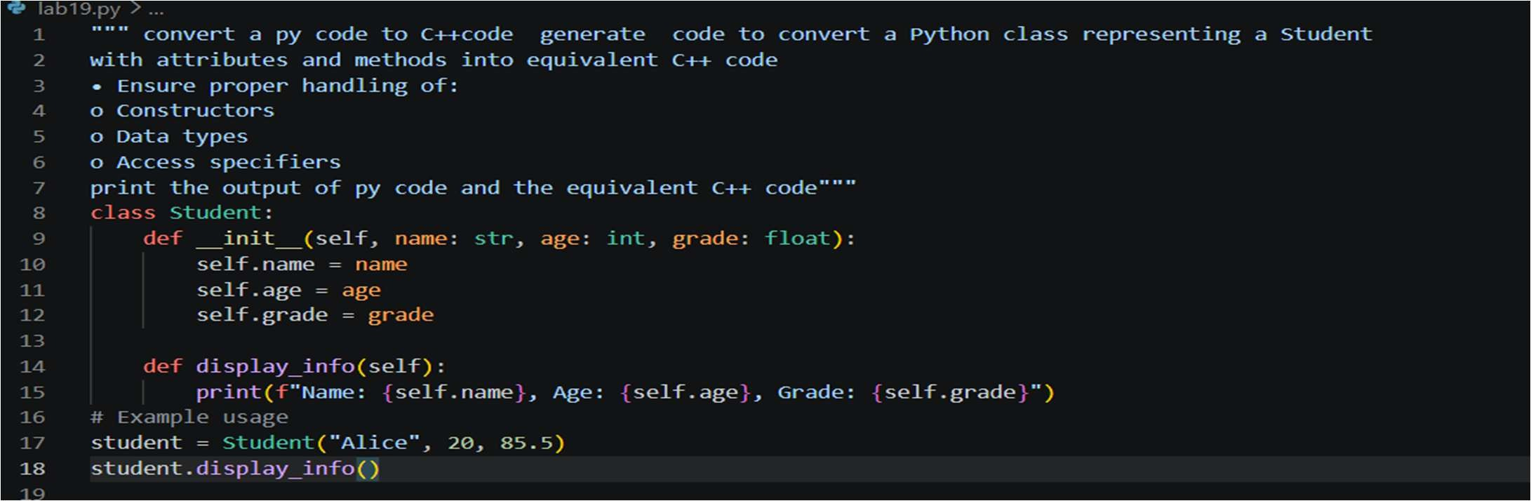
PY Output:
C++ Code:
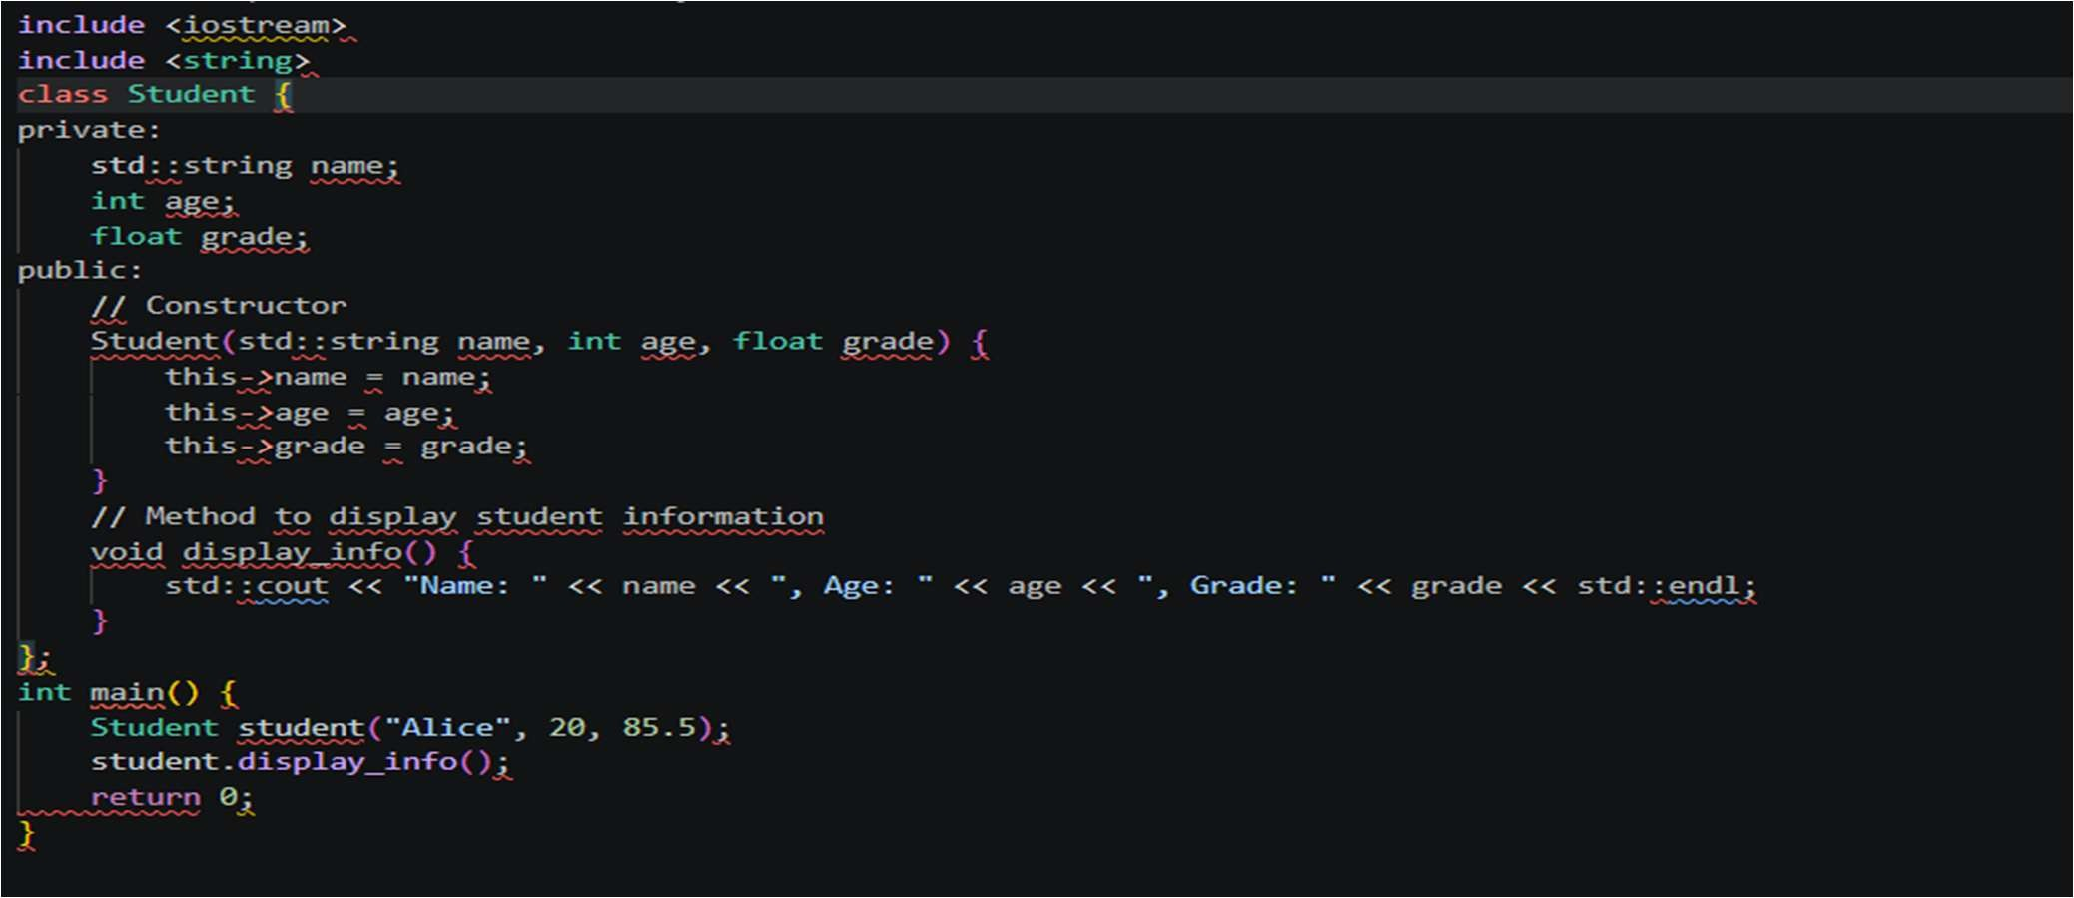

Task 2 – Java to Python Function Conversion Task:
Convert a Java method that checks whether a number is prime into Python.
Instructions:
- Ask AI to translate a Java isPrime() method into Python
- Test the function with multiple inputs
- Ensure the Python version follows Pythonic syntax and logic Expected Output:
A correct Python function equivalent to the original Java prime-Prompt and code:
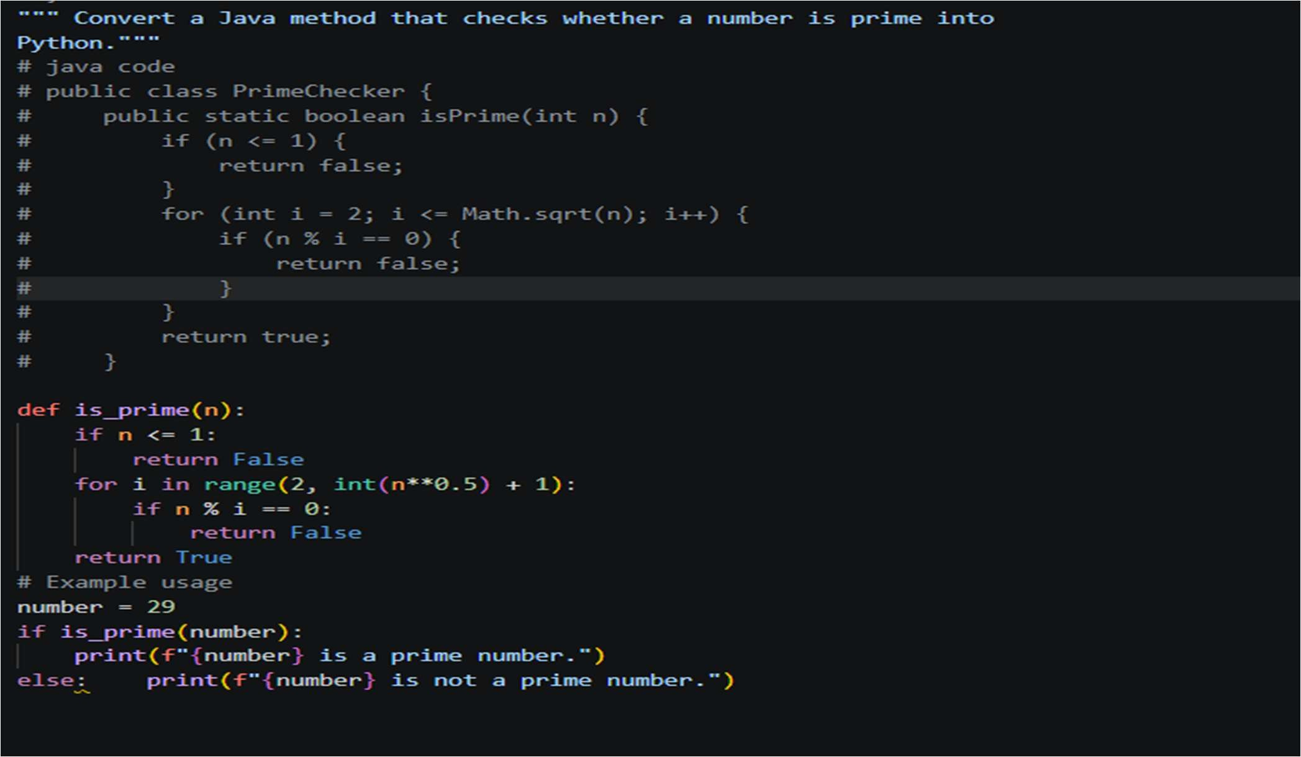
Output:

Task_03:
Task 3 – Pseudocode to Python Implementation Task:
Translate a given pseudocode algorithm into Python using AI. Instructions:
- Provide AI with pseudocode for sorting numbers (e.g., bubble sort or selection sort)
- Ask AI to convert it into executable Python code
- Validate correctness using sample input lists Expected Output:
A working Python program that correctly implements the pseudocode logic.

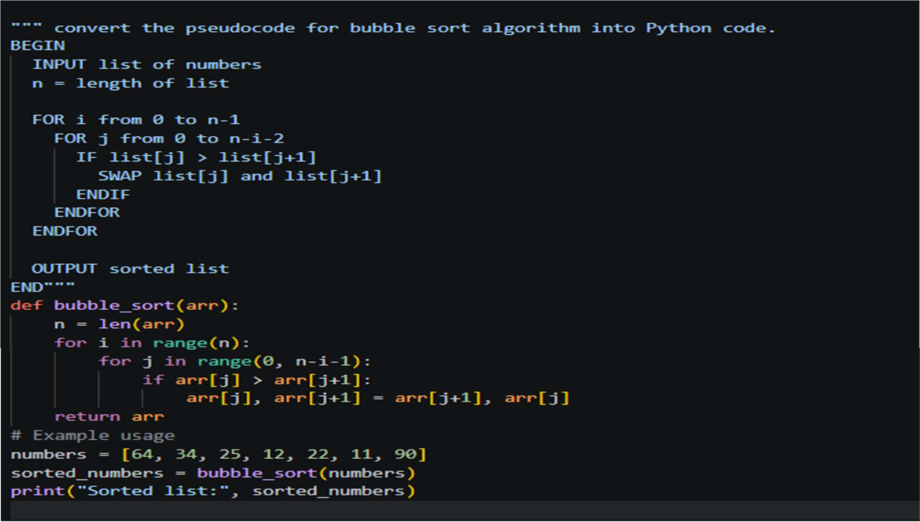

Output:
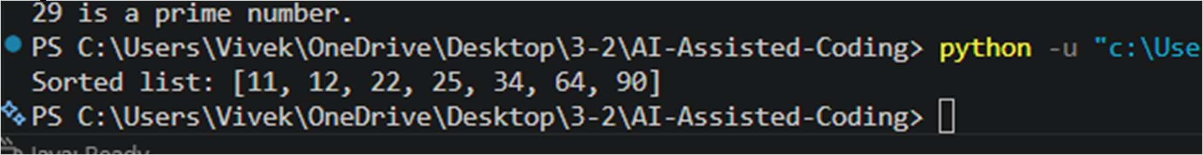
Task:4
Translate a SQL query into a Pandas DataFrame operation in Python.
Instructions:
- Provide AI with a SQL query (e.g., SELECT name, salary FROM employees WHERE salary > 50000).
- Ask AI to generate equivalent Pandas code.
- Test the generated code on a sample DataFrame. Expected Output:
- Equivalent Pandas query that retrieves the correct subset of data.
CODE and PROMPT:
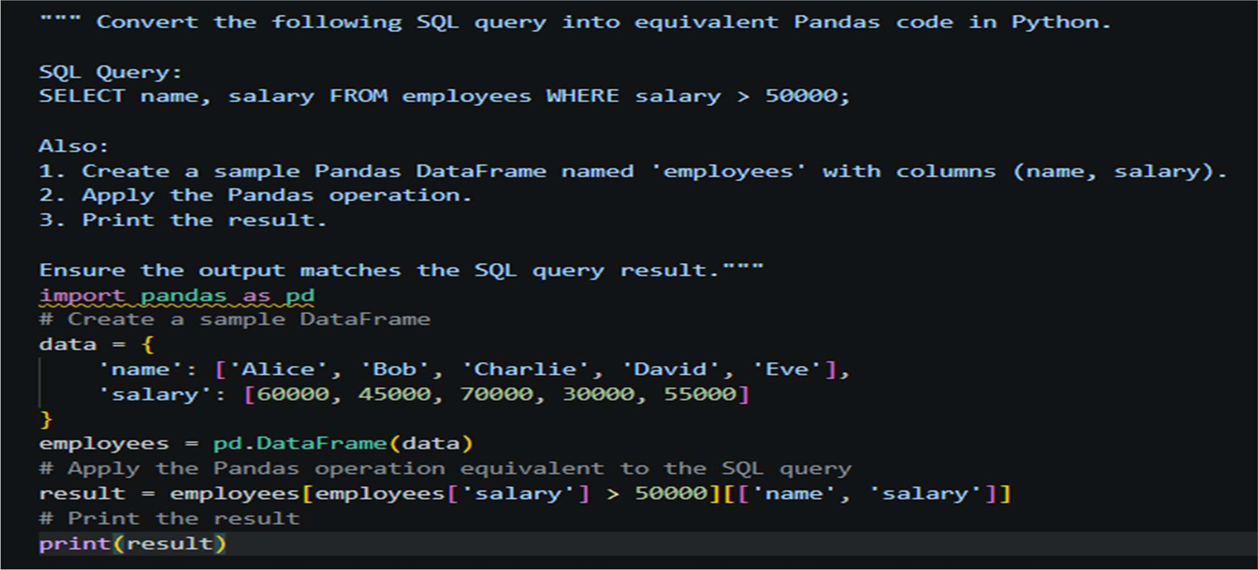

Output:
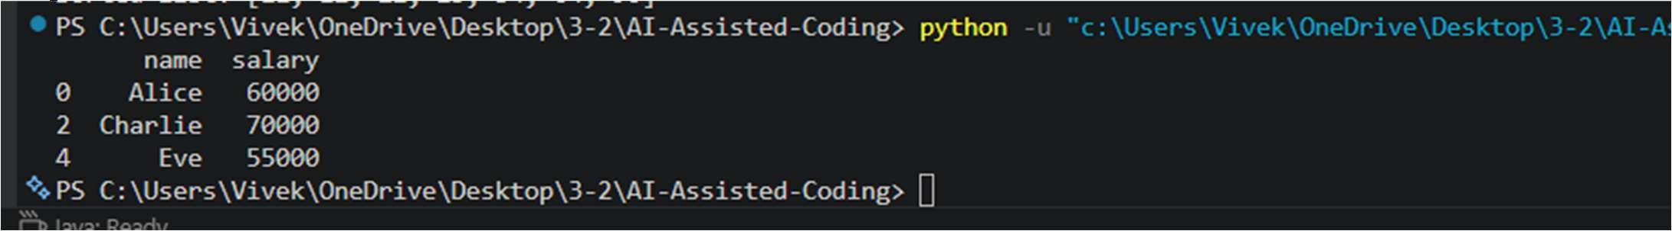
Task_05:
Task 5 - Real-Time Application: Algorithm Translation Across Languages
Scenario:
A company maintains algorithms written in different programming languages. Examples:
. Converting a Python searching algorithm into C Translating a Java sorting program into JavaScript Instructions:
. Use AI to translate a selected algorithm between two programming languages
. Execute and test both versions
. Document translation challenges such as:
- Syntax differences
- Library support Memory management Expected Output:
Equivalent, tested code implementations in two different programming languages.
Prompt and code:
"""Translate the following Python algorithm into C. Python Code:
# Binary Search
def binary_search(arr, target): left, right = 0, len(arr) - 1 while left <= right:
mid = (left + right) // 2 if arr[mid] == target:
return mid
elif arr[mid] < target:
left = mid + 1 else:
right = mid - 1 return -1
Also explain:
- Key syntax differences
- Memory management differences””” Code:
