AI Assistant Coding Assignment-4
Name of Student: P.Sharanya
Batch : 42
Enrollment No: 2303A52333

Task 1: Sentiment Classification for Customer Reviews.
- Prepare 6 short customer reviews mapped to sentiment labels.
- Design a Zero-shot prompt to classify sentiment.
- Design a One-shot prompt with one labeled example.
Prompt Zero Shot:
An e-commerce platform wants to analyze customer reviews and classify them into Positive, Negative, or Neutral sentiments. Give a python code for the same. Should take input from the user.

generate 6 short customer reviews.
Prompt One Shot:

An e-commerce platform wants to analyze customer reviews and classify them into Positive, Negative, or Neutral sentiments. Give a python code for the same. Take input from the user.
Write a python code for the above senario. Example reviews:
“Loved it—arrived fast and works perfectly.” “Decent quality, but the packaging was damaged.”

Code: Zero shot:
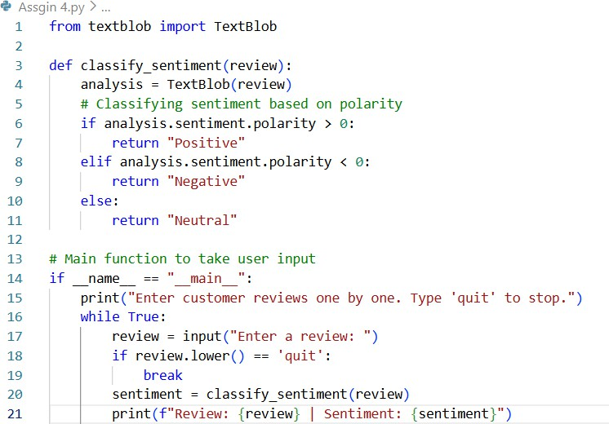

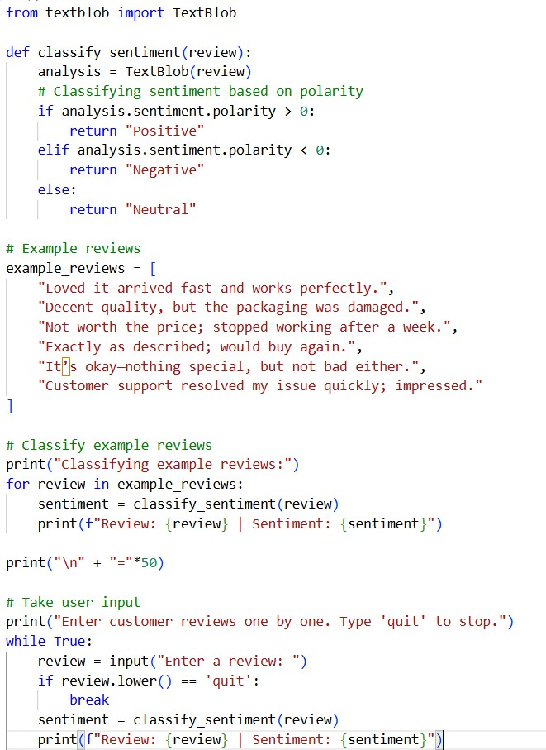
One-shot:

Output:

Zero Shot:
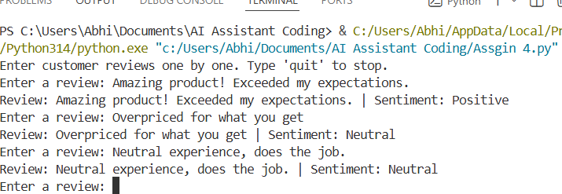
One Shot:
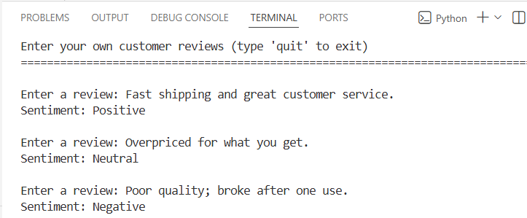

Explanation:
This task demonstrates sentiment analysis using Zero-shot and One-shot prompting techniques. The prompts guide the AI to classify customer reviews into Positive, Negative, or Neutral sentiments, while the code uses the TextBlob library to compute sentiment polarity. In the One-shot approach, example reviews are provided to guide the model toward better contextual understanding. The outputs show correct sentiment predictions for both predefined and user-entered reviews, validating the effectiveness of prompt design.

Task 2: Email Priority Classification

Perform classification using One-shot prompting. Perform classification using Few-shot prompting.

Prompt-1:
Write a python code for this:
An e-commerce platform wants to analyze customer reviews and classify them into Positive, Negative, or Neutral sentiments.Take input from the user.

Customer Reviews can be like this:
“Loved it—arrived fast and works perfectly.” “Decent quality, but the packaging was damaged.”

Prompt-2:
Write a python code for this:
An e-commerce platform wants to analyze customer reviews and classify them into Positive, Negative, or Neutral sentiments.Take input from the user.

Customer Reviews can be like this:
Examples:
“Loved it—arrived fast and works perfectly.” “Decent quality, but the packaging was damaged.” “Not worth the price; stopped working after a week.”
“Customer support resolved my issue quickly; impressed.”

Code: One Shot:
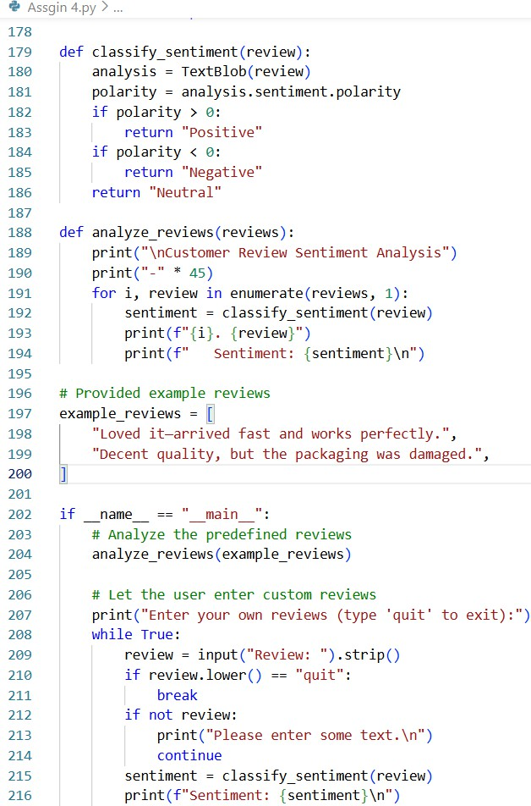

Few Shot:
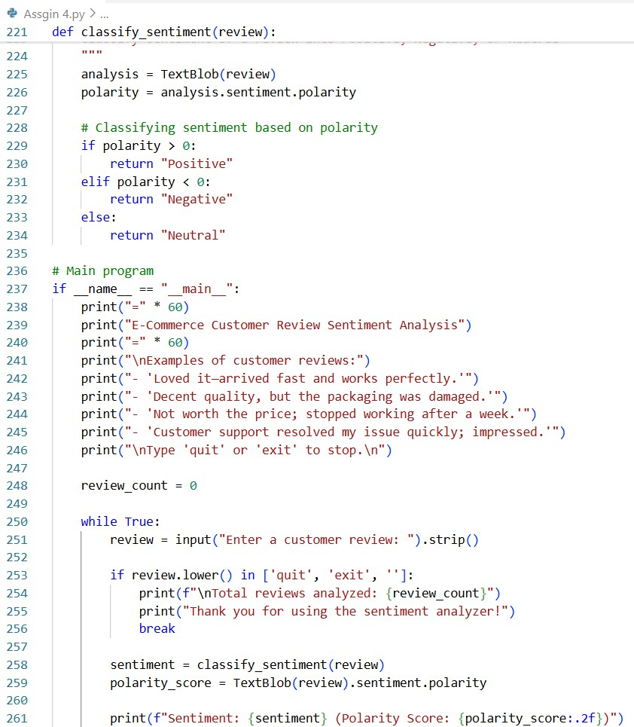

Output:
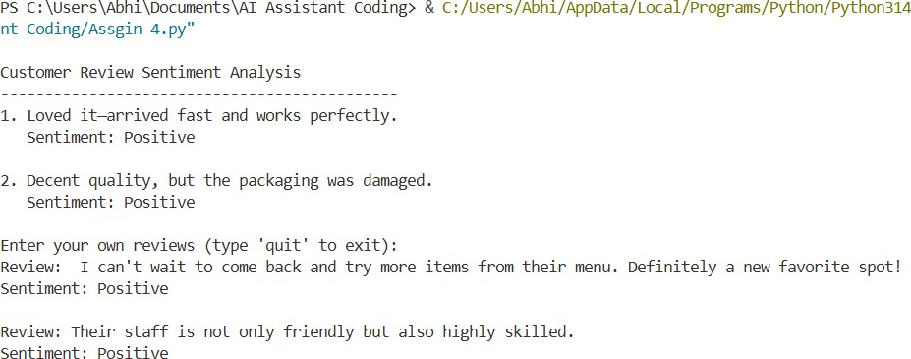

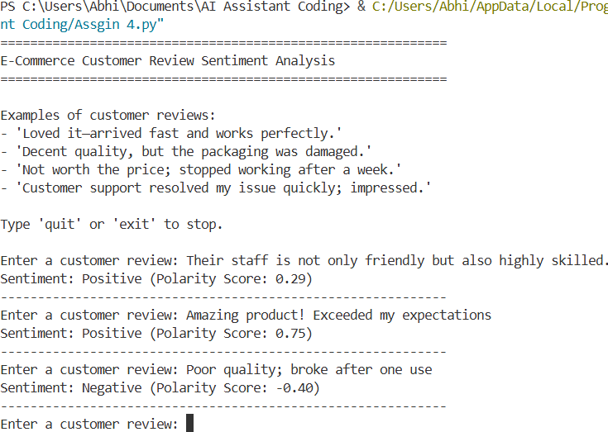

Explanation:

This task extends sentiment classification by introducing one-shot and few-shot prompting techniques. The prompts include multiple labeled examples, allowing the AI to better generalize sentiment boundaries. The code processes both example reviews and live user inputs, displaying sentiment along with polarity scores. Compared to one-shot prompting, few-shot prompting improves robustness for mixed or ambiguous reviews. The output confirms more stable and context-aware sentiment predictions, highlighting the benefit of richer prompt examples.

Task 3: Student Query Routing System
- Create 6 sample student queries mapped to departments.
- Implement Zero-shot intent classification using an LLM.
- Improve results using One-shot prompting.
Prompt- Zero Shot:Write a python program for classifying the student queries to Admissions, Exams, Academics, or Placements.
Prompt-One Shot:Write a python program for classifying the student queries to Admissions, Exams, Academics, or Placements.
Ex queries:
What is the admission deadline? How do I access course materials?

Code:
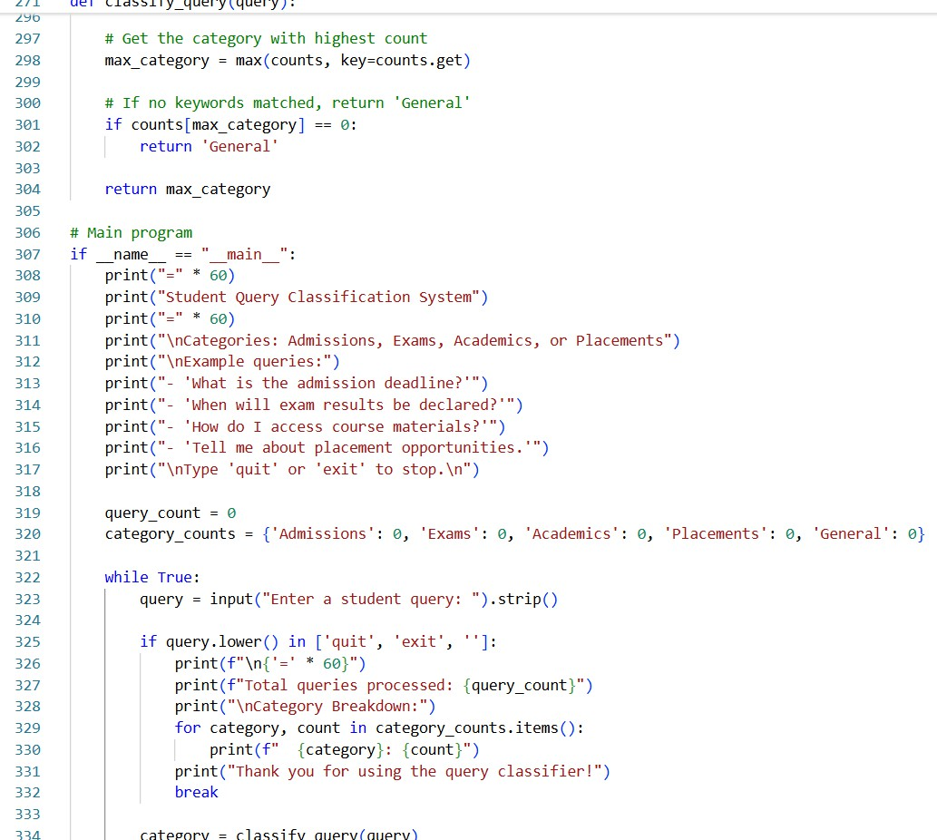

One Shot:
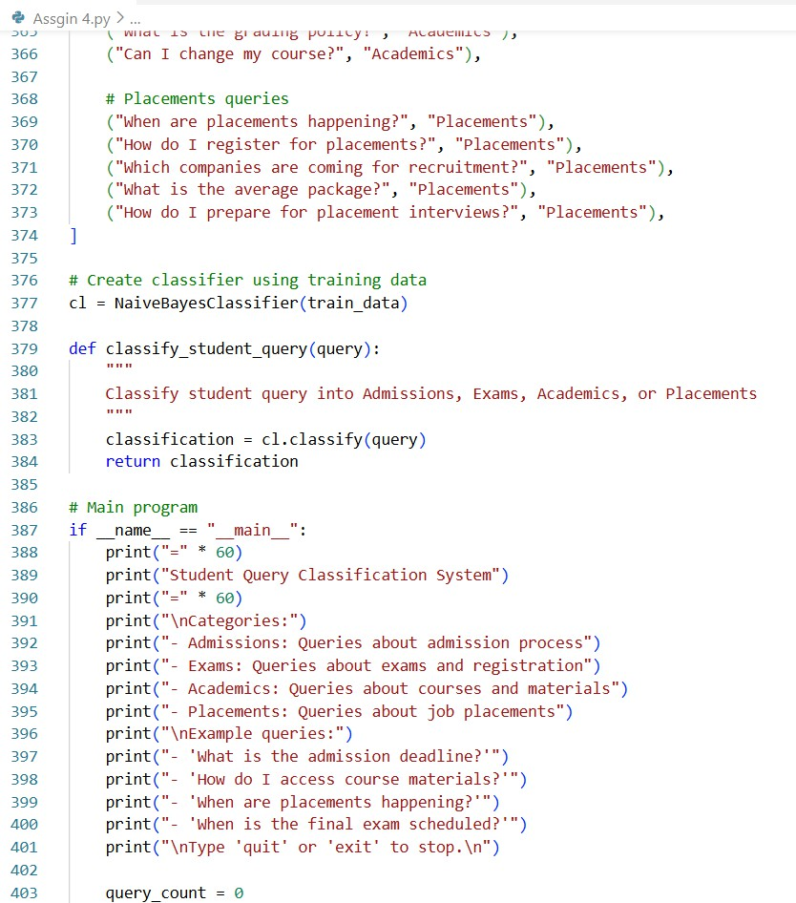

Output:
Zero Shot:
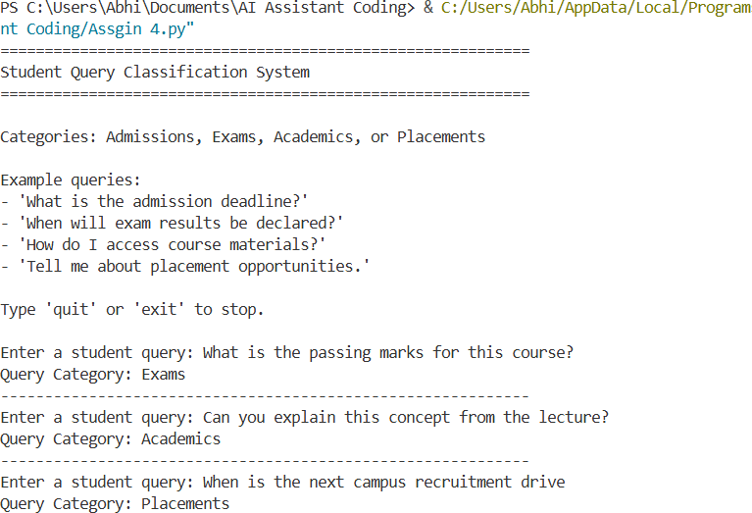

One Shot:
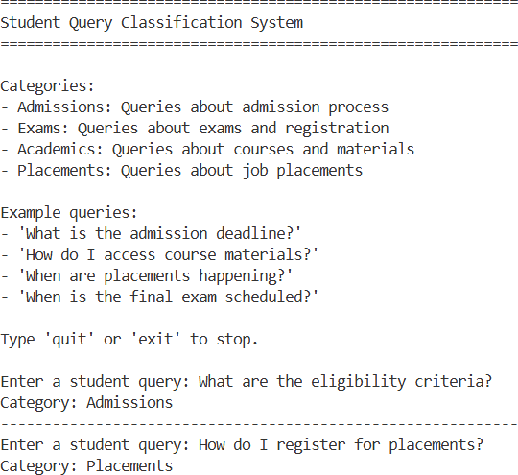

Explanation:
This task focuses on intent classification by routing student queries to departments such as Admissions, Exams, Academics, or Placements. The zero-shot approach uses keyword-based logic to infer categories without prior examples, while the one-shot approach introduces labeled training data. The code accepts continuous user input and assigns the most relevant department.

One-shot prompting improves classification accuracy, especially for overlapping or unclear queries. The outputs clearly show correct routing decisions, making the system suitable for real-world academic helpdesks.

Task 4: Chatbot Question Type Detection
- Design prompts for Zero-shot, One-shot.

Prompt:
Generate the python code in which identifies whether a user query is Informational,Transactional, Complaint, or Feedback.
Code:

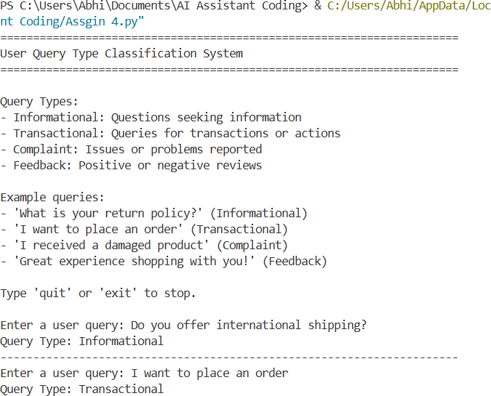

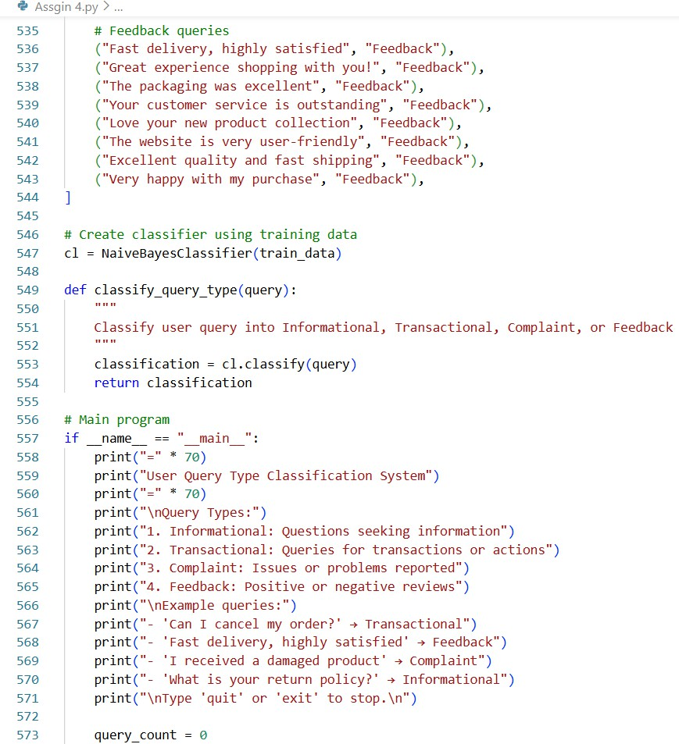

Output:

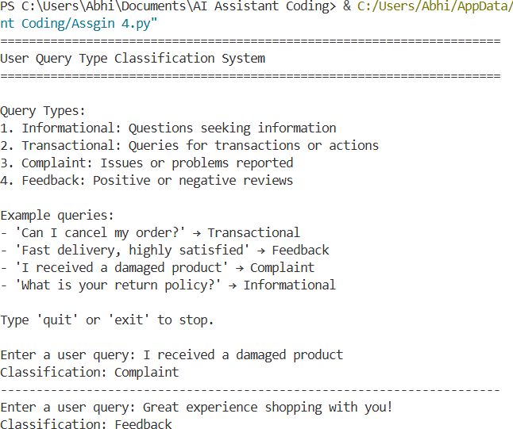

Explanation:

In this task, the goal is to classify user queries into Informational, Transactional, Complaint, or Feedback categories. The prompts guide the AI to generate Python code capable of recognizing intent based on example-driven learning.
The one-shot approach uses predefined labeled examples to improve accuracy. The program continuously accepts user queries and outputs the detected question type. The outputs demonstrate correct intent recognition, showcasing how chatbots can efficiently triage user requests.

Use One-shot prompting with an example.
Use Few-shot prompting with multiple emotions. Prompt:
Generate the python code in which it detects emotions like Happy, Sad, Angry,Anxious, Neutral.
Code:
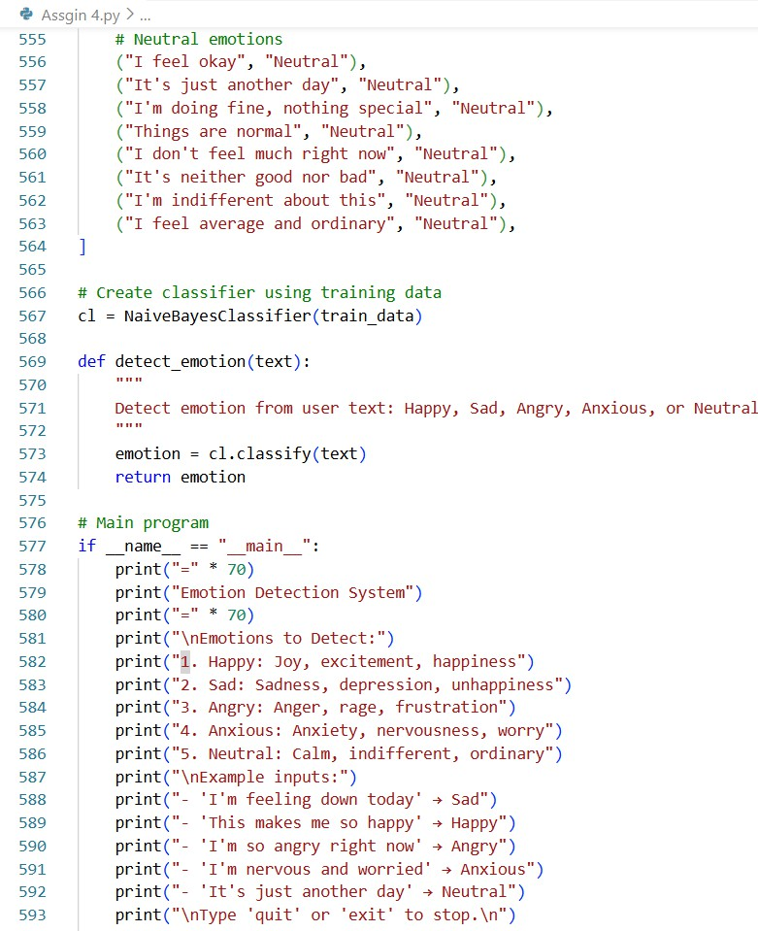

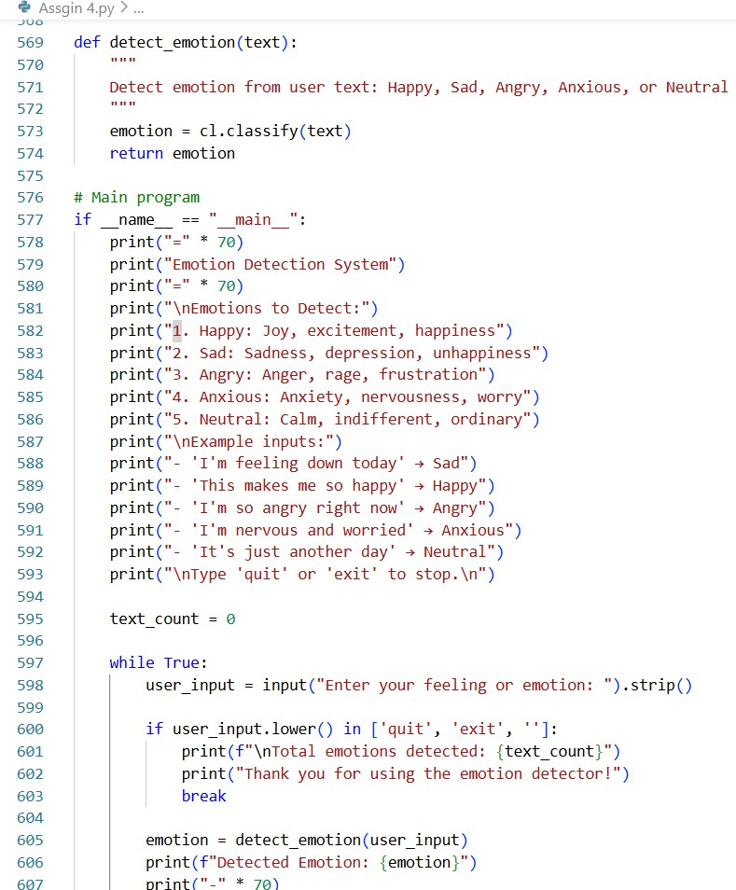

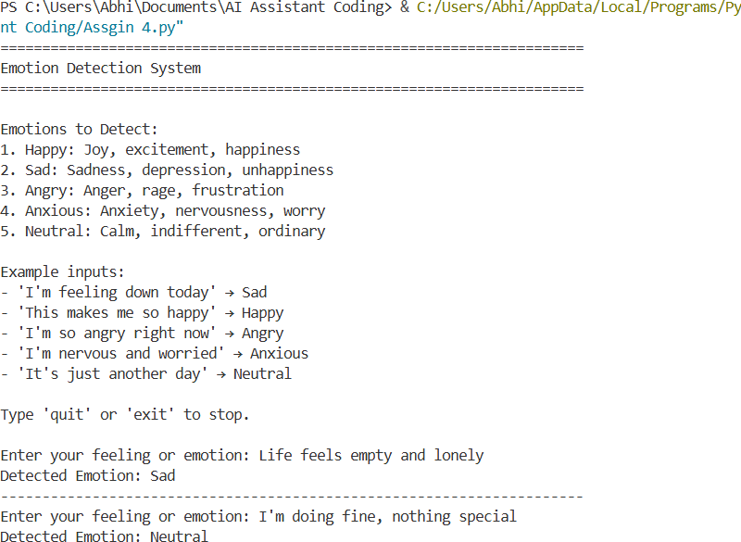
Few Shot:
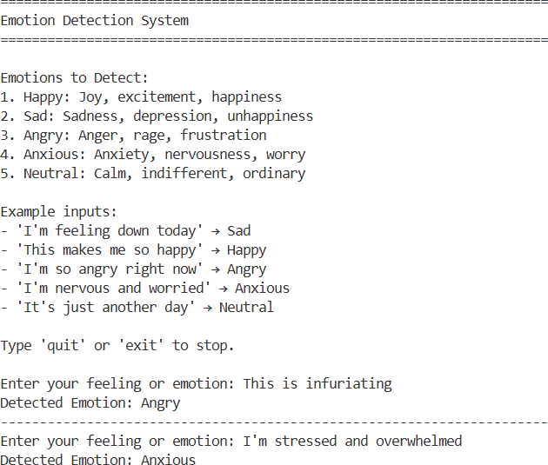

This task applies one-shot and few-shot prompting to detect emotions such as Happy, Sad, Angry, Anxious, and Neutral. The prompts guide the AI to generate Python code that classifies emotional tone from text input. Few-shot prompting introduces multiple emotion examples, improving classification reliability. The code repeatedly accepts user input and predicts emotions until the user exits.
The outputs confirm accurate emotion detection, illustrating practical applications in mental health monitoring and user experience analysis.

