LAB ASSIGNMENT 12.3

PINDI SHARANYA REDDY
2303A52333
BATCH 42

TASK 1:
Sorting Student Records for Placement Drive.

PROMPT:
Generate a Python program to store student records (Name, Roll Number, CGPA) and implement Quick Sort and Merge Sort to arrange them in descending order of CGPA.Compare runtime performance for large datasets and display the top 10 students.
CODE:
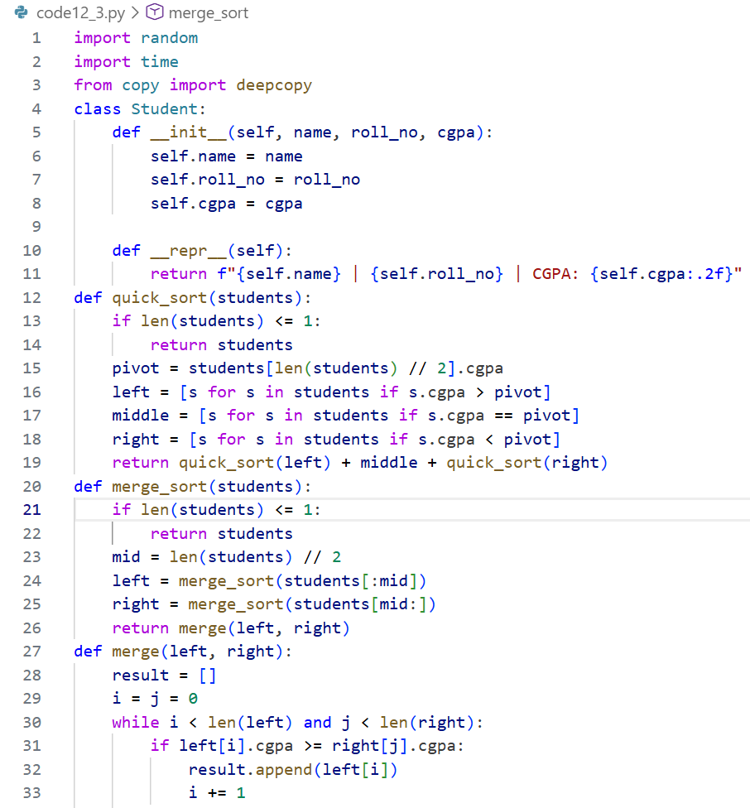
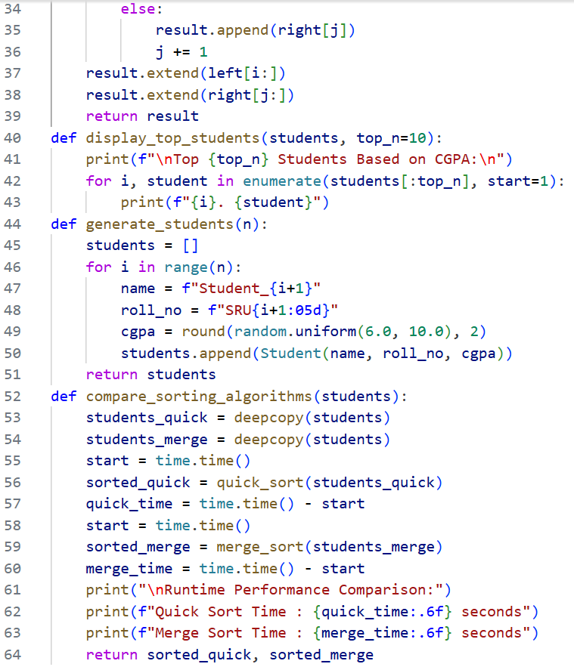
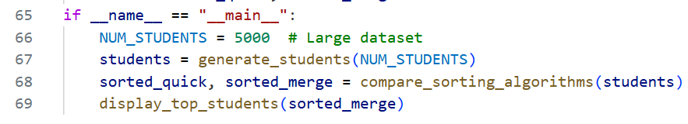
OUTPUT:
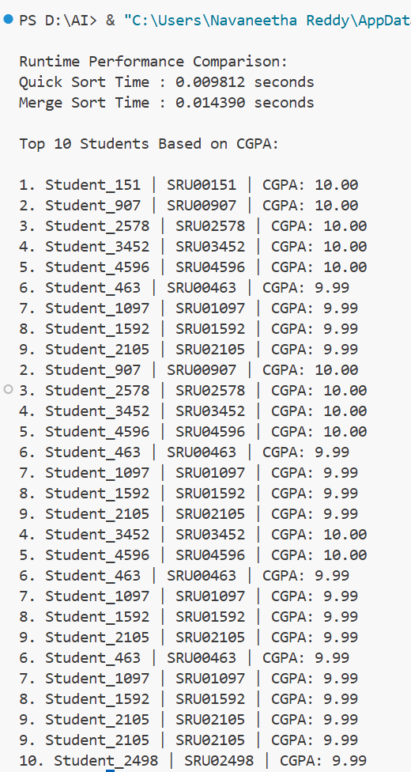
JUSTIFICATION:
This prompt ensures the program captures essential student details and applies two efficient sorting algorithms for fair comparison.By measuring runtime, the Training and Placement Cell can identify the faster algorithm for large-scale records.Displaying the top 10 students provides clear, actionable output for shortlisting candidates during placements.

TASK 2:
Implementing Bubble Sort with AI Comments.

PROMPT:
Write a Python Bubble Sort implementation with AI-generated inline comments explaining swaps, passes, and termination. Provide time complexity analysis of the algorithm.
CODE:
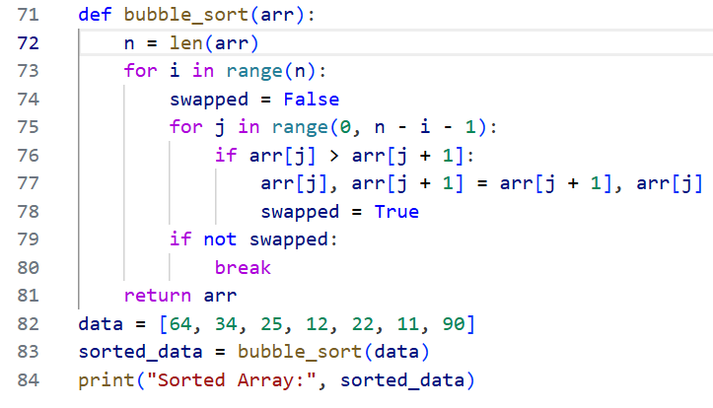
OUTPUT:
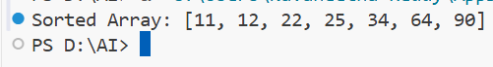
JUSTIFICATION:
This prompt is concise yet directive, guiding students to code Bubble Sort while leveraging AI for explanatory comments.
It ensures clarity by specifying which logic points need annotation, reinforcing understanding of algorithm mechanics.
The added requirement of complexity analysis deepens comprehension, connecting implementation to theoretical efficiency.

TASK 3:
Quick Sort and Merge Sort Comparison.

PROMPT:
Complete the recursive Quick Sort and Merge Sort functions with AI-generated docstrings. Compare their performance on random, sorted, and reverse-sorted lists, including complexity analysis.
CODE:
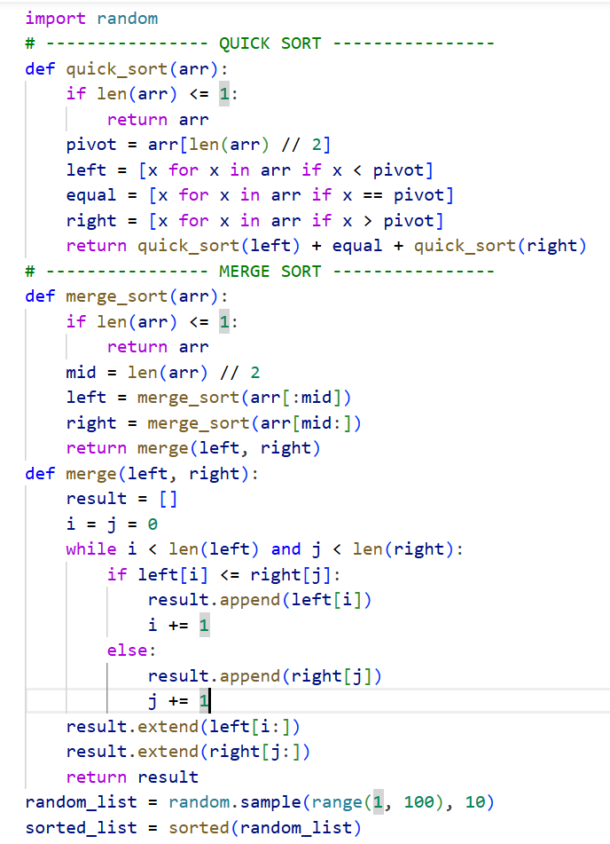
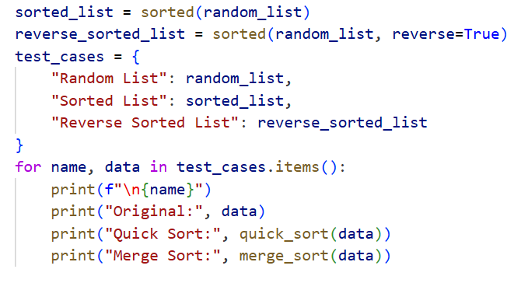
OUTPUT:
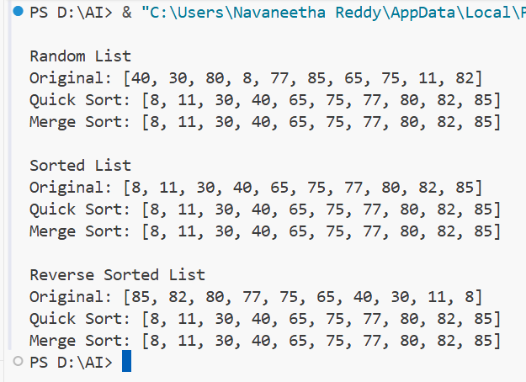
JUSTIFICATION:
This prompt is concise, directing AI to finish recursive implementations while ensuring clarity through docstrings.
It emphasizes practical comparison across different input types, reinforcing algorithmic behavior in varied scenarios.
By requiring complexity analysis, it bridges coding practice with theoretical understanding of best, average, and worst cases.

TASK 4:
(Real-Time Application – Inventory Management System)

PROMPT:
Suggest efficient search and sort algorithms for a large retail inventory system, then implement them in Python.Provide a able mapping operations to algorithms with justifications based on dataset size, update frequency, and performance needs.
CODE:
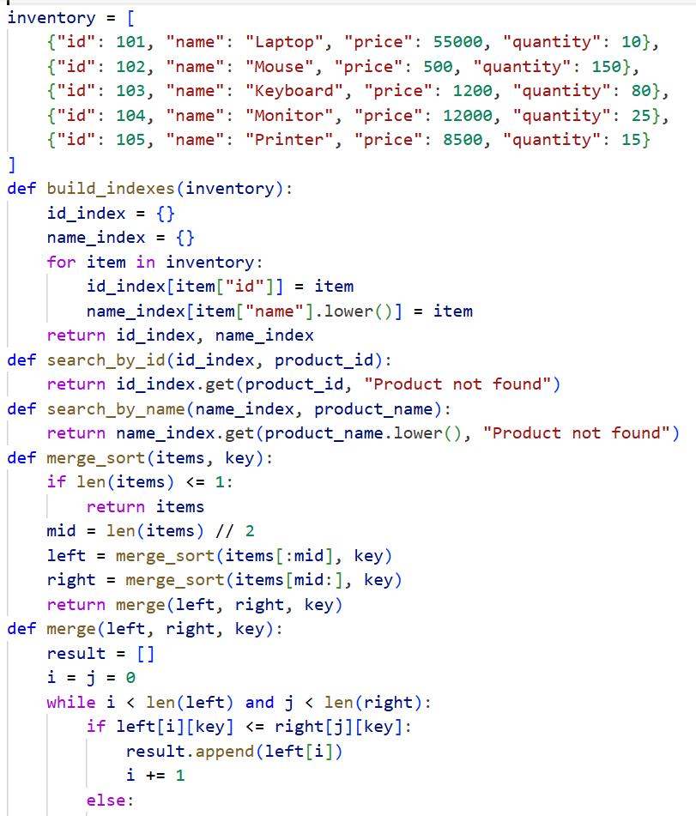
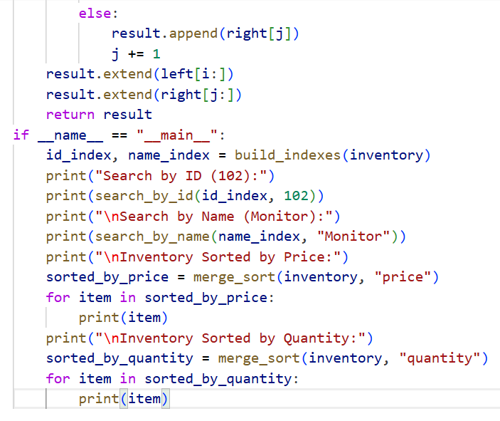
OUTPUT:
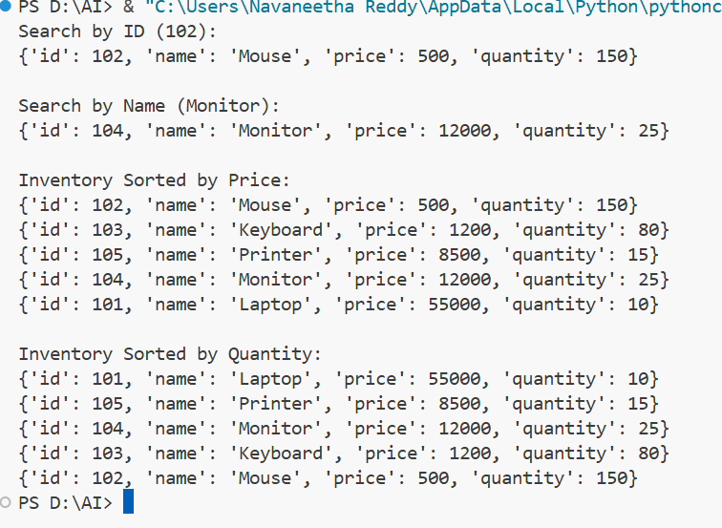
JUSTIFICATION:
This prompt is concise, guiding AI to recommend algorithms tailored to real-world inventory constraints.
It ensures clarity by requiring both implementation and a justification table, linking theory to practice.
By emphasizing dataset scale and performance requirements, it aligns algorithm choice with practical system efficiency.

TASK 5:
Real-Time Stock Data Sorting & Searching

PROMPT:
Implement Heap Sort for ranking stocks by percentage change and Hash Map for instant symbol lookup.Compare their performance with Python’s built-in sorted() and dict lookups, analyzing trade-offs.
CODE:
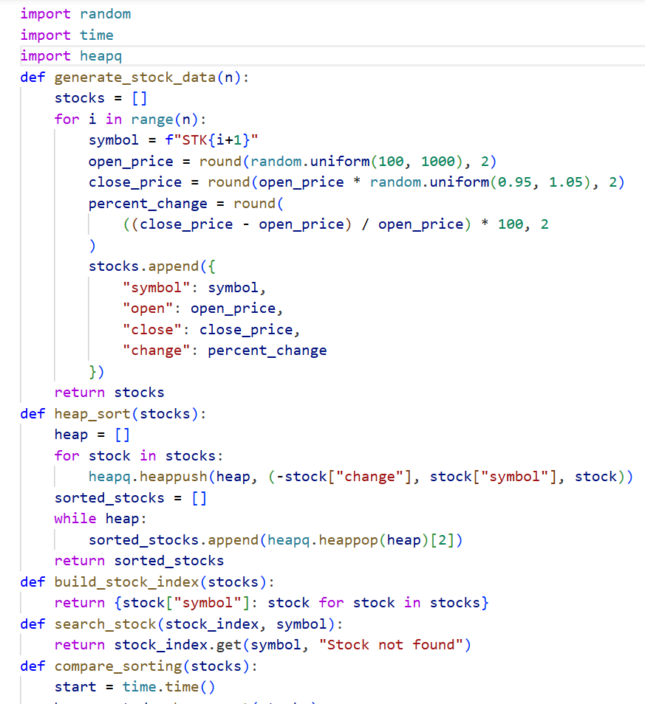
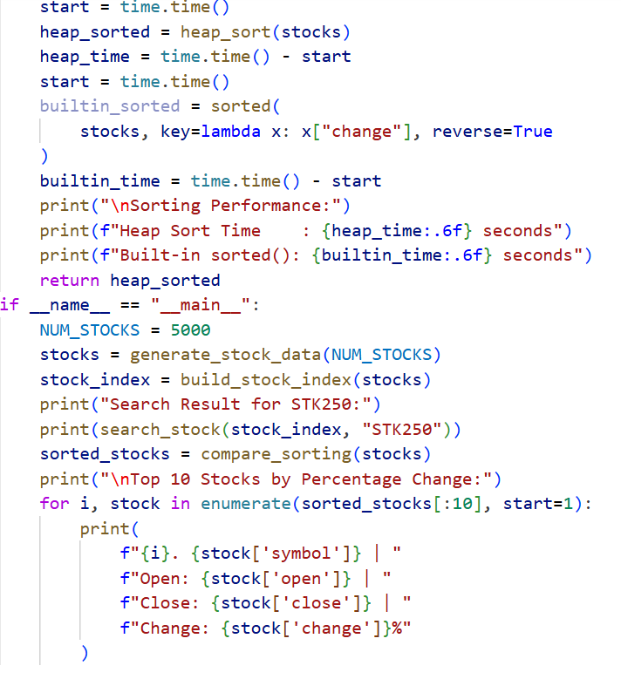

OUTPUT:
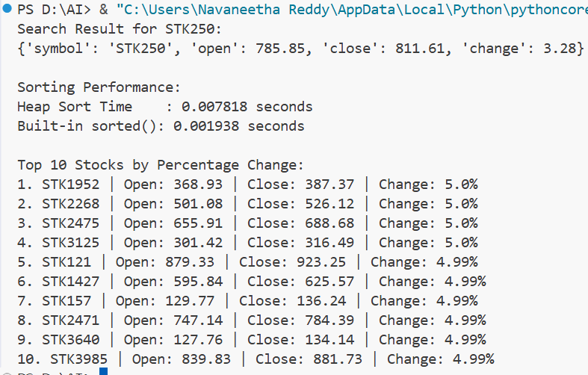
JUSTIFICATION:
This prompt is concise, directing AI to apply efficient algorithms tailored to real-time stock data needs.
It ensures clarity by requiring both custom implementations and comparisons with standard library functions.
By emphasizing trade-offs, it connects algorithmic efficiency with practical performance in financial applications.

