LAB ASSIGNMENT 13.4

PINDI SHARANYA REDDY
2303A52333
BATCH 42

TASK 1
Refactoring Data Transformation Logic

PROMPT:
Refactor the loop-based transformation into a concise list comprehension that doubles each value. Ensure the refactored code produces the same output as the legacy version.
CODE:
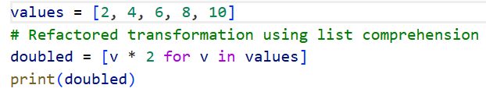
OUTPUT:
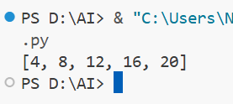
JUSTIFICATION:
List comprehensions are more Pythonic because they reduce boilerplate and improve readability compared to explicit loops. They preserve the same logic while making the intent clearer: applying a transformation across all elements in a collection. This approach also scales better, as it avoids manual list construction and keeps the code concise and maintainable.

TASK 2
Improving Text Processing Code Readability

PROMPT:
Refactor the string concatenation loop into a single join operation that builds the sentence from the list of words. Ensure the refactored code outputs the same message as the legacy version.
CODE:
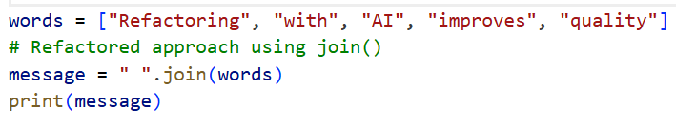
OUTPUT:
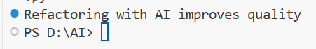
JUSTIFICATION:
Using " ".join(words) is more efficient because it avoids repeated string concatenations, which are costly in Python. It also makes the intent clearer: combining a list of words into a single space-separated string. This approach improves readability, reduces complexity, and ensures the output remains identical to the original implementation.

TASK 3
Safer Access to Configuration Data

PROMPT:
Refactor the dictionary key check into a safer access method using dict.get with a default value. Ensure the refactored code behaves the same when the key is missing.
CODE:
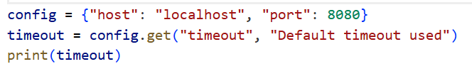
OUTPUT:
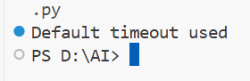
JUSTIFICATION:
Using config.get("timeout", "Default timeout used") is more concise and eliminates the need for explicit conditional checks. It improves readability by clearly expressing the intent: retrieve a value if present, otherwise fall back to a default. This approach also reduces boilerplate code and makes configuration handling more robust across different deployment settings.

TASK 4
Refactoring Conditional Logic for Scalability

PROMPT:
Refactor the multiple if–elif conditions into a dictionary mapping actions to their corresponding operations. Ensure the refactored code produces the same result as the legacy version.
CODE:
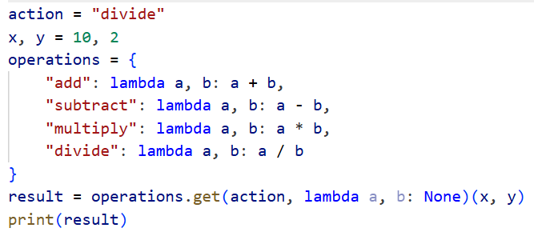
OUTPUT:
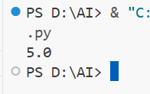
JUSTIFICATION:
Using a mapping approach makes the code more scalable, as new operations can be added without expanding conditional chains. It improves readability by clearly associating each action with its function in a single structure. This design also reduces redundancy and makes the utility module easier to maintain and extend over time.

TASK 5
Simplifying Search Logic in Collections

PROMPT:
Refactor the manual loop search into a more concise expression using the in operator. Ensure the refactored code outputs the same availability message as the legacy version.
CODE:
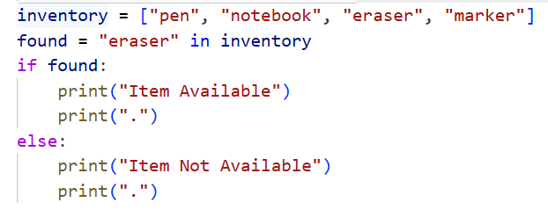
OUTPUT:
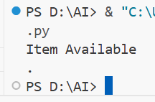
JUSTIFICATION:
Using the in operator directly eliminates the need for explicit loops and flag variables, making the code shorter and clearer. It expresses the intent—checking membership in a collection—in a single line. This approach improves readability, reduces complexity, and preserves the same behavior for item availability checks.

