LAB ASSIGNMENT 5.3
Pindi Sharanya Reddy
2303A52333
Batch 42

TASK 1
Privacy and Data Security in AI-Generated Code
Prompt:
AI tools may create insecure login systems. Generate a simple Python login program, analyze it for risks like hardcoded credentials, plain-text passwords, or weak logic, then revise it to be secure using hashing and input validation. Provide the insecure code, the risks, the secure version, and a short explanation of improvements.
Code:
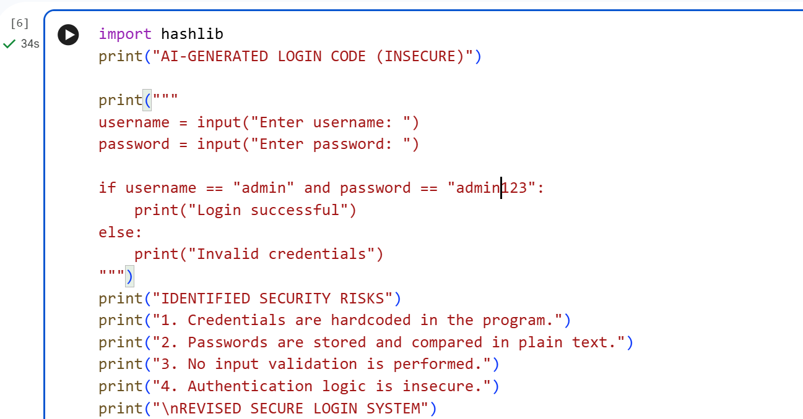
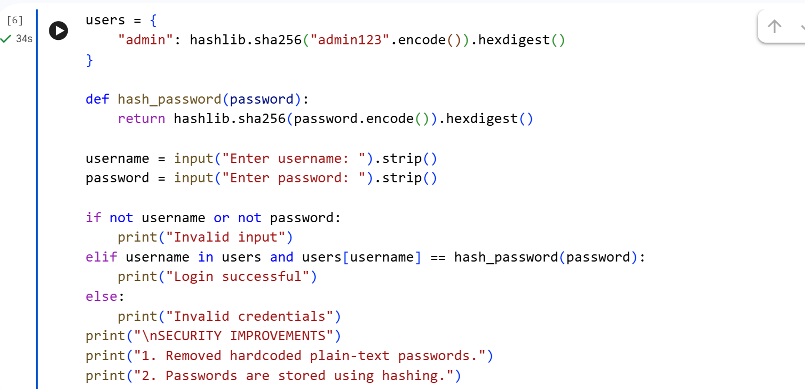

Output:
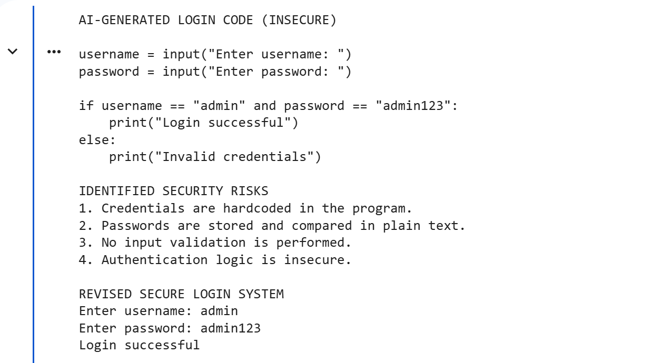


Justification:
The AI-generated login code was insecure because it used hardcoded credentials and plain-text password comparison. These issues can expose sensitive data and allow unauthorized access. The revised code improves security by using password hashing and basic input validation, making the system safer and more reliable.

TASK 2
Bias Detection in AI-Generated Decision Systems
Prompt:
AI systems can unintentionally introduce bias in decision-making. Generate a simple loan approval system in Python, then vary applicant names and genders to test if the logic treats them unfairly or relies on irrelevant personal attributes. Analyze the code for biased logic, discuss fairness issues, and suggest strategies to reduce or remove bias. The output should include the Python code, identified risks, fairness discussion, and mitigation methods.
Code:
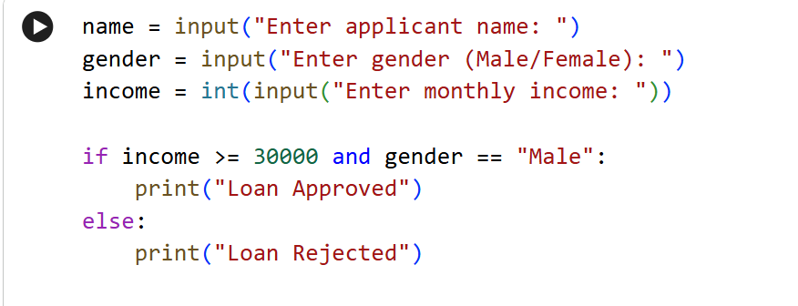
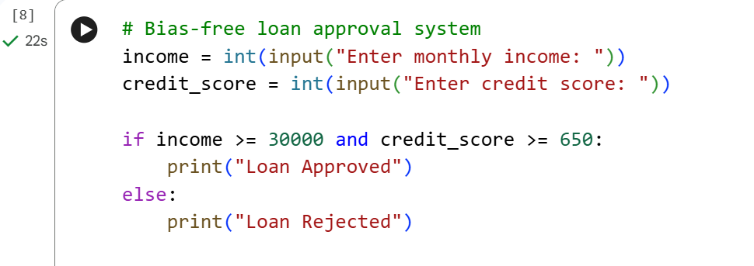
Output:


Justification:
The initial AI-generated system was biased because it used gender as a decision factor. This caused unfair rejection despite sufficient income. The revised system removes personal attributes and relies only on financial data. This ensures fairness, transparency, and unbiased decision-making.

TASK 3
Transparency and Explainability in AI-Generated Code (Recursive Binary Search)
Prompt:
AI-generated code should be clear and easy to understand. Create a Python program that uses recursion to implement binary search on a sorted list. Include inline comments and a step-by-step explanation of the base case and recursive case. Then analyze whether the explanation matches the code logic and if it is understandable for beginner students. The output should be the Python program, comments and explanation, plus an assessment of clarity and transparency.
Code:
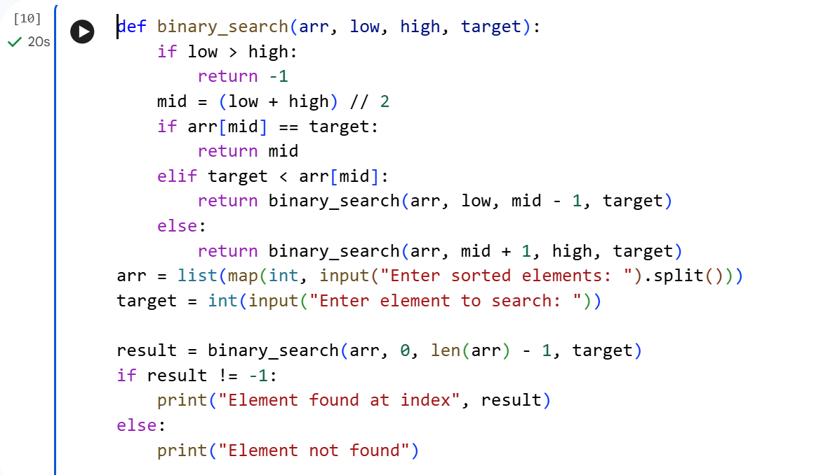
Output:

Justification:
The AI-generated code is transparent and easy to understand due to clear comments and structure.
The base case and recursive cases are correctly explained and implemented.
The logic is simple enough for beginner-level students to follow.
Overall, the program demonstrates good explainability and correctness in AI-generated code.

TASK 4
Ethical Evaluation of AI-Based Scoring Systems
Prompt:
AI-generated scoring systems can affect hiring fairness.
Generate a Python program to score applicants based on skills, experience, and education.
Analyze whether gender, names, or irrelevant attributes influence the scoring logic.
Provide the code, identify bias if present, and give an ethical evaluation of fairness.
Code:
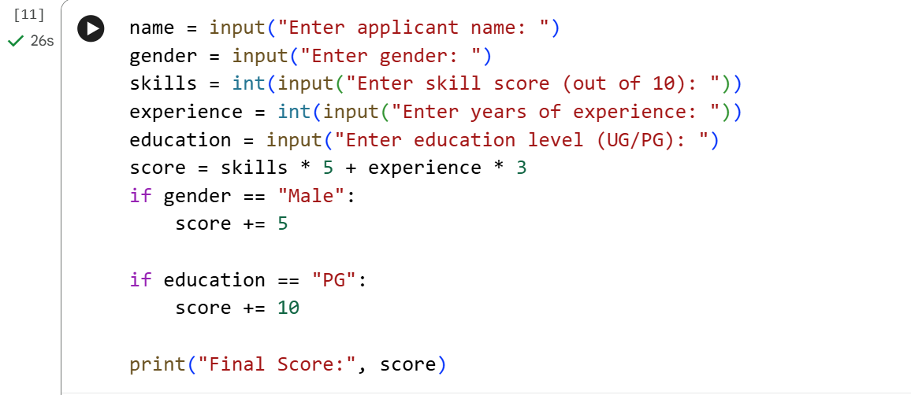
Output:
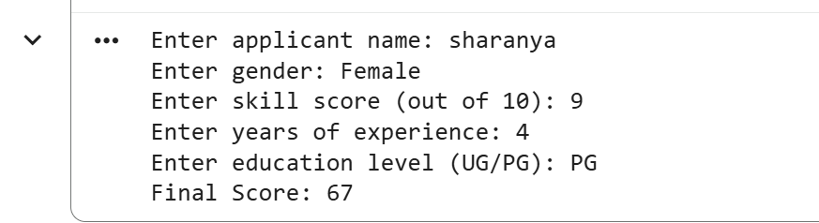
Justification:
The AI-generated system shows bias by using gender in scoring.
This can unfairly influence hiring decisions.
Removing sensitive attributes improves fairness and objectivity.
Ethical evaluation is essential before deploying AI scoring systems.

TASK 5
Inclusiveness and Ethical Variable Design
Prompt:
AI-generated code should avoid assumptions about gender or identity.
Generate a Python snippet that processes user or employee details.
Analyze it for gender-specific variables, non-inclusive naming, or biased logic.
Revise the code with gender-neutral variables and explain how inclusiveness was improved.
Code:
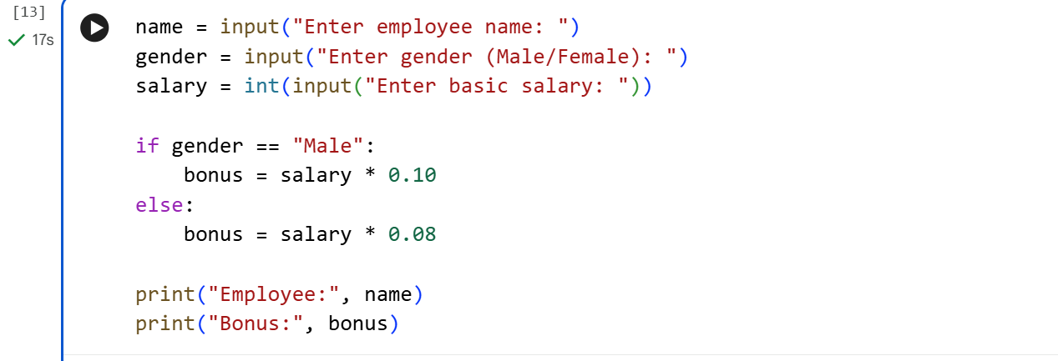
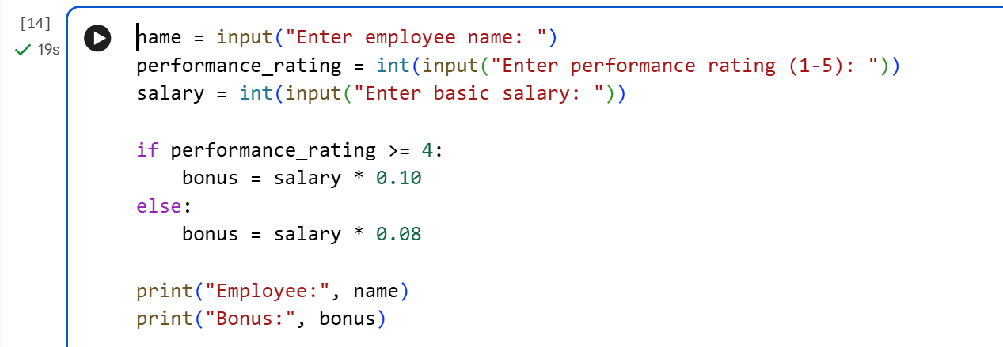
Output:


Justification:
The original AI-generated code was non-inclusive because it linked benefits to gender.
Such assumptions can lead to unfair treatment and bias.
The revised code uses gender-neutral variables and performance-based logic.This promotes fairness, inclusiveness, and ethical software design. b

