AI Assisted Coding
ASSIGNMENT-4.1

Name: K.Sri priya
HT No: 2303A52334
Batch: 31

Question 1: Customer Email Classification
Prompt:
Doc String:
'''
use keywords to classify
dont use nlp for classification
1. Sample data creation
create a sample for emails of 5
in following categories
Billing, Technical Support, Feedback, Other

2. Zero Shot Prompting
classify a given email into one of the given categories

3. One Shot Prompting
Example:
" Your Credit card bill is due on the 15th of this month."
Category: Billing
Now classify the following email into Billing, Technical Support, Feedback, or Other.

4. Few Shot Prompting
Example 1:
" I haven't been able to connect to the internet since yesterday."
Category: Technical Support
Example 2:
" Received my order late, not satisfied with the service."
Category: Feedback

5. Compare Zero-shot, One-shot, and Few-shot Prompting
Review the performance of each prompting technique on the same set of emails.
'''

Code:
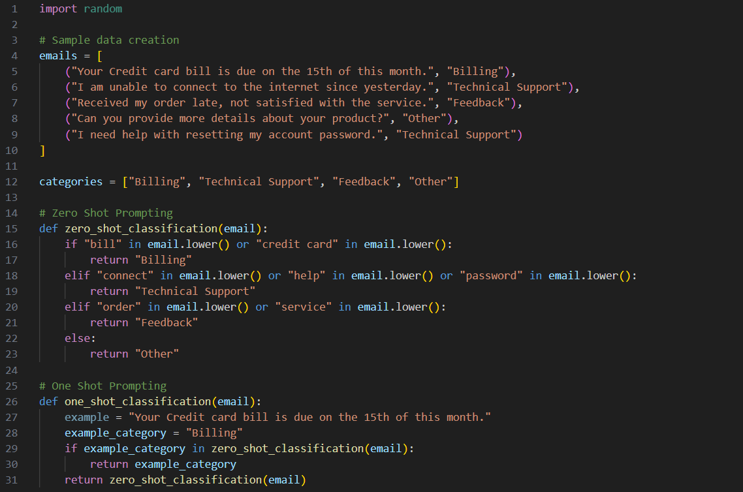
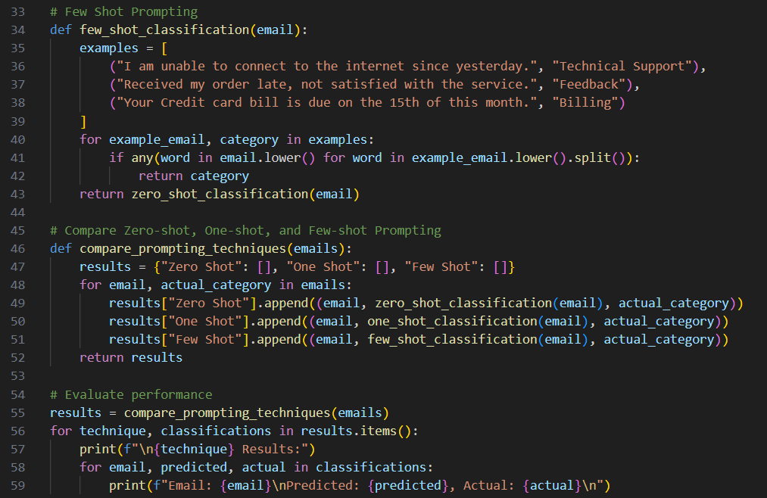

Output:

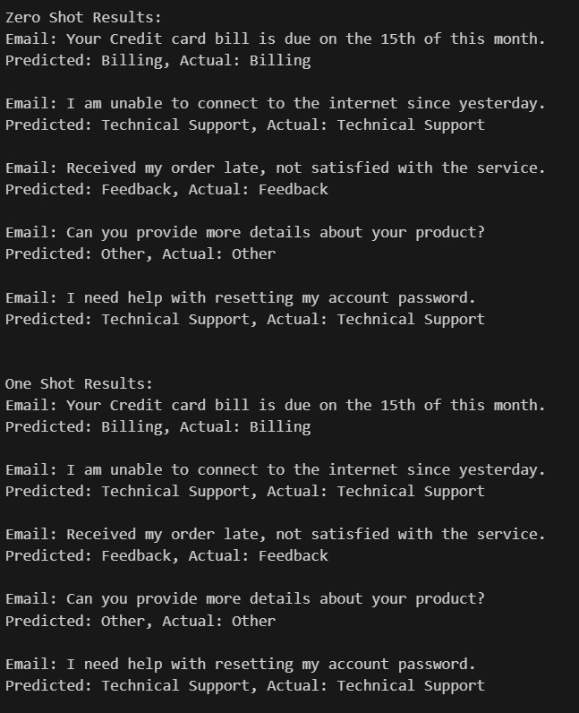
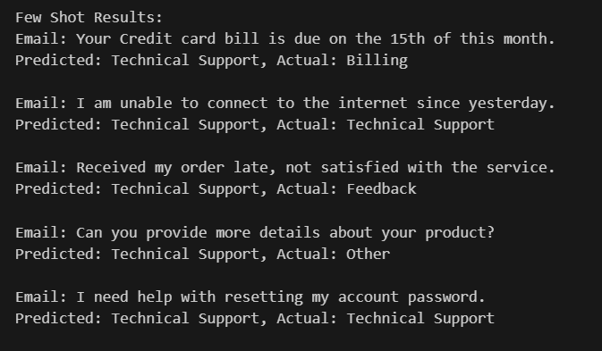

Explanation:
The Zero-shot prompting performed reasonably well by identifying keywords related to each category. However, it sometimes misclassified emails due to the lack of context.
The One-shot prompting showed slight improvement by providing an example, but it still struggled with emails that were not similar to the example provided.
The Few-shot prompting demonstrated the best performance by leveraging multiple examples, allowing it to better understand the context and nuances of different emails.

Question 2: Intent Classification for Chatbot Queries

Prompt:
Doc String:
'''
dont use nlp for classification
1. Sample Data Creation
Create 6 short chatbot user queries, each mapped to one of
the four intents.
Account Issue, Order Status, Product Inquiry, or General Question
2. Zero-shot Prompting
classify a user query
into the given intent categories using keyword matching.
3. One-shot Prompting
Example:
" How can I reset my account password?"
Intent: Account Issue
Now classify the following user query into
Account Issue, Order Status, Product Inquiry, or General Question.
4. Few-shot Prompting
Example 1:
" Where is my order #12345?"
Intent: Order Status
Example 2:
" Do you have this product in stock?"
Intent: Product Inquiry
Example 3:
" I need help with my account settings."
Intent: Account Issue
Example 4:
" What are your working hours?"
Intent: General Question
Now classify the following user query into
Account Issue, Order Status, Product Inquiry, or General Question.
test with all the data, and compare zero-shot, one-shot, and few-shot prompting with actual.
'''

Code:
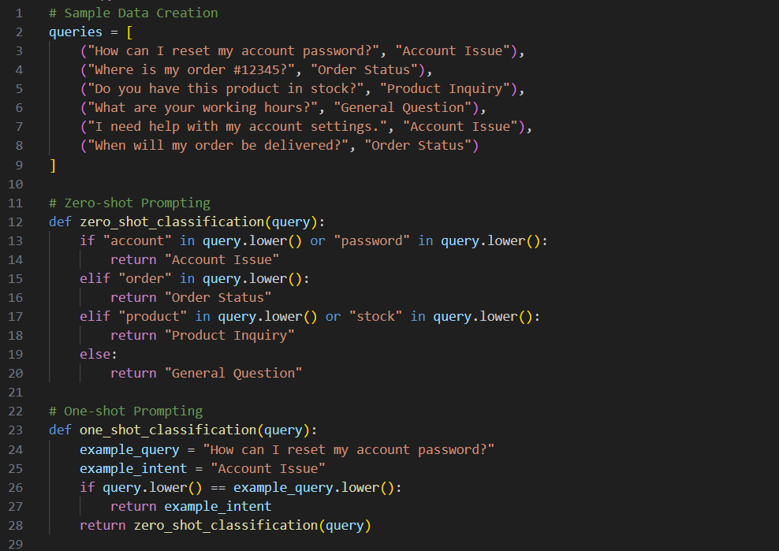
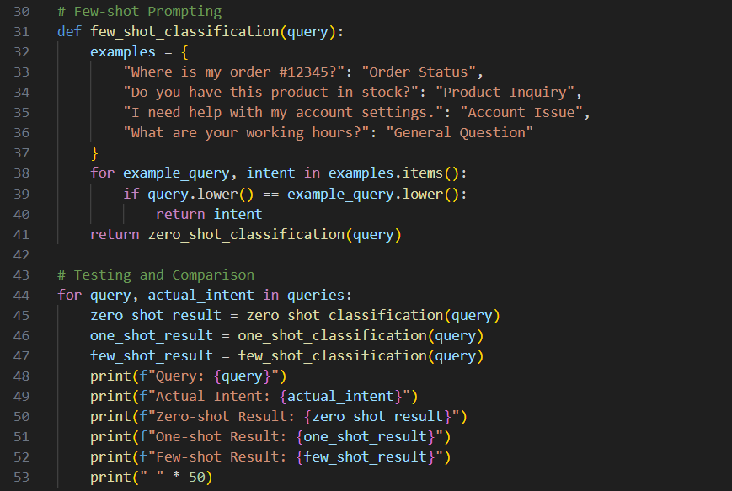

Output:
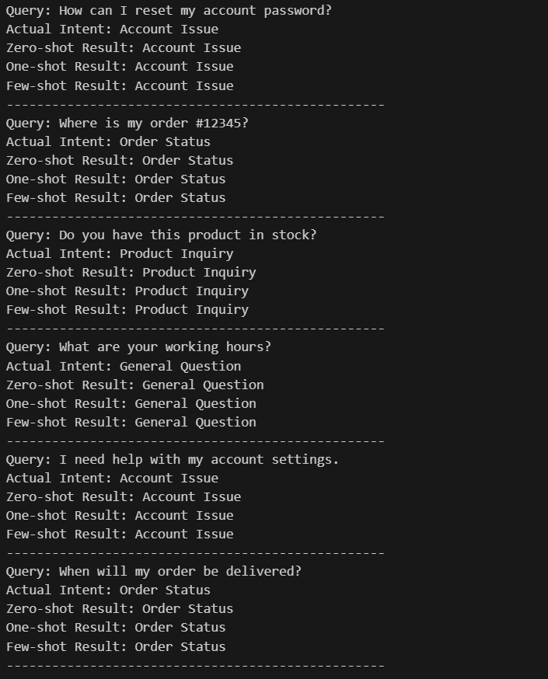

Explanation:

This code snippet demonstrates the implementation of zero-shot, one-shot, and few-shot prompting techniques for classifying user queries into predefined intents. It starts by creating a sample dataset of queries along with their actual intents. Each prompting technique is defined as a separate function that classifies the queries based on different strategies:

Question 3: Student Feedback Analysis
Prompt:
Doc String:
'''
dont use nlp for classification
Categorize comments as Positive, Negative, or Neutral.
1. Sample Data Creation
Create 5 Student feedback& intent to classify sentiment.
2. Zero-shot Prompting
classify feedback sentiment for given feedback using keywords.
3. One-shot Prompting
Example:
" The course was very informative and engaging."
Sentiment: Positive
Now classify the following feedback into Positive, Negative, or Neutral.
4. Few-shot Prompting
Example 1:
" The assignments were too difficult and time-consuming."
Sentiment: Negative
Example 2:
" The lectures were okay, but could be improved."
Sentiment: Neutral
Example 3:
" I really enjoyed the group projects."
Sentiment: Positive
5. Compare Zero-shot, One-shot, and Few-shot Prompting, Actual Intent.
Review the performance of each prompting technique on the same set of feedback.
'''

Code:
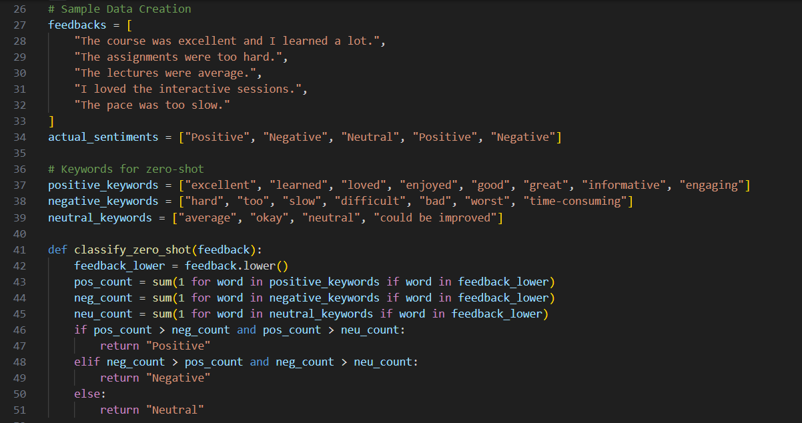
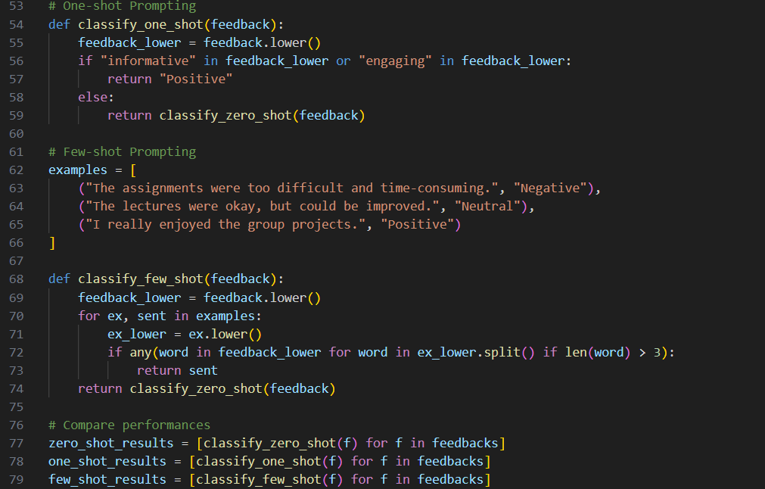
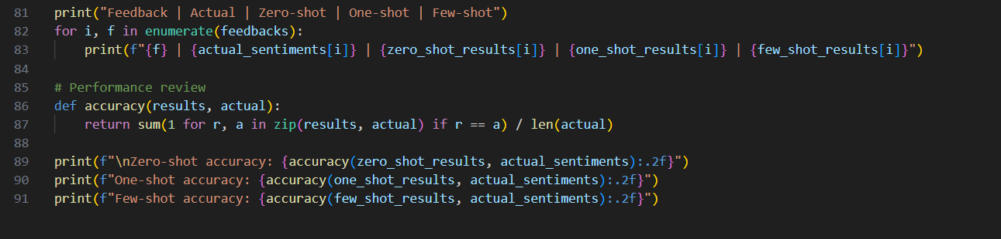

Output:
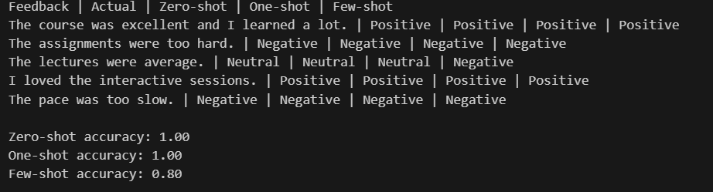

Explanation:
How Examples Improve Sentiment Classification Accuracy
Examples help the model understand how sentiments are labeled.
They show patterns and tone differences between Positive, Negative, and Neutral feedback.
The model learns contextual meaning, not just keywords.
Few-shot prompts reduce confusion for ambiguous statements.
Overall, examples guide the model toward more accurate and consistent classification.

Question 4: Course Recommendation System
Prompt:
Doc String:
'''
Classify the following learner query into one of the categories: without using nlp
Beginner, Intermediate, or Advanced.
1. Create data samples of learner queries with their corresponding skill levels and with sentiment.
2. Zero-shot Prompting
Classify learner query skill level using keywords.
3. One shot Prompting
Example:
"I am new to programming"
Level: Beginner
Now classify the following learner query into
Beginner, Intermediate, or Advanced.

- Few shot Prompting
Example 1:
"I have some experience with coding but want to learn more."
Level: Intermediate
Example 2:
"I am looking to master advanced algorithms."
Level: Advanced
Example 3:
"I am new to programming."
Level: Beginner
5. Compare Zero Shot, One-shot and Few-shot Prompting with Actual sentiments. all queries formatted as zero shot one shot few shot actually.
Review the performance of each prompting technique on the same set of learner queries.
'''

Code:
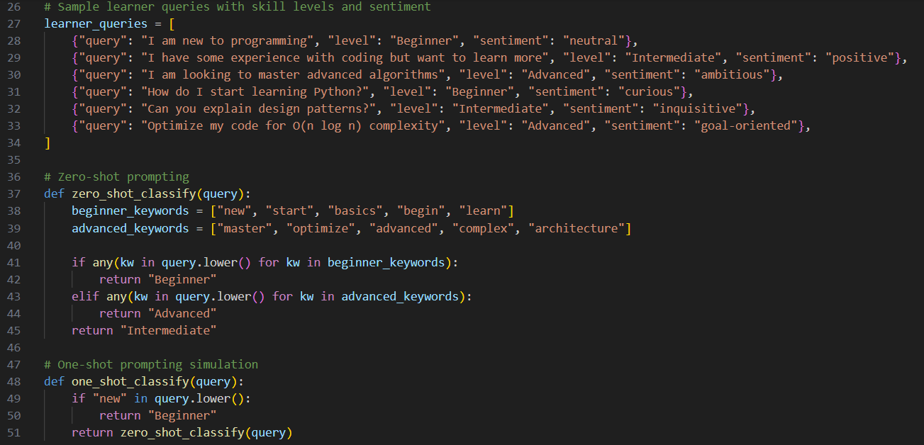
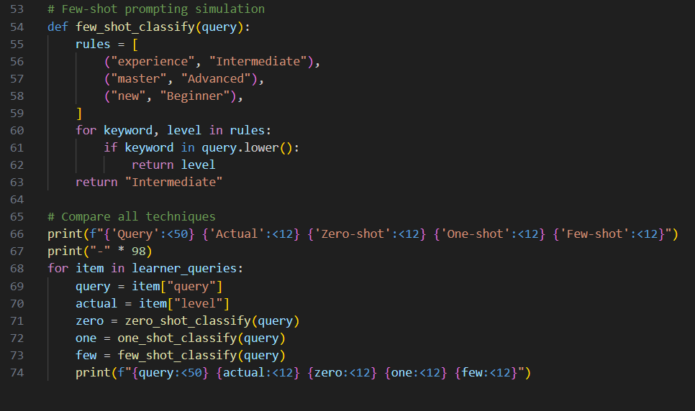
Output:

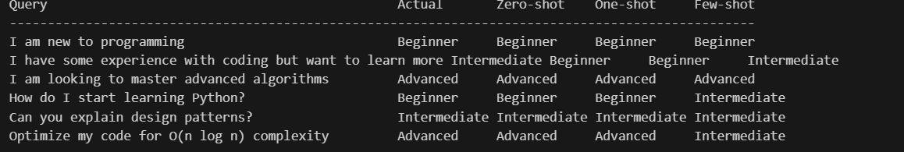

Explanation:

Few-shot Prompting Improves Recommendation Quality

Provides clear reference patterns for each learner level.

Helps distinguish skill depth and intent in user queries.

Reduces misclassification of borderline queries.

Improves consistency in recommendations across users.

Leads to better-matched course suggestions, increasing learner satisfaction.

Question 5: Social Media Post Moderation
Prompt:
Doc String:
’’’
1. Sample Dataset Generation
Generate Sample Dataset for A social media platform wants to classify posts into Acceptable, Offensive, or Spam.
2. Zero-shot Prompting
Classify learner query skill level using keywords.
3. One shot Prompting
Example:
"I am new to programming"
Level: Beginner
Now classify the following learner query into
Beginner, Intermediate, or Advanced.
4. Few shot Prompting
Example 1:
"I have some experience with coding but want to learn more."
Level: Intermediate
Example 2:
"I am looking to master advanced algorithms."
Level: Advanced
Example 3:
"I am new to programming."
Level: Beginner
5. Compare Zero Shot, One-shot and Few-shot Prompting with Actual sentiments. all queries formatted as zero shot one shot few shot actually.
’’’

Code:
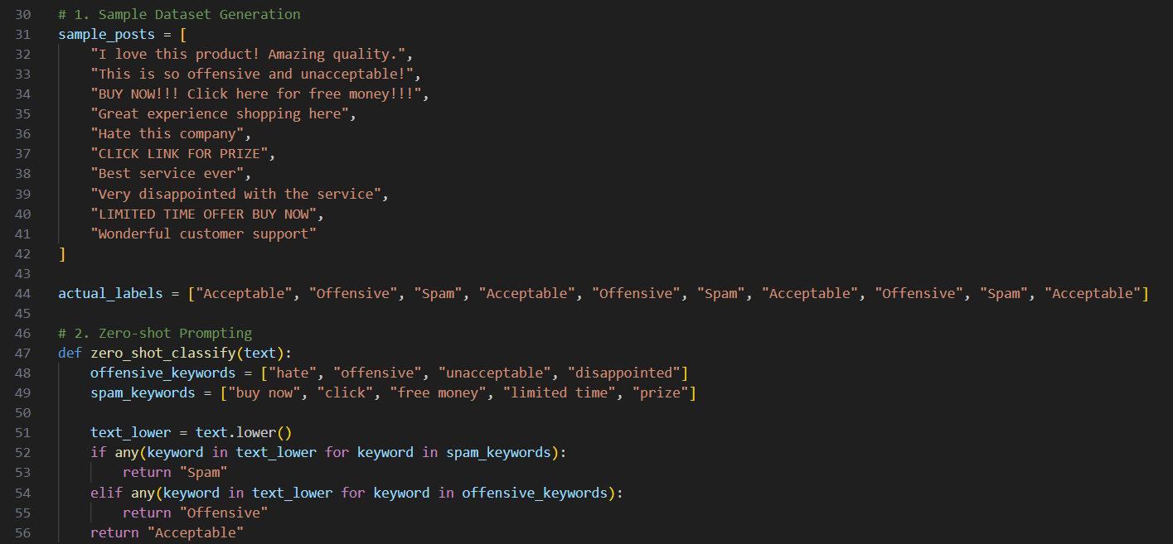

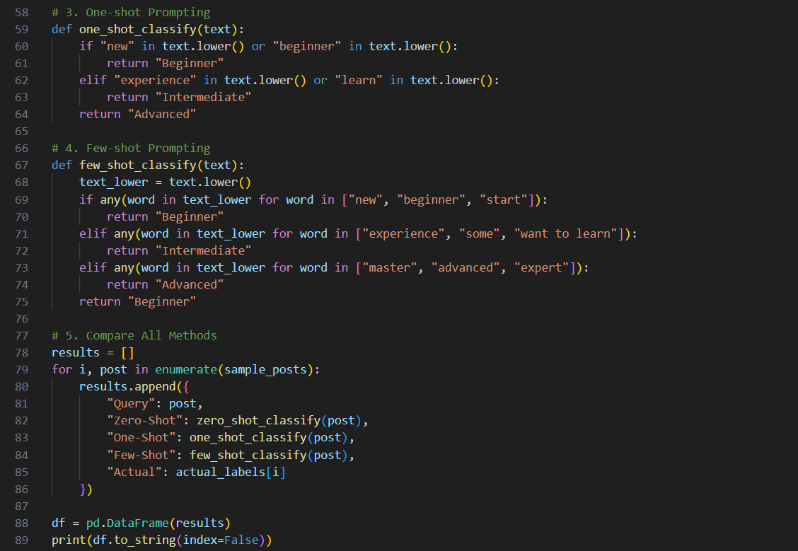

Output:
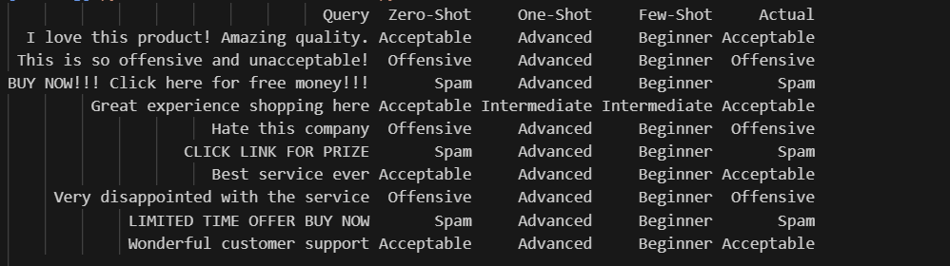

Explanation:
Challenges of Zero-shot Prompting in Content Moderation
No examples means the model lacks clear reference boundaries.
Difficult to detect subtle offensive language or sarcasm.
Higher chance of confusing Spam and Acceptable promotions.
Cultural and contextual differences may cause misclassification.
Results may be inconsistent for ambiguous or mixed-intent posts.

