AI Assisted Coding
ASSIGNMENT 2.3
Name: K.Sri priya
HT No: 2303A52334
Batch: 31

Task 1: Word Frequency from Text File

Prompt:

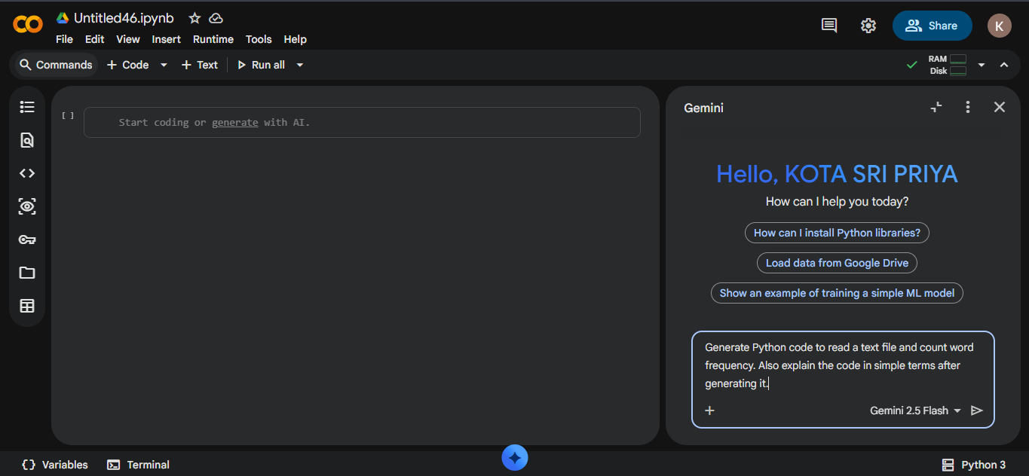

Code:

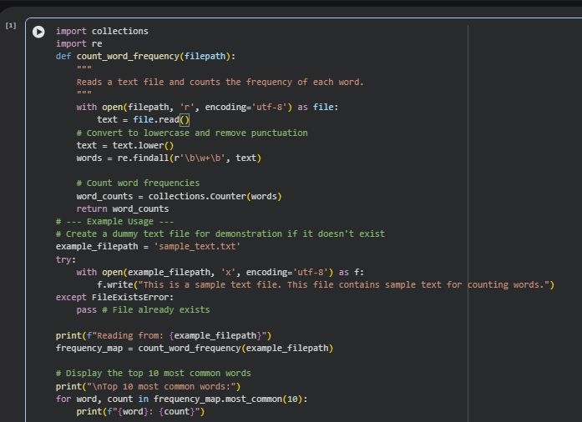

Output:

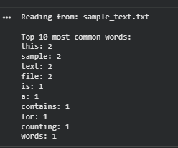

Explanation:

The program reads a text file and converts all words to lowercase to ensure uniformity.
It then splits the text into individual words and uses the Counter class to count their frequency.
This approach avoids manual counting and makes the code efficient and easy to understand.
Finally, the program displays each word along with the number of times it appears in the file.

Task2:

Prompt:

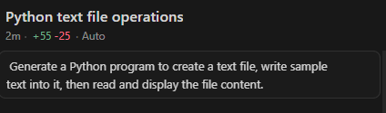

Code:

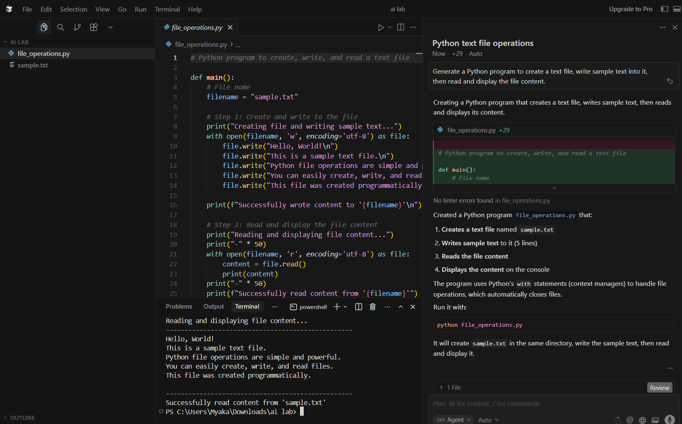

Explanation:

This program demonstrates basic file handling in Python using Cursor.
First, a text file is created and sample text is written into it.
Then, the same file is opened in read mode and its contents are displayed on the screen.
It shows how Python can be used to create, write, and read files easily.
Such operations are useful in automation and data storage tasks.

Task3:

Prompt:

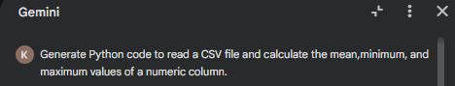

Code:

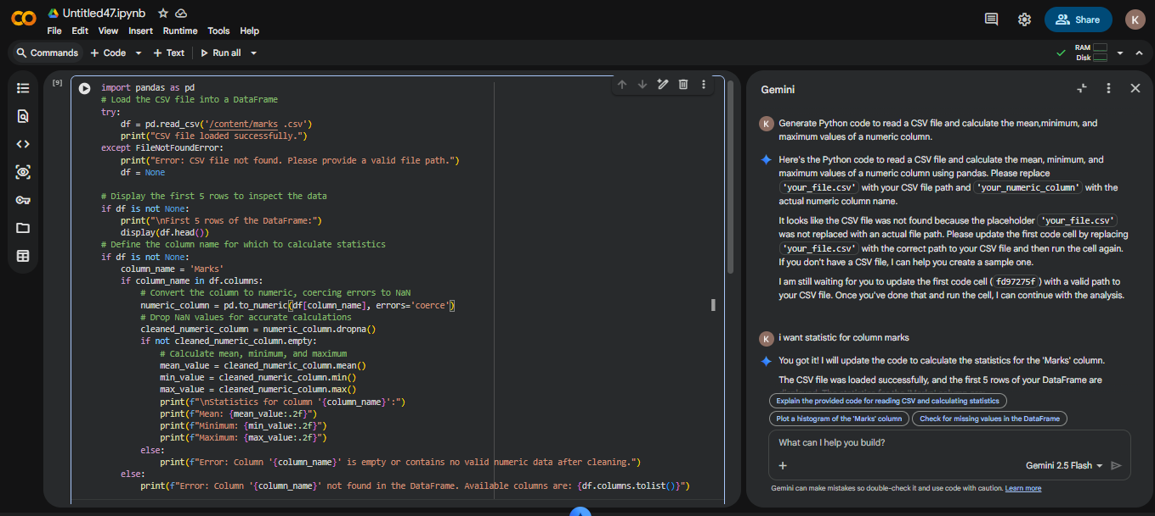

Output:

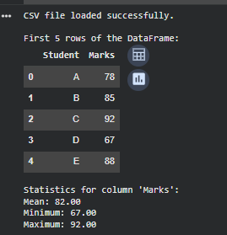

Explanation:
This program reads data from a CSV file using Python.
It extracts numerical values from a column and calculates the mean,
minimum, and maximum. CSV analysis is used in data processing and analytics applications.

Task4:

Prompt:

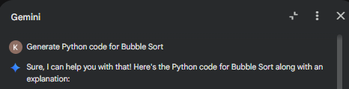
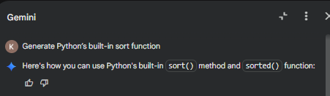

Code:

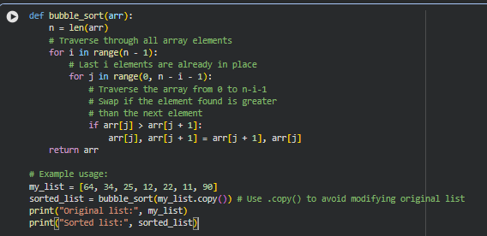

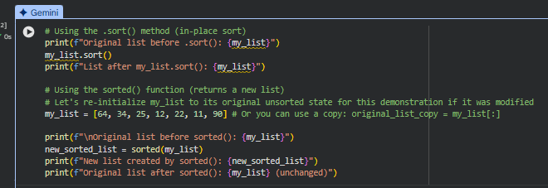

Output:
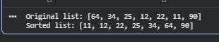
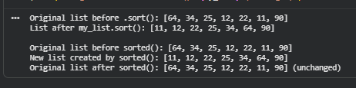

Explanation:

Bubble sort uses repeated comparisons and swaps, making it slow for large datasets.
The built-in sort() function uses an optimized algorithm and performs faster.
Bubble sort is mainly useful for learning purposes.
Built-in sorting is recommended for real-world applications.

