Assignment 3

P Sree Varshini
2303A52336
Batch 40

Question 1: Zero-Shot Prompting (Palindrome Number Program)
Write a zero-shot prompt (without providing any examples) to generate
a Python function that checks whether a given number is a palindrome.
Task:
• Record the AI-generated code.
• Test the code with multiple inputs.
• Identify any logical errors or missing edge-case handling.

Prompt:
#Write a python program to find whether the given number is palindrome or not
# Check if the string representation of the number is equal to its reverse
# Take input from the user
# Check and display whether the number is a palindrome

Code and Output: 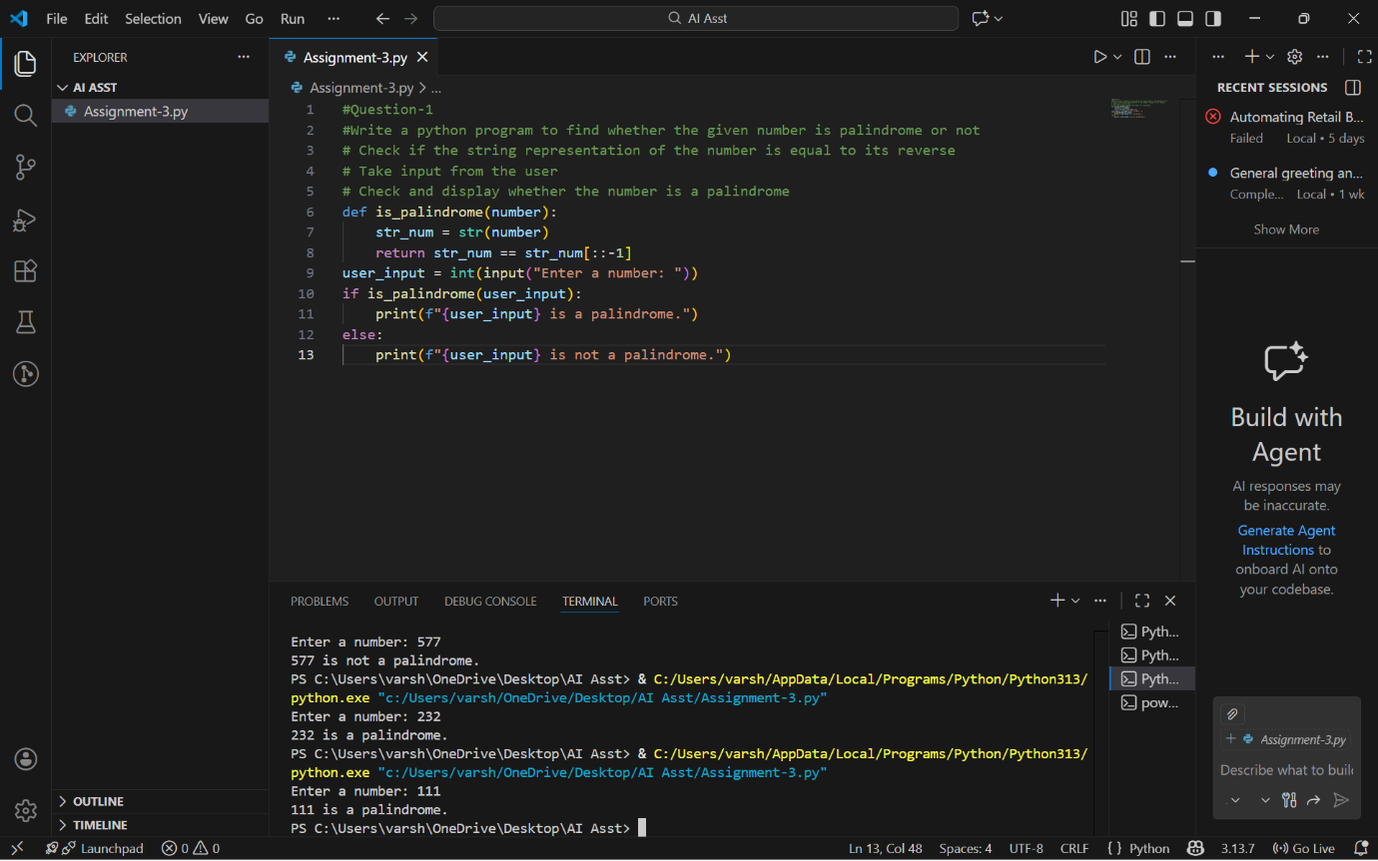

Analysis:
Works correctly for basic positive numbers
Negative numbers fail due to string behavior, not real logic
No input type checking is done
Relies only on string conversion
Suitable only for simple or beginner-level tasks

Question 2: One-Shot Prompting (Factorial Calculation)
Write a one-shot prompt by providing one input-output example and
ask the AI to generate a Python function to compute the factorial of a
given number.
Example:
Input: 5 → Output: 120
Task:
• Compare the generated code with a zero-shot solution.
• Examine improvements in clarity and correctness.

Prompt:
#Write a python program to find given number is factorial or not e.g input=5 output=120
# Base case: factorial of 0 or 1 is 1
# Recursive case
# Take input from the user

Code and Output:
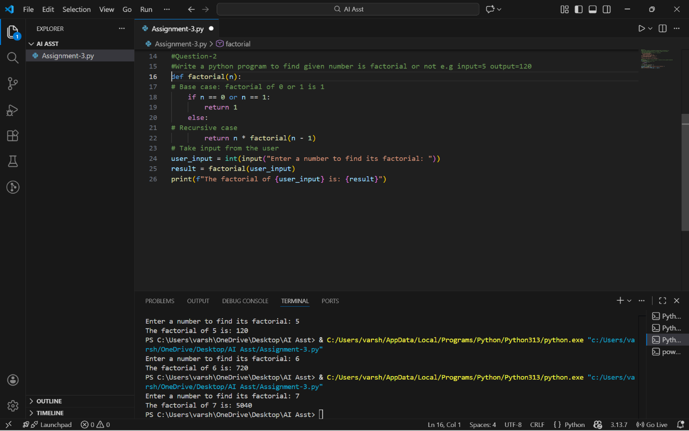
Analysis:
One-shot code clearly handles the base case (0! = 1)
Zero-shot version misses explicit handling of zero
One-shot solution is easier to understand and more structured
One-shot result is mathematically more correct
Example helps the AI generate safer and clearer logic.

Question 3: Few-Shot Prompting (Armstrong Number Check)
Write a few-shot prompt by providing multiple input-output examples
to guide the AI in generating a Python function to check whether a
given number is an Armstrong number.
Examples:
• Input: 153 → Output: Armstrong Number
• Input: 370 → Output: Armstrong Number
• Input: 123 → Output: Not an Armstrong Number
Task:
• Analyze how multiple examples influence code structure and
accuracy.
• Test the function with boundary values and invalid inputs.

Prompt:
#write a python code to check whether the given number is armstrong or not
#Input: 153 → Output: Armstrong Number
#Input: 370 → Output: Armstrong Number
#Input: 123 → Output: Not an Armstrong Number
# Calculate the sum of each digit raised to the power of the number of digits
# Check if the sum of powers is equal to the original number
# Take input from the user
# Check and display whether the number is an Armstrong number

Code and Output:
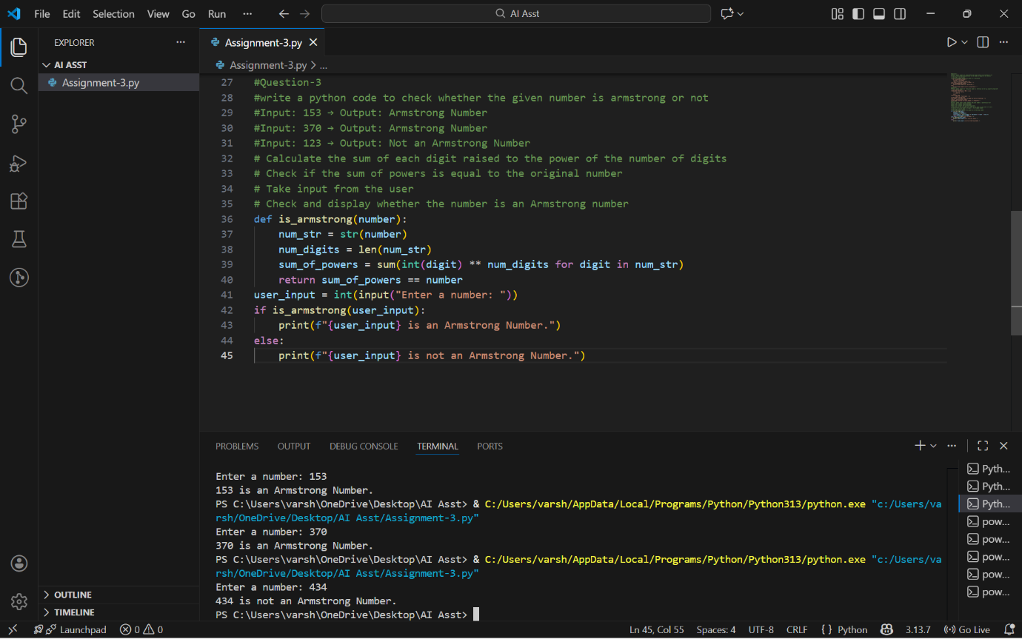
Analysis:
Giving examples helps the AI understand what kind of answer is expected.
Multiple examples make the code cleaner and more logical.
Showing both correct and incorrect cases avoids confusion.
Testing small numbers like 0 and 1 ensures the function works properly.
Checking wrong inputs makes the program safer and more reliable.

Question 4: Context-Managed Prompting (Optimized Number
Classification)
Design a context-managed prompt with clear instructions and
constraints to generate an optimized Python program that classifies a
number as prime, composite, or neither.
Task:
• Ensure proper input validation.
• Optimize the logic for efficiency.
• Compare the output with earlier prompting strategies.
Prompt:
#Write a python program to find the given number is prime,compositeor neither
# Check if the number is less than 2 (neither prime nor composite)
# Check for factors from 2 to the square root of the number
# Take input from the user
# Check and display whether the number is prime, composite, or neither
Code and Output: 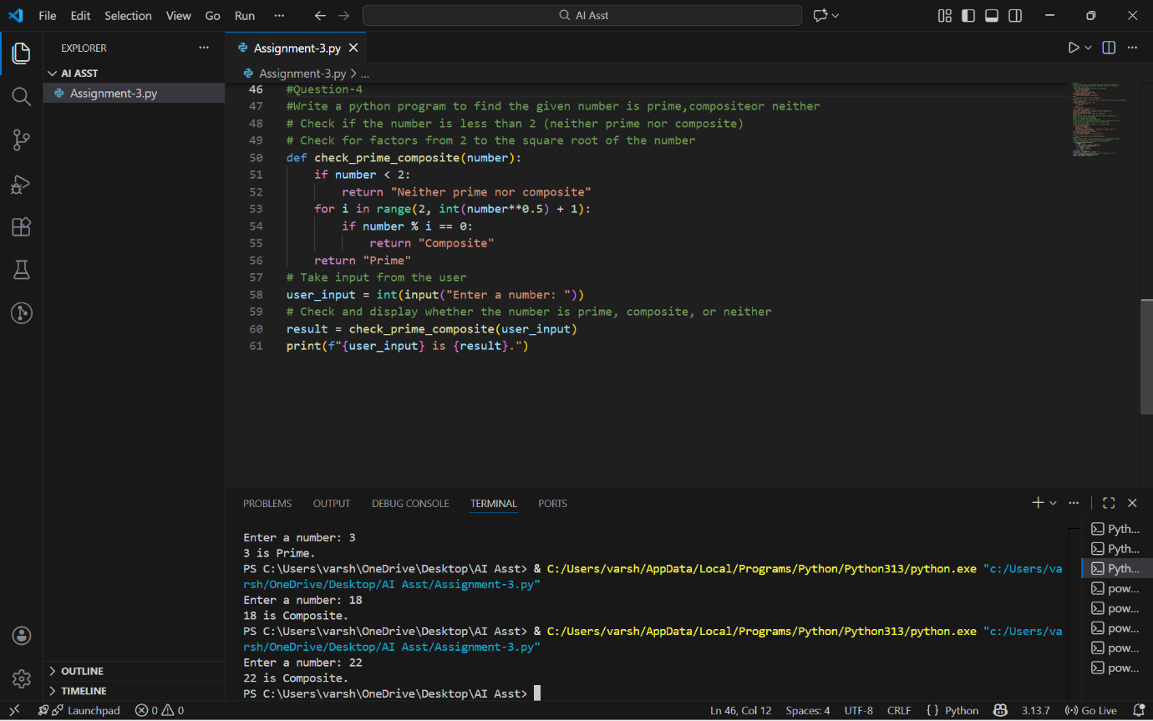
Analysis:
Clear instructions help the AI understand exactly what is needed.
Input validation avoids crashes from wrong inputs.
Efficient logic makes the program faster and smarter.
The AI performs better than with simple prompts.
Results are clearer and more reliable.

Question 5: Zero-Shot Prompting (Perfect Number Check)
Write a zero-shot prompt (without providing any examples) to
generate a Python function that checks whether a given number is a
perfect number.
Task:
• Record the AI-generated code.
• Test the program with multiple inputs.
• Identify any missing conditions or inefficiencies in the logic.

Prompt:
#Write python program to find whether given input is perfect number or not
# Calculate the sum of divisors of the number
# Check if the sum of divisors is equal to the original number
# Take input from the user
# Check and display whether the number is a perfect number
Code and Output:
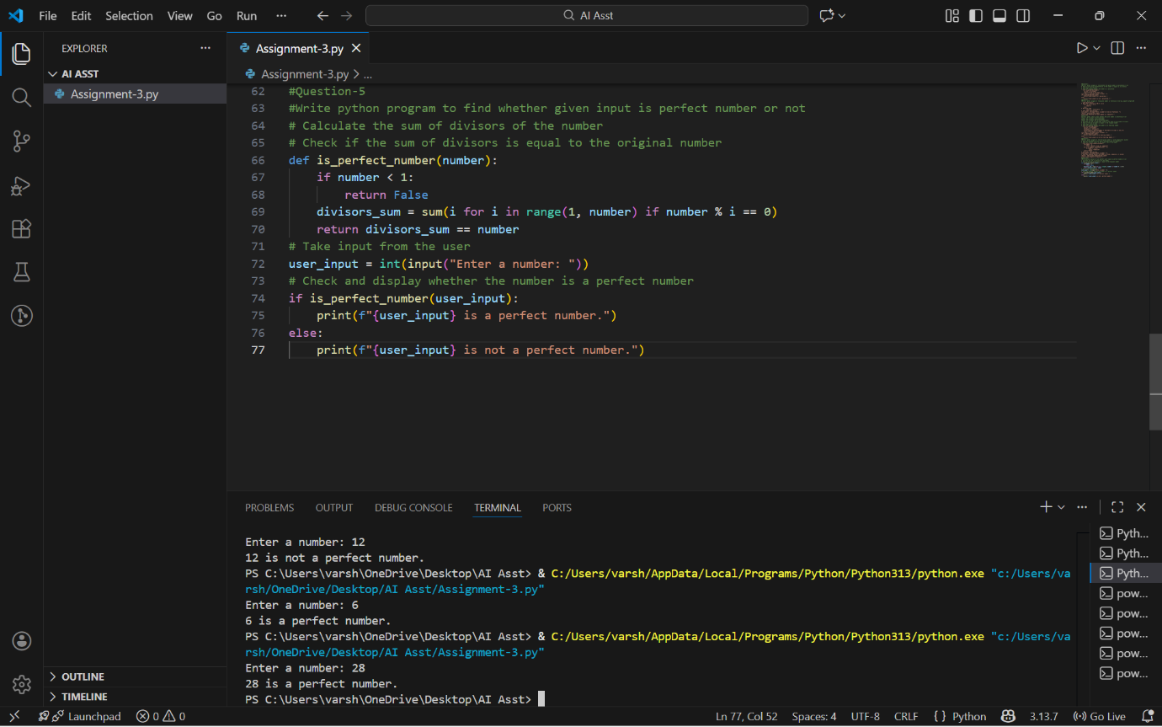
Analysis:
The AI works only with instructions, no examples.
The code usually works but may miss some cases.
Testing with different numbers shows if it’s correct.
The logic may be slower without optimization.
Extra checks improve accuracy.

Question 6: Few-Shot Prompting (Even or Odd Classification with
Validation)
Write a few-shot prompt by providing multiple input-output
examples to guide the AI in generating a Python program that
determines whether a given number is even or odd, including proper
input validation.
Examples:
• Input: 8 → Output: Even
• Input: 15 → Output: Odd
• Input: 0 → Output: Even
Task:
• Analyze how examples improve input handling and output
clarity.
• Test the program with negative numbers and non-integer inputs.

Prompt:
#Write a python code to check whether given input is even or odd number
#e.g input=4 output=Even
#e.g input=15 output=Odd
# Take input from the user
# Check and display whether the number is even or odd

Code and Output:
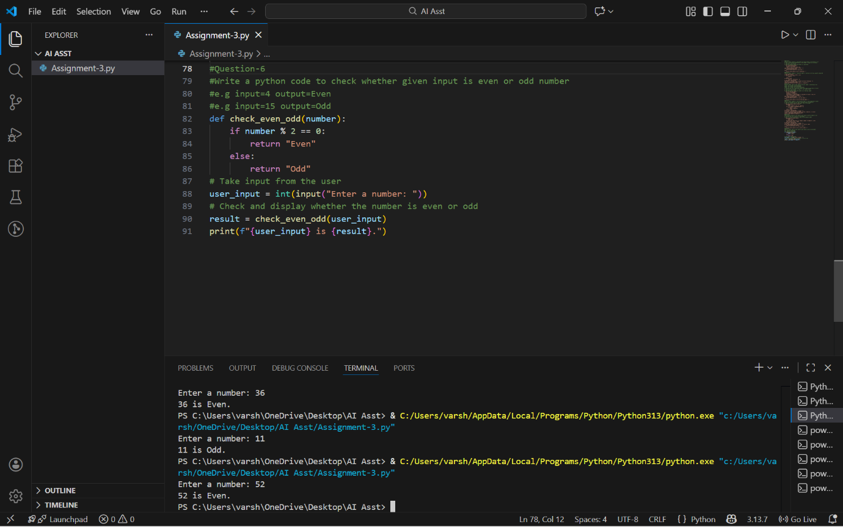

Analysis:
Examples make the task easy to understand.
The AI gives clear even or odd results.
Input validation improves with examples.
Negative numbers are handled properly.
Wrong inputs are easier to detect.

