AI ASSISTED CODING
ASSIGNMENT-9.2
Name: A.Siddartha
Roll Number: 2303A52340
Batch: 40
Lab 9 – Documentation Generation: Automatic Documentation and Code Comments
Lab Objectives
• To use AI-assisted coding tools for generating Python
documentation and code comments.
• To apply zero-shot, few-shot, and context-based prompt
engineering for documentation creation.
• To practice generating and refining docstrings, inline comments,
and module-level documentation.
• To compare outputs from different prompting styles for quality
analysis.
Task Description -1 (Documentation – Function Summary Generation)
Task:
Use AI to generate concise functional summaries for each Python function in a given script.
Instructions:
• Provide a Python script to the AI.
• Ask the AI to write a short summary describing the purpose of each function.
• Ensure summaries are brief and technically accurate.
• Do not include code implementation details.

Code:
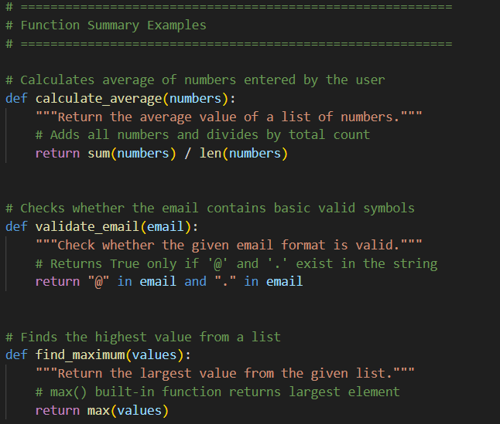
Expected Output -1:
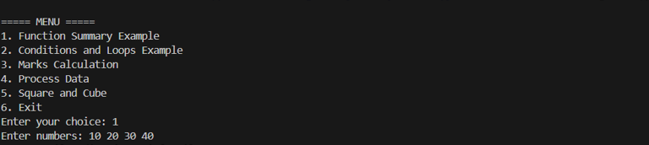

Task Description -2 (Documentation – Logical Explanation for Conditions and Loops)
Task:
Use AI to document the logic behind conditional statements and loops in a Python program.
Instructions:
• Provide a Python program without comments.
• Instruct AI to explain only decision-making logic and loop behavior.
• Skip basic syntax explanations.
Code:
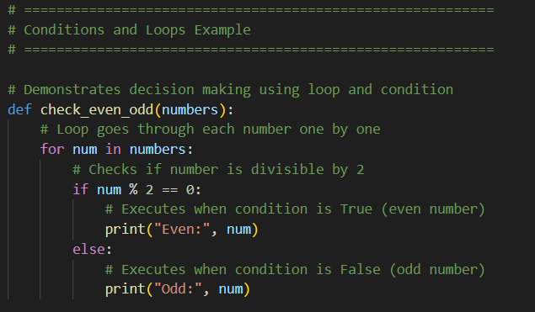
Expected Output -2:
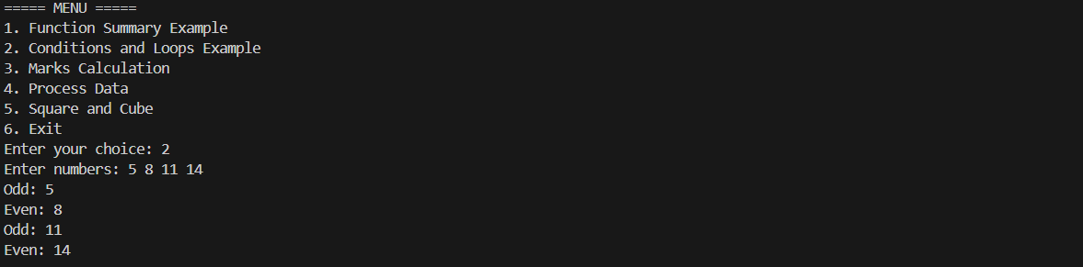
Task Description -3 (Documentation – File-Level Overview)
Task:
Use AI to generate a high-level overview describing the functionality of an entire Python file.
Instructions:
• Provide the complete Python file to AI.
• Ask AI to write a brief overview summarizing the file’s purpose and functionality.
• Place the overview at the top of the file.
Code:
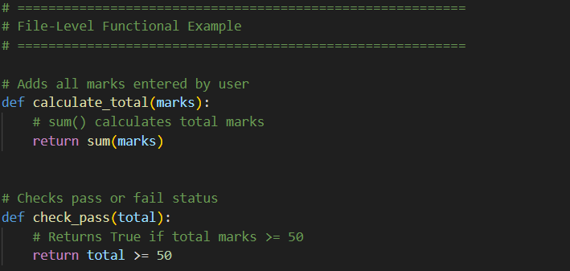
Expected Output -3:
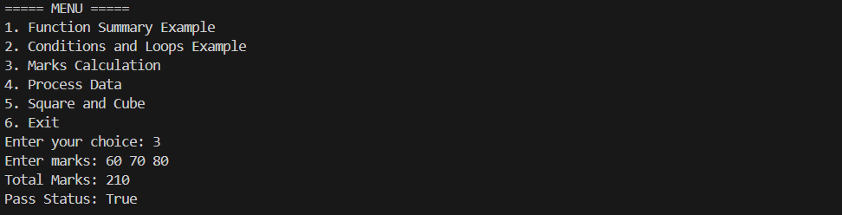

Task Description -4 (Documentation – Refine Existing Documentation)
Task:
Use AI to improve clarity and consistency of existing documentation in Python code.
Instructions:
• Provide Python code containing basic or unclear comments.
• Ask AI to rewrite the documentation to improve clarity and consistency.
• Ensure technical meaning remains unchanged.
Code:
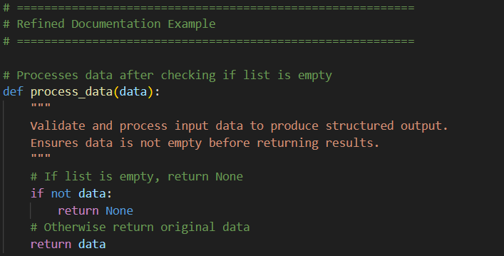
Expected Output -4:
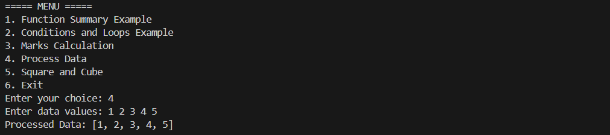

Task Description -5 (Documentation – Prompt Detail Impact Study)
Task:
Study the impact of prompt detail on AI-generated documentation quality.
Instructions:
Create two prompts: one brief and one detailed.
• Use both prompts to document the same Python function.
• Compare the generated outputs.
Code:
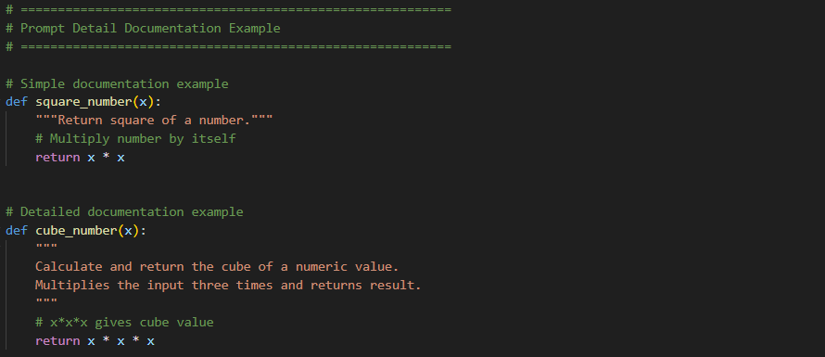
Expected Output -5:
