6.4-Assignment
R.Abhinav Reddy
2303A52348
Batch – 44
Task 1: Student Performance Evaluation System
Scenario :
You are building a simple academic management module for a university
system where student performance needs to be evaluated automatically.
Task Description :
Create the skeleton of a Python class named Student with the attributes:
• name
• roll_number
• marks
Code :
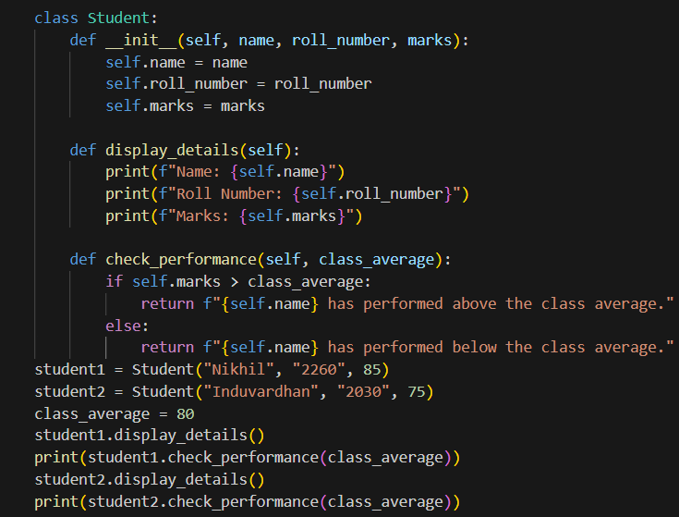
Output :
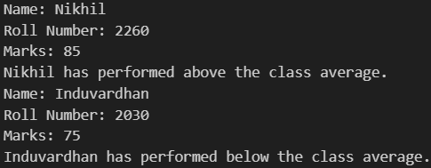

Task 2: Data Processing in a Monitoring System
Scenario
You are working on a basic data monitoring script where sensor readings
are collected as numbers. Only even readings need further processing.
Task Description
Write the initial part of a for loop to iterate over a list of integers
representing sensor readings.
Code :
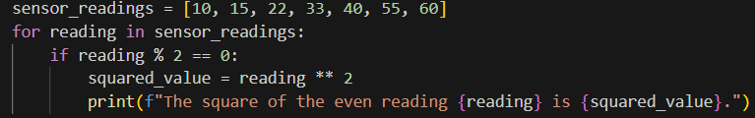
Output :
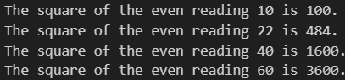

Task 3: Banking Transaction Simulation
Scenario :
You are developing a basic banking module that handles deposits and withdrawals for customers.
Task Description :
Create the structure of a Python class named BankAccount with attributes:
• account_holder
• balance
Code :
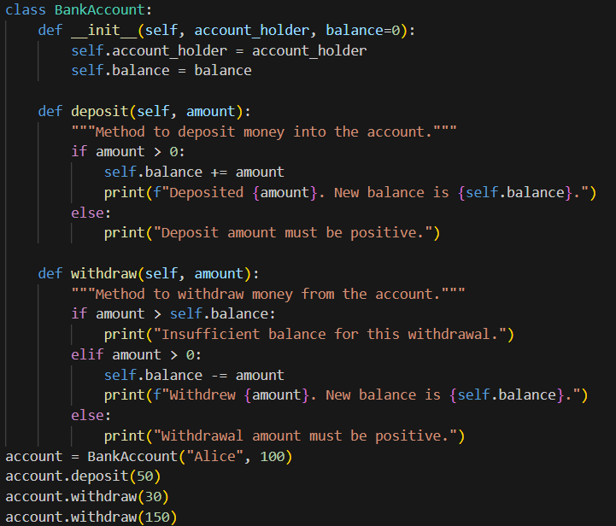
Output :
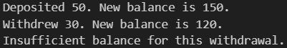
Task 4: Student Scholarship Eligibility Check
Scenario :
A university wants to identify students eligible for a merit-based scholarship based on their scores.
Task Description :
Define a list of dictionaries where each dictionary represents a student with:
• name
• score
Write the initialization and list structure yourself.
Then, prompt GitHub Copilot to generate a while loop that:
• Iterates through the list
• Prints the names of students who scored more than 75
Code :
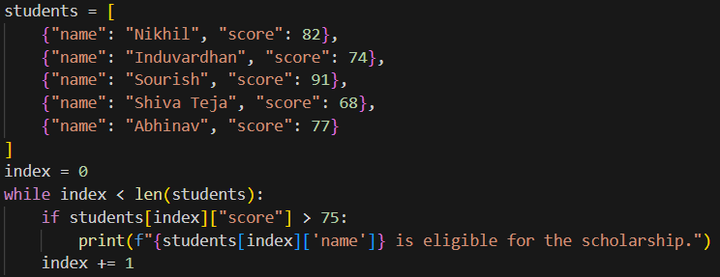
Output :
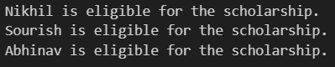

Task 5: Online Shopping Cart Module
Scenario :
You are designing a simplified shopping cart system for an e-commerce website that supports item management and discount calculation.
Task Description :
Begin writing a Python class named ShoppingCart with:
• An empty list to store items (each item may include name, price,
quantity)
Code :
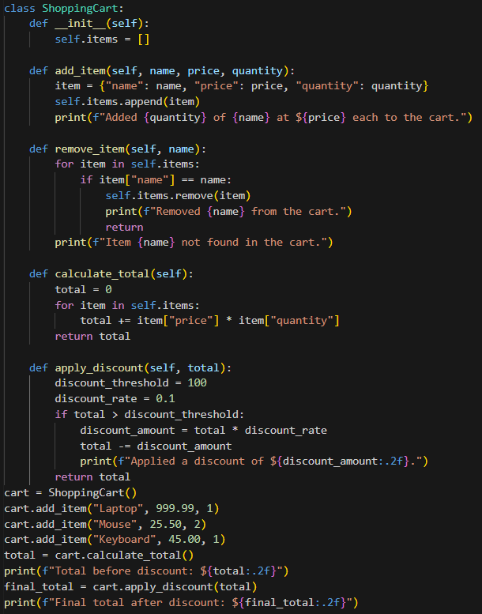
Output :
