Assignment-7.1
R.Abhinav Reddy
2303A52348
Batch-44
Task 1 description: (Syntax Errors – Missing Parentheses in Print Statement)
Task: Provide a Python snippet with a missing parenthesis in a print statement
(e.g., print "Hello"). Use AI to detect and fix the syntax error.
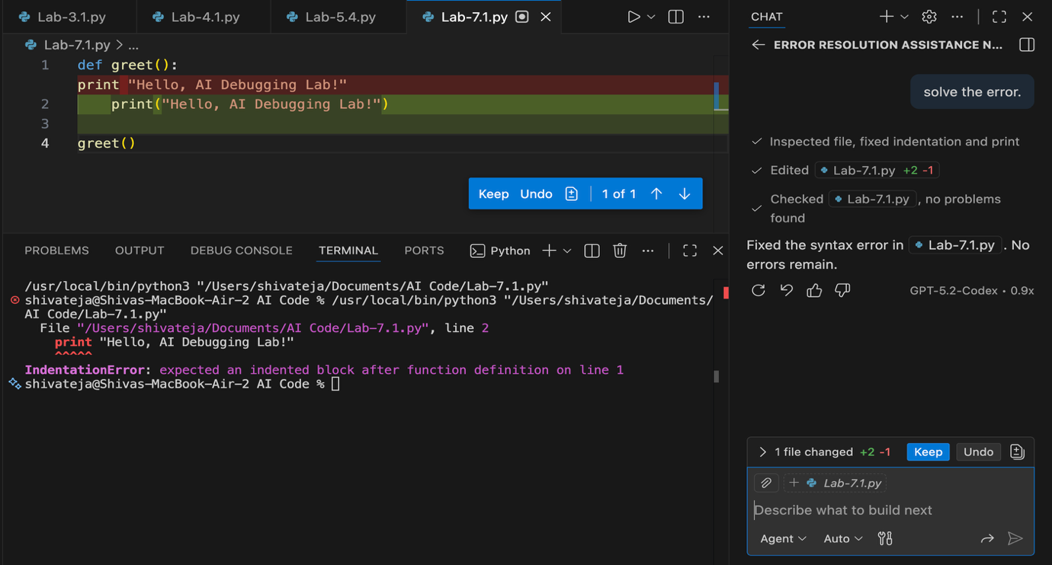
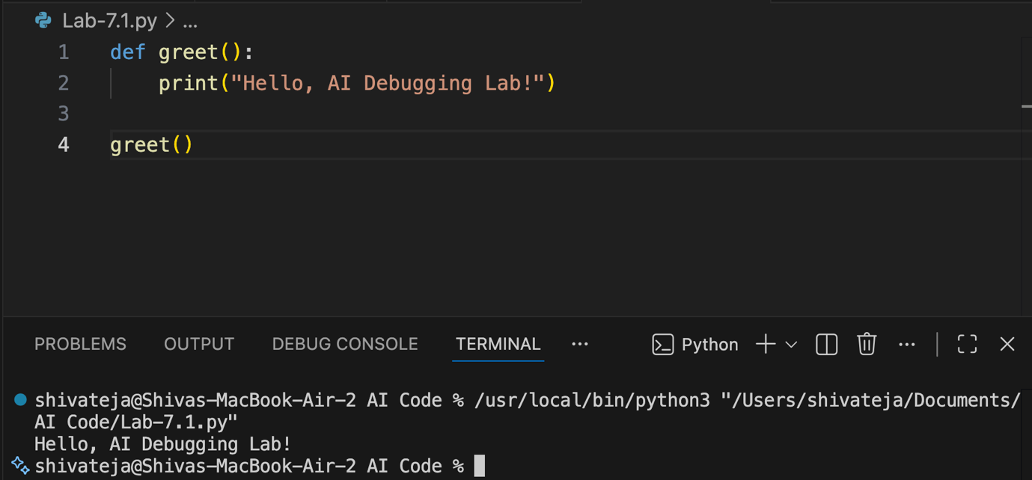

Task 2 description: (Incorrect condition in an If Statement)
Task: Supply a function where an if-condition mistakenly uses = instead of ==.
Let AI identify and fix the issue.
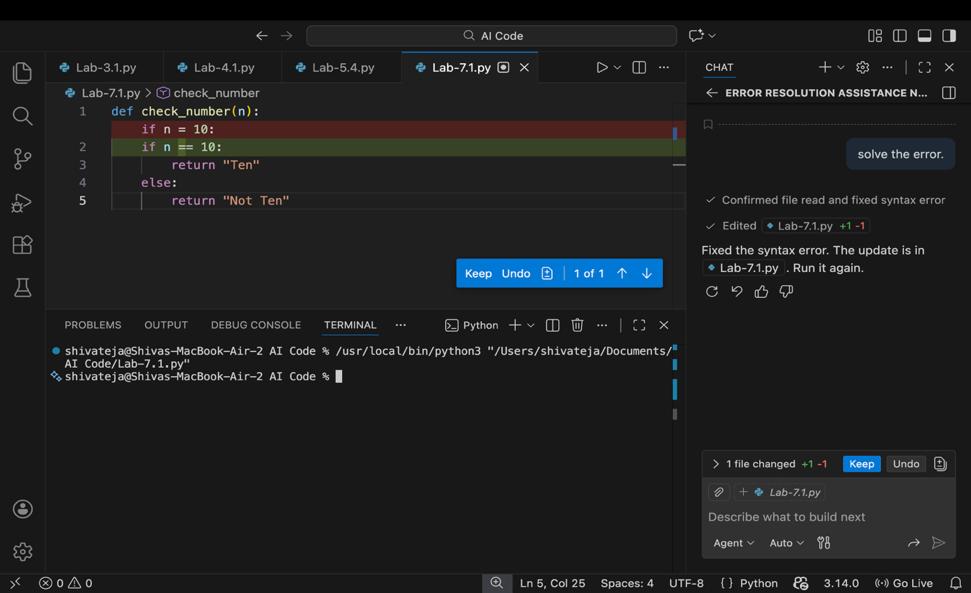
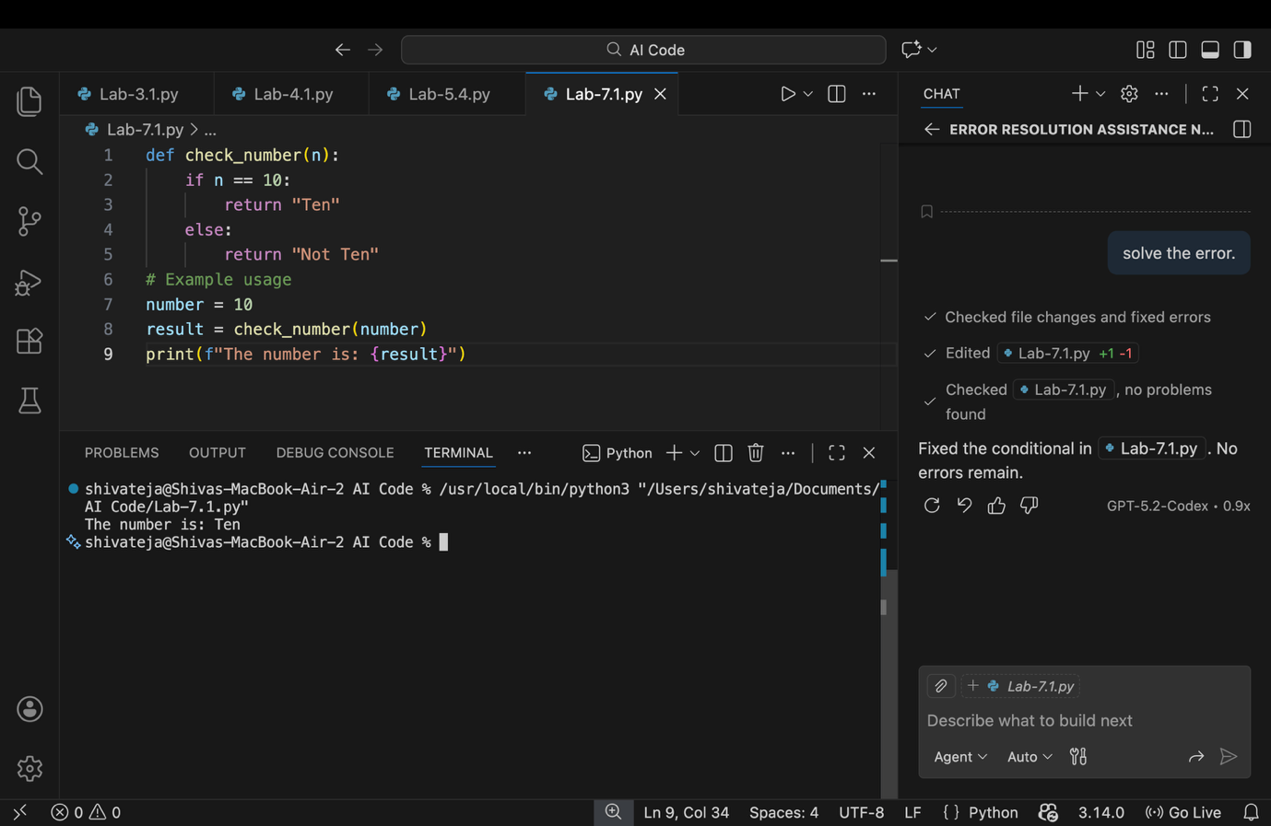

Task 3 description: (Runtime Error – File Not Found)
Task: Provide code that attempts to open a non-existent file and crashes.
Use AI to apply safe error handling

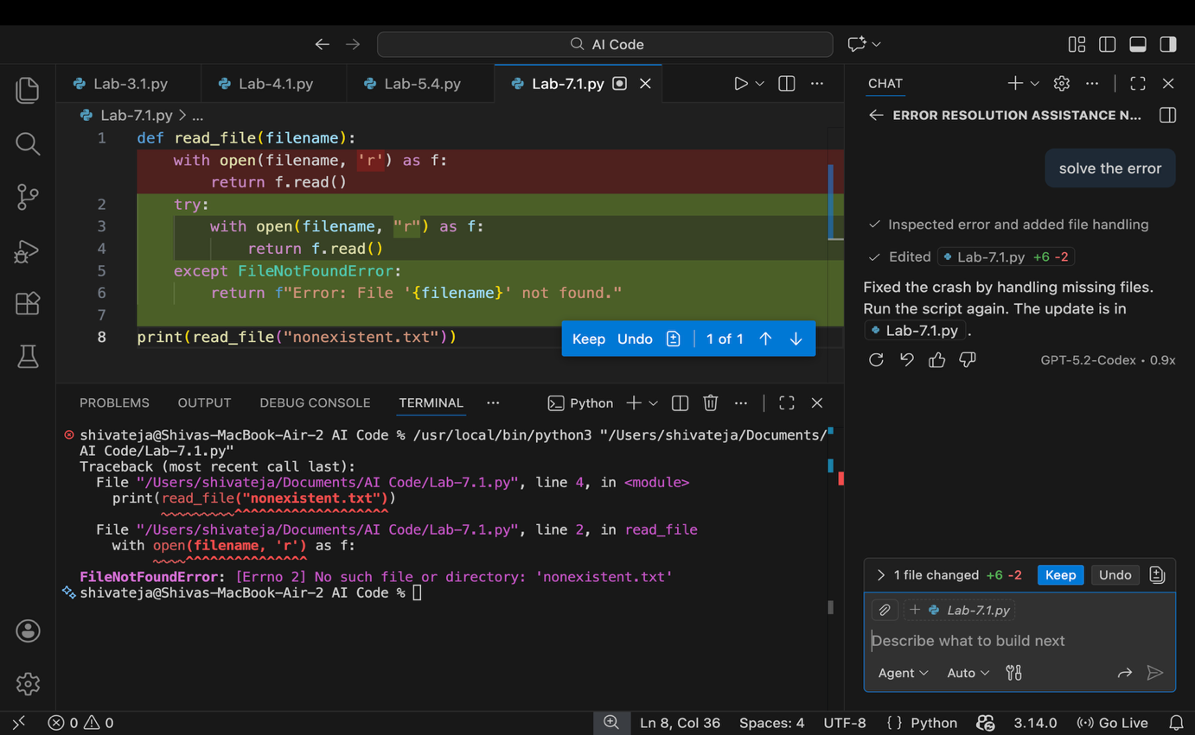
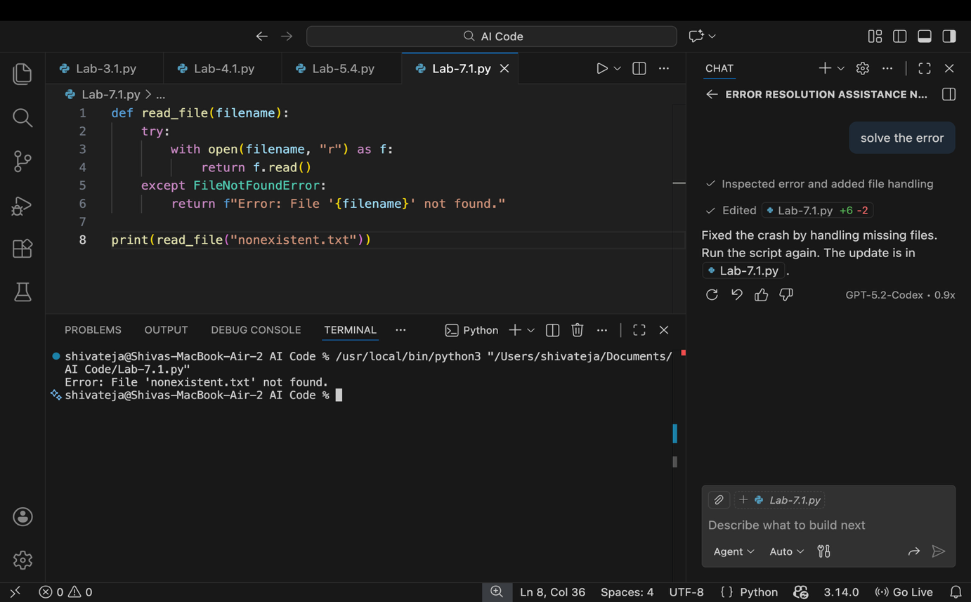

Task 4 description: (Calling a Non-Existent Method)
Task: Give a class where a non-existent method is called (e.g.,obj.undefined_method()). Use AI to debug and fix.
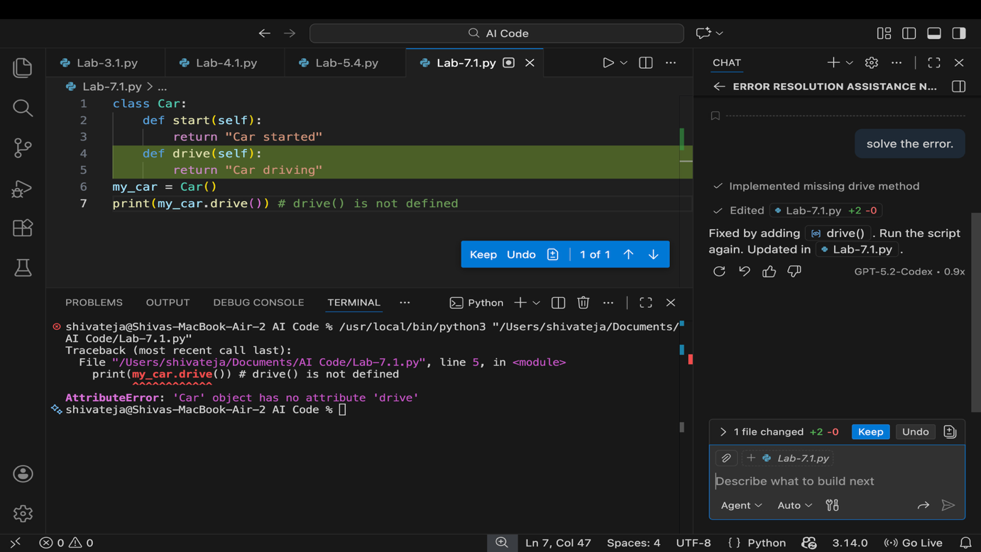
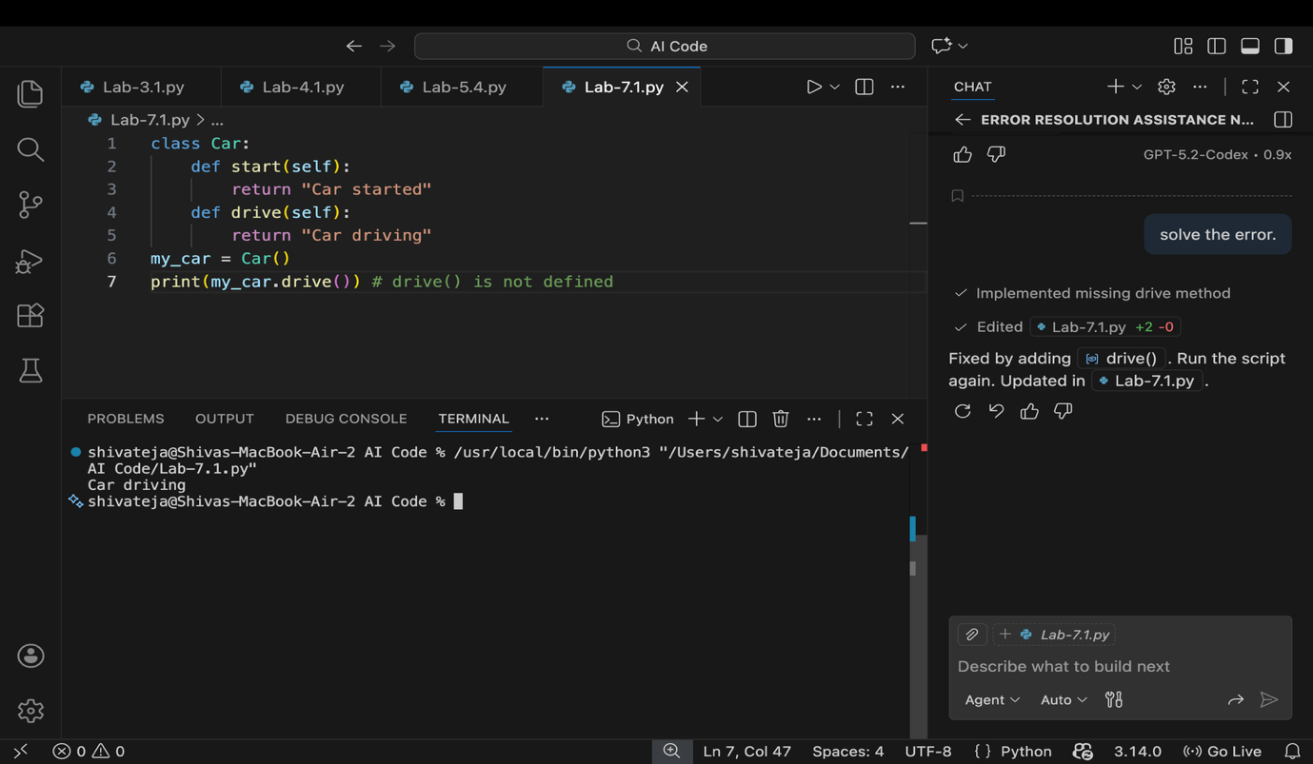

Task 5 description: (Type Error – Mixing Strings and Integers in Addition)
Task: Provide code that adds an integer and string ("5" + 2) causing a Type Error.
Use AI to resolve the bug.
