9.4-Assignment
R.Abhinav Reddy
2303A52348
Batch – 44
Task 1: Auto-generating Function Documentation in a Shared Codebase.
Code:
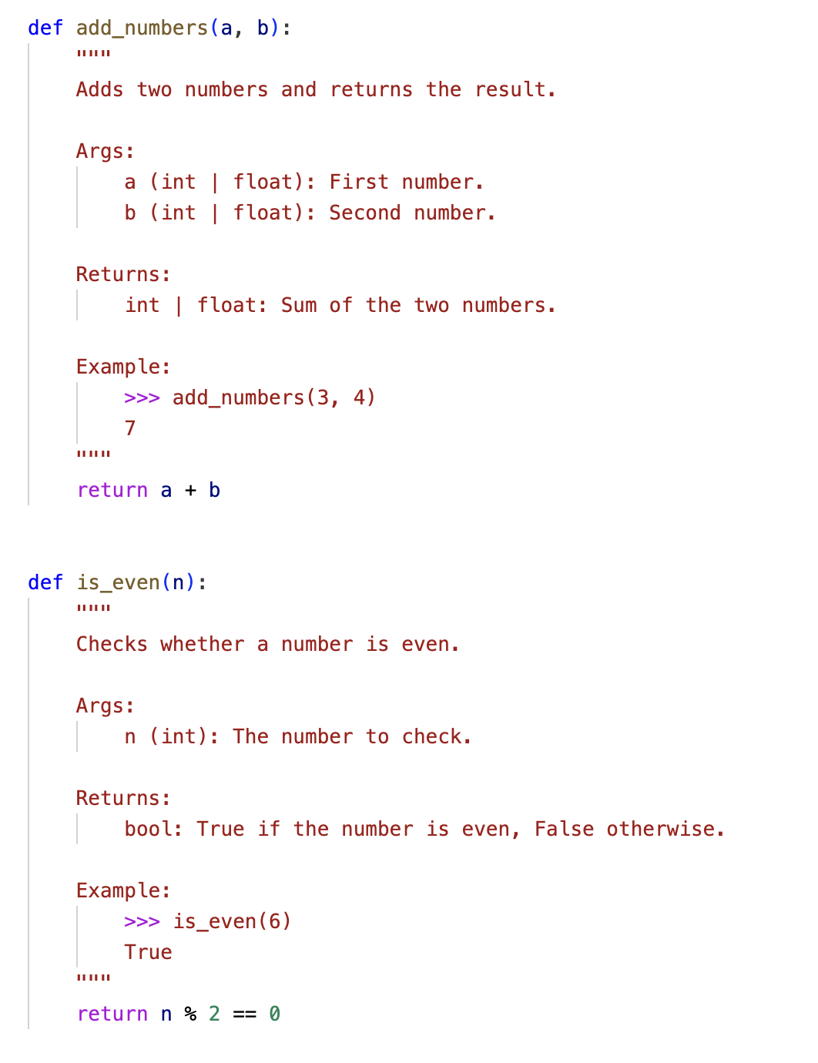

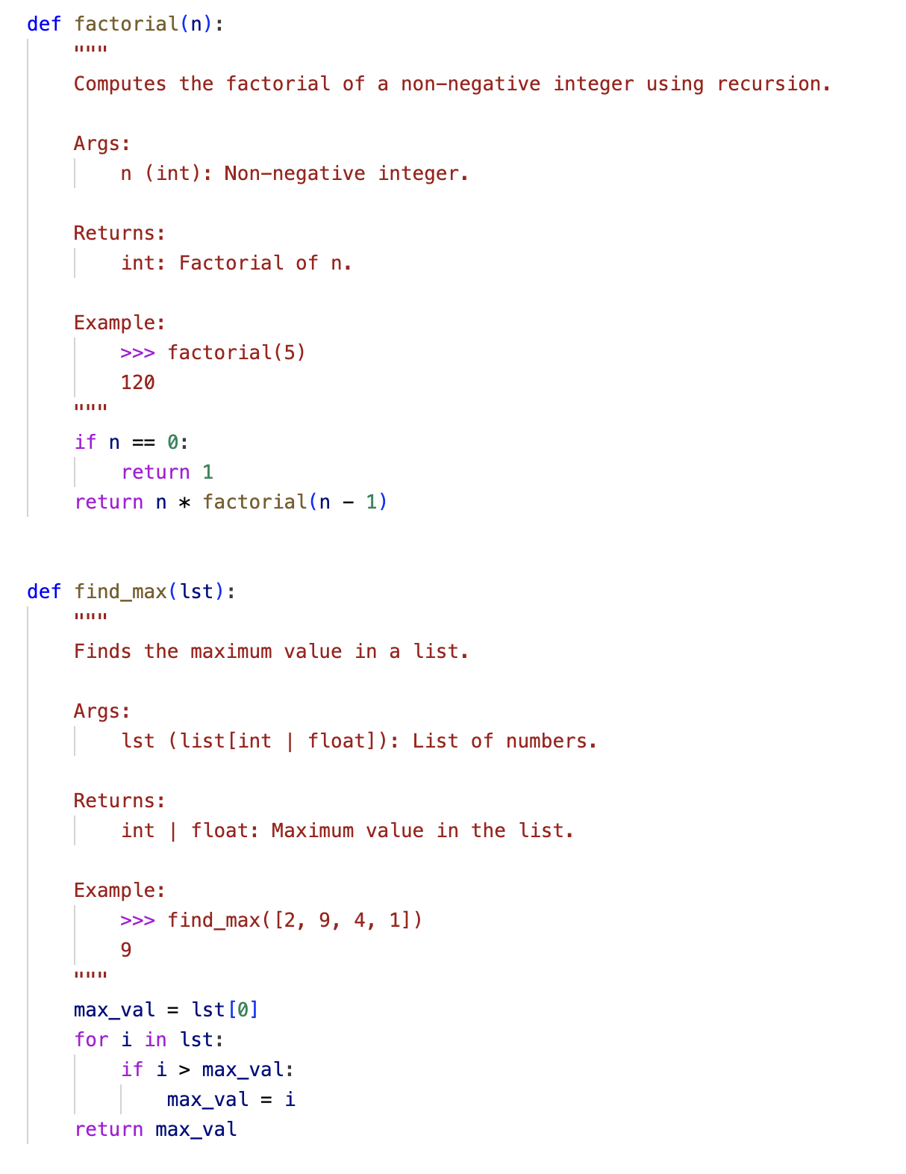

Task 2: Enhancing Readability Through AI-Generated Inline Comments.
Code:
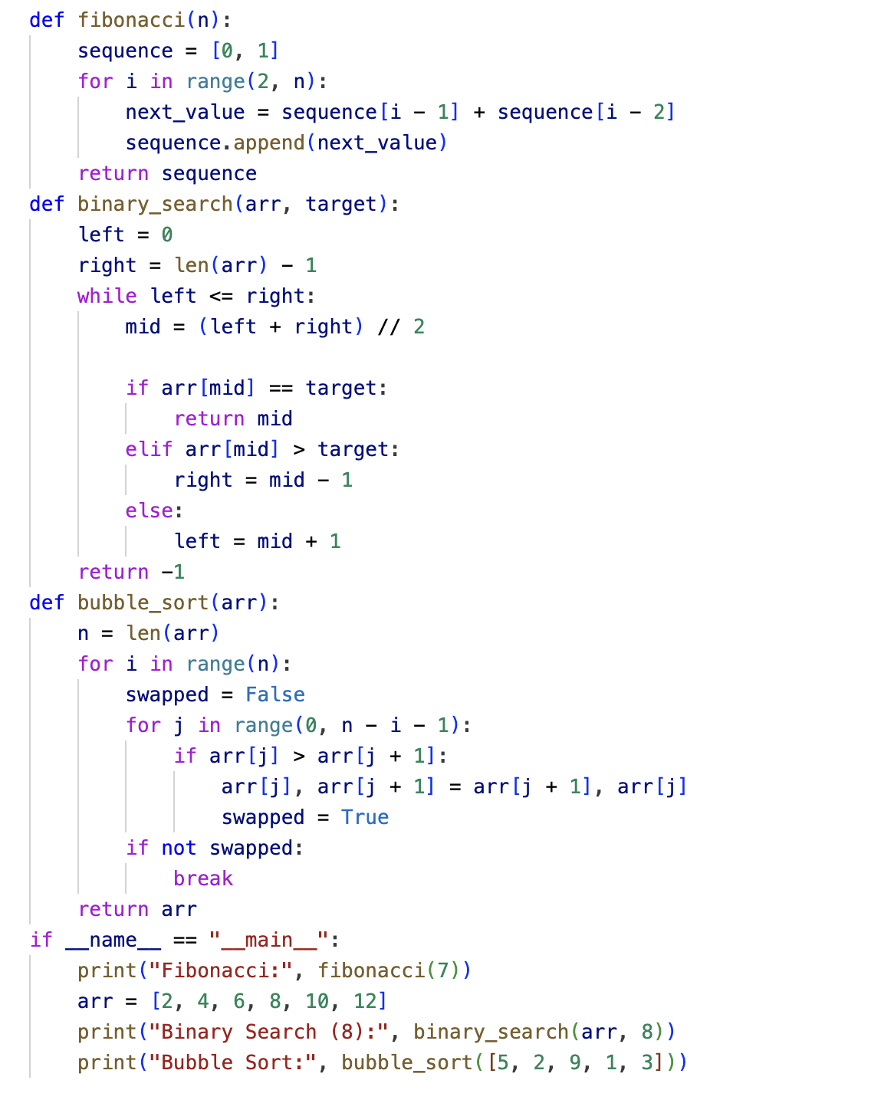

Output:
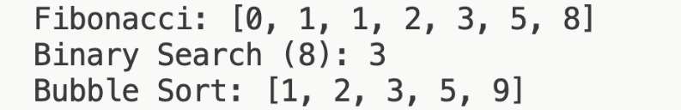

Task 3: Generating Module-Level Document for a Python Package.
Code:
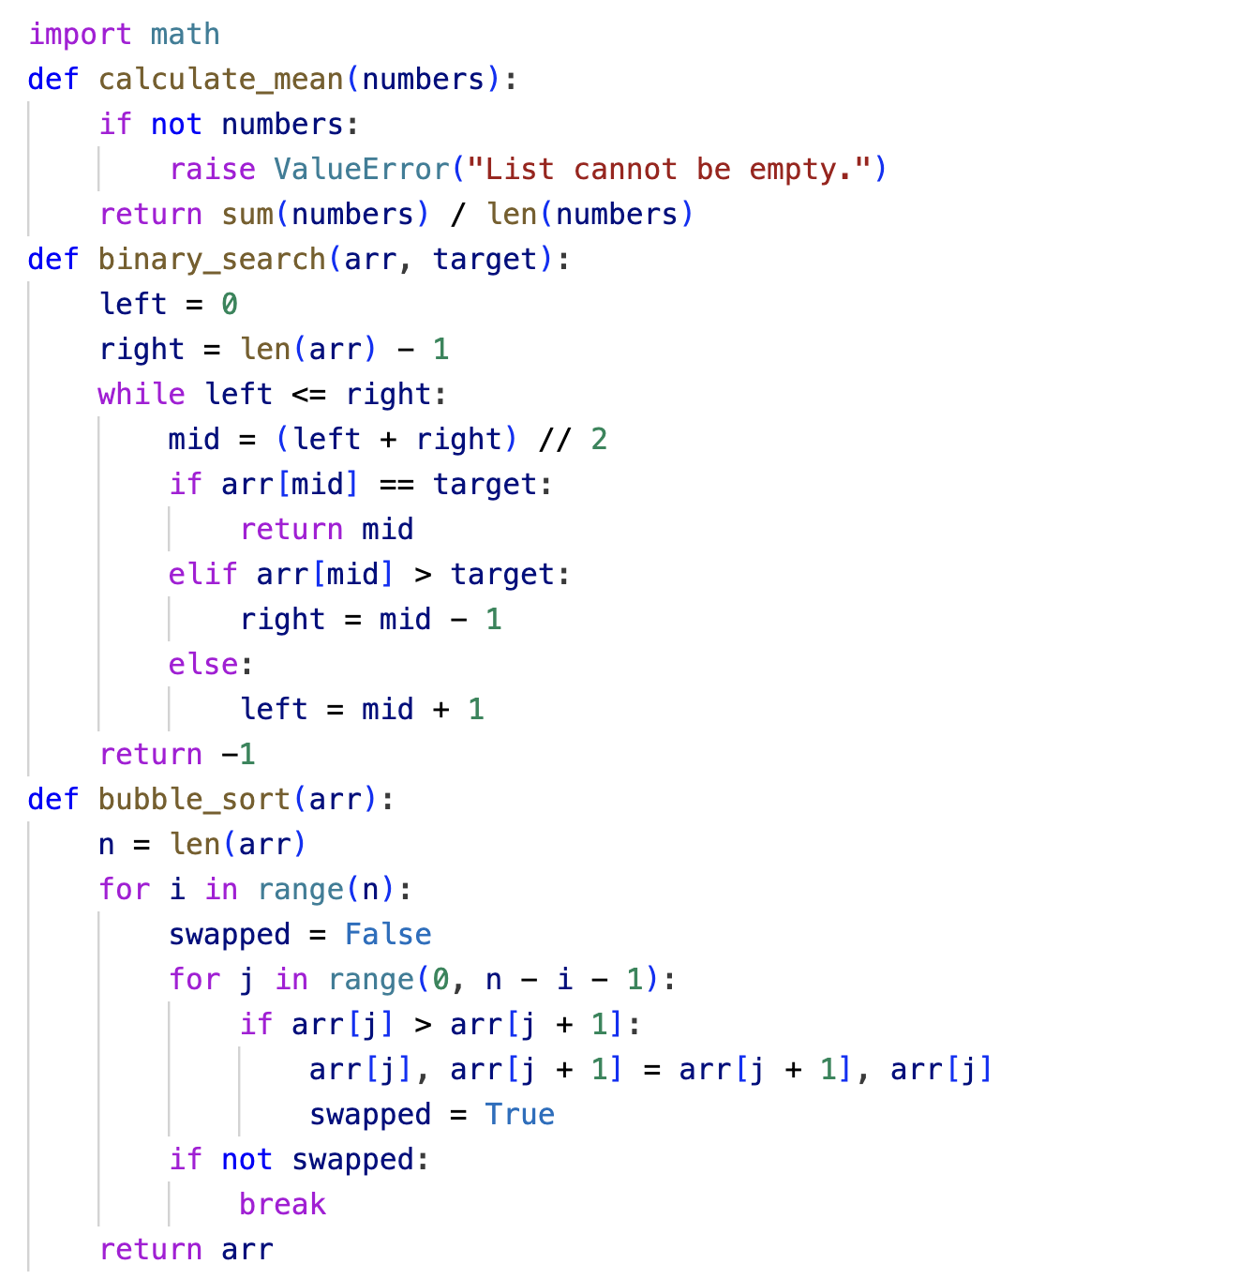

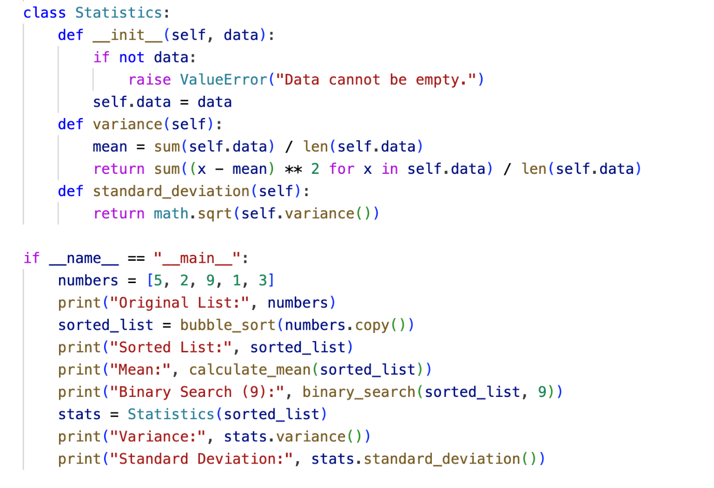

Output:
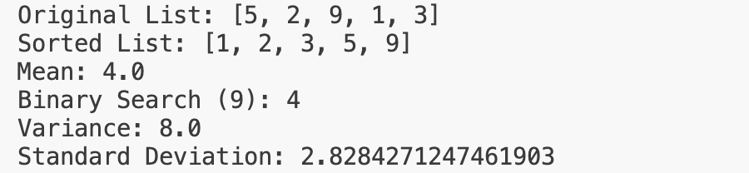

Task 4: Converting Developer Comments into Structural Docstrings.
Code:

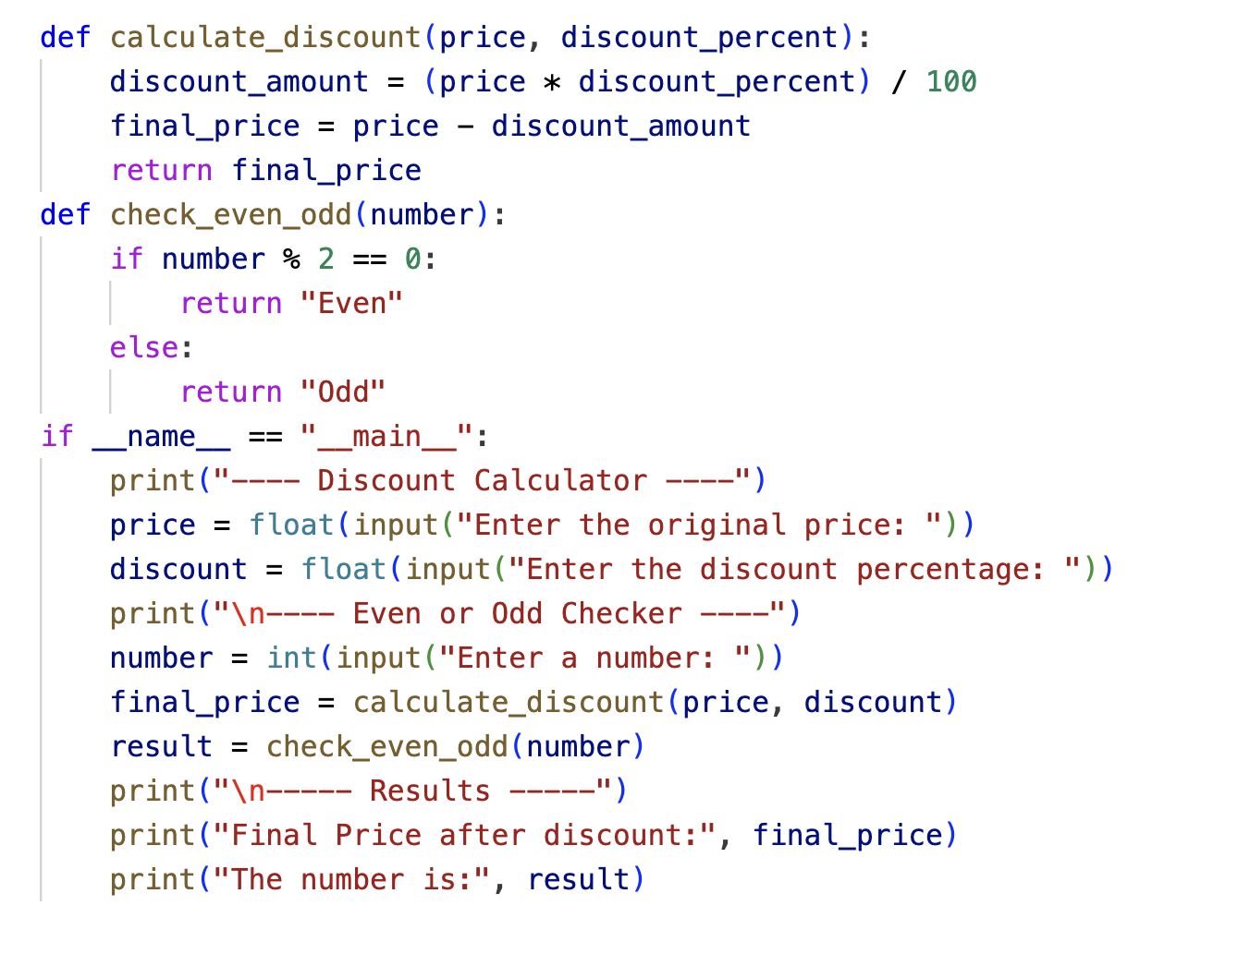
Input:
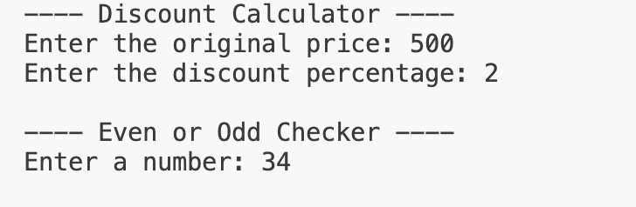

Output:
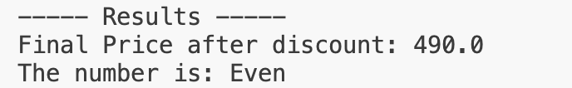

Task 5: Building a Mini Automatic Documentation Generator.
Code:

Main.py
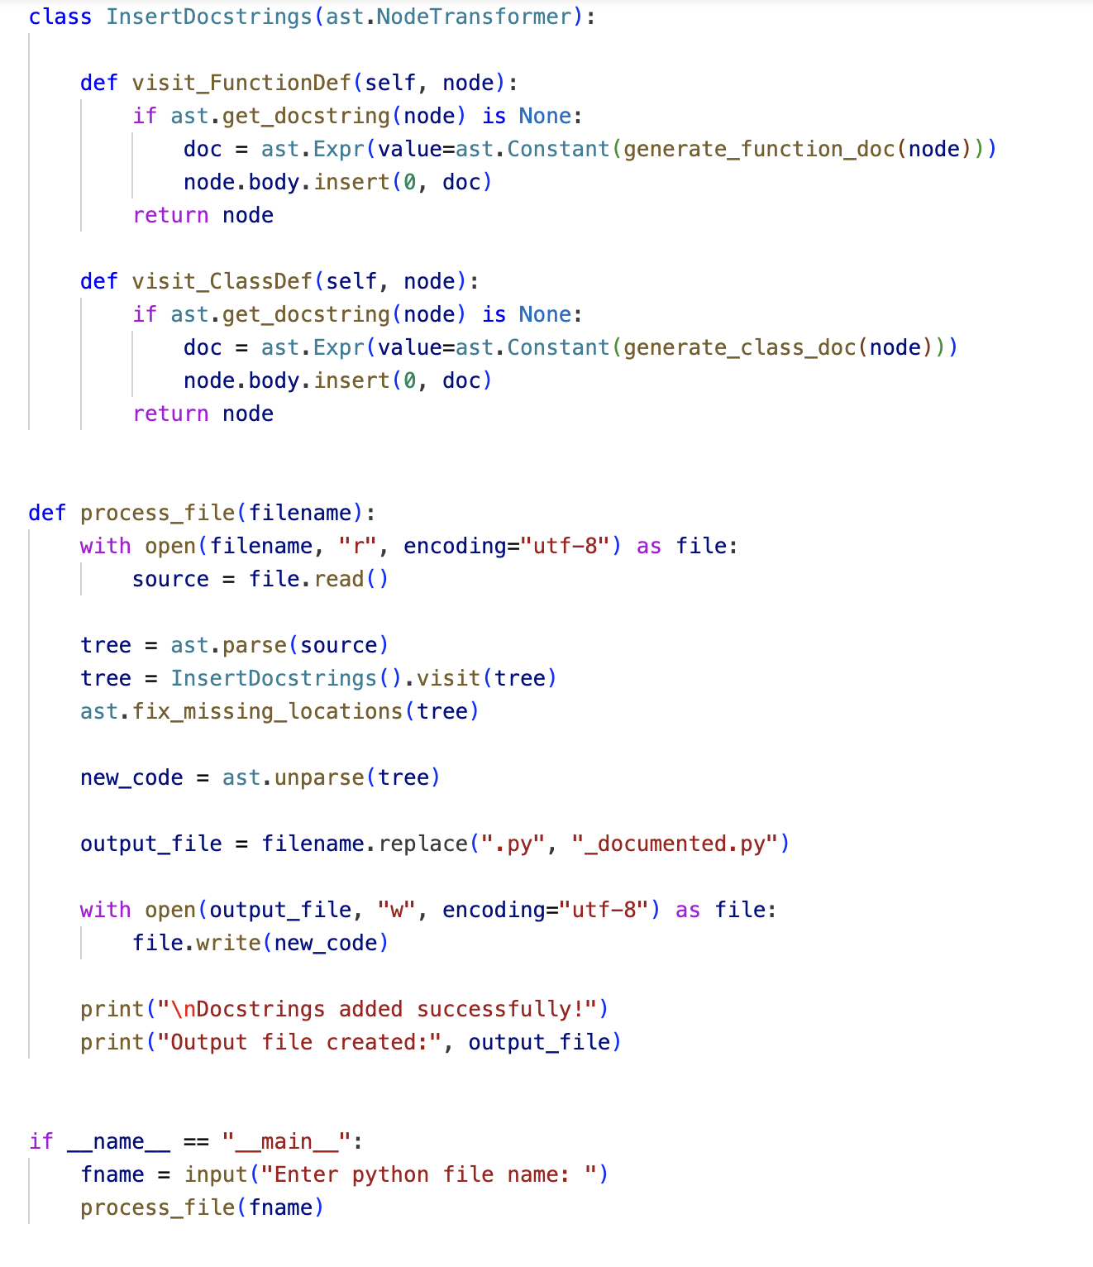

Sample_input.py
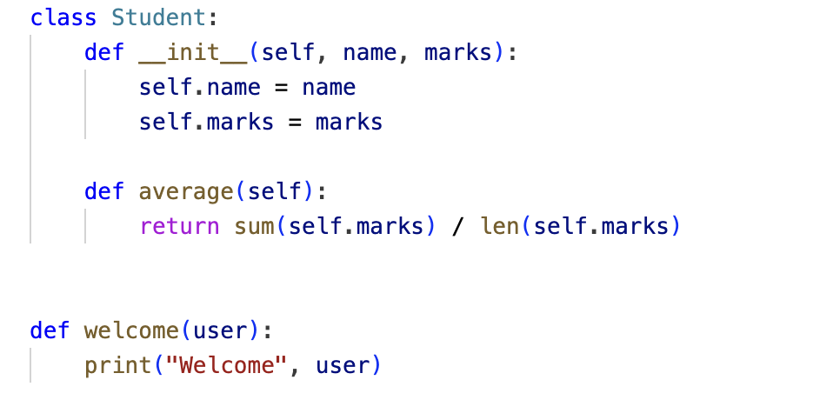

Input:
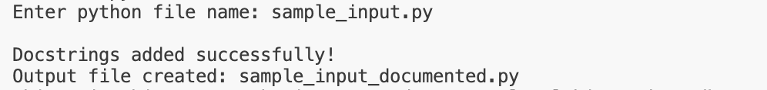

Output:


