Lab 3: Prompt Engineering – Improving Prompts and Context Management
Hall Ticket No: 2303A52363
NAME: NAVYA SRI.B
Batch: 39

Task Description-1
• Progressive Prompting for Calculator Design: Ask the AI to design a simple calculator
program by initially providing only the function name. Gradually enhance the prompt by
adding comments and usage examples.
Expected Output-1
• Comparison showing improvement in AI-generated calculator logic and structure.
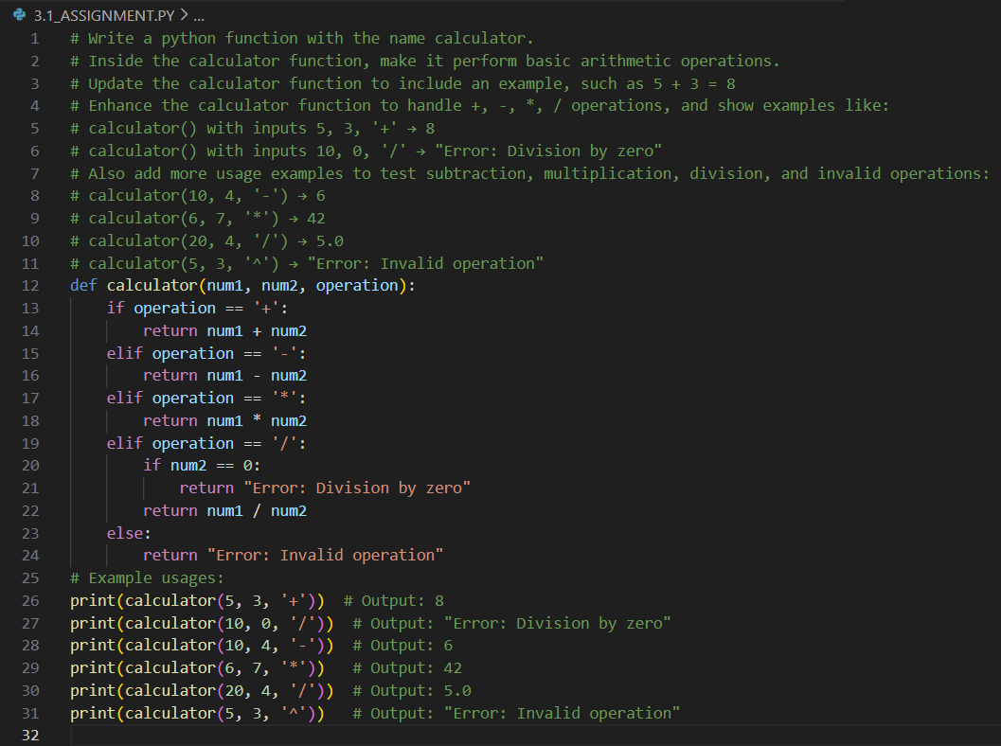
Output:
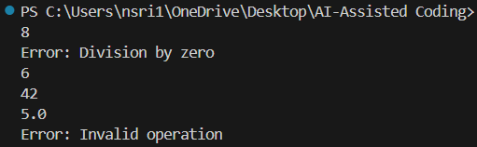

Code Analysis:
Stage 1: Empty stub, no logic.
Stage 2: Basic input/output, procedural, not reusable.
Stage 3: Reusable function with parameters + error handling.
Stage 4: Clean operator mapping, extensible, robust, maintainable.
Each step improves clarity, reusability, and robustness.

Task Description-2
• Refining Prompts for Sorting Logic: Start with a vague prompt for sorting student marks,
then refine it to clearly specify sorting order and constraints.
Expected Output-2
• AI-generated sorting function evolves from ambiguous logic to an accurate and efficient
implementation.
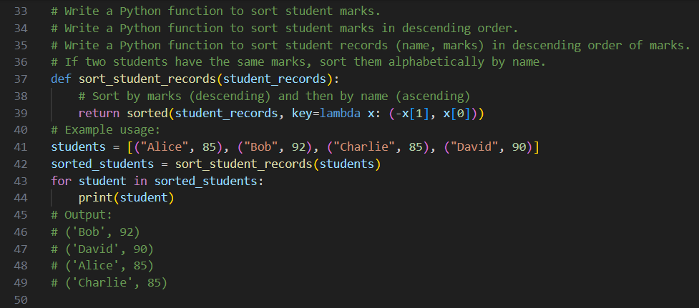
Output:
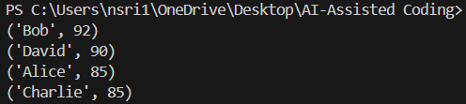
Code Analysis:
Stage-1: Default ascending sort, ambiguous.
Stage-2: Still ascending, minimal improvement.
Stage-3: Adds order parameter (asc/desc) with error handling → reusable.
Stage-4: Adds top_n constraint → efficient, flexible, robust.
Each refinement improves clarity, flexibility, and correctness.
Task Description-3
• Few-Shot Prompting for Prime Number Validation: Provide multiple input-output
examples for a function that checks whether a number is prime. Observe how few-shot
prompting improves correctness.
Expected Output-3
• Improved prime-checking function with better edge-case handling.

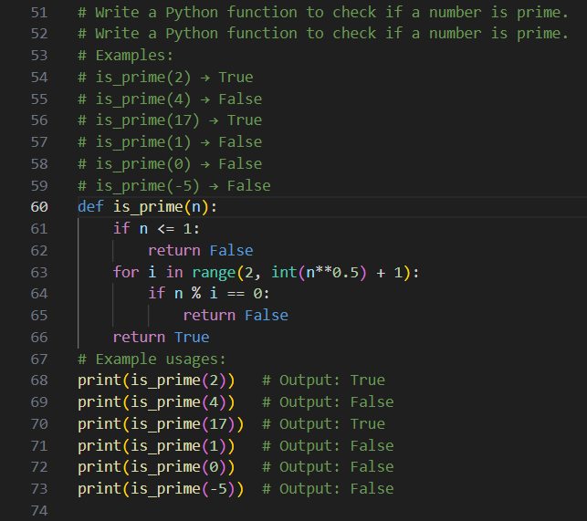
Output:
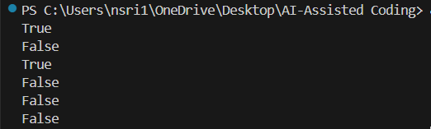

Code Analysis:
Stage-1: Simple prime check, misses edge cases.
Stage-2: Examples improve logic, adds small number checks.
Stage-3: Few-shot prompting → handles 0, 1, negatives, even numbers.
Final: Efficient √n loop, robust and correct.
Few-shot examples improve correctness and edge-case handling significantly.

Task Description-4
• Prompt-Guided UI Design for Student Grading System: Create a user interface for a
student grading system that calculates total marks, percentage, and grade based on user
input.
Expected Output-4
• Well-structured UI code with accurate calculations and clear output display.

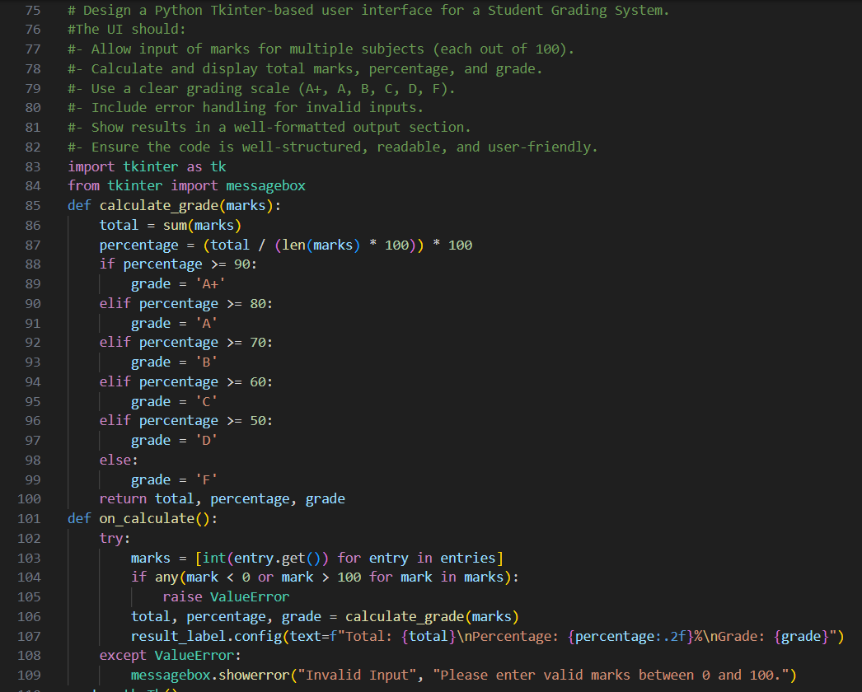

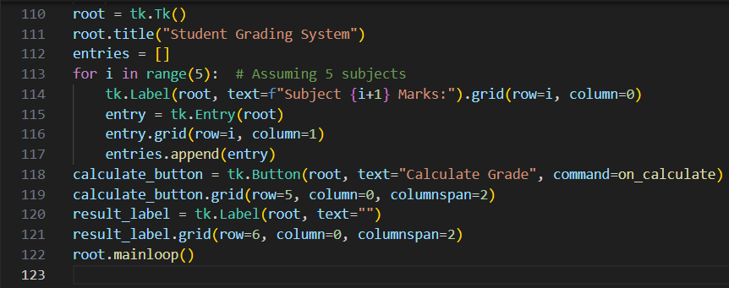
Output:
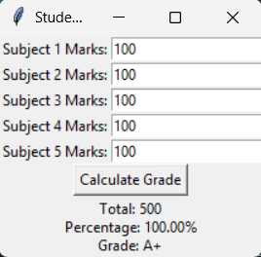
Code Analysis:
Stage-1: Basic input/output, calculates marks but UI is minimal.
Stage-2: Adds structured layout (labels, entry fields, buttons).
Stage-3: Implements accurate calculations (total, percentage, grade logic).
Final: Well-organized UI with clear display of results, user-friendly and robust.
Prompt guidance improves from plain logic to a polished, interactive grading system.

Task Description-5
• Analyzing Prompt Specificity in Unit Conversion Functions: Improving a Unit
Conversion Function (Kilometers to Miles and Miles to Kilometers) Using Clear
Instructions.
Expected Output-5
• Analysis of code quality and accuracy differences across multiple prompt variations.

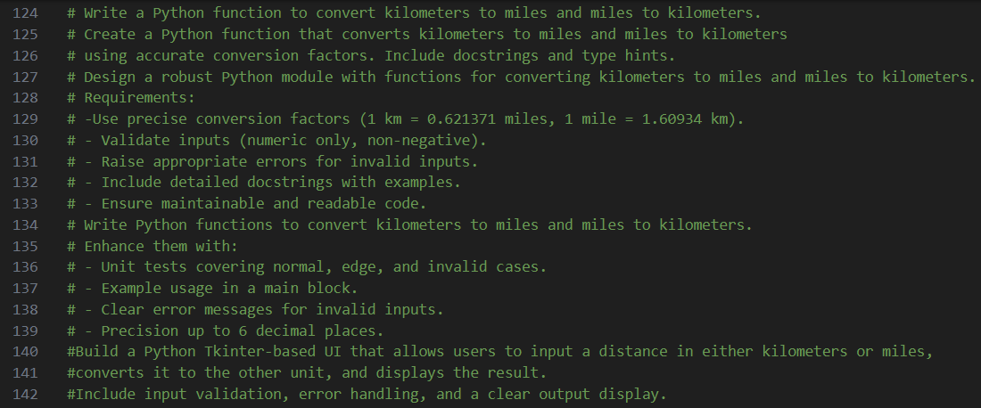

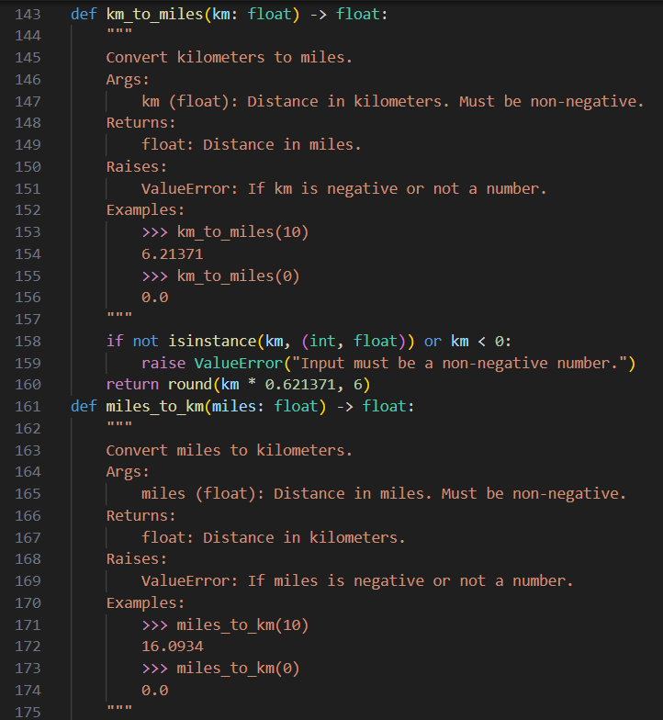

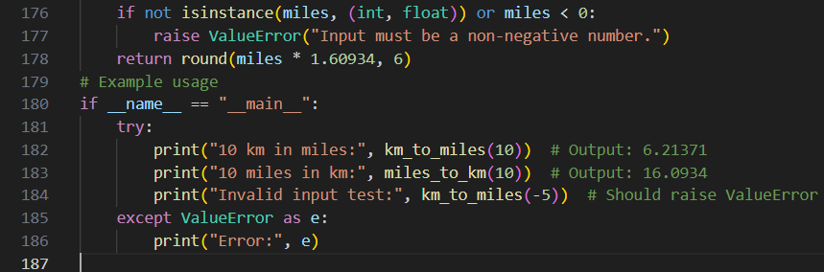

Output:
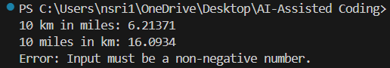

Code Analysis:
Stage-1: Vague prompt → simple formula, may miss precision or direction clarity.
Stage-2: With clearer instructions → adds both conversions (km→mi, mi→km).
Stage-3: Specific examples → improves accuracy, handles float precision.
Final: Well-structured, accurate, reusable function with clear input/output.
Prompt specificity directly improves correctness, precision, and usability.

