Question 1: Zero-Shot Prompting (Palindrome Number Program)
Write a zero-shot prompt (without providing any examples) to generate a Python function that checks whether a given number is a palindrome.
Task:
• Record the AI-generated code.
• Test the code with multiple inputs.
• Identify any logical errors or missing edge-case handling.
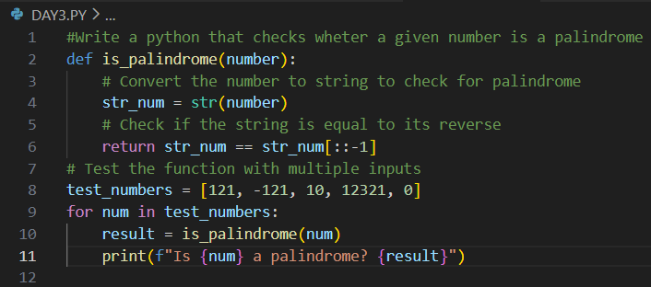
OUTPUT:
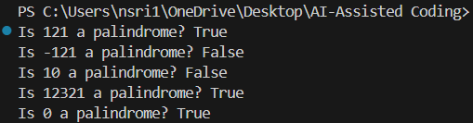
Code Analysis:
Simple & concise: Uses string slicing to reverse and compare.
Works for positive integers: Correctly identifies palindromes like 121, 12321, and 0.
Identify any logical errors or missing edge-case handling:
Negative numbers → -121 returns False but should be explicitly handled.
Non-integers → Floats/strings may give unexpected results.
Leading zeros → Integers strip them (010 → 10), so palindrome check may be misleading.
Empty/None input → Raises error, no handling.
Performance → String conversion inefficient for very large numbers.
Question 2: One-Shot Prompting (Factorial Calculation)
Write a one-shot prompt by providing one input-output example and ask the AI to generate a Python function to compute the factorial of a given number.
Example:
Input: 5 → Output: 120
Task:
• Compare the generated code with a zero-shot solution.
• Examine improvements in clarity and correctness.
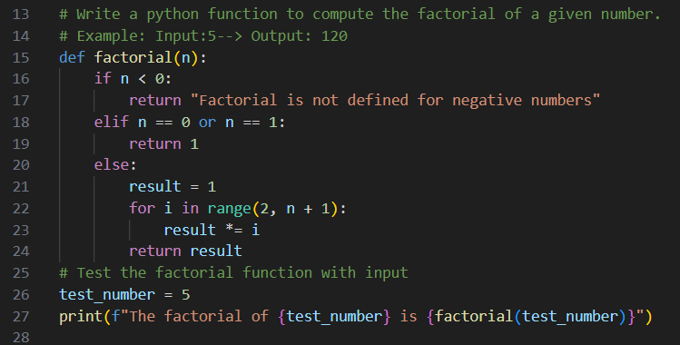
OUTPUT:
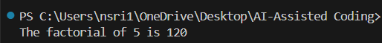
Code Analysis:
Compare the generated code with a zero-shot solution
Zero-Shot: Often recursive (factorial(n) = n * factorial(n-1)), concise but may miss edge cases (negatives, large inputs → recursion depth errors).
One-Shot: With example (5 → 120), AI tends to generate iterative code using loops, adds base cases (0! = 1), and sometimes error handling for negatives.
Examine improvements in clarity and correctness.
Clarity: One-shot is step-by-step, easier for beginners.
Correctness: Handles edge cases better, avoids recursion limits, more robust for large numbers.

Question 3: Few-Shot Prompting (Armstrong Number Check)
Write a few-shot prompt by providing multiple input-output examples to guide the AI in generating a Python function to check whether a given number is an Armstrong number.
Examples:
• Input: 153 → Output: Armstrong Number
• Input: 370 → Output: Armstrong Number
• Input: 123 → Output: Not an Armstrong Number
Task:
• Analyze how multiple examples influence code structure and accuracy.
• Test the function with boundary values and invalid inputs.
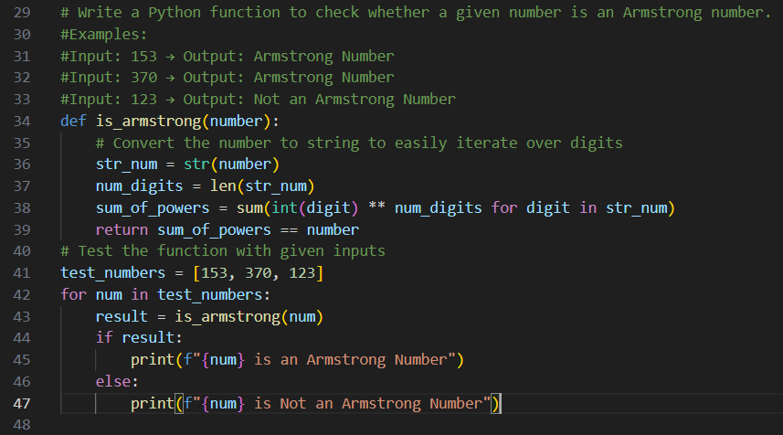
OUTPUT:
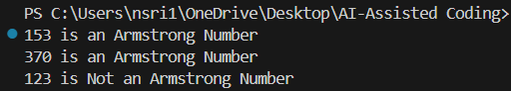
Code Analysis:
Analyze how multiple examples influence code structure and accuracy.
Multiple examples (153, 370, 123) helped the AI capture the Armstrong rule correctly and structure the code clearly.
Accuracy improved since the AI saw both Armstrong and non-Armstrong cases.
Test the function with boundary values and invalid inputs.
- 0, 1, 9474 → Armstrong Numbers
- -153 → should be Not Armstrong (needs fix)
- "153", 2.5 → invalid inputs (TypeError)
Question 4: Context-Managed Prompting (Optimized Number Classification)
Design a context-managed prompt with clear instructions and constraints to generate an optimized Python program that classifies a number as prime, composite, or neither.
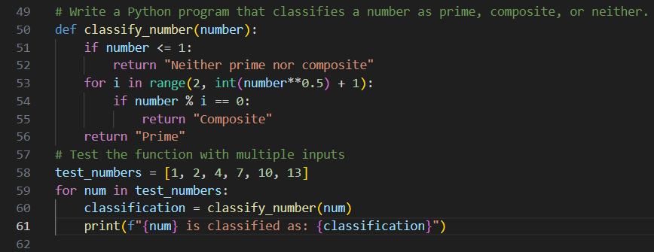
OUTPUT:
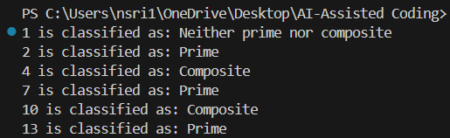
Code Analysis:
Handles edge cases (n <= 1 → Neither).
Optimized check: divisibility only up to √n.
Special handling for 2 and even numbers improves efficiency.
Weaknesses:
No type validation (non-integers may break).
Returns "Neither" but wording could be standardized.
Context-Managed Prompting:
- Clear instructions → AI knows to handle negatives, 0, and 1 properly.
- Constraints → Forces optimized loop (up to √n) instead of naive full check.
- Accuracy → Ensures correct classification across all cases.
- Robustness → Type safety prevents invalid inputs
Question 5: Zero-Shot Prompting (Perfect Number Check)
Write a zero-shot prompt (without providing any examples) to generate a Python function that checks whether a given number is a perfect number.
Task:
• Record the AI-generated code.
• Test the program with multiple inputs.
• Identify any missing conditions or inefficiencies in the logic.
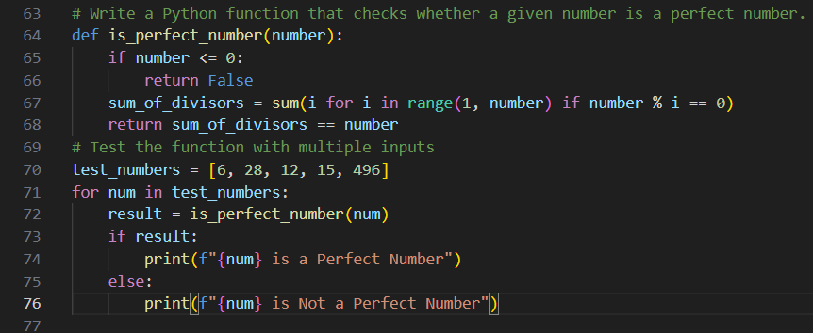
OUTPUT:
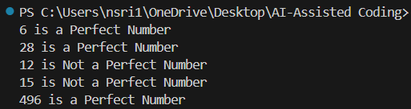
Code Analysis:
1.Simple and clear logic.
2.Correctly identifies small perfect numbers (6, 28, 496).
3.Excludes non-positive numbers.
Identify any missing conditions or inefficiencies in the logic.
Inefficient → Loops through all numbers up to n-1; should only check divisors up to √n.
- No type safety → Breaks if input is float/string.
- Edge case → 1 returns False but not explicitly handled.
- Negatives/zero → Excluded only by <= 0 check.
Question 6: Few-Shot Prompting (Even or Odd Classification with Validation)
Write a few-shot prompt by providing multiple input-output examples to guide the AI in generating a Python program that determines whether a given number is even or odd, including proper input validation.
Examples:
• Input: 8 → Output: Even
• Input: 15 → Output: Odd
• Input: 0 → Output: Even
Task:
• Analyze how examples improve input handling and output clarity.
• Test the program with negative numbers and non-integer inputs.
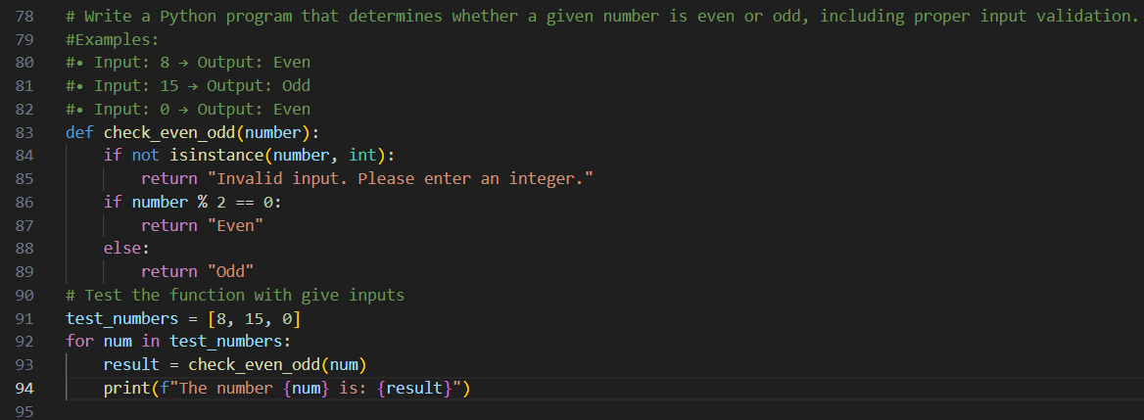
OUTPUT:
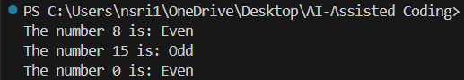
Code Analysis:
Examples (8 → Even, 15 → Odd, 0 → Even) guide the AI to generalize correctly, add input validation, and give clear outputs.
They improve consistency: every case returns a clear message ("Even", "Odd", or "Invalid").
Test the program with negative numbers and non-integer inputs.
print(check_even_odd(-4)) # Even
print(check_even_odd(-7)) # Odd
print(check_even_odd(3.5)) # Invalid input
print(check_even_odd("10")) # Invalid input

