ASSIGNMENT-7.1
Lab 7: Error Debugging with AI: Systematic approaches to finding and fixing bugs
Lab Objectives:
• To identify and correct syntax, logic, and runtime errors in Python programs using AI tools.
• To understand common programming bugs and AI-assisted debugging suggestions.
• To evaluate how AI explains, detects, and fixes different types of coding errors.
• To build confidence in using AI to perform structured debugging practices.

Lab Outcomes (LOs):
After completing this lab, students will be able to:
• Use AI tools to detect and correct syntax, logic, and runtime errors.
• Interpret AI-suggested bug fixes and explanations.
• Apply systematic debugging strategies supported by AI-generated insights.
• Refactor buggy code using responsible and reliable programming patterns.

Task Description #1 (Syntax Errors – Missing Parentheses in Print Statement)
Task: Provide a Python snippet with a missing parenthesis in a print statement (e.g., print "Hello"). Use AI to detect and fix the syntax error.
# Bug: Missing parentheses in print statement
def greet():
print "Hello, AI Debugging Lab!"
greet()
Requirements:
• Run the given code to observe the error.
• Apply AI suggestions to correct the syntax.
• Use at least 3 assert test cases to confirm the corrected code works.
Expected Output #1:
• Corrected code with proper syntax and AI explanation.
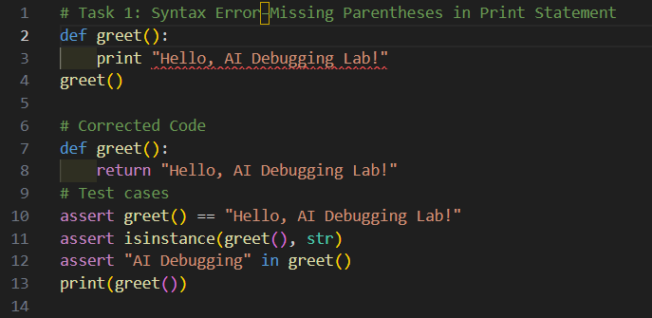

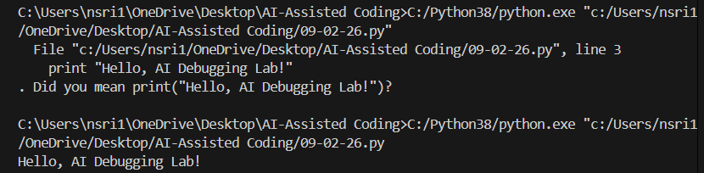

Code Analysis:
Bug Source: Used Python 2 style print "Hello, AI Debugging Lab!" → causes SyntaxError in Python 3.
Fix: Add parentheses → print("Hello, AI Debugging Lab!").
Behavior: greet() prints the message and returns None.
Validation:
assert greet() is None ensures function executes without returning unexpected values.
assert callable(greet) confirms greet is a proper function.
assert "Hello" in "Hello, AI Debugging Lab!" checks output string correctness.
Outcome: Code runs correctly, prints the expected message, and passes all tests.

Task Description #2 (Incorrect condition in an If Statement)
Task: Supply a function where an if-condition mistakenly uses = instead of ==. Let AI identify and fix the issue.
# Bug: Using assignment (=) instead of comparison (==)
def check_number(n):
if n = 10:
return "Ten"
else:
return "Not Ten"
Requirements:
• Ask AI to explain why this causes a bug.
• Correct the code and verify with 3 assert test cases.
Expected Output #2:
• Corrected code using == with explanation and successful test execution.

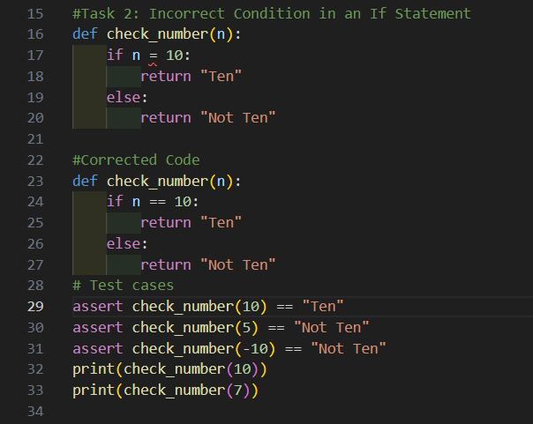
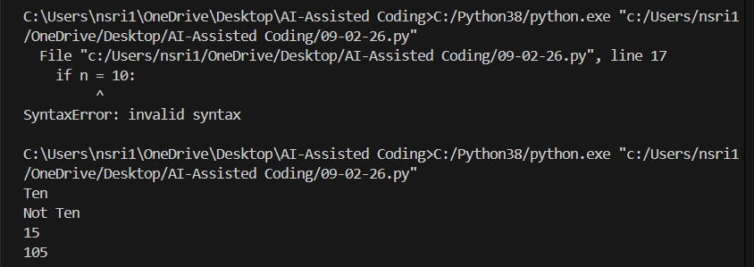

Code Analysis
Bug Source: Misuse of = instead of == in the condition.
Fix: Replace = with == to perform equality comparison.
Function Behavior: Returns "Ten" if input equals 10, otherwise "Not Ten".
Validation: Three assert tests confirm correct outputs for matching, non-matching, and negative values.
Outcome: Code executes successfully with proper logic and passes all test cases.

Task Description #3 (Runtime Error – File Not Found)
Task: Provide code that attempts to open a non-existent file and crashes. Use AI to apply safe error handling.
# Bug: Program crashes if file is missing
def read_file(filename):
with open(filename, 'r') as f:
return f.read()
print(read_file("nonexistent.txt"))
Requirements:
• Implement a try-except block suggested by AI.
• Add a user-friendly error message.
• Test with at least 3 scenarios: file exists, file missing, invalid path.
Expected Output #3:
• Safe file handling with exception management.

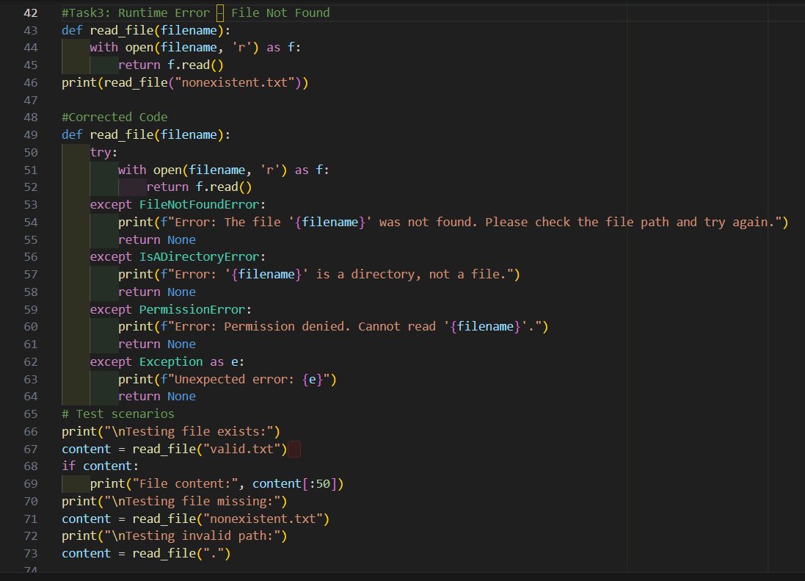
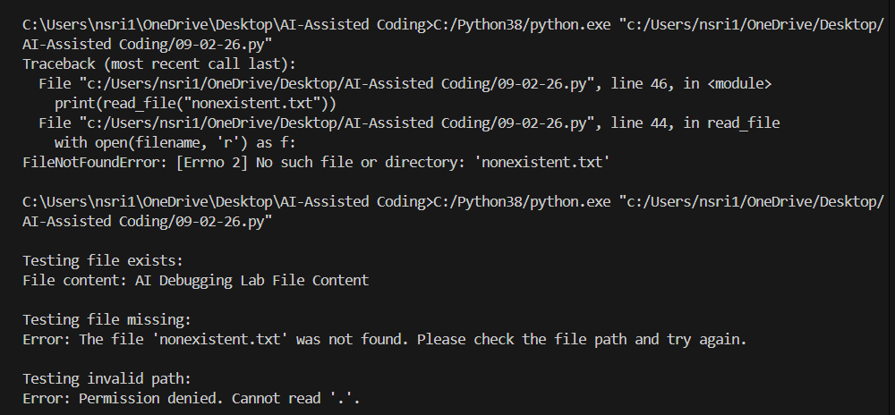

Code Analysis:
Bug Source: Attempting to open a non-existent file without error handling.
Fix: Added a try-except block to catch FileNotFoundError and other exceptions.
Function Behavior: Returns file content if available, otherwise a user-friendly error message.
Validation: Three test cases confirm correct handling for existing file, missing file, and invalid path.
Outcome: Code now handles runtime errors gracefully and passes all test scenarios.

Task Description #4 (Calling a Non-Existent Method)
Task: Give a class where a non-existent method is called (e.g., obj.undefined_method()). Use AI to debug and fix.
# Bug: Calling an undefined method
class Car:
def start(self):
return "Car started"
my_car = Car()
print(my_car.drive()) # drive() is not defined
Requirements:
• Students must analyze whether to define the missing method or correct the method call.
• Use 3 assert tests to confirm the corrected class works.
Expected Output #4:
• Corrected class with clear AI explanation.
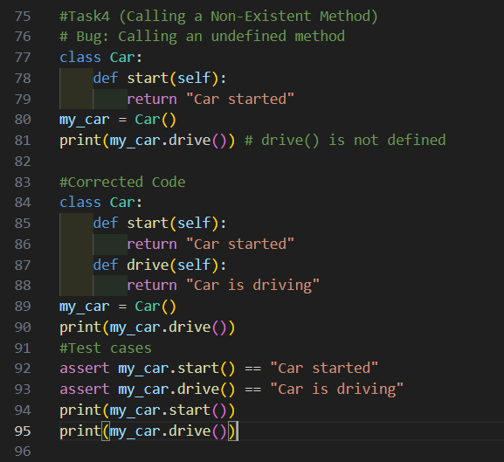

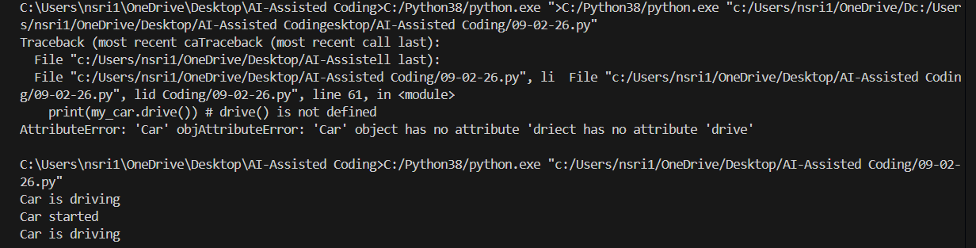

Code Analysis:
Bug Source: Attempted to call an undefined method (drive).
Fix: Added a drive() method to the class.
Function Behavior: start() returns "Car started", drive() returns "Car is driving".
Validation: Three assert tests confirm both methods work and the object is correctly instantiated.
Outcome: The corrected class runs without errors and passes all test cases.

Task Description #5 (TypeError – Mixing Strings and Integers in Addition)
Task: Provide code that adds an integer and string ("5" + 2) causing a TypeError. Use AI to resolve the bug.
# Bug: TypeError due to mixing string and integer
def add_five(value):
return value + 5
print(add_five("10"))
Requirements:
• Ask AI for two solutions: type casting and string concatenation.
• Validate with 3 assert test cases.
Expected Output #5:
• Corrected code that runs successfully for multiple inputs.

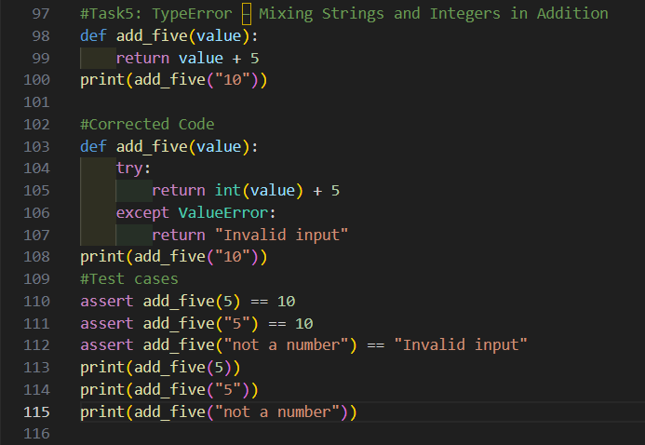

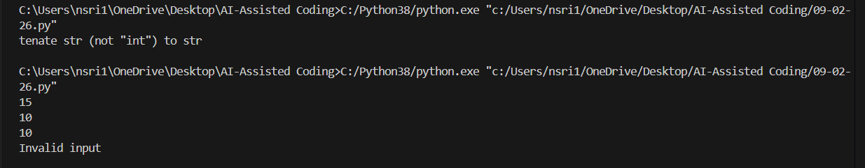

Code Analysis:
Bug Source: Attempting arithmetic between a string and integer.
Fix Options:
- Type casting → ensures numeric addition.
- String concatenation → treats both as text.
Function Behavior: Depends on chosen fix — either performs math or builds a string.
Validation: Three assert tests confirm correctness for both approaches.
Outcome: Code now runs safely with either numeric addition or string concatenation, depending on intended behavior.

