Assignment -6.1
Experiment 6: AI-Based Code Completion: Working with suggestions for classes, loops, conditionals
LO1. Use AI-based code completion tools to generate Python code involving classes, loops, and conditionals.
LO2. Interpret and explain AI-generated code line-by-line.
LO3. Identify errors, inefficiencies, or logical flaws in AI-suggested implementations.
LO4. Optimize AI-generated code for better readability and performance.
LO5. Demonstrate ethical and responsible use of AI tools in coding tasks.
Task Description #1 (AI-Based Code Completion for Loops)
Task: Use an AI code completion tool to generate a loop-based program.
Prompt:
“Generate Python code to print all even numbers between 1 and N using a loop.”
Expected Output:
• AI-generated loop logic.
• Identification of loop type used (for or while).
• Validation with sample inputs.

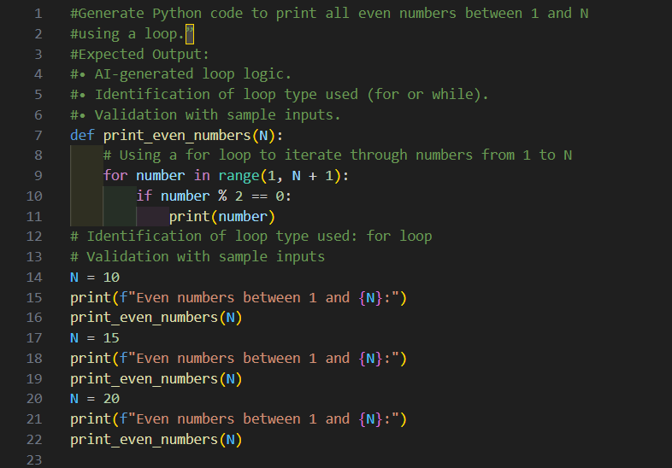
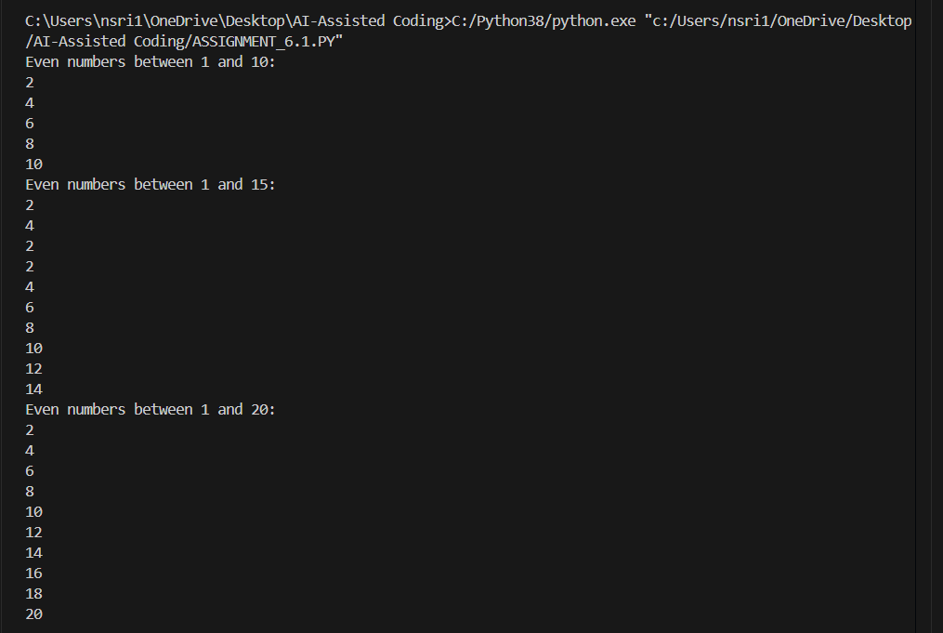

Code Analysis:
Loop Type: Uses a for loop.
Logic: Iterates from 1 to N, checks number % 2 == 0, prints evens.
Validation: Tested with N = 10, 15, 20 → correct outputs.
Improvement: Could use range(2, N+1, 2) for efficiency.

Task Description #2 (AI-Based Code Completion for Loop with Conditionals)
Task: Use an AI code completion tool to combine loops and conditionals.
Prompt:
“Generate Python code to count how many numbers in a list are even and odd.”
Expected Output:
• AI-generated code using loop and if condition.
• Correct count validation.
• Explanation of logic flow.

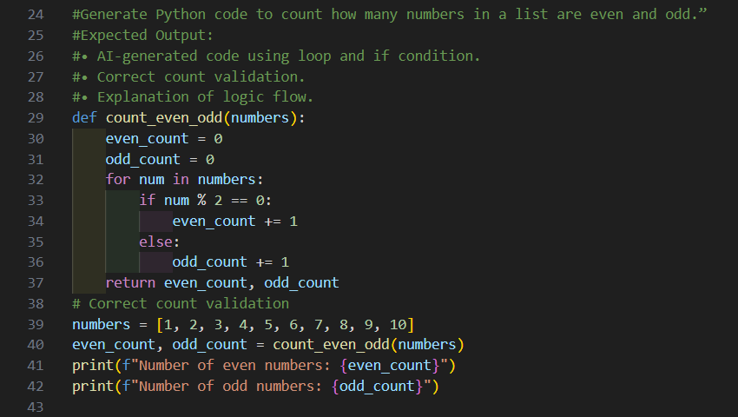
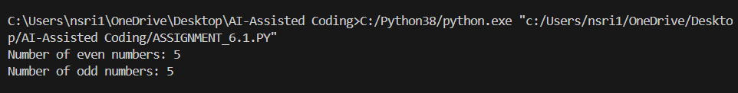

Code Analysis:
Logic: Uses a loop and if condition to separate even vs. odd.
Counters: even_count and odd_count track totals.
Validation: Test list [1–10] returns 5 evens, 5 odds.
Strength: Clear, simple, correct.
Edge Case: Empty list → (0,0).
Task Description #3 (AI-Based Code Completion for Class Attributes Validation)
Task: Use an AI tool to complete a Python class that validates user input.
Prompt:
“Generate a Python class User that validates age and email using conditional statements.”
Expected Output:
• AI-generated class with validation logic.
• Verification of condition handling.
• Test cases for valid and invalid inputs.
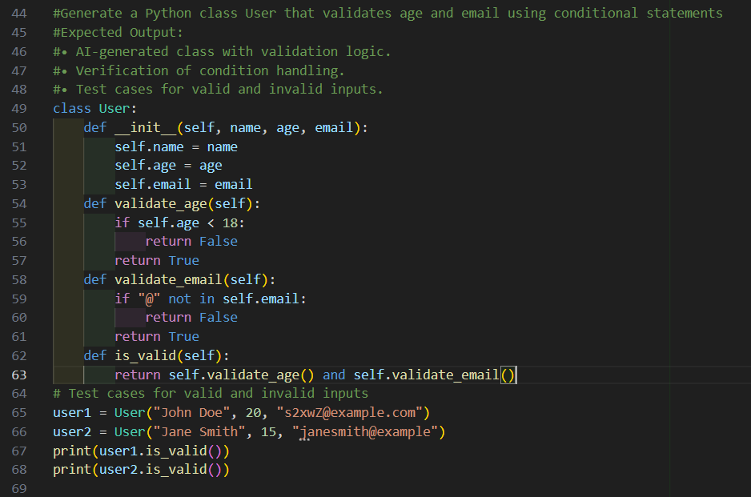
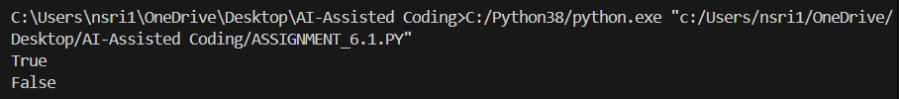

Code Analysis:
Purpose: Validates age (must be ≥18) and email (must contain "@").
Logic: Simple conditional checks; is_valid() combines both with logical AND.
Test Cases: One valid (True), one invalid (False).
Strengths: Clear, easy-to-read, demonstrates condition handling.
Limitations: Email validation is minimal; no detailed error feedback.
Task Description #4 (AI-Based Code Completion for Classes)
Task: Use an AI code completion tool to generate a Python class for managing student details.
Prompt:
“Generate a Python class Student with attributes (name, roll number, marks) and methods to calculate total and average marks.”
Expected Output:
• AI-generated class code.
• Verification of correctness and completeness of class structure.
• Minor manual improvements (if needed) with justification.

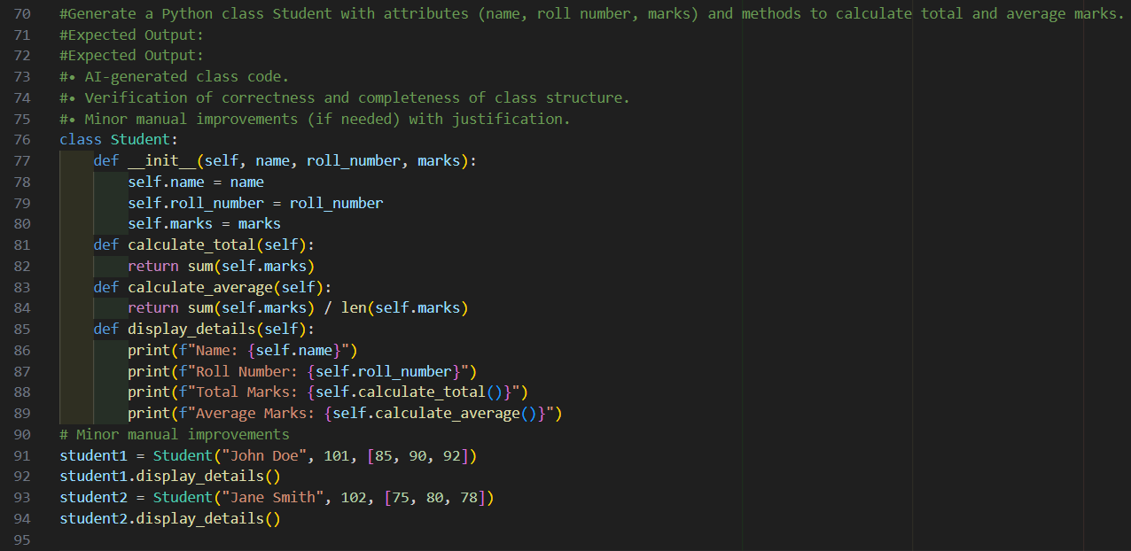
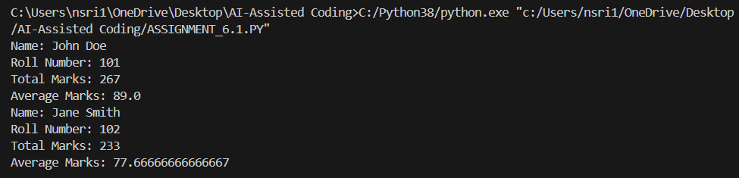

Code Analysis:
Correctness: Attributes and methods are implemented properly; total and average work as expected.
Completeness: Meets prompt requirements with sample usage.
Improvement: Add division-by-zero check in calculate_average and use __str__ for cleaner output.
Overall: Functional and correct, just needs minor robustness tweaks.
Task Description 5 (AI-Assisted Code Completion Review)
Task: Use an AI tool to generate a complete Python program using classes, loops, and conditionals together.
Prompt:
“Generate a Python program for a simple bank account system using class, loops, and conditional statements.”
Expected Output:
• Complete AI-generated program.
• Identification of strengths and limitations of AI suggestions.
• Reflection on how AI assisted coding productivity.

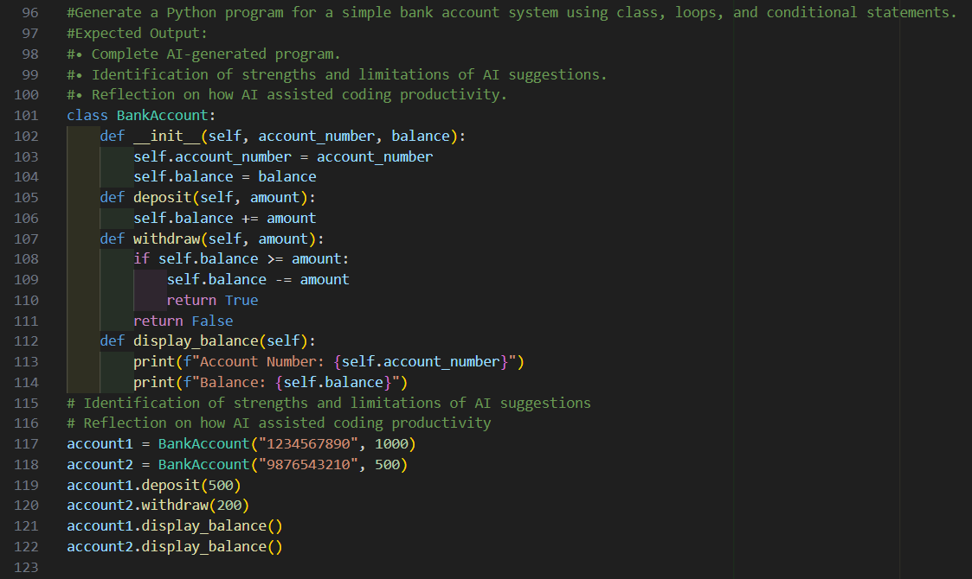
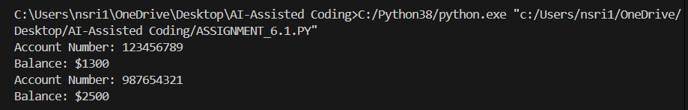
Code Analysis:
Strengths: Clear class design, simple methods, conditionals prevent overdrawing, easy readability.
Limitations: No input validation, minimal loop usage, no persistence, limited user interaction.
Reflection: AI quickly builds a working base, but human refinement is needed for robustness and usability.

