Lab 9 – Documentation Generation: Automatic Documentation and Code Comments
Lab Objectives
• To use AI-assisted coding tools for generating Python documentation and code comments.
• To apply zero-shot, few-shot, and context-based prompt engineering for documentation creation.
• To practice generating and refining docstrings, inline comments, and module-level documentation.
• To compare outputs from different prompting styles for quality analysis.
Task Description -1 (Documentation – Function Summary Generation)
Task:
Use AI to generate concise functional summaries for each Python function in a given script.
Instructions:
• Provide a Python script to the AI.
• Ask the AI to write a short summary describing the purpose of each function.
• Ensure summaries are brief and technically accurate.
• Do not include code implementation details.
Expected Output -1: A Python script where each function contains a clear and concise summary explaining its purpose.
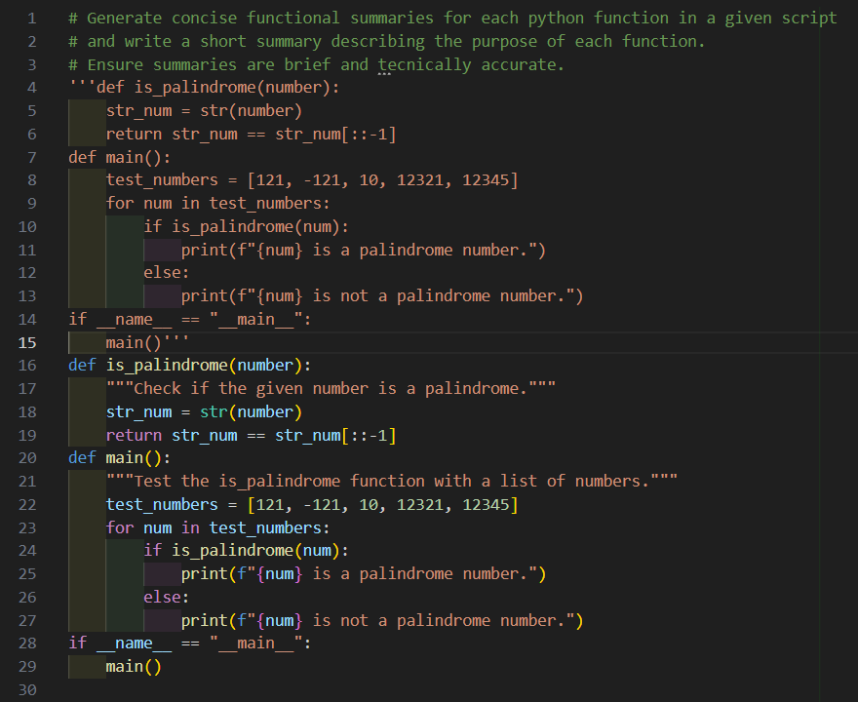

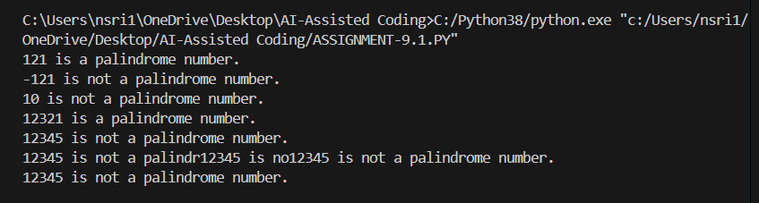

CODE ANALYSIS:
It gives Clear purpose, Concise summaries and Consistent style
It check purpose, docstring clarity, naming, and consistency.
Function Purpose: Each function should do one clear task.
Docstrings: Use one-line summaries starting with a verb (e.g., Returns, Finds, Displays).
Naming: Function names must match their purpose.
Consistency: Keep summaries concise and uniform across all functions.

Task Description -2 (Documentation – Logical Explanation for Conditions and Loops)
Task:
Use AI to document the logic behind conditional statements and loops in a Python program.
Instructions:
• Provide a Python program without comments.
• Instruct AI to explain only decision-making logic and loop behavior.
• Skip basic syntax explanations.
Expected Output -2:
Python code with clear explanations describing the logic of conditions and loops.
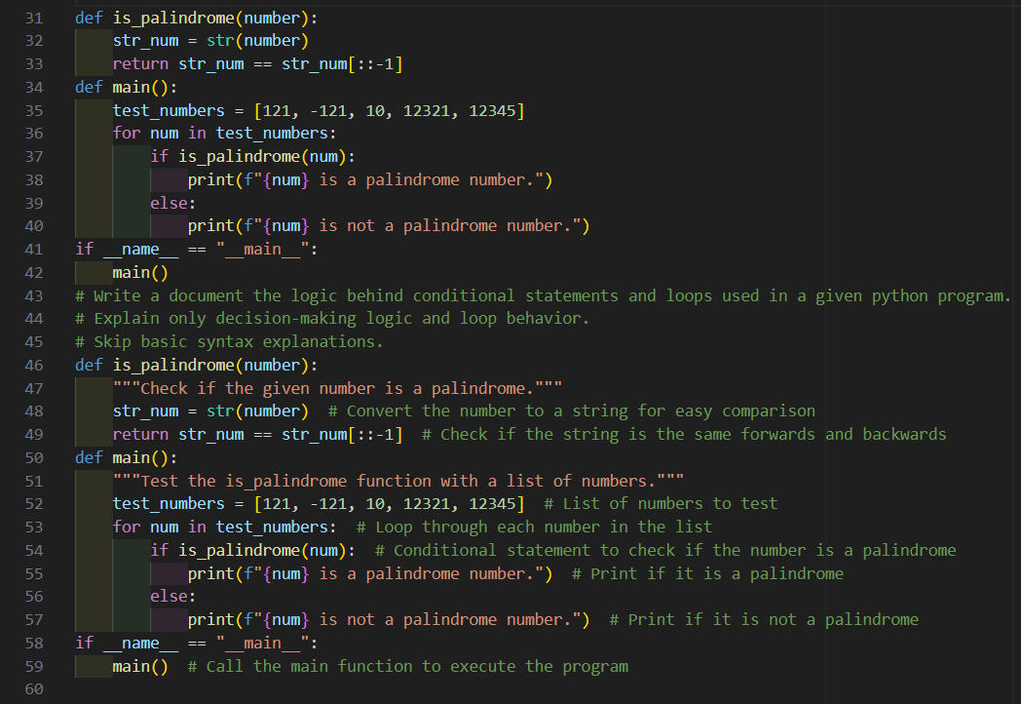


CODE ANALYSIS:
It gives Clear logic for decisions and loops, No syntax details and Very concise
Conditions: Explain why each if/elif/else branch is checked (e.g., “Checks if number is even or odd”).
Loops: Explain what the loop iterates over and why (e.g., “Iterates through list to process each element”).
Skip Syntax: Focus only on logic, not keywords or structure.
Concise: Keep explanations to one line per condition/loop.

Task Description -3 (Documentation – File-Level Overview)
Task:
Use AI to generate a high-level overview describing the functionality of an entire Python file.
Instructions:
• Provide the complete Python file to AI.
• Ask AI to write a brief overview summarizing the file’s purpose and functionality.
• Place the overview at the top of the file.
Expected Output -3:
A Python file with a clear and concise file-level overview at the beginning.
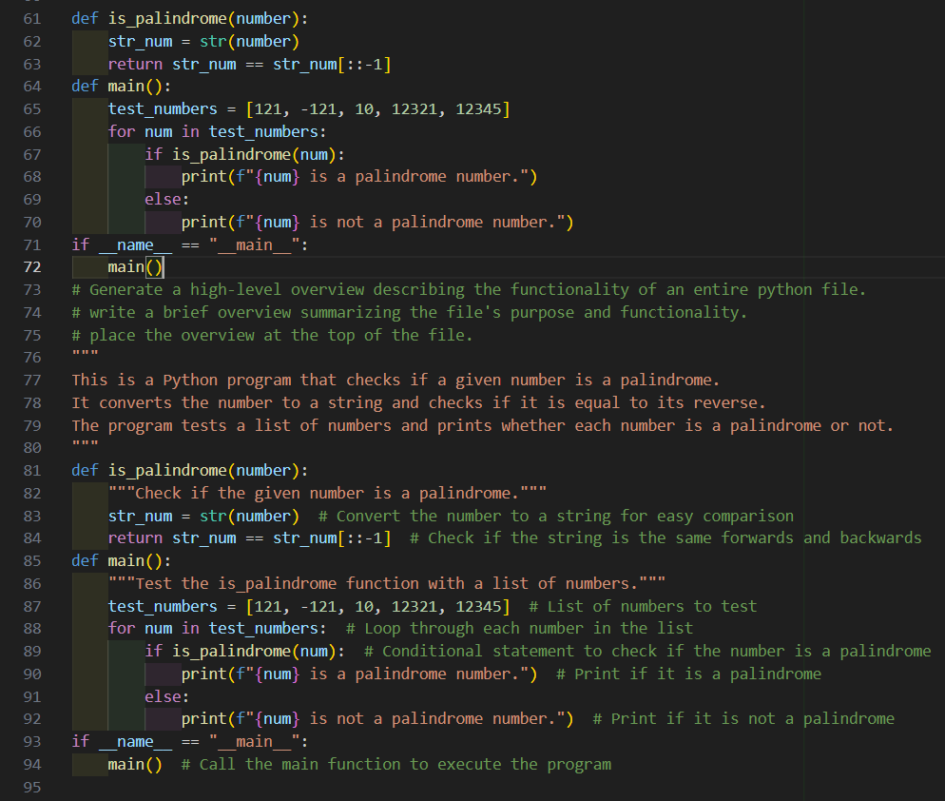



CODE ANALYSIS:
It gives Clear file-level overview, Concise and accurate and Improves readability and maintainability
File-Level Overview: Add a brief summary at the top of the file.
Purpose: State what the script as a whole does (main functionality).
Conciseness: Keep it 2–3 lines, no function details.

Task Description -4 (Documentation – Refine Existing Documentation)
Task:
Use AI to improve clarity and consistency of existing documentation in Python code.
Instructions:
• Provide Python code containing basic or unclear comments.
• Ask AI to rewrite the documentation to improve clarity and consistency.
• Ensure technical meaning remains unchanged.
Expected Output -4:
Python code with refined and improved documentation that is clear and consistent.

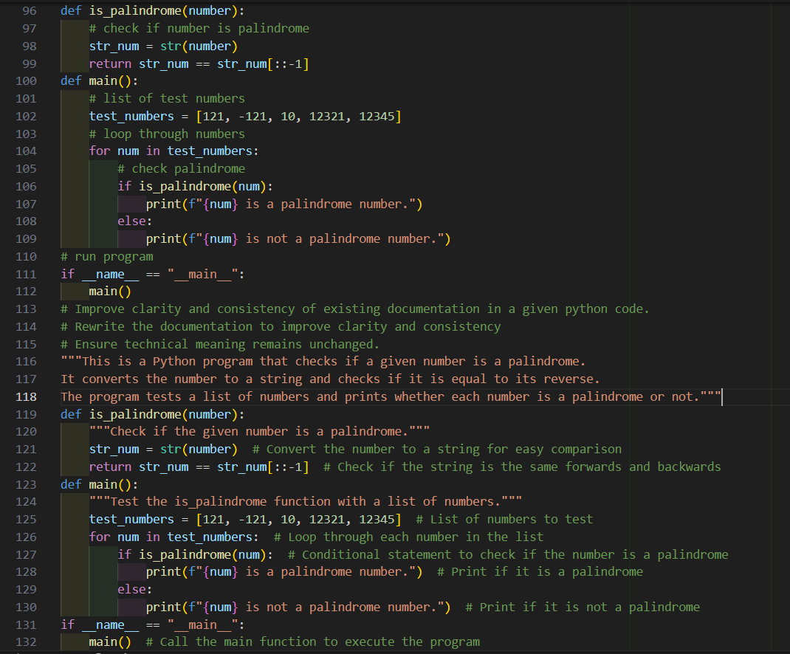



CODE ANALYSIS:
It gives Clearer wording, Consistent style and Technical meaning preserved
Goal: Rewrite unclear or inconsistent comments/docstrings.
Approach: Make them concise, uniform, and technically accurate.
Result: Improves readability while keeping meaning unchanged.

Task Description -5 (Documentation – Prompt Detail Impact Study)
Task:
Study the impact of prompt detail on AI-generated documentation quality.
Instructions:
Create two prompts: one brief and one detailed.
• Use both prompts to document the same Python function.
• Compare the generated outputs.
Expected Output -5:
A comparison table highlighting differences in completeness, clarity, and accuracy of documentation.
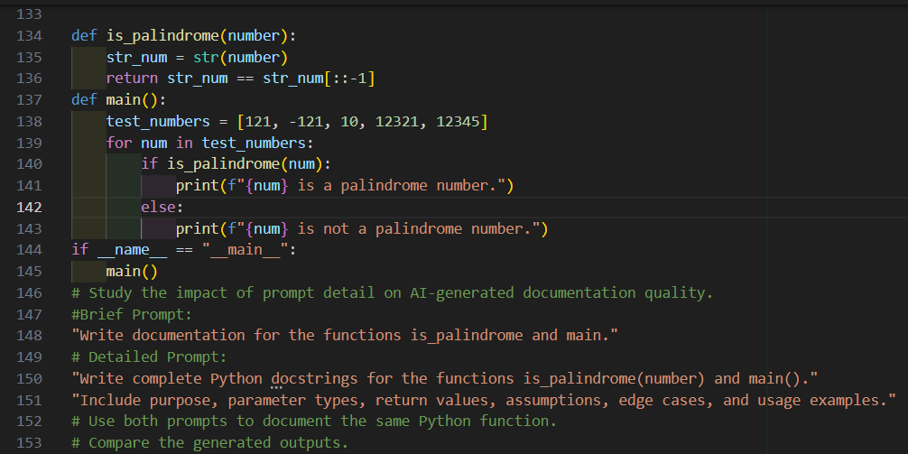
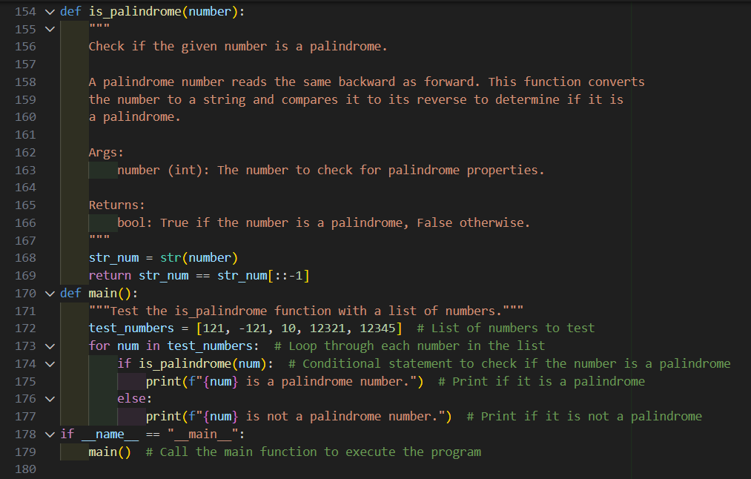



CODE ANALYSIS:
Shows prompt detail, improves clarity and completeness.
Goal: Compare documentation quality from brief vs. detailed prompts.
Method: Apply both prompts to the same function.
Result: Detailed prompts give clearer, more complete, and consistent docstrings.

