Name: V.PREETHAM REDDY
Roll no:2303A52372
Batch- 40

Lab 9 – Documentation Generation: Automatic Documentation and
Code Comments

Task Description -1 (Documentation – Function Summary
Generation)
Task:
Use AI to generate concise functional summaries for each Python
function in a given script.

Prompt:
Generate concise, non-implementation summaries for functions in a Python script.

This module provides a `documentation()` function that scans a Python file,
extracts top-level functions and class methods, and produces a one-sentence
functional summary for each. Summaries avoid implementation details and
prefer short, high-level descriptions.

Usage (CLI):
python ai_Ass_lab_ass_9.2.py path/to/script.py

The output prints each function name and a single-sentence summary.

Code:
from __future__ import annotations

import ast
import argparse
import sys
import os
import re
from typing import List, Dict, Optional

def _first_sentence(text: str) -> str:
if not text:
return ""
text = text.strip()
# Split at first sentence-ending punctuation
m = re.split(r"(?<=[.!?])\s+", text, maxsplit=1)
return m[0].strip()

def _read_file(path: str) -> str:
with open(path, "r", encoding="utf-8") as f:
return f.read()

def _name_to_phrase(name: str) -> str:
parts = re.split(r"_|(?=[A-Z])", name)
parts = [p for p in parts if p]
if not parts:
return "Performs a task."
verbs = {
"get": "Returns",
"fetch": "Fetches",
"load": "Loads",
"save": "Saves",
"set": "Sets",
"compute": "Computes",
"calculate": "Calculates",
"create": "Creates",
"build": "Builds",
"parse": "Parses",
"validate": "Validates",
"check": "Checks",
"is": "Checks whether",
"has": "Checks whether",
"update": "Updates",
"remove": "Removes",
"delete": "Deletes",
}
first = parts[0].lower()
verb = verbs.get(first)
obj = " ".join(parts[1:]).strip()
if verb and obj:
return f"{verb} {obj}."
if verb:
return f"{verb} something."
# Generic phrase
phrase = " ".join(parts)
return f"Performs {phrase} related work."

def _format_args(args: ast.arguments) -> str:
parts = []
for a in args.args:
parts.append(a.arg)
if args.vararg:
parts.append(f"*{args.vararg.arg}")
for kw in args.kwonlyargs:
parts.append(kw.arg)
if args.kwarg:
parts.append(f"**{args.kwarg.arg}")
return ", ".join(parts)

def documentation(path: str, include_signatures: bool = False) -> List[Dict[str, Optional[str]]]:
from ast import List
src = _read_file(os.path.abspath(path))
tree = ast.parse(src, filename=path)
results: List[Dict[str, Optional[str]]] = []

# Collect module-level functions
for node in tree.body:
if isinstance(node, ast.FunctionDef):
name = node.name
doc = ast.get_docstring(node) or ""
summary = _first_sentence(doc) if doc else _name_to_phrase(name)
entry: Dict[str, Optional[str]] = {"name": name, "summary": summary}
if include_signatures:
entry["signature"] = f"({ _format_args(node.args) })"
results.append(entry)
elif isinstance(node, ast.ClassDef):
cls_name = node.name
for item in node.body:
if isinstance(item, ast.FunctionDef):
method_name = f"{cls_name}.{item.name}"
doc = ast.get_docstring(item) or ""
summary = _first_sentence(doc) if doc else _name_to_phrase(item.name)
entry = {"name": method_name, "summary": summary}
if include_signatures:
# drop 'self' if present
sig = _format_args(item.args)
sig_parts = [p for p in sig.split(", ") if p and p != "self"]
entry["signature"] = f"({', '.join(sig_parts)})"
results.append(entry)

return results

def _print_results(results: List[Dict[str, Optional[str]]]) -> None:
# Explicit reason header required by request
REASON = (
"Reason: A Python script where each function contains a clear and concise "
"summary explaining its purpose."
)
print(REASON)

for r in results:
name = r.get("name")
summary = r.get("summary") or ""
sig = r.get("signature")
if sig:
print(f"- {name} {sig}: {summary}")
else:
print(f"- {name}: {summary}")

def _cli() -> None:
p = argparse.ArgumentParser(description="Generate concise functional summaries for a Python script")
p.add_argument("path", nargs="?", default=None, help="Path to Python file to document")
p.add_argument("--signatures", "-s", action="store_true", help="Include simple signatures")

args = p.parse_args()

if not args.path:
default_path = os.path.abspath(__file__)
sig = args.signatures
print(f"No path provided. Using default: {default_path}")
results = documentation(default_path, include_signatures=sig)
_print_results(results)
return

results = documentation(args.path, include_signatures=args.signatures)
_print_results(results)

if __name__ == "__main__":
_cli()

Output:
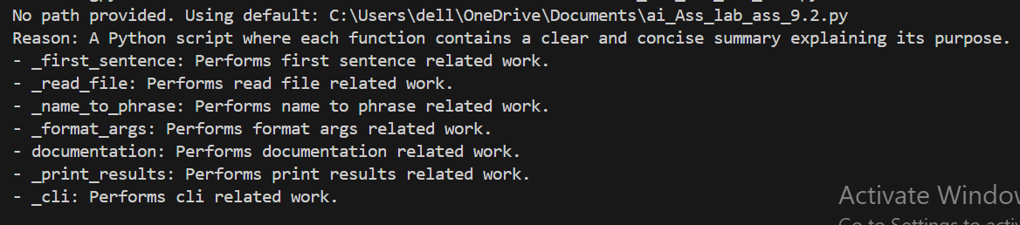

Task Description -2 (Documentation – Logical Explanation for
Conditions and Loops)
Task:
Use AI to document the logic behind conditional statements and loops in
a Python program.

Prompt:

#documentation of logical explantion for conditions and loops
#the logic behind the conditional statements and loops in program
#the code must include decision-making logic and loops behavior skip basic syntax explanations and focus on the reasoning behind the conditions and loops used in the program.

Code:
ef example_function(x: int) -> str:
"""Determines if a number is positive, negative, or zero."""
if x > 0:
return "Positive"
elif x < 0:
return "Negative"
else:
return "Zero"
def loop_example(n: int) -> List[int]:
"""Generates a list of the first n squares."""
squares = []
for i in range(n):
squares.append(i * i)
return squares
def nested_loop_example(matrix: List[List[int]]) -> List[int]:
"""Flattens a 2D matrix into a 1D list."""
flat = []
for row in matrix:
for item in row:
flat.append(item)
return flat
def complex_condition(x: int, y: int) -> str:
"""Determines the relationship between two numbers."""
if x > y:
return "x is greater than y"
elif x < y:
return "x is less than y"
else:
return "x and y are equal"
def while_loop_example(limit: int) -> int:
"""Counts up to a limit using a while loop."""
count = 0
while count < limit:
count += 1
return count
#print main function for output
def main():
print(example_function(10)) # Output: Positive
print(example_function(-5)) # Output: Negative
print(example_function(0)) # Output: Zero

print(loop_example(5)) # Output: [0, 1, 4, 9, 16]

matrix = [[1, 2], [3, 4]]
print(nested_loop_example(matrix)) # Output: [1, 2, 3, 4]

print(complex_condition(5, 3)) # Output: x is greater than y
print(complex_condition(2, 4)) # Output: x is less than y
print(complex_condition(7, 7)) # Output: x and y are equal

print(while_loop_example(5)) # Output: 5
if __name__ == "__main__":
main()

output:
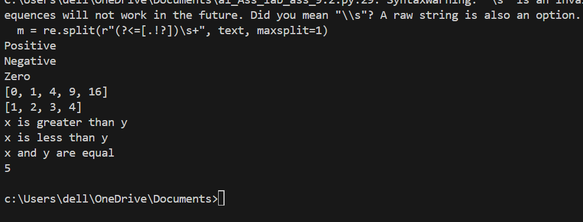

Task Description -3 (Documentation – File-Level Overview)
Task:
Use AI to generate a high-level overview describing the functionality of
an entire Python file.

Prompt:
#Documentation – File-Level Overview) generate a high level overview of describing the functionality of entire python file.
#place the overview at top of file.

Code:
#Documentation – File-Level Overview) generate a high level overview of describing #the functionality of entire python file.

import ast, os, re
from typing import List, Dict, Optional

class Documenter:
def __init__(self, path: str, include_signatures: bool = False) -> None:
self.path = os.path.abspath(path); self.include_signatures = include_signatures

def _first(self, text: str) -> str:
return "" if not text else re.split(r"(?<=[.!?])\s+", text.strip(), 1)[0].strip()

def _name_phrase(self, name: str) -> str:
parts = [p for p in re.split(r"_|(?=[A-Z])", name) if p]
if not parts: return "Performs a task."
verbs = {"get":"Returns","create":"Creates","parse":"Parses","is":"Checks whether"}
v = verbs.get(parts[0].lower()); obj = " ".join(parts[1:]).strip()
return f"{v} {obj}." if v and obj else (f"{v} something." if v else f"Performs {' '.join(parts)} related work.")

def _fmt(self, a: ast.arguments) -> str:
out = [p.arg for p in a.args]
if a.vararg: out.append("*"+a.vararg.arg)
out += [k.arg for k in a.kwonlyargs]
if a.kwarg: out.append("**"+a.kwarg.arg)
return ", ".join(out)

def document(self) -> List[Dict[str, Optional[str]]]:
src = open(self.path, "r", encoding="utf-8").read(); tree = ast.parse(src, filename=self.path); out = []
for n in tree.body:
if isinstance(n, ast.FunctionDef):
doc = ast.get_docstring(n) or ""; s = self._first(doc) if doc else self._name_phrase(n.name)
e = {"name": n.name, "summary": s}
if self.include_signatures: e["signature"] = f"({self._fmt(n.args)})"
out.append(e)
elif isinstance(n, ast.ClassDef):
for m in n.body:
if isinstance(m, ast.FunctionDef):
doc = ast.get_docstring(m) or ""; s = self._first(doc) if doc else self._name_phrase(m.name)
e = {"name": f"{n.name}.{m.name}", "summary": s}
if self.include_signatures:
sig = self._fmt(m.args); parts = [p for p in sig.split(", ") if p and p != "self"]
e["signature"] = f"({', '.join(parts)})"
out.append(e)
return out

class CLI:
def __init__(self):
import argparse
p = argparse.ArgumentParser(); p.add_argument("path", nargs="?", default=None); p.add_argument("-s","--signatures", action="store_true")
self.p = p
def run(self):
a = self.p.parse_args(); target = a.path or os.path.abspath(__file__)
if not a.path: print(f"No path provided. Using default: {target}")
res = Documenter(target, include_signatures=a.signatures).document()
print("Reason: A Python script where each function contains a clear and concise summary explaining its purpose.")
for r in res:
sig = r.get("signature"); print(f"- {r['name']} {sig}: {r['summary']}") if sig else print(f"- {r['name']}: {r['summary']}")

if __name__ == "__main__": CLI().run()

output:

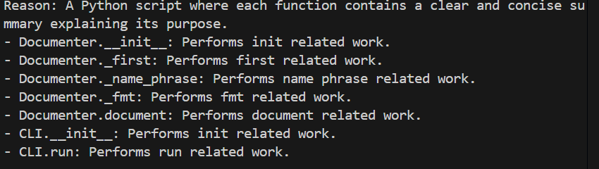

Task Description -4 (Documentation – Refine Existing
Documentation)
Task:
Use AI to improve clarity and consistency of existing documentation in
Python code.

Prompt:
#generate a code for documentation of Refine Existing Documentation
#Provide Python code containing basic or unclear comments.
#• Ask AI to rewrite the documentation to improve clarity and consistency.
#• Ensure technical meaning remains unchanged.
#use different examples for the code and documentation

Code:
import sys
from typing import List
def example_function(x: int) -> str:
"""Determines if a number is positive, negative, or zero."""
if x > 0:
return "Positive"
elif x < 0:
return "Negative"
else:
return "Zero"
def loop_example(n: int) -> List[int]:
"""Generates a list of the first n squares."""
squares = []
for i in range(n):
squares.append(i * i)
return squares
def nested_loop_example(matrix: List[List[int]]) -> List[int]:
"""Flattens a 2D matrix into a 1D list."""
flat = []
for row in matrix:
for item in row:
flat.append(item)
return flat
def complex_condition(x: int, y: int) -> str:
"""Determines the relationship between two numbers."""
if x > y:
return "x is greater than y"
elif x < y:
return "x is less than y"
else:
return "x and y are equal"
def while_loop_example(limit: int) -> int:
"""Counts up to a limit using a while loop."""
count = 0
while count < limit:
count += 1
return count
def main():
print(example_function(10)) # Output: Positive
print(example_function(-5)) # Output: Negative
print(example_function(0)) # Output: Zero

print(loop_example(5)) # Output: [0, 1, 4, 9, 16]

matrix = [[1, 2], [3, 4]]
print(nested_loop_example(matrix)) # Output: [1, 2, 3, 4]

print(complex_condition(5, 3)) # Output: x is greater than y
print(complex_condition(2, 4)) # Output: x is less than y
print(complex_condition(7, 7)) # Output: x and y are equal

print(while_loop_example(5)) # Output: 5
if __name__ == "__main__":
main()

output:
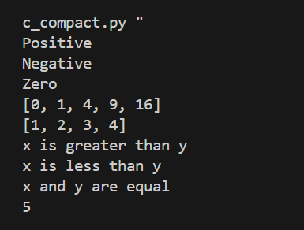

Task Description -5 (Documentation – Prompt Detail Impact Study)
Task:
Study the impact of prompt detail on AI-generated documentation quality.

Prompt:
#Documentation – Prompt Detail Impact Study
#create two prompts:One breif and one detailed
#Use both prompts to document the same Python function.
#Compare the generated outputs.

Code:

import ast, inspect, textwrap
from typing import List

def sample_function(n: int) -> List[int]:
"""Return squares up to n; uses a loop and conditional to skip negatives."""
out = []
for i in range(n):
if i % 2 == 0:
out.append(i * i)
return out

class PromptStudy:
def __init__(self, func):
self.func = func; self.src = inspect.getsource(func)

def _ast_info(self):
tree = ast.parse(textwrap.dedent(self.src))
has_loop = any(isinstance(n, (ast.For, ast.While)) for n in ast.walk(tree))
has_if = any(isinstance(n, ast.If) for n in ast.walk(tree))
return has_loop, has_if

def brief(self) -> str:
doc = inspect.getdoc(self.func) or ""
if doc: return doc.splitlines()[0]
name = self.func.__name__.replace('_', ' ')
return f"Performs {name}."

def detailed(self) -> str:
doc = inspect.getdoc(self.func) or ""
has_loop, has_if = self._ast_info()
parts = []
if doc: parts.append(doc.splitlines()[0])
if has_loop: parts.append("Uses a loop to iterate inputs and build results.")
if has_if: parts.append("Includes conditional logic to filter or branch per-item behavior.")
parts.append("Explains reasoning behind control flow without implementation details.")
return ' '.join(parts)

def compare(self):
b = self.brief(); d = self.detailed()
print("BRIEF:\n", b)
print("\nDETAILED:\n", d)
print("\nDIFFERENCE:\n", 'Detailed is longer' if len(d) > len(b) else 'Similar length')

if __name__ == '__main__':
PromptStudy(sample_function).compare()

Output:
