ASSIGNMENT 1.5
2303A52376
BT.NO-45
TASK 0
Install and configure GitHub Copilot in VS Code. Take screenshots of each step.
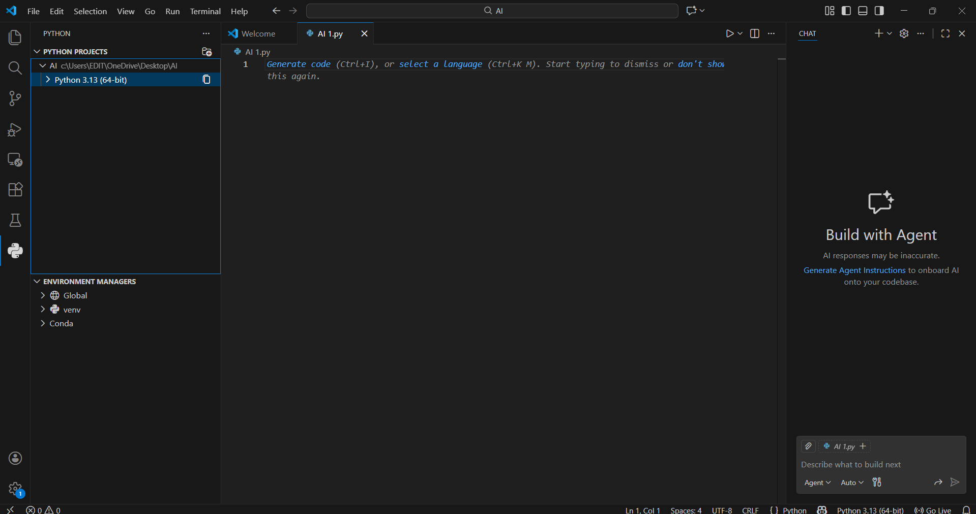
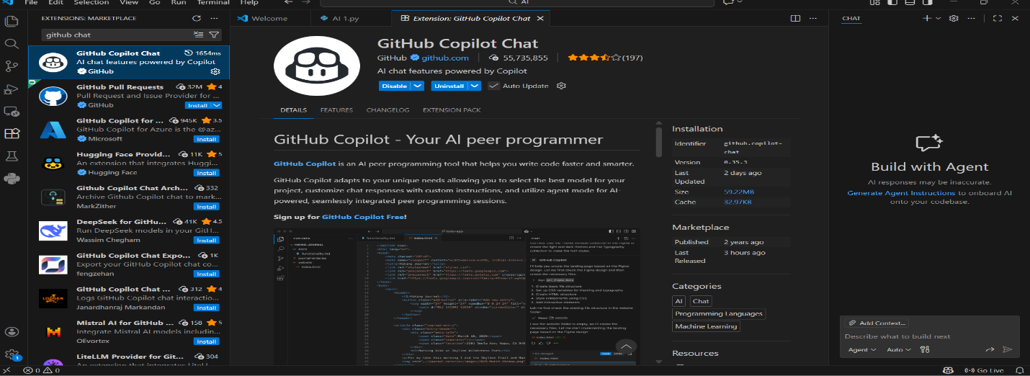
TASK1:
Use GitHub Copilot to generate a Python program that:
➢ Reverses a given string
➢ Accepts user input
➢ Implements the logic directly in the main code
➢ Does not use any user-defined functions
PROMPT:
Write a python code forReverse a given string that accepts a user input and implements the logic directly in the main code and it doesnot use any user defined functions.
CODE
user_input = input("Enter a string: ")
reversed_string = user_input[::-1]
print("Reversed string:", reversed_string)

OUTPUT
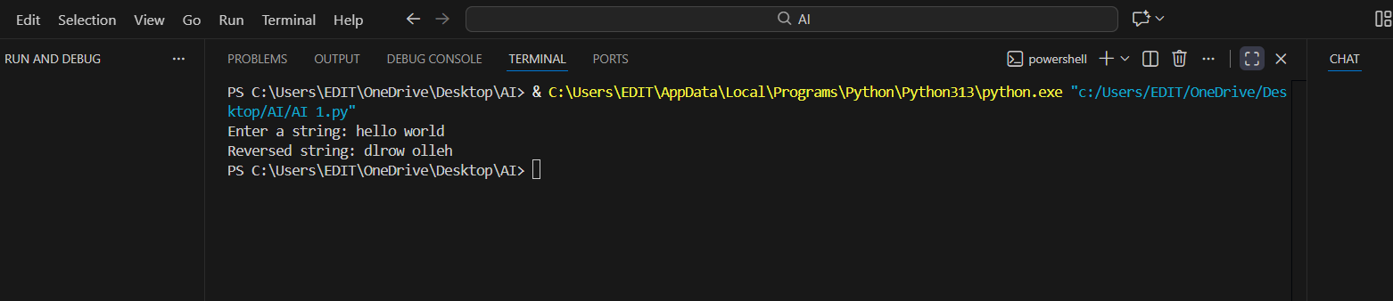
EXPLANATION
This code accepts user input i.e,a string.Then for reversing a string we use ::-1,Then print reversed string.
TASK 2
Examine the Copilot-generated code from Task 1 and improve it by:
➢ Removing unnecessary variables
➢ Simplifying loop or indexing logic
➢ Improving readability
➢ Use Copilot prompts like:
▪ “Simplify this string reversal code”
▪ “Improve readability and efficiency”
Hint:
Prompt Copilot with phrases like
“optimize this code”, “simplify logic”, or “make it more readable”
PROMPT
optimize this code, simplify logic, or make it more readable
CODE
print("Reversed string:", input("Enter a string: ")[::-1])
OUTPUT
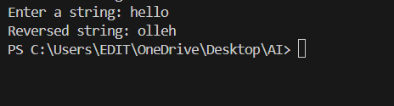
EXPLANATION
Here,Task1 code is compressed and used efficiently,in only one line we can complete the code,like:in print statement both user input and reversed string logic must be done.It reduces time complexity.
TASK 3
Use GitHub Copilot to generate a function-based Python program that:
➢ Uses a user-defined function to reverse a string
➢ Returns the reversed string
➢ Includes meaningful comments (AI-assisted)
PROMPT
# Uses a user-defined function to reverse a string,Returns the reversed string,Includes meaningful comments (AI-assisted)
CODE
def reverse_string(s):
"""
This function takes a string as input and returns the reversed string.

Parameters:
s (str): The string to be reversed.

Returns:
str: The reversed string.
"""
return s[::-1]
# Get user input
user_input = input("Enter a string: ")
# Call the function and display the result
reversed_string = reverse_string(user_input)
print("Reversed string:", reversed_string)

OUTPUT
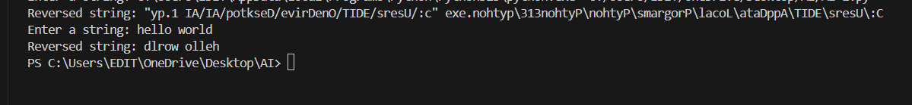
EXPLANATION
Using a user defined function i.e,def reversed we should reverse a string,Return the reversed string and call the function and print the output.
TASK 4
Compare the Copilot-generated programs:
➢ Without functions (Task 1)
➢ With functions (Task 3)
Analyze them based on:
➢ Code clarity
➢ Reusability
➢ Debugging ease
➢ Suitability for large-scale applications
PROMPT
Compare the two codes without function and with function.and make a comparison table based on code clarity,reusability,debugging ease,suitability for large scale applications.
EXPLANATION AND OUTPUT
comparison_table = {
"Aspect": ["Code Clarity", "Reusability", "Debugging Ease", "Suitability for Large-Scale Applications"],
"Without Function": [
"Straightforward for simple tasks but less clear for complex logic.",
"Limited to a single use case; not reusable.",
"Harder to debug as logic is not isolated.",
"Less adaptable to larger projects."
],
"With Function": [
"Clearer by encapsulating logic in a named function.",
"Reusable; can be called multiple times with different inputs.",
"Easier to debug due to isolated logic.",
"More suitable for large-scale applications due to modularity."
]
}
TASK 5
Prompt GitHub Copilot to generate:
➢ A loop-based string reversal approach
➢ A built-in / slicing-based string reversal approach
PROMPT
A loop-based string reversal approach
A built-in / slicing-based string reversal approach
CODE
# Loop-based string reversal
user_input = input("Enter a string: ")
reversed_string_loop = ""
for char in user_input:
reversed_string_loop = char + reversed_string_loop
print("Reversed string (loop-based):", reversed_string_loop)
# Built-in / slicing-based string reversal
user_input = input("Enter a string: ")
reversed_string_slicing = user_input[::-1]
print("Reversed string (slicing-based):", reversed_string_slicing)

OUTPUT
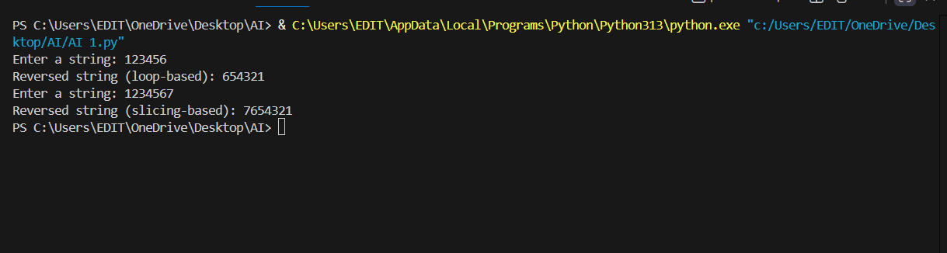
EXPLANATION
Using a loop like: for write a code for reversing a string,then built-in / slicing-based string reversal approach and print the output.then compare the two codes The loop-based approach iterates through each character of the string, building the reversed string step by step. The slicing-based approach directly accesses the string in reverse order using Python's slicing syntax.Time Complexity:Both approaches have a time complexity of O(n), where n is the length of the string. However, the slicing approach may have a slight overhead due to the way Python handles slicing internally. When Each Approach is Appropriate:The loop-based approach is more appropriate when you need to perform additional operations on each character during the reversal process. The slicing-based approach is ideal for quick and straightforward string reversals without any additional processing.

