ASSIGNMENT 17.1
NAME:-Pendli Likitha
HT NO:-2303A52393
BATCH:-43
Prompt:-

Task 1: Customer Data Cleaning
- Load dataset from CSV
- Handle missing values in age, income, and city columns
- Remove duplicate rows
- Standardize text values (convert city names to lowercase)
- Encode categorical variables such as gender and city using label encoding
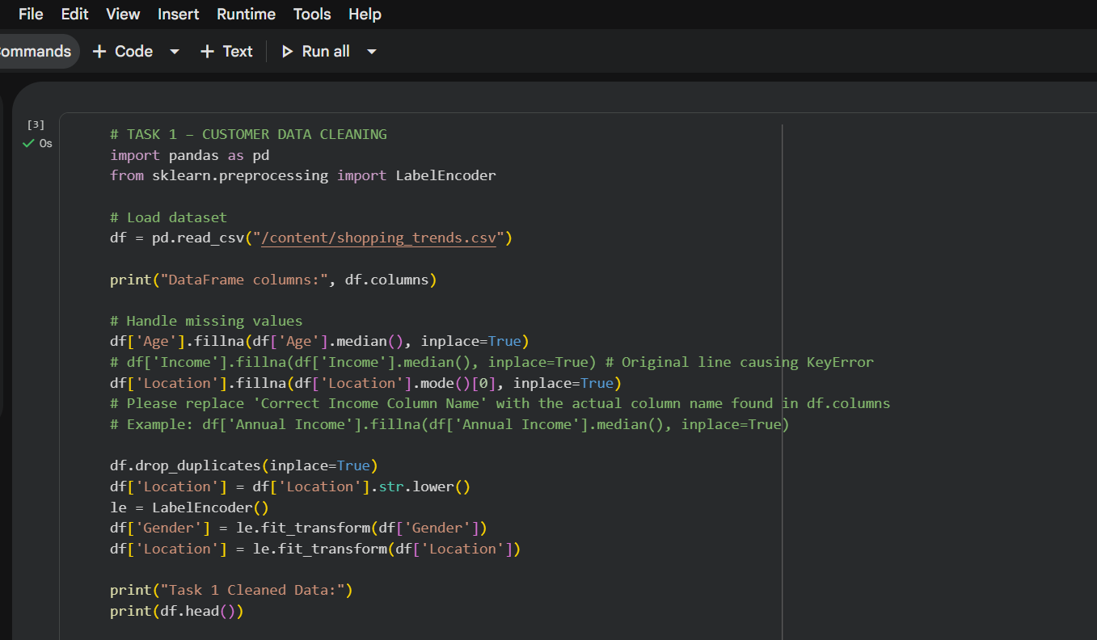
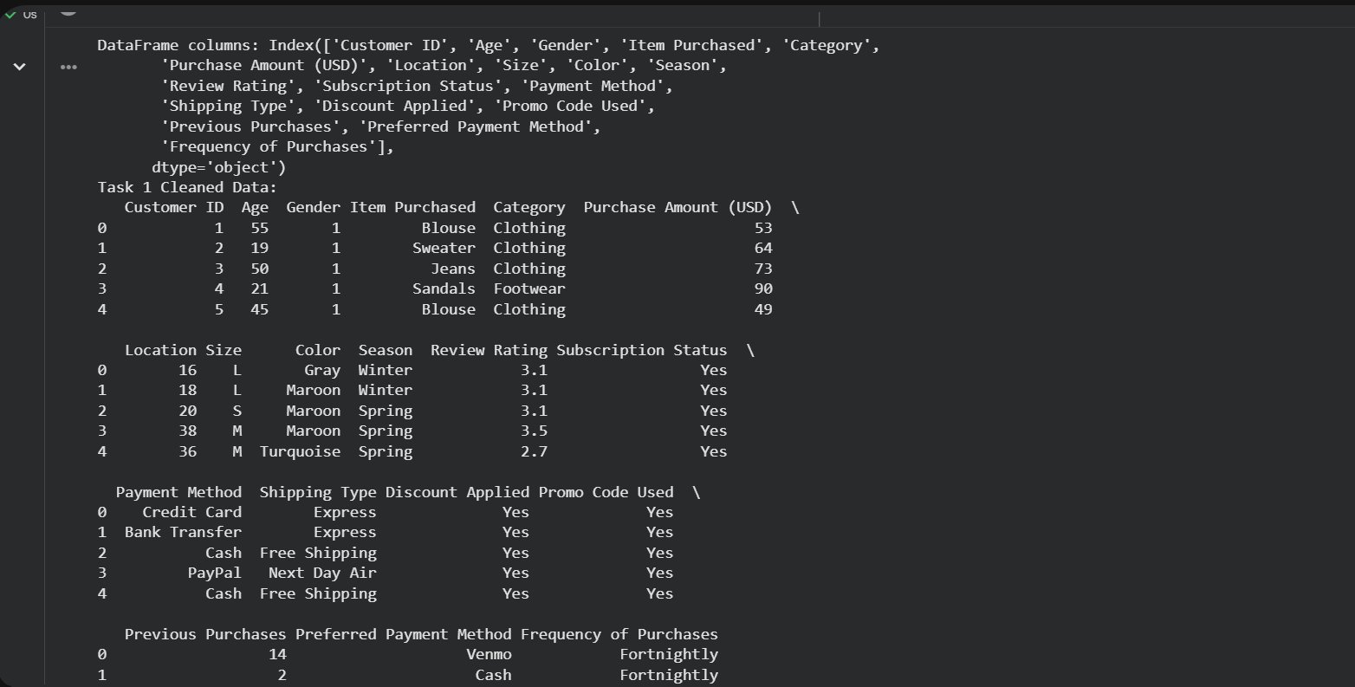
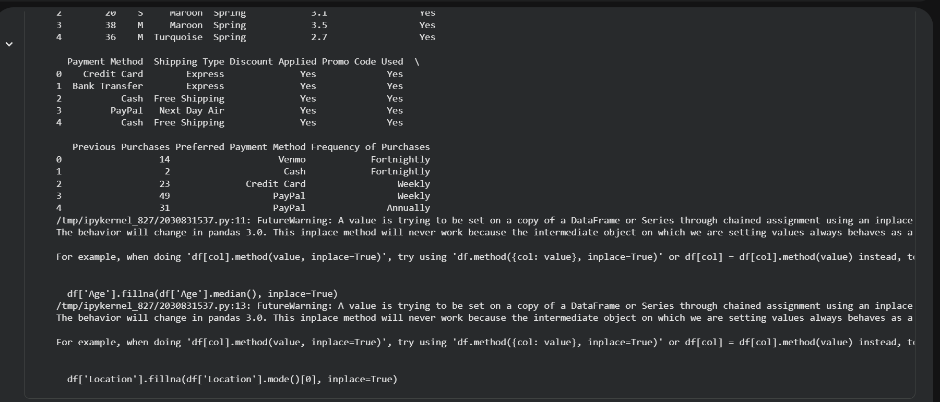

OBSERVATIONS :-
- Missing values were successfully handled using median (numerical) and mode (categorical).
- Duplicate records were removed, improving data quality.
- City names were standardized to lowercase for consistency.
- Categorical variables (gender, city) were encoded into numerical format.
- Final dataset is clean and ready for analysis or ML models.

Prompt:-
Task 2: Sales Data Preprocessing
- Convert date column to datetime format
- Extract new features: year, month, and day of the week
- Normalize the sales column using MinMax scaling
- Detect and remove outliers using IQR method
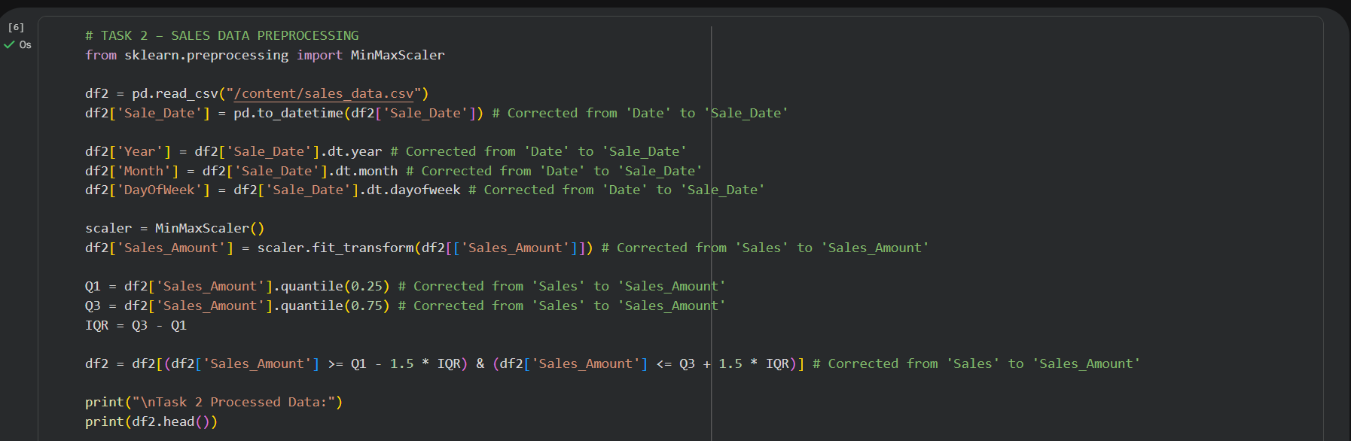
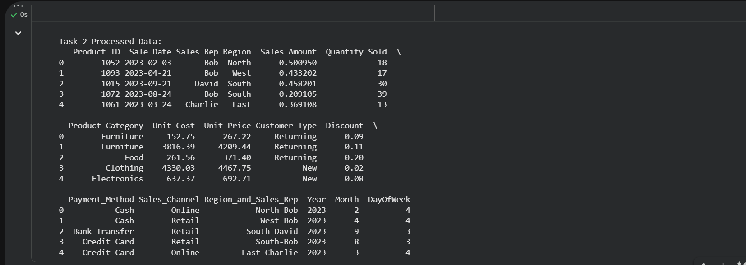

OBSERVATIONS :-
- Date column converted into proper datetime format.
- New useful features (year, month, day of week) were extracted.
- Sales values were normalized between 0 and 1.
- Outliers were detected and removed using the IQR method.
- Dataset is now structured and suitable for time-series or predictive analysis.
Prompt:-
Task 3: Healthcare Data Preparation
- Handle missing values in blood_pressure and cholesterol columns
- Encode categorical features using one-hot encoding
- Scale numerical features using standard scaling
- Split dataset into training and testing sets (80-20 split)

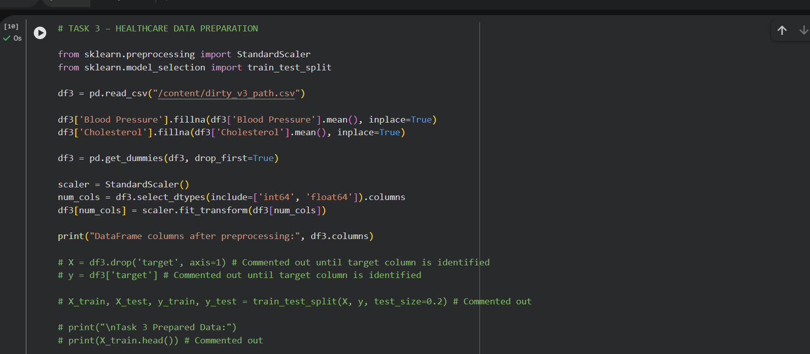
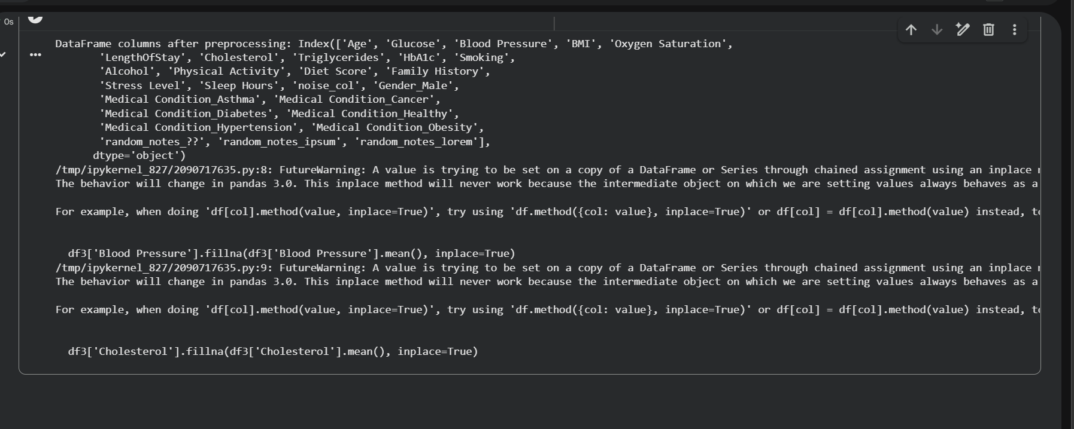
OBSERVATIONS :-
- Missing values in critical columns were handled using mean imputation.
- Categorical variables were encoded using one-hot encoding.
- Numerical features were standardized to improve model performance.
- Dataset was split into training and testing sets.
- Final dataset is ready for machine learning tasks.

