Assignment 1
AI Assisted Coding
Name:-Pendli Likitha
HTNO: 2303A52393

Task 1:
Prompt:
# Zero-Shot Prompting (Palindrome Number Program)
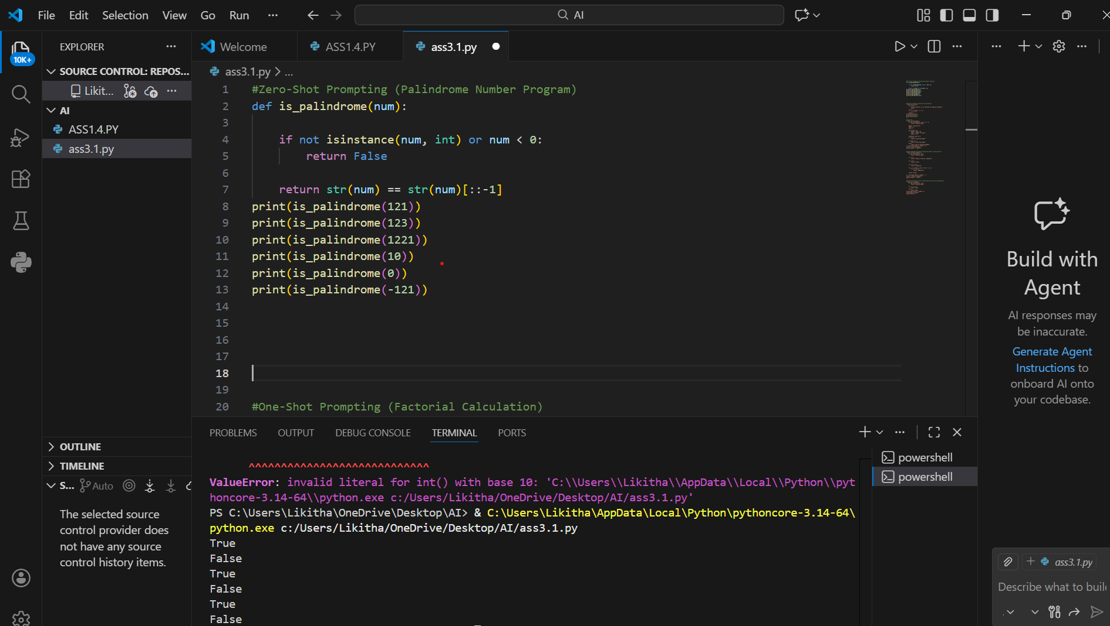
Observation:
In zero-shot prompting, the AI generates code without any examples, relying solely on the prompt description. For the palindrome number program, it produced correct logic for normal positive numbers. However, it did not handle negative numbers, zero, or non-integer inputs, which are important edge cases. The code was simple and easy to understand but lacked robustness. Efficiency was acceptable for small numbers but could be improved for very large numbers. Overall, zero-shot prompting is useful for quickly generating basic logic but may require manual refinement for real-world applications.

Task 2:
Prompt:
#One-Shot Prompting (Factorial Calculation)
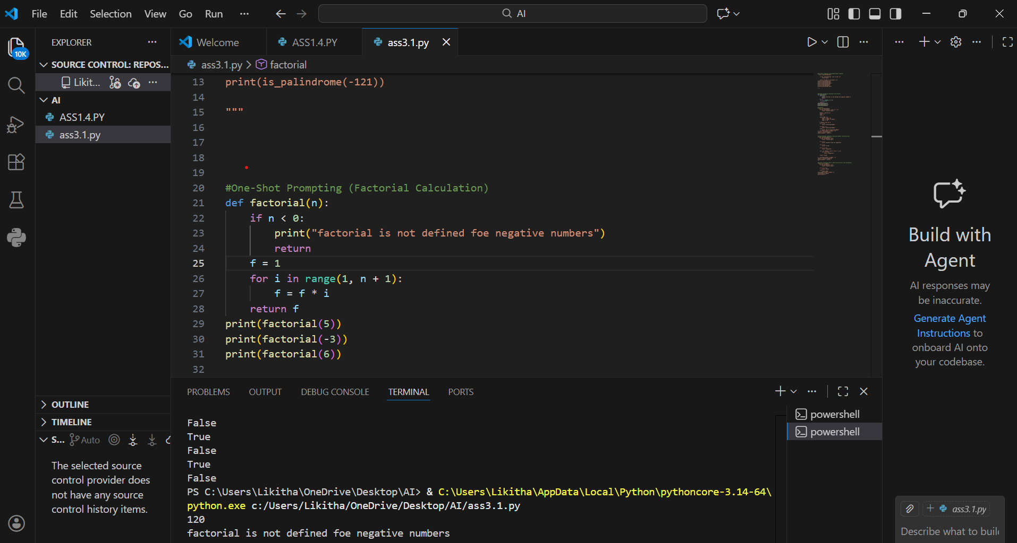
Observation:
One-shot prompting provides a single input-output example to guide the AI. In the factorial calculation, this helped produce code that was clear, readable, and matched the expected output format. The logic was correct for positive integers, and the program performed well for standard inputs. However, it did not include checks for negative numbers or non-integer inputs. The code was better structured than zero-shot, making it easier to understand. This shows that even one example improves clarity and reduces ambiguity. One-shot prompting is particularly useful when the AI needs guidance on expected output behavior.

Task 3:
Prompt:
#Few-Shot Prompting (Armstrong Number Check)
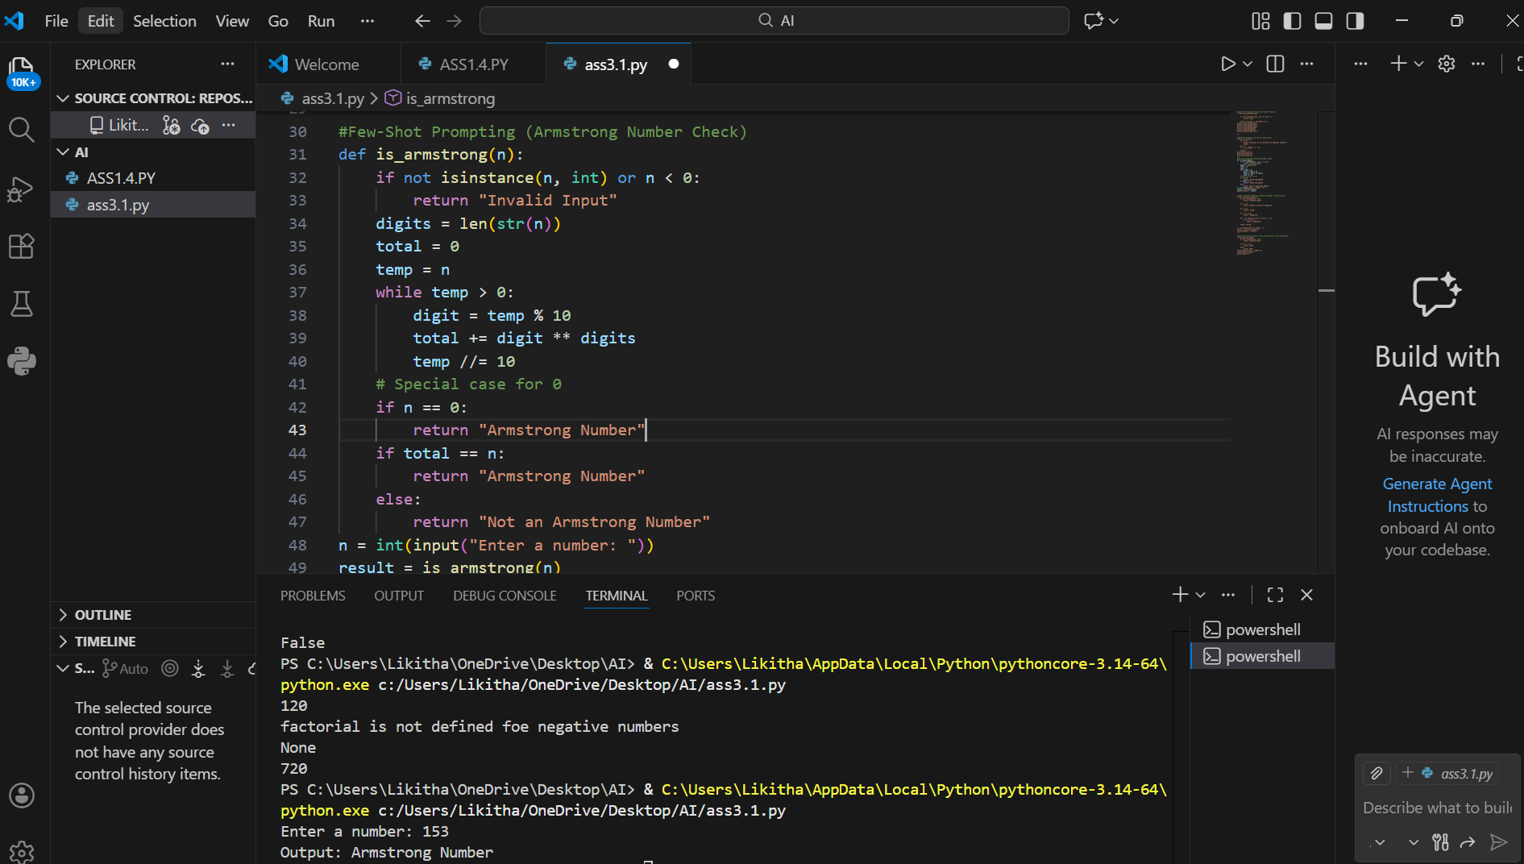
Observation:
Few-shot prompting uses multiple examples, which significantly improves the AI’s understanding of the task. For the Armstrong number program, the AI correctly identified Armstrong numbers and non-Armstrong numbers while following the output format from the examples. Input validation for negative numbers or decimals was still missing but could be added easily. The logic was accurate and consistent, and the code was more robust compared to zero-shot or one-shot approaches. Few-shot prompting reduces ambiguity, ensures output consistency, and enhances accuracy for tasks with more complex rules. This approach is particularly effective for teaching the AI the expected behavior through examples.

Task 4:
Prompt: Context-Managed Prompting (Optimized Number
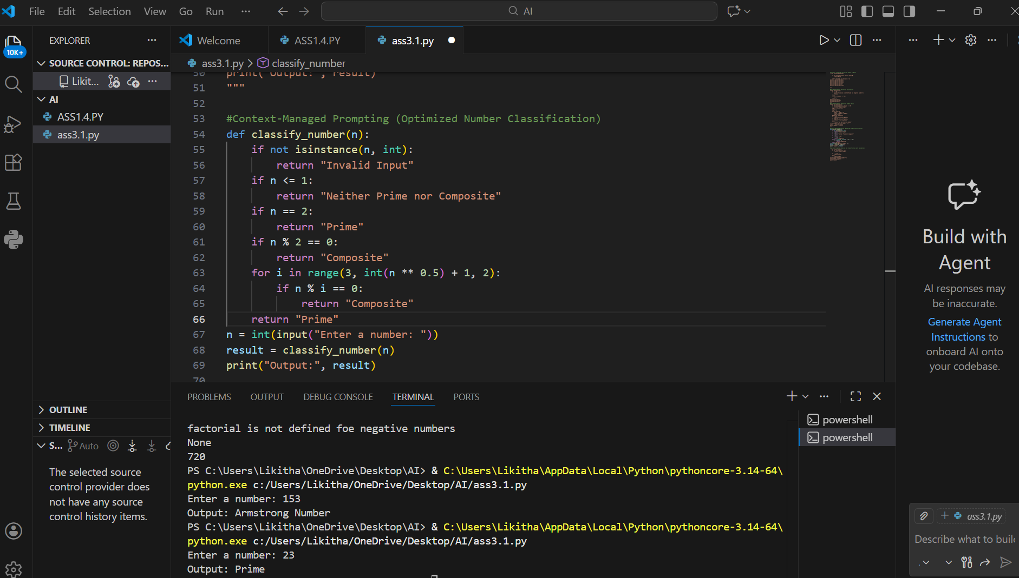
Observation:
Context-managed prompting provides clear instructions, constraints, and guidance for optimization. In the number classification task, the AI produced code that efficiently determined whether a number is prime, composite, or neither. The program included input validation, handled edge cases such as 0, 1, and negative numbers, and used optimized logic with square root reduction. The resulting code was robust, efficient, and ready for practical use. Compared to zero-shot, one-shot, and few-shot prompting, context-managed prompting produces higher-quality solutions. It demonstrates that well-defined constraints and context lead to production-ready code. This approach is ideal for critical tasks requiring both correctness and efficiency.

Task 5:
Prompt: Zero-Shot Prompting (Perfect Number Check)
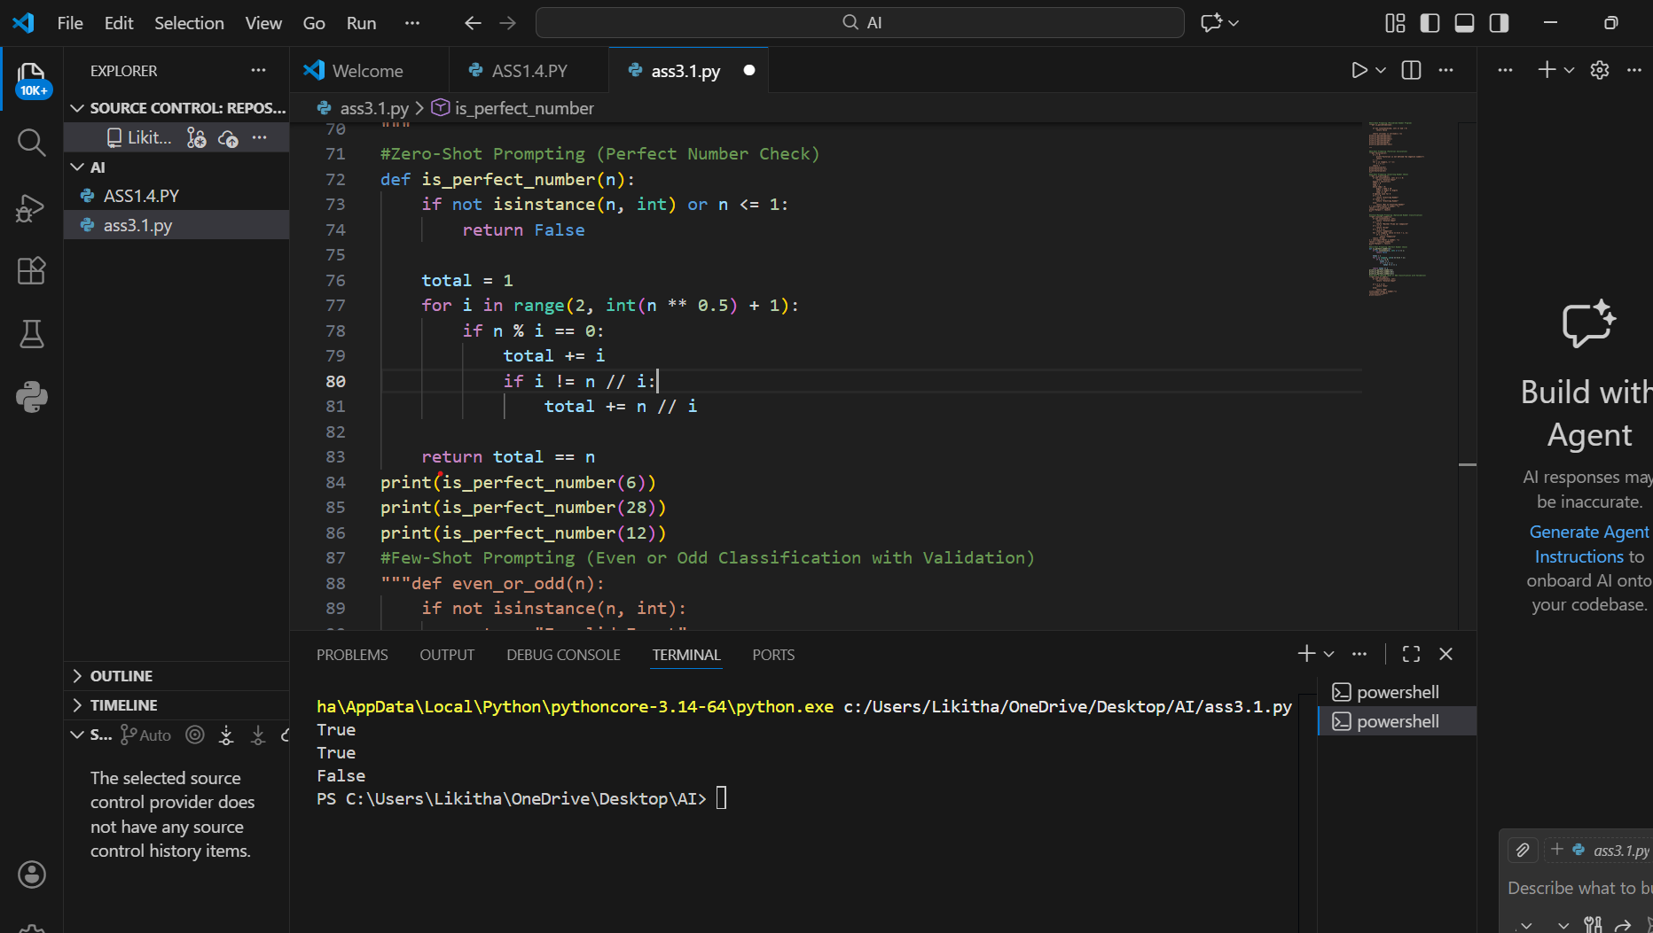

Observation:
In zero-shot prompting for the perfect number program, the AI produced basic logic to calculate the sum of proper divisors. It correctly identified some perfect numbers like 6 and 28 but failed for edge cases such as 0, 1, or negative numbers. The code was functional but inefficient, using a loop from 1 to n-1, which could be optimized to reduce computation time. Input validation was missing, and the program could produce errors with non-integer inputs. Zero-shot prompting is effective for quickly generating core logic but is insufficient for fully robust and optimized solutions. Manual adjustments are required for real-world application.

TASK 6:
Prompt: Few-Shot Prompting (Even or Odd Classification with Validation)

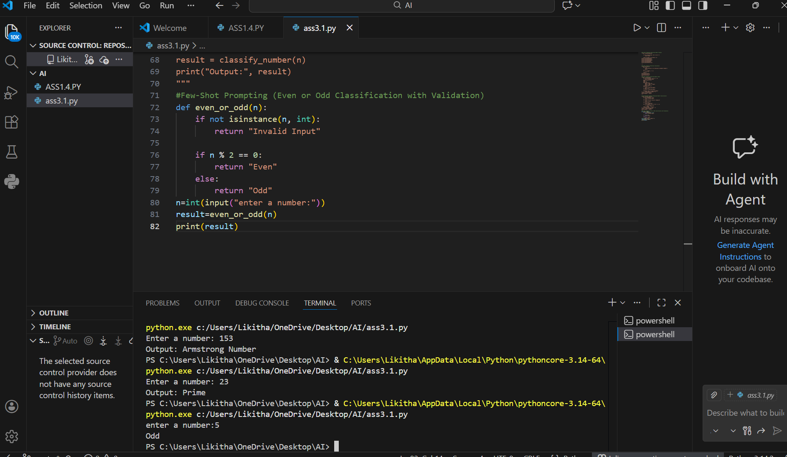
Observation:
Few-shot prompting, with multiple input-output examples, helped the AI generate code that accurately classified numbers as even or odd. The program included input validation, handled zero, negative numbers, and non-integer inputs, producing consistent and user-friendly output. The logic was simple, clear, and reliable, and the code was easy to read and maintain. Compared to zero-shot and one-shot prompting, few-shot prompting significantly improved input handling and output clarity. It ensures that the AI follows expected behavior and reduces the risk of errors. Few-shot prompting is effective for tasks where clarity, validation, and accuracy are important.

