AI-ASS 21.5
NAME:-PENDLI LIKITHA
HTNO:-2303A52393
BATCH:-43

Task A – AI-Based Initial Program Development
Prompt:
Generate a Python program for a Student Grade Calculator that takes marks as input and calculates the grade. Then enhance the program by adding input validation, error handling, and features like average calculation and multiple subject support.

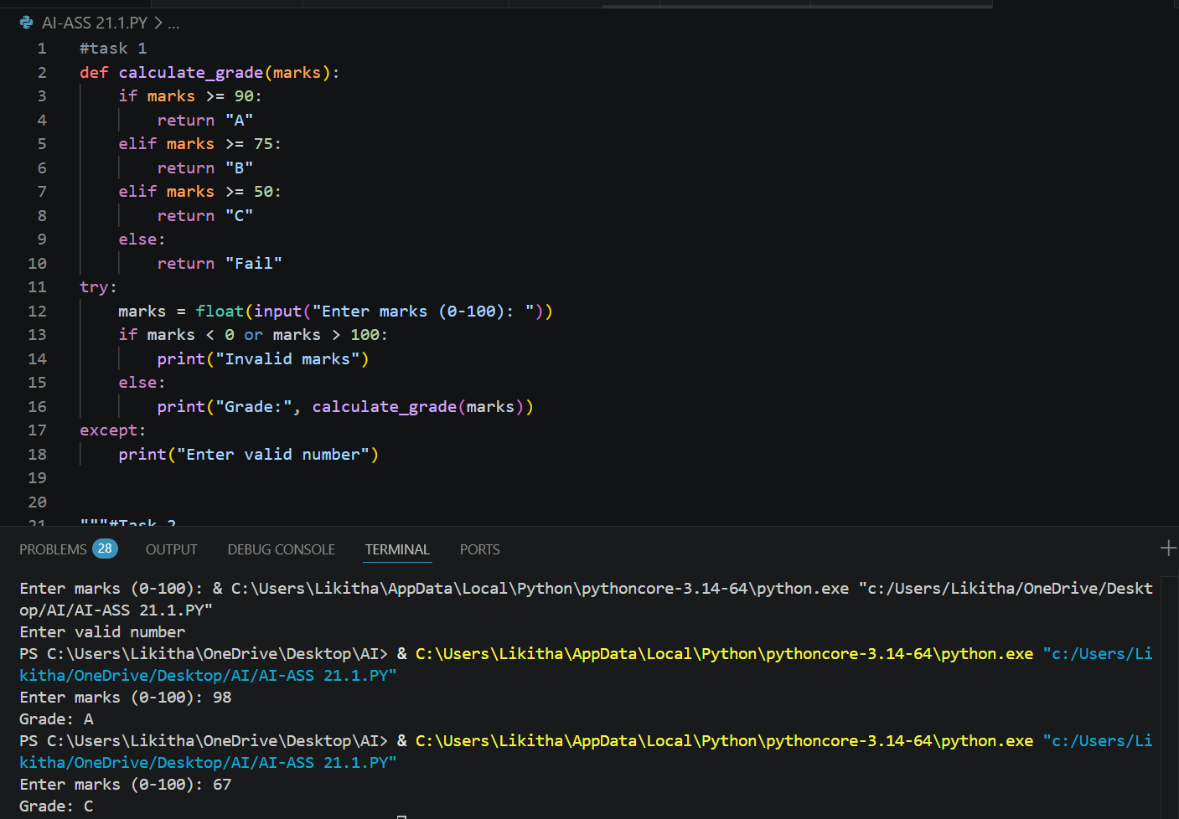
Observation:
The initial program only performed basic grade calculation without checking input validity. The enhanced version added validation and handled incorrect inputs effectively. Additional features improved usability and functionality. This shows how AI can refine simple programs into more reliable applications.

Task B – AI-Assisted Application Improvement
Prompt:
Generate a basic Library Management System in Python to add and view books. Then enhance it by adding features such as search, issue/return books, and menu-driven interaction.
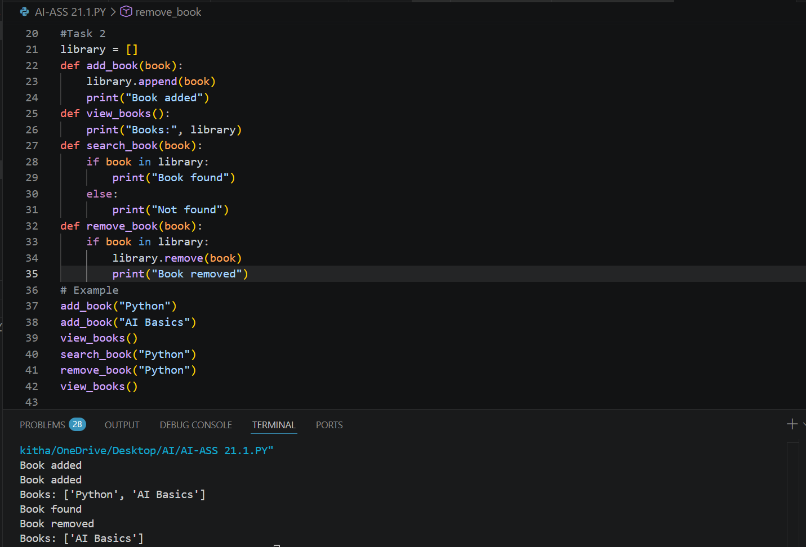
Observation:
The initial program had minimal functionality and lacked structure. AI enhancements introduced better modular design and user interaction. Additional features improved performance and usability. This demonstrates how AI can significantly improve application design.

Task D – Branching and Merging with AI Support
Prompt:
Develop a basic Python program in the main branch. Create a feature branch and use AI to add new functionality or improve the program. Merge the changes back into the main branch and verify the output.

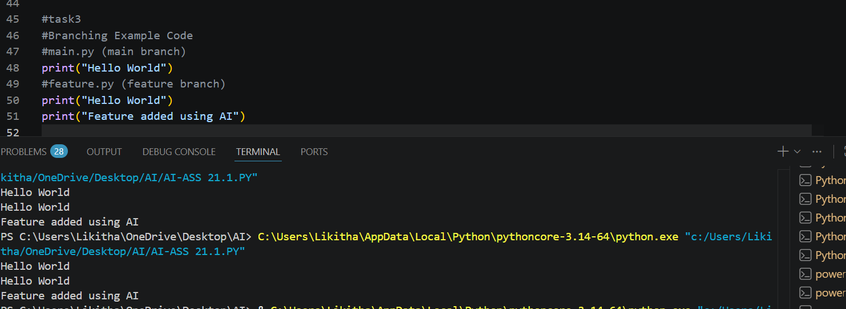
Observation:
The main branch contained the initial version of the program. The feature branch allowed isolated development of new features. AI helped enhance the code efficiently without affecting the main version. Merging ensured smooth integration and demonstrated effective version control practices.

Task F – Pair Programming with AI Assistance
Prompt:
Student A develops a basic Python program. Student B uses AI to enhance the program by adding validation, optimization, and additional features. Integrate both versions using Git.

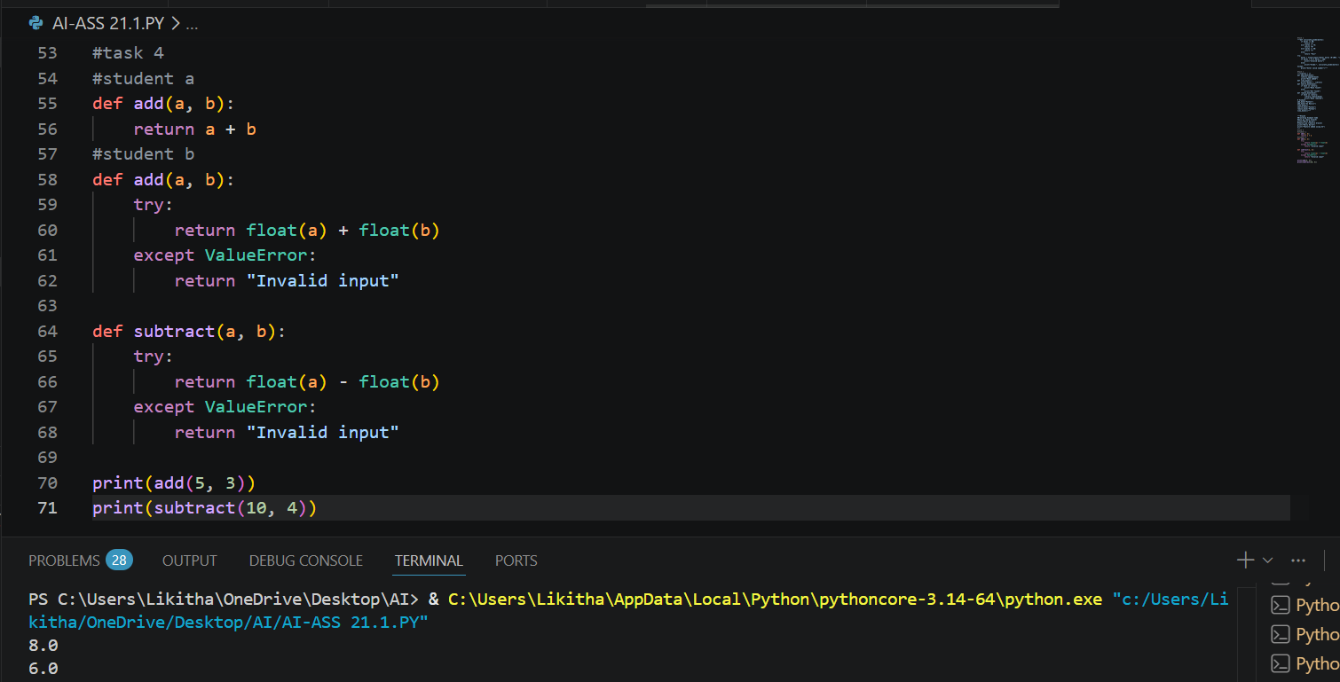
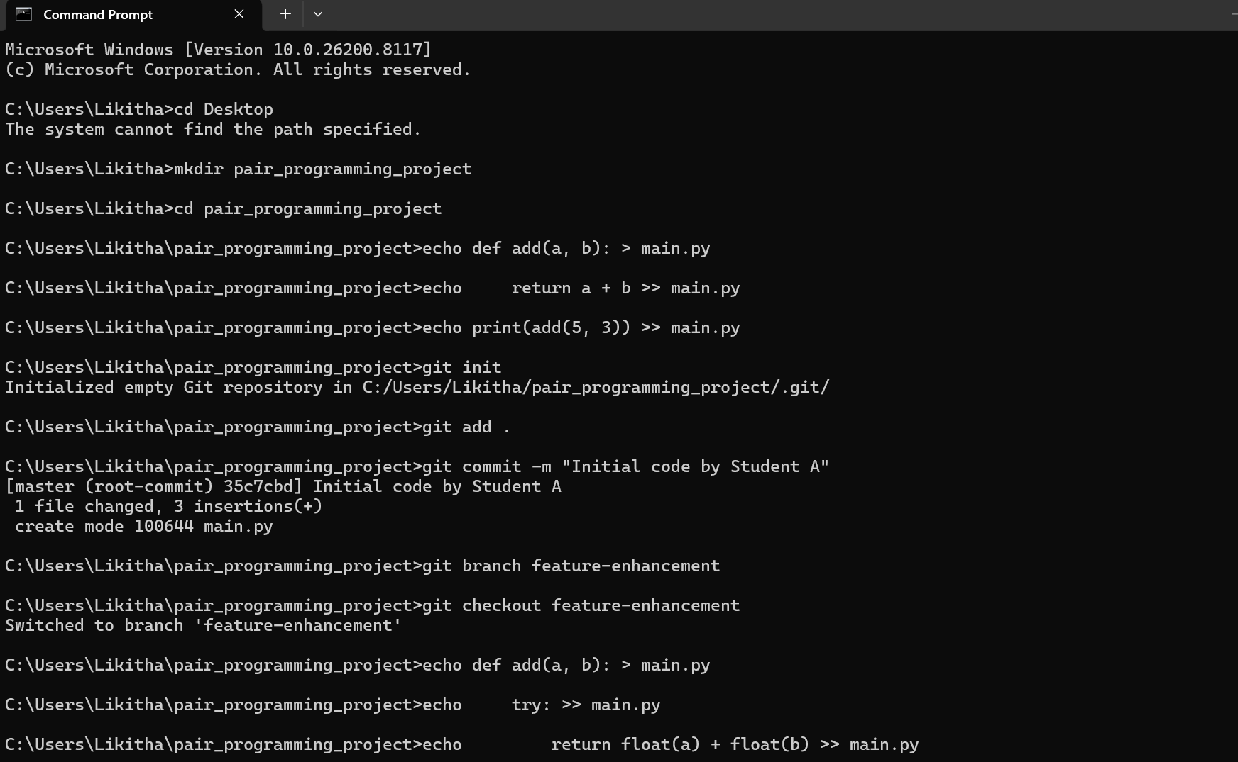

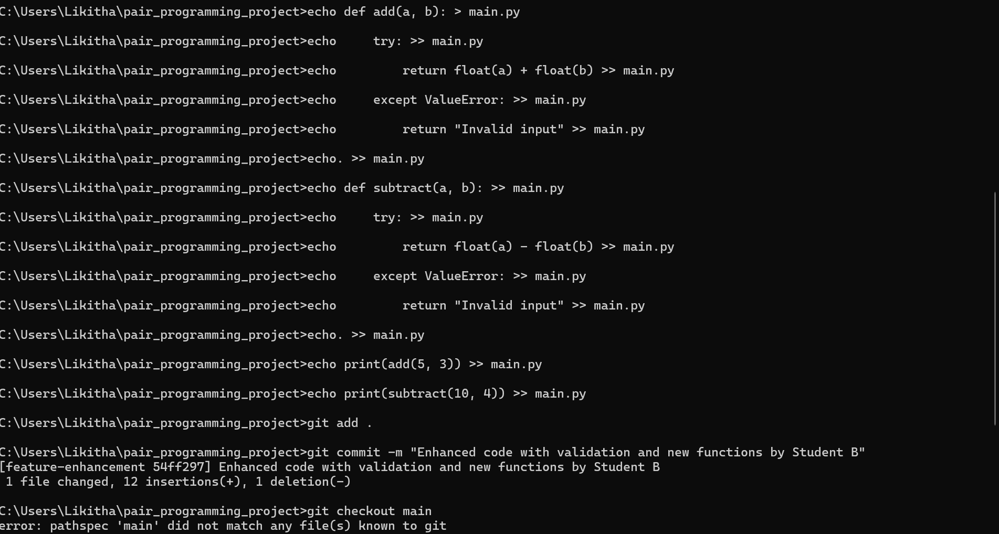

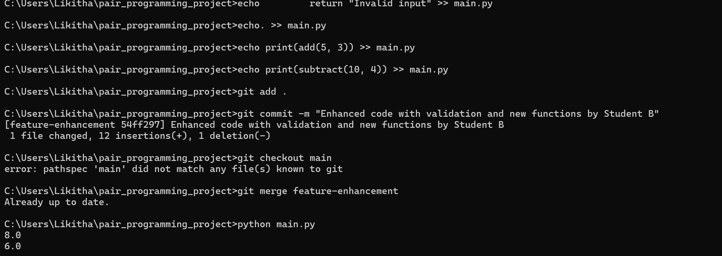

Observation:
Student A created a simple working program with limited functionality. Student B improved the code using AI by adding validation and optimization. Git helped manage contributions and merge changes effectively. This demonstrates collaborative development and the role of AI in improving code quality.

Task H – AI-Supported Team Coding Workflow
Prompt
Simulate a team coding environment where multiple developers build a Python application. Use AI to suggest improvements, add new features, and optimize code. Manage the workflow using Git branches and merge all contributions into the main project.

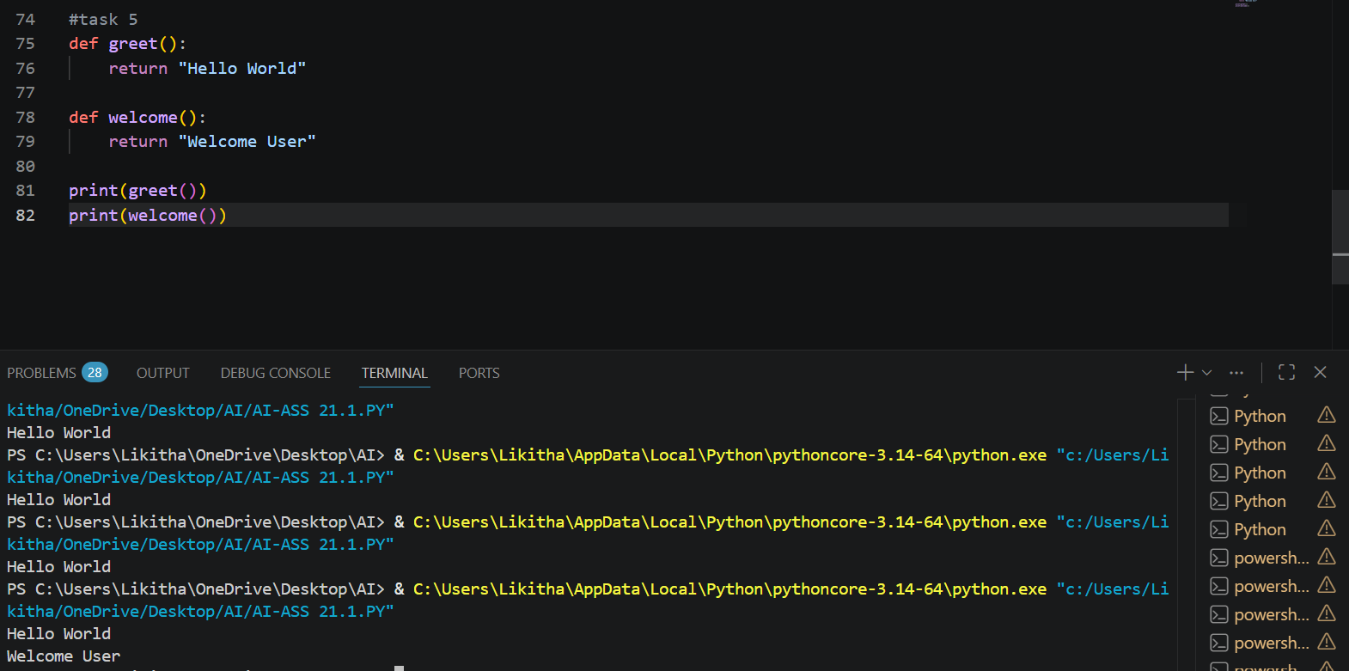

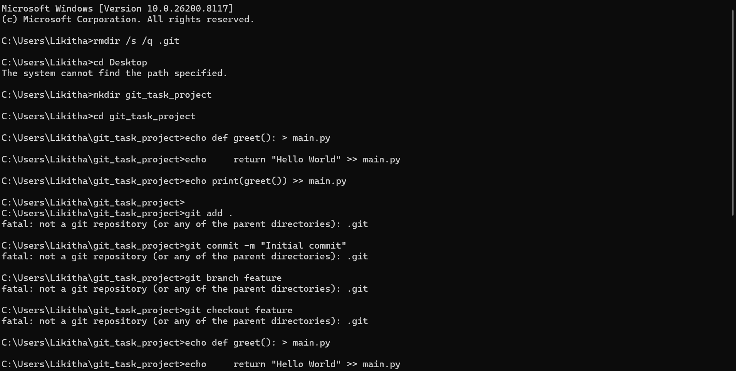
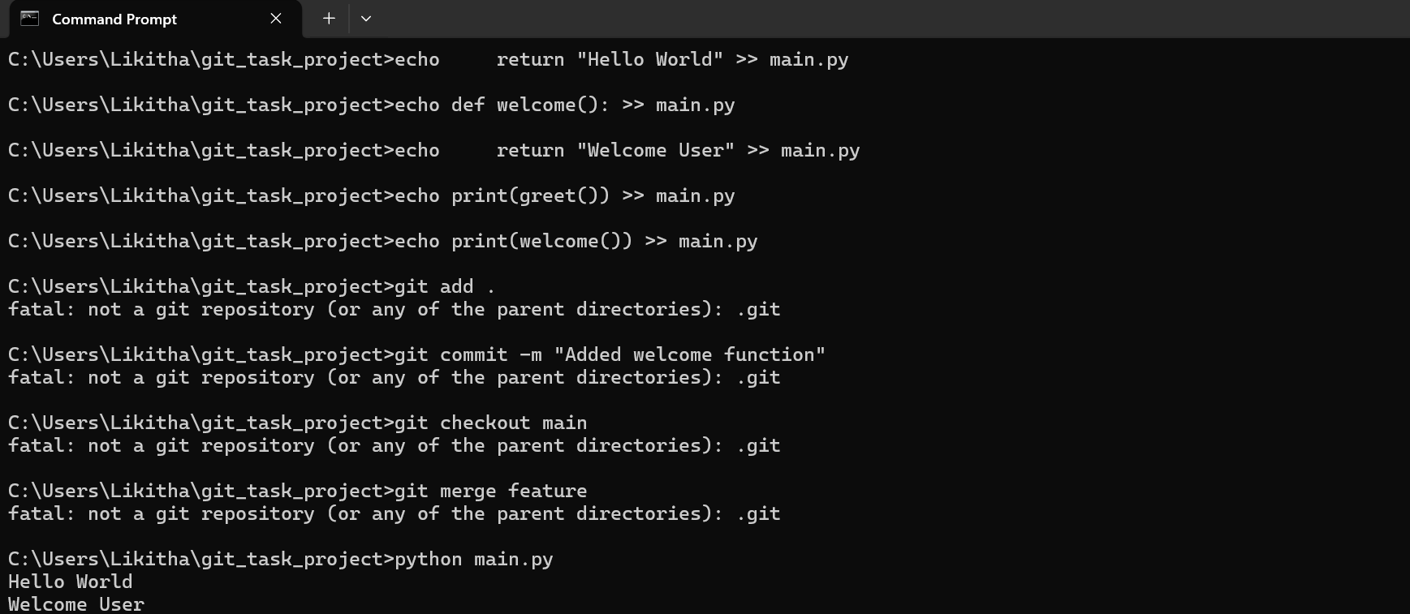
Observation
AI helped developers generate code faster and improve logic with better suggestions. Team members worked on different features using separate branches without conflicts. Git ensured smooth integration of all contributions into the main branch. This workflow improved collaboration, code quality, and overall development efficiency.

