AI-ASS(20.5)
NAME:-PENDLI LIKITHA
HTNO:-2303A52393
BATCH N0:-43
Task 1 – Password Storage Vulnerability Check
Prompt:
Generate a Python user registration script that stores usernames and passwords in a dictionary. Then analyze whether the passwords are stored securely or in plain text. Modify the script to use password hashing with hashlib or bcrypt.
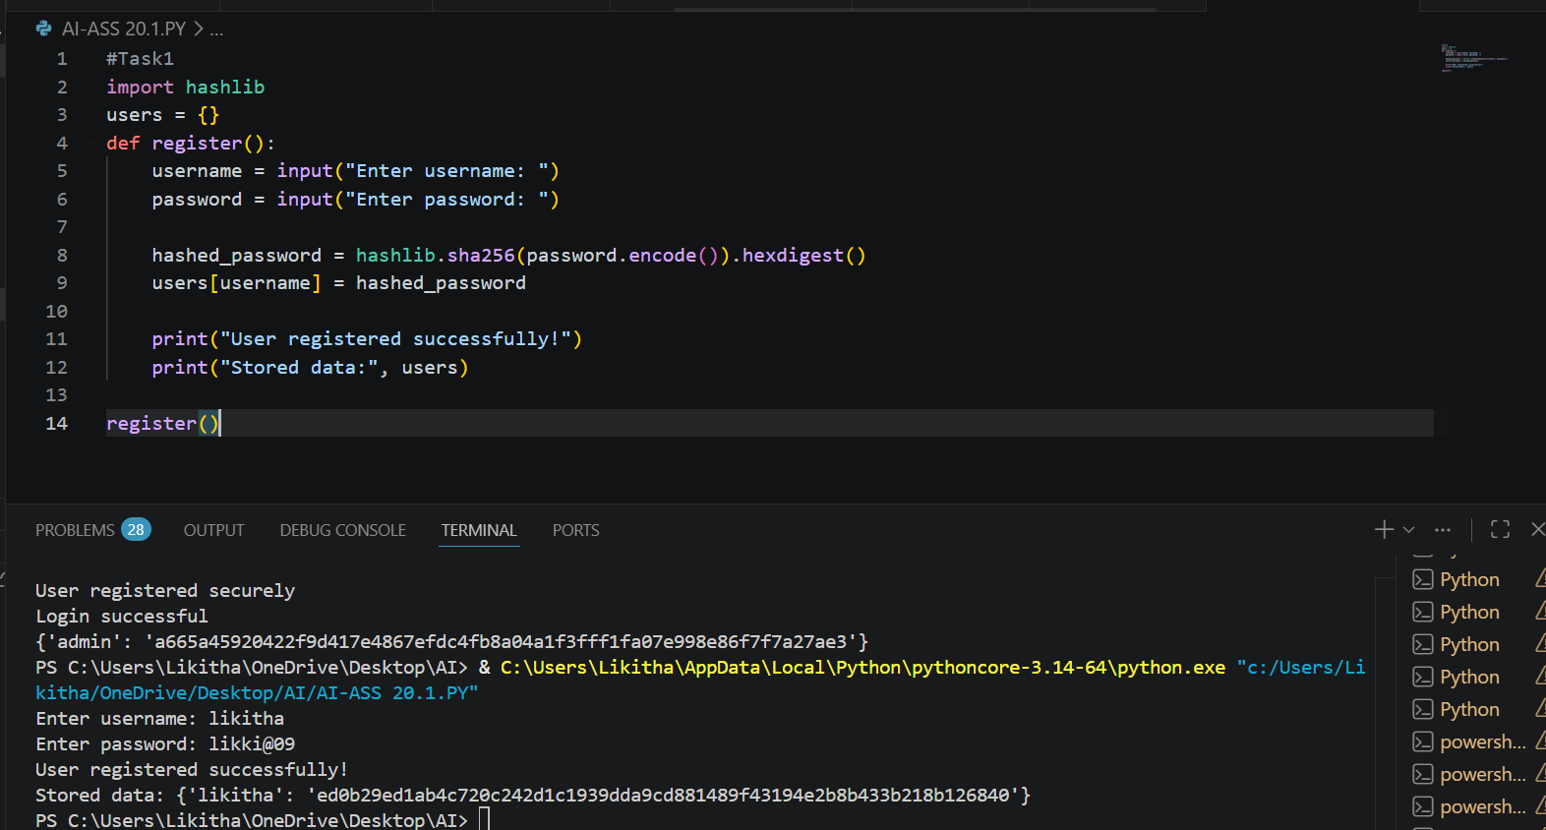
Observation:
The AI-generated code initially stored passwords in plain text, which is highly insecure. This makes user credentials vulnerable if the system is compromised. After applying hashing (SHA-256/bcrypt), passwords are stored securely. Hashing ensures passwords cannot be easily reversed or exposed.

Task 2 – Hardcoded Secrets Detection
Prompt:
Generate a Python script that connects to an external API using an API key. Check if the API key is hardcoded in the script and refactor the code to securely store the key using environment variables.
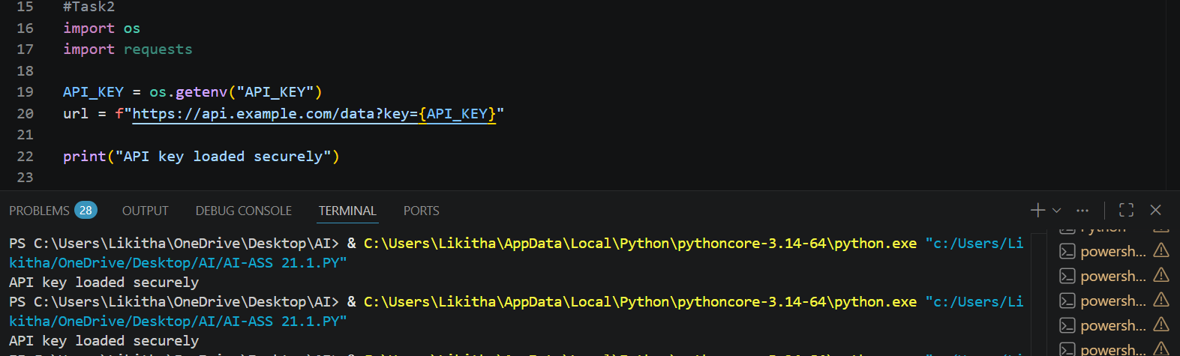
Observation:
The generated script included a hardcoded API key, which is a security risk when sharing code. Hardcoded secrets can be exposed through version control systems. Refactoring to use environment variables improves security. This ensures sensitive data is not directly visible in the codebase.

Task 3 – File Upload Security Validation
Prompt:
Generate a Flask application that allows users to upload files. Analyze the code for potential vulnerabilities such as unrestricted file types and lack of validation. Improve it by adding file type, size checks, and secure filename handling.
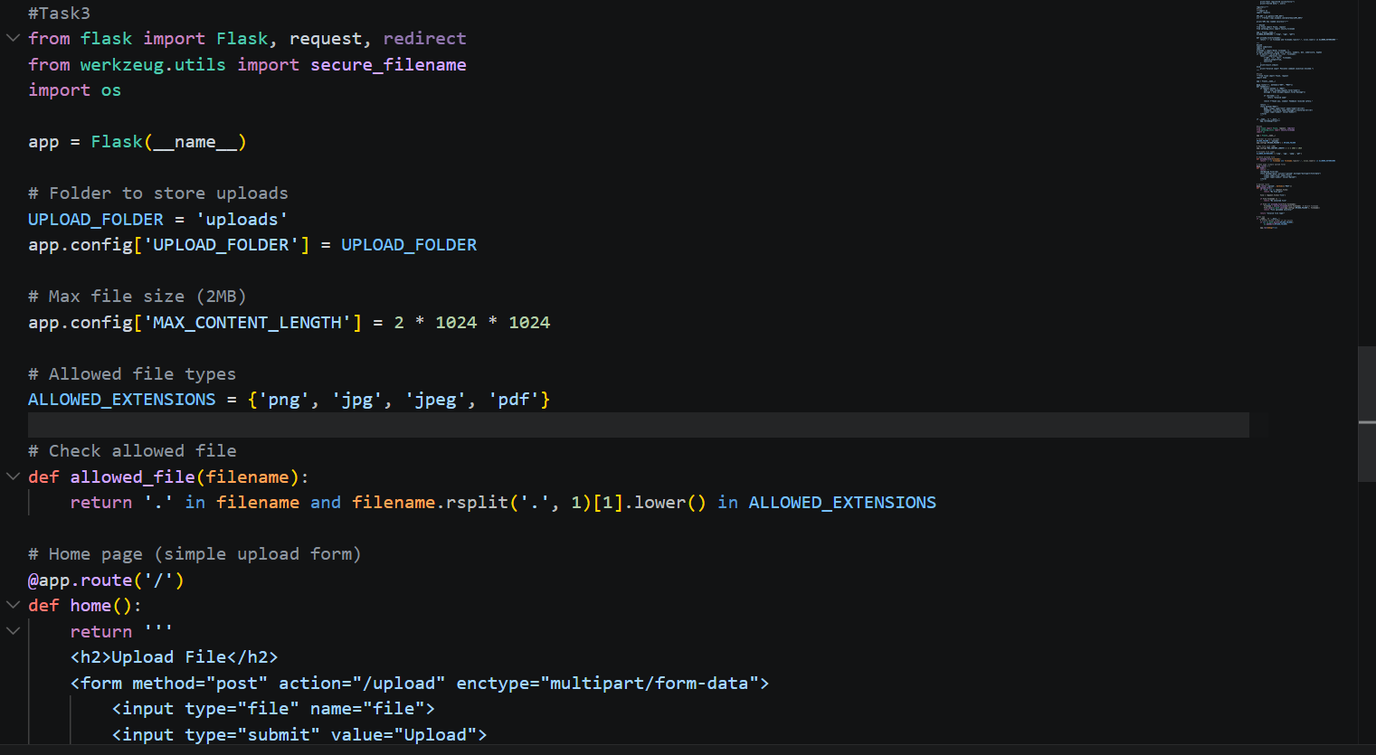
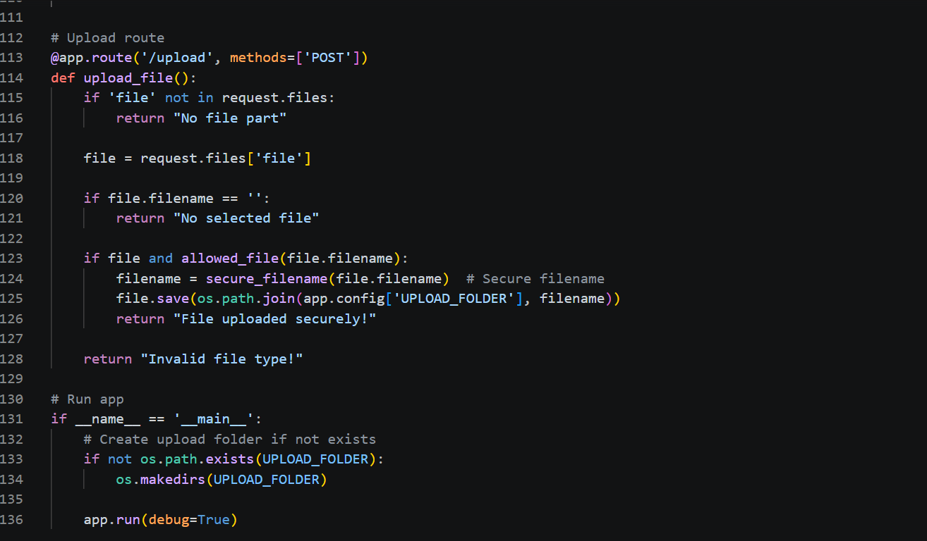
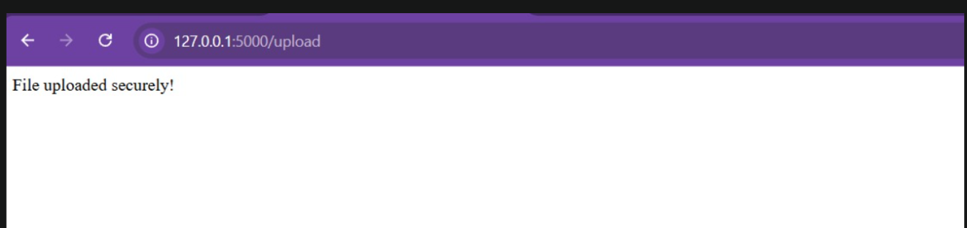
Observation:
The initial code allowed any file type to be uploaded without validation. This could enable attackers to upload malicious or executable files. Adding restrictions on file type and size improves security. Using secure_filename prevents directory traversal attacks.

Task 4 – Command Injection Prevention
Prompt:
Generate a Python script that executes system commands using user input. Identify possible command injection vulnerabilities and refactor the script using safer methods like subprocess with proper validation.
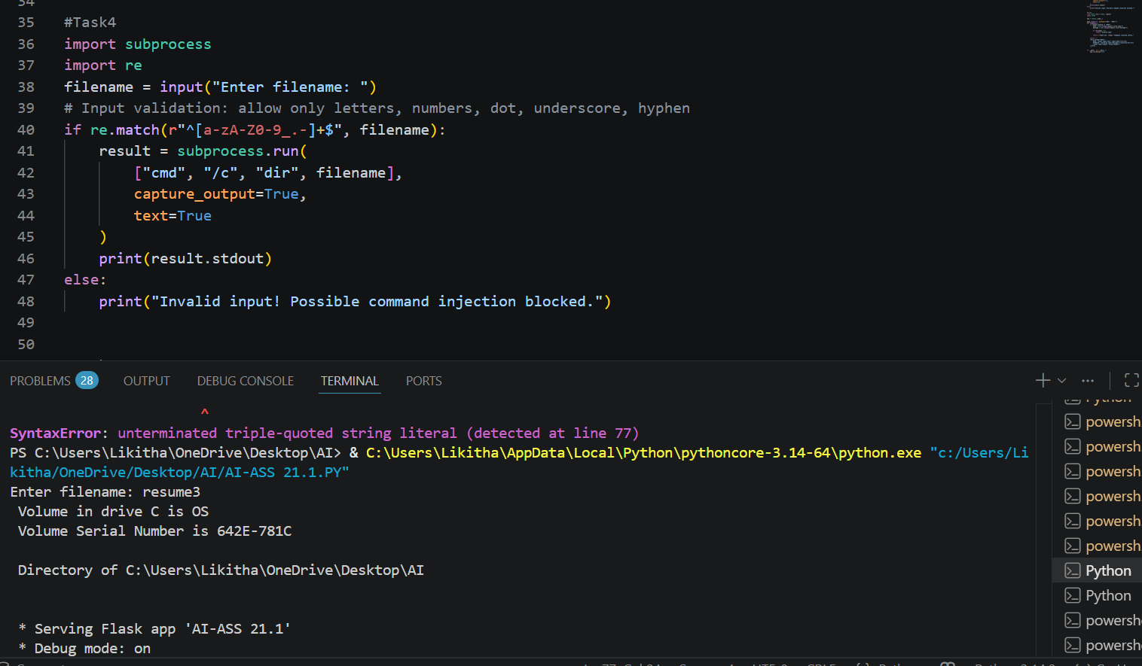
Observation:
The generated code used os.system() with user input, making it vulnerable to command injection. Attackers could execute harmful commands on the system. Replacing it with subprocess.run() reduces risk. Input validation further ensures only safe commands are executed.

Task 5 – Secure Input Handling in Web Forms
Prompt:
Generate an HTML form with a Flask backend that accepts user input and displays it. Analyze the code for missing validation and potential XSS vulnerabilities. Improve it using input validation and secure rendering.
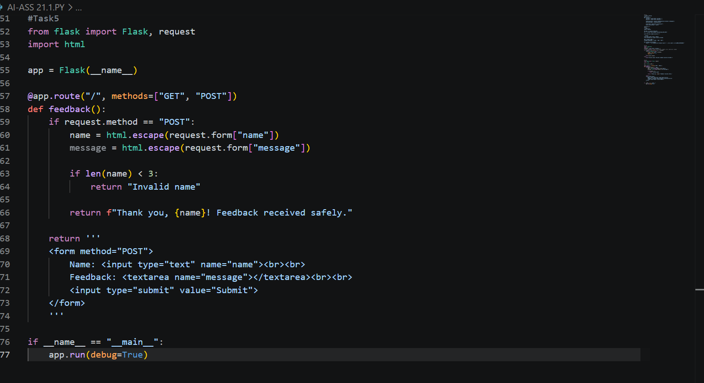
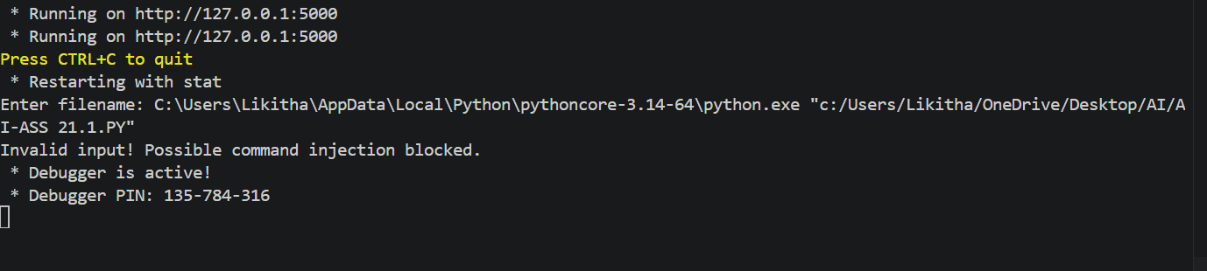
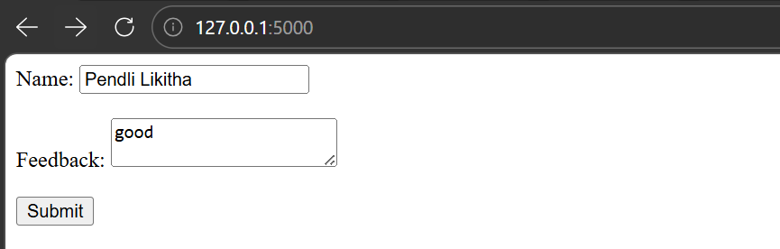
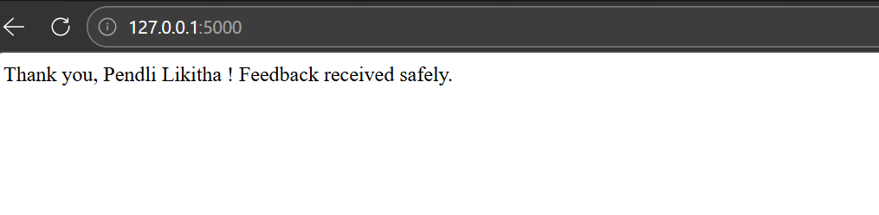
Observation:
The original code directly rendered user input without validation, leading to XSS risks. Malicious scripts could be executed in the browser. Adding server-side validation ensures only safe input is accepted. Using templating engines like Jinja prevents unsafe rendering.

