NAME: M.MANOGNA
BATCH:39HTNO:2303A52396
ASSIGNMENT 3.2
Task Description-1
- Progressive Prompting for Calculator Design: Ask the AI to design a simple calculator program by initially providing only the function name. Gradually enhance the prompt by adding comments and usage examples.
Expected Output-1
- Comparison showing improvement in AI-generated calculator logic and structure.
PROMPT:
#Create a Python function named calculator().The function should perform basic arithmetic operations. # Create a Python function named calculator().
# The function should:
# - Take two numbers and an operator as input
# - Support addition, subtraction, multiplication, and division # - Use if-elif-else logic
# - Handle division by zero
# Add proper comments explaining each step.
# Create a Python function named calculator(). # Requirements:
# - Inputs: two numbers and an operator (+, -, *, /) # - Perform the selected operation
# - Handle invalid operators and division by zero # - Print meaningful error messages
# Example usage:
# calculator(10, 5, '+') → Output: 15

# calculator(8, 0, '/') → Output: Division by zero error
# Write clean and readable Python code with comments.TAKE input from user.
CODE:
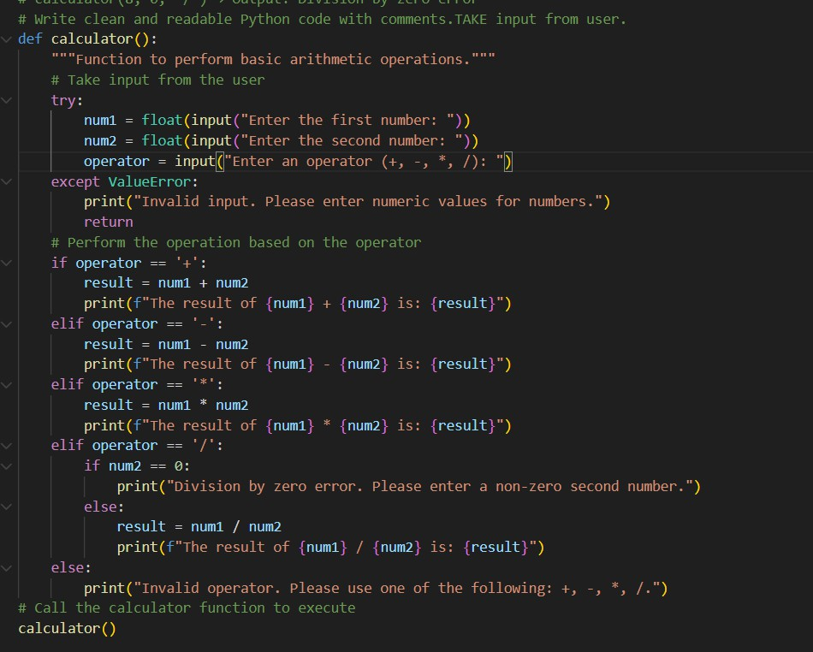
OUTPUT:
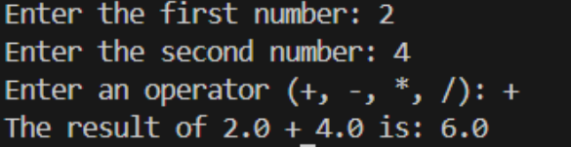
ANALYSIS:
As the prompt became more detailed, the AI-generated calculator showed better structure, clearer logic, and improved error handling. Step-by-step prompting guided the model to produce cleaner, more readable, and more reliable code
___________________________________________________________________________

Task Description-2
- Refining Prompts for Sorting Logic: Start with a vague prompt for sorting student marks,
then refine it to clearly specify sorting order and constraints. Expected Output-2
- AI-generated sorting function evolves from ambiguous logic to an accurate and efficient
implementation. PROMPT:
# Write a Python function to sort student marks. # Write a Python function named sort_marks().

# The function should:
# - Take a list of student marks as input # - Sort the marks in ascending order
# - Return the sorted list

# Use Python built-in sorting methods.
# Write a Python function named sort_marks().

# Requirements:
# - Input: list of integer student marks # - Sort marks in descending order
# - Do not modify the original list # - Handle empty lists
# - Return the sorted list

# Example:
# Input: [78, 90, 45, 88]
# Output: [90, 88, 78, 45]

# Add comments explaining each step.TAKE input from user.
CODE:

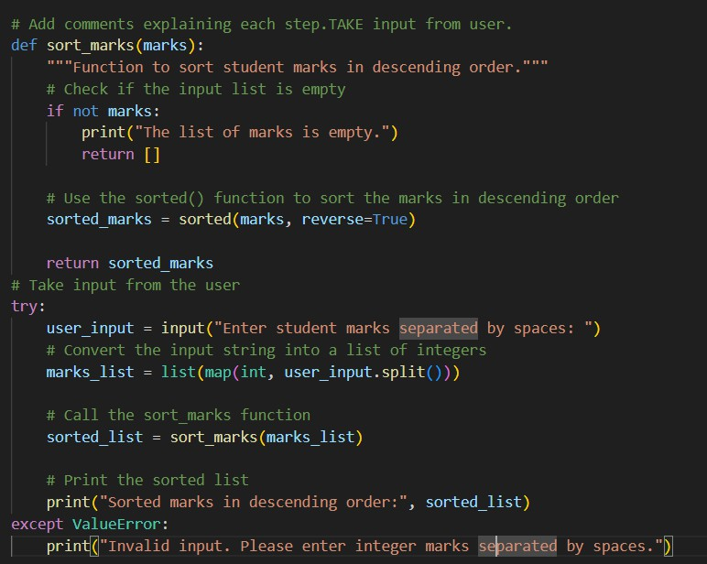
OUTPUT:

ANALYSIS:
Vague prompts resulted in ambiguous and inconsistent sorting logic.
Refined prompts clearly defined the sorting order and constraints.
Clear instructions improved the correctness of the sorting process.
The generated code became more efficient and easier to understand.
Overall, better prompts led to accurate and well-structured sorting implementations.

Task Description-3
- Few-Shot Prompting for Prime Number Validation: Provide multiple input-output
examples for a function that checks whether a number is prime. Observe how few- shot

prompting improves correctness. Expected Output-3
- Improved prime-checking function with better edge-case handling. PROMPT:
# Write a Python function named is_prime(n).
# Use the following examples to understand expected behavior: # is_prime(2) → True
# is_prime(3) → True # is_prime(4) → False # is_prime(1) → False # is_prime(0) → False
# is_prime(-5) → False # is_prime(17) → True

# Requirements:
# - Handle edge cases
# - Return True if number is prime, else False
# - Use efficient logic (avoid unnecessary loops)
# - Add comments for explanation.TAKE INPUT FROM USER.
CODE:
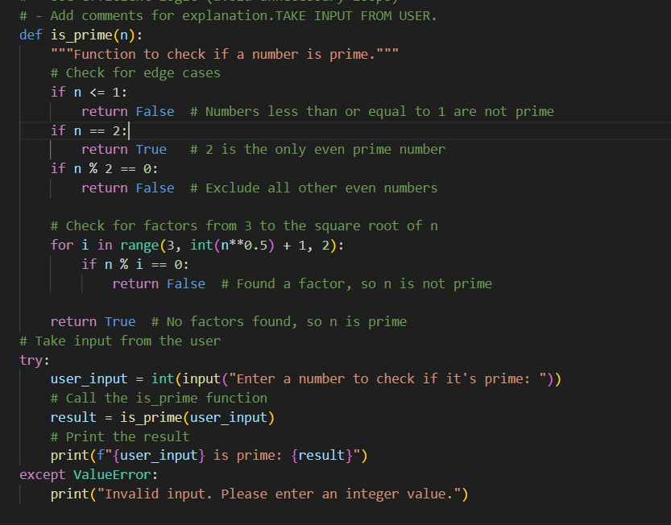
OUTPUT:

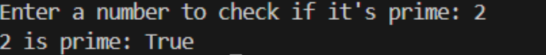

ANALYSIS: Providing input-output examples significantly improved prime number validation and edge case handling. Few-shot prompting guided the AI toward correct logical behavior

Task Description-4
- Prompt-Guided UI Design for Student Grading System: Create a user interface for a
student grading system that calculates total marks, percentage, and grade based on user
input.
Expected Output-4
- Well-structured UI code with accurate calculations and clear output display. PROMPT:
# Create a Python console-based student grading system. # Requirements:
# - Ask the user to enter marks for 5 subjects # - Calculate total marks
# - Calculate percentage
# - Assign grade based on percentage:
# * ≥ 90 → A
# * ≥ 75 → B
# * ≥ 60 → C
# * ≥ 40 → D
# * < 40 → Fail

# Display:
# - Total marks # - Percentage # - Grade

# Use functions and clear print statements.
# Add comments explaining each step.take input from user.
CODE:

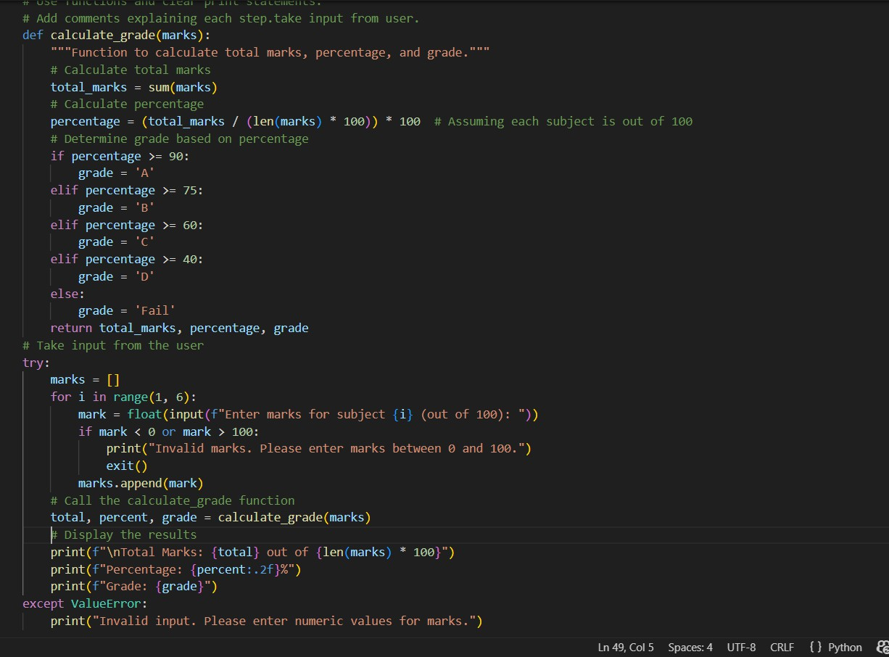
OUTPUT:
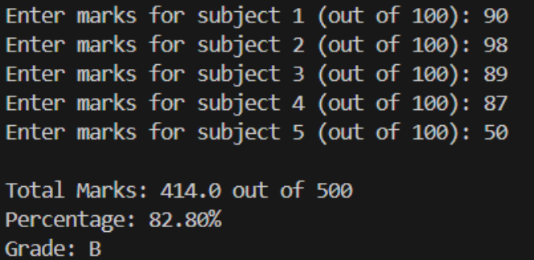
ANALYSIS:
Well-organized UI with clear display of results, user-friendly and robust.
Prompt guidance improves from plain logic to a polished, interactive grading system.

Task Description-5
- Analyzing Prompt Specificity in Unit Conversion Functions: Improving a Unit

Conversion Function (Kilometers to Miles and Miles to Kilometers) Using Clear Instructions.
Expected Output-5
- Analysis of code quality and accuracy differences across multiple prompt variations. PROMPT:
# Write a Python function to convert kilometers to miles. # Write two Python functions:
# 1. km_to_miles(km)
# 2. miles_to_km(miles)

# Conversion rules:
# - 1 km = 0.621371 miles # - 1 mile = 1.60934 km

# Return converted values.
# Write two Python functions:

# 1. km_to_miles(km)
# 2. miles_to_km(miles)

# Requirements:
# - Accept float values
# - Perform accurate conversion
# - Round results to 2 decimal places
# - Handle negative input with error message # - Include example calls and outputs

# Add comments explaining formulas.take input from user.
CODE:
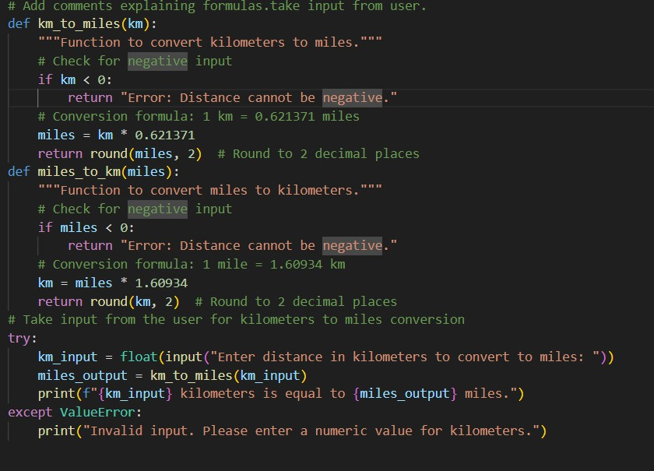
OUTPUT:

ANALYSIS:
Highly specific prompts improved unit conversion accuracy, validation, and rounding. Clear instructions resulted in more robust and professional-quality code. Consistent comments and structured error handling enhanced readability and user-friendliness. Using precise formulas ensured reliable and repeatable results across different inputs.

