AI Assignment Coding
Assignment – 2.3
Name : Shruthi
HT No : 2303A52407
Batch : 31

Task 1: Word Frequency from Text File
Prompt: Generate Python code that reads a text file, counts the frequency of each word using an efficient approach, and provide a clear line-by-line explanation of the code

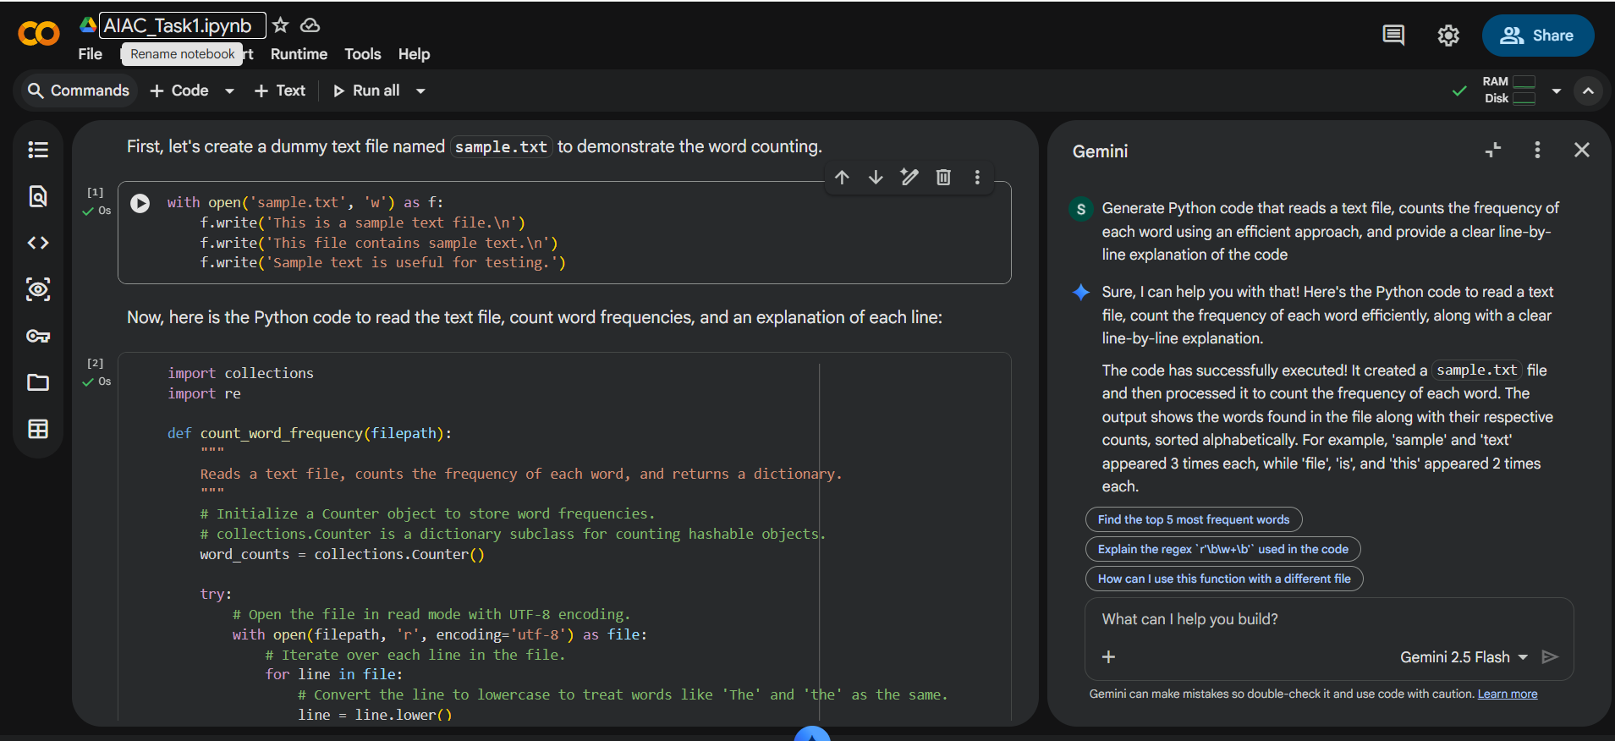
Output:
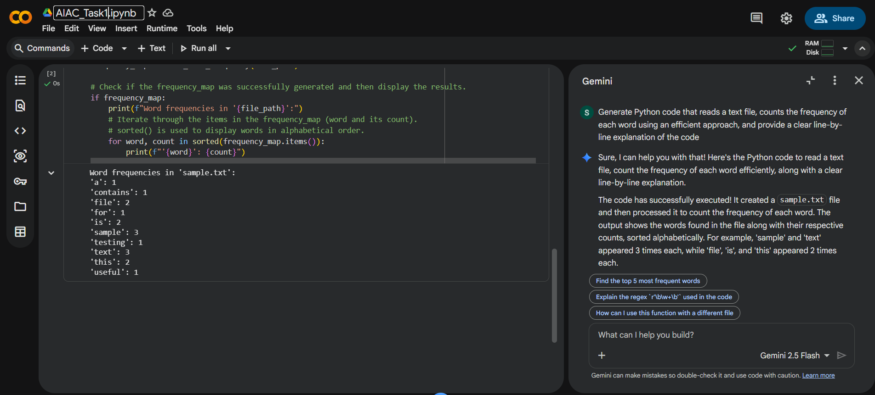
Explanation :
The program reads a text file and converts all words to lowercase for consistency.
It splits the text into words and uses the Counter class to count occurrences efficiently.
This avoids manual counting and improves performance.
Finally, each word with its frequency is displayed.
Task2:
Prompt: Generate a Python program to create a text file, write sample text into it, then read and display the file content.
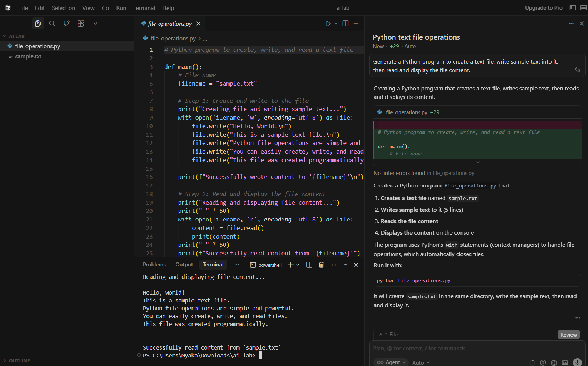

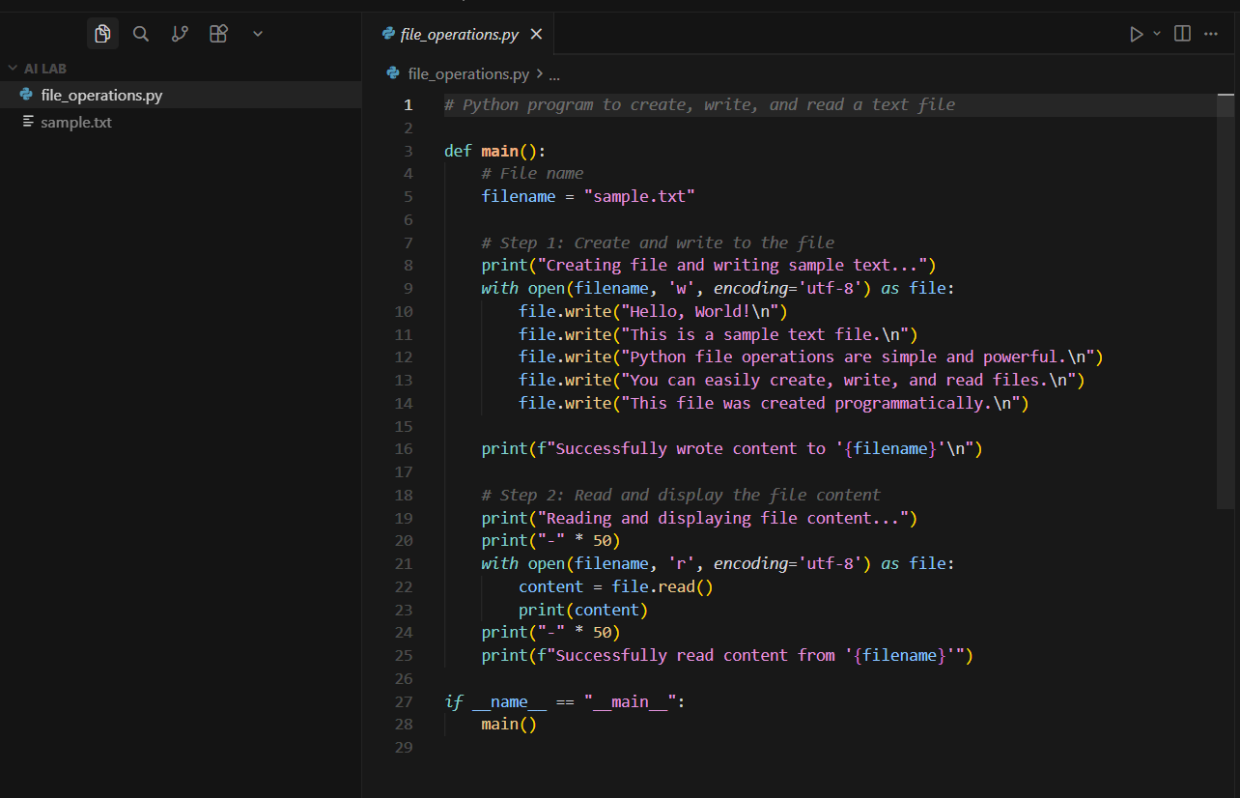
Explanation:
The program creates a text file and writes sample content into it.
After writing, the file is reopened in read mode.
The stored text is read and displayed on the console.
This confirms successful file creation and reading.
Task3:
Prompt:
Generate Python code to read a CSV file and calculate the mean, minimum, and maximum values of a numeric column.

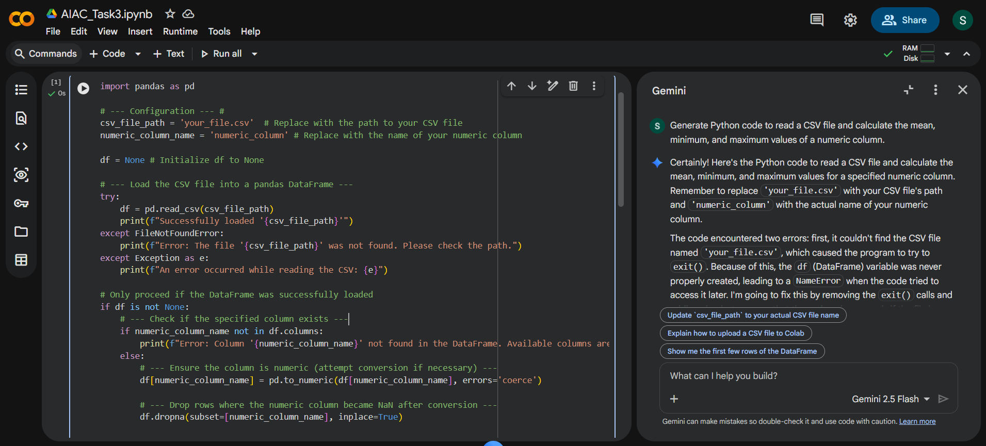

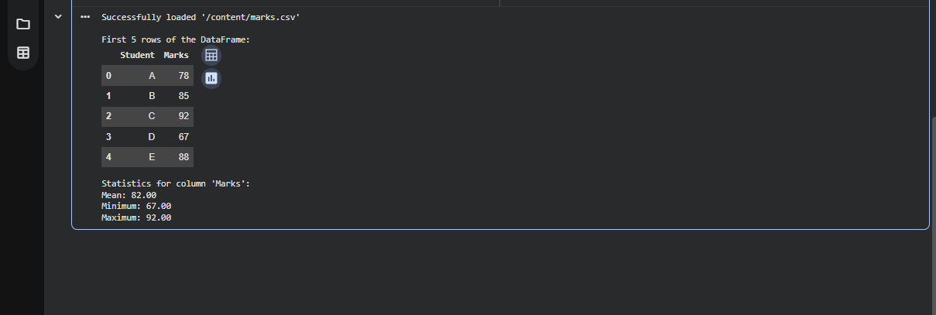
Explanation:
The program reads a CSV file using the pandas library.
It processes a numeric column to calculate mean, minimum, and maximum values.
Built-in functions make the calculations simple and efficient.
This approach is useful for analyzing structured data.

Task4:
Prompt: Generate Python code for Bubble Sort and Python’s built-in sort function

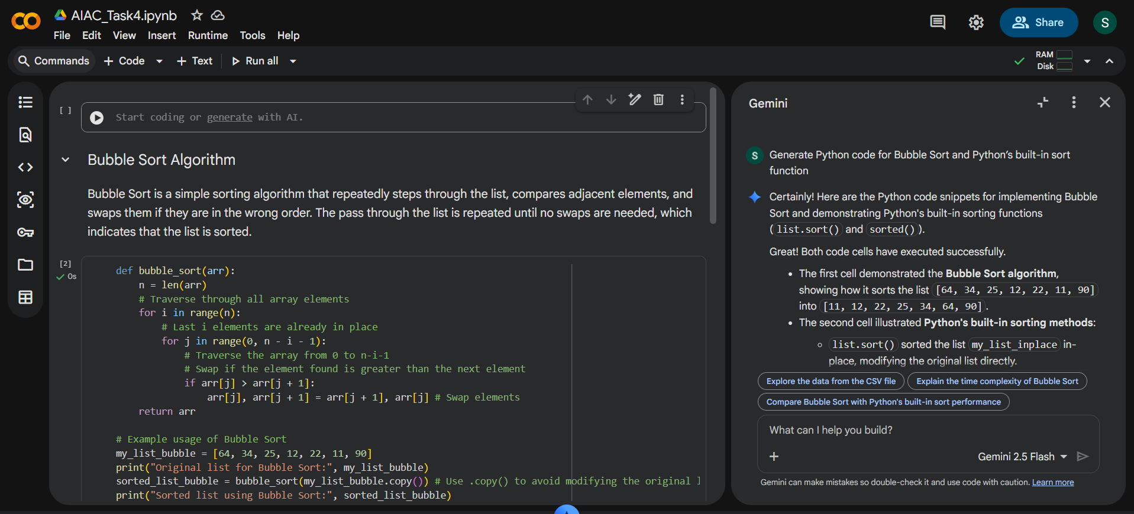

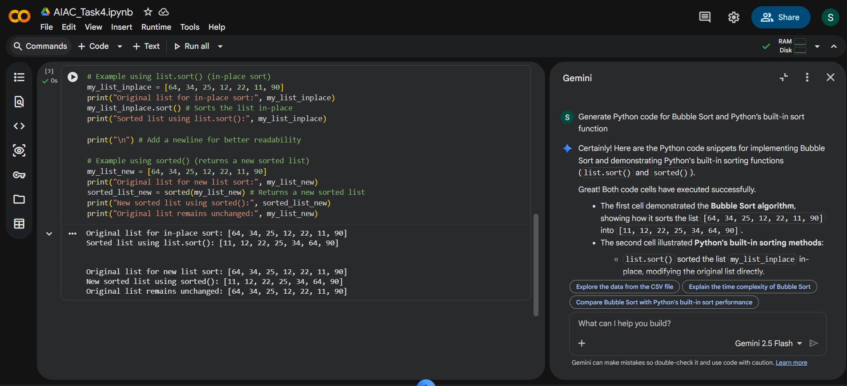
Explanation:
Bubble sort compares and swaps elements repeatedly, making it slow for large data.
Python’s built-in sort() uses an optimized algorithm and runs faster.
Bubble sort is mainly used for learning purposes.
Built-in sorting is preferred for real-world applications.

