AI Assisted Coding
Assignment 5.1&6
Task 1:
Employee Data
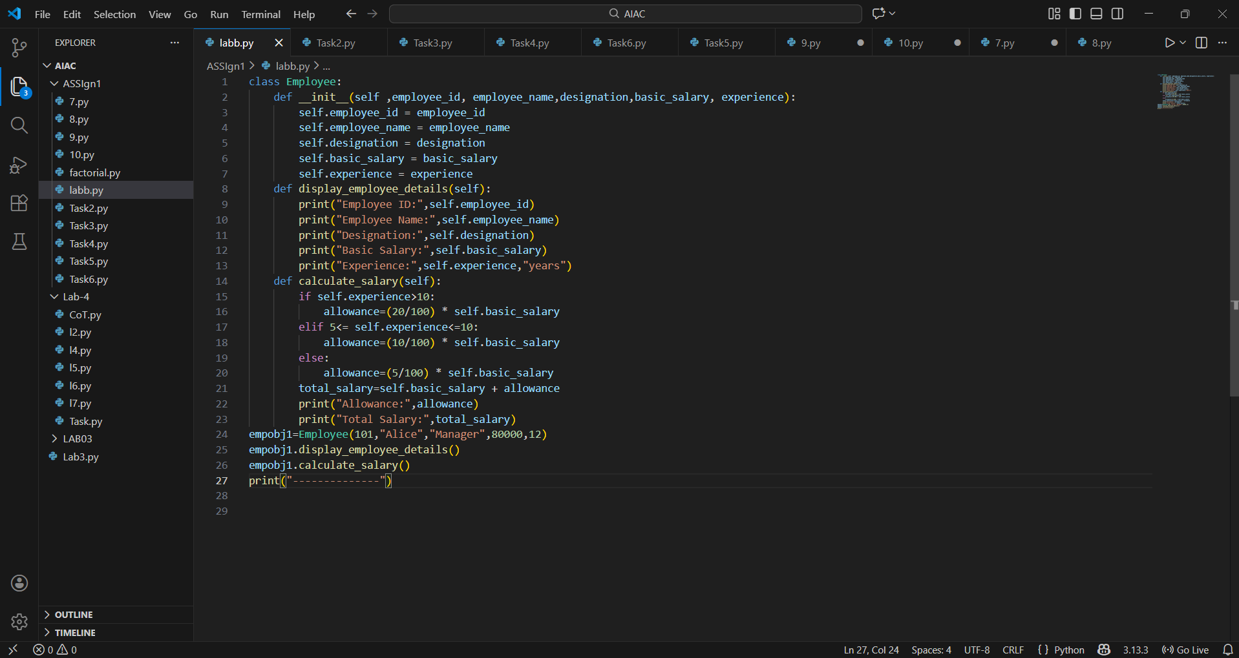
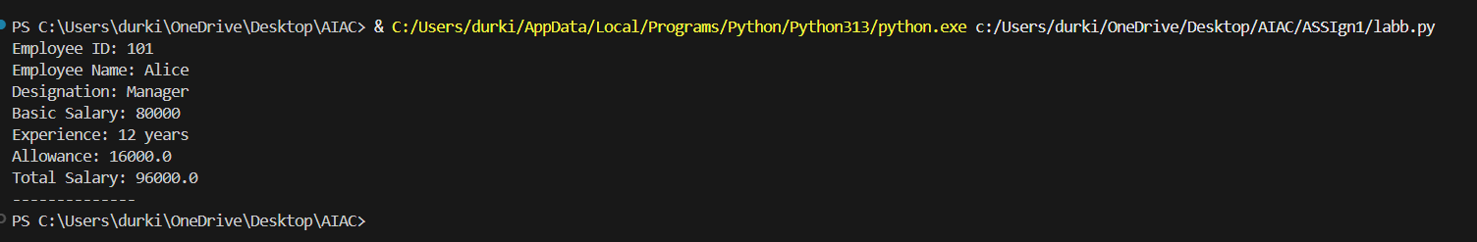
Task 2:
Electricity bill
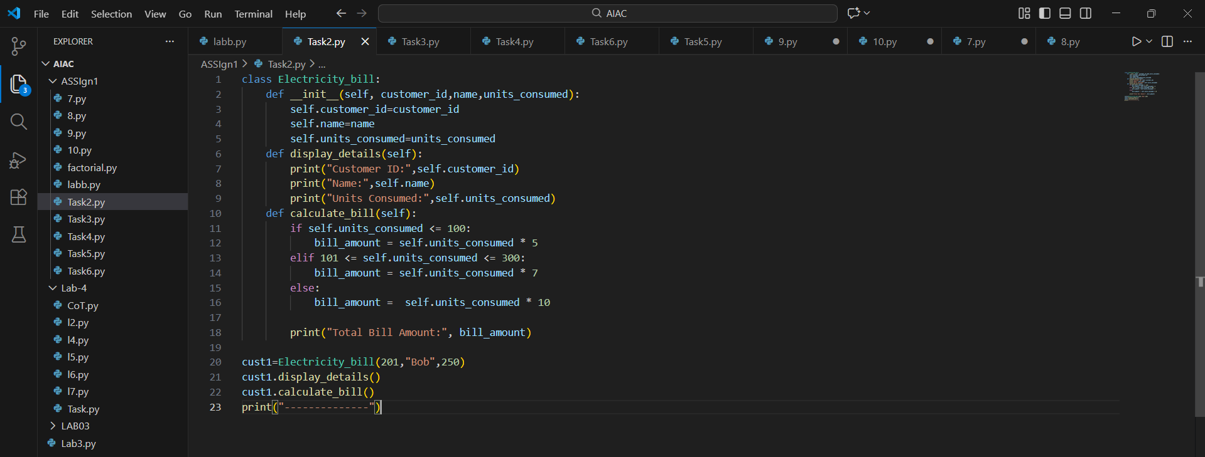
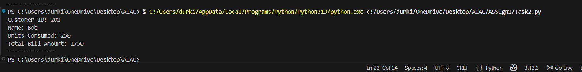
Task 3:
Product Discount
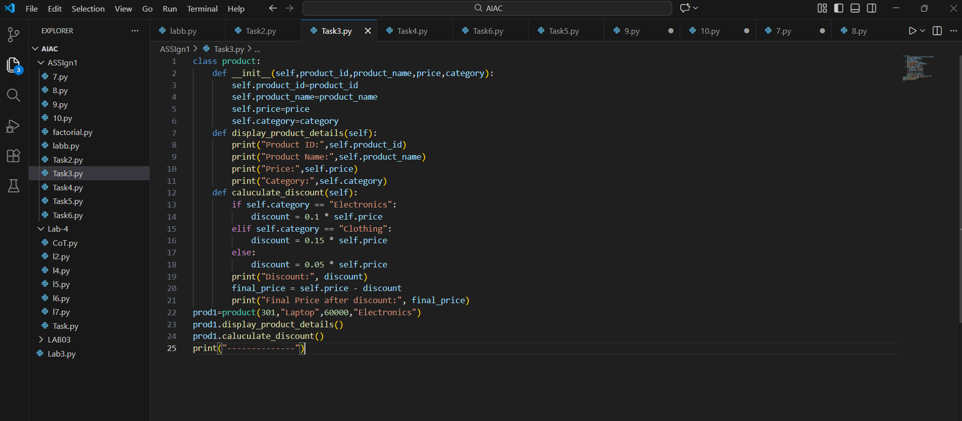
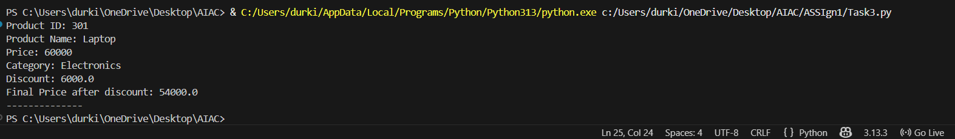

Task 4:
Library Book
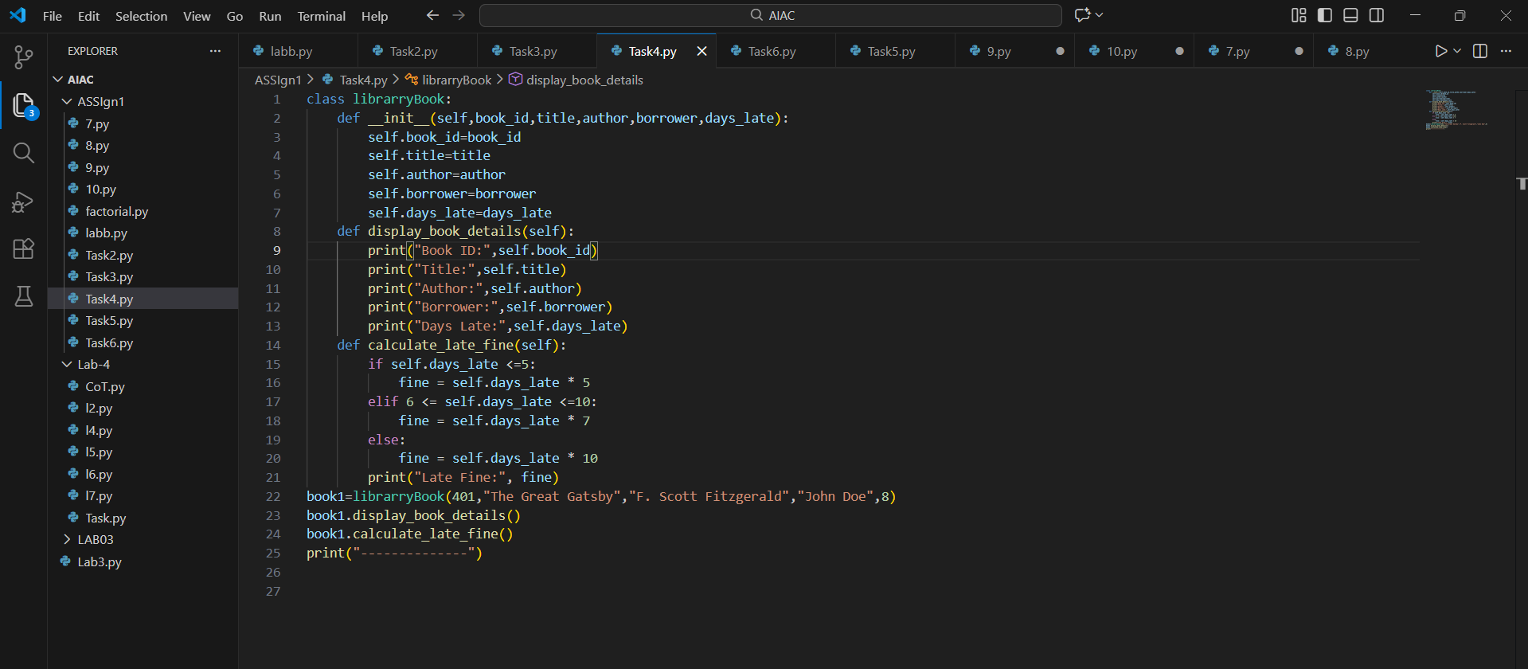
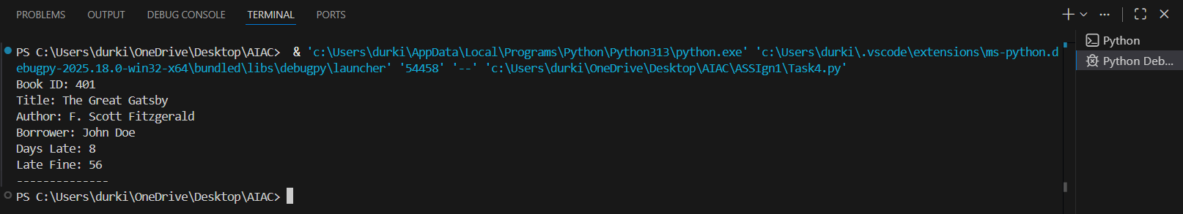

Task 5:
Student report
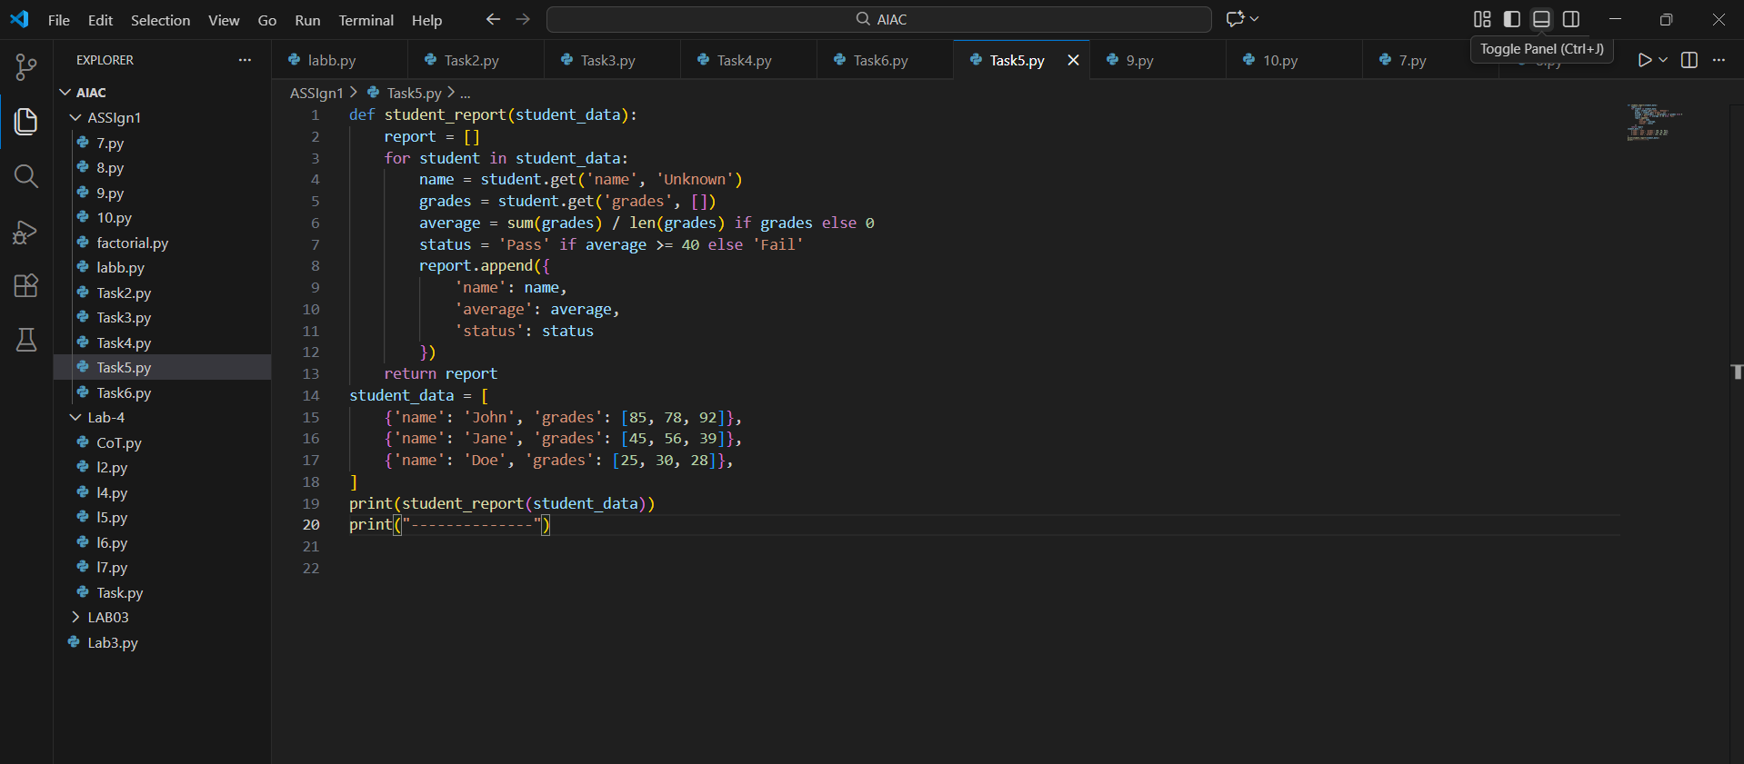
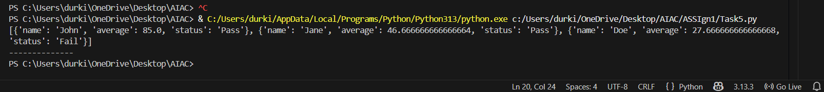
Task 6:
TaxiRide
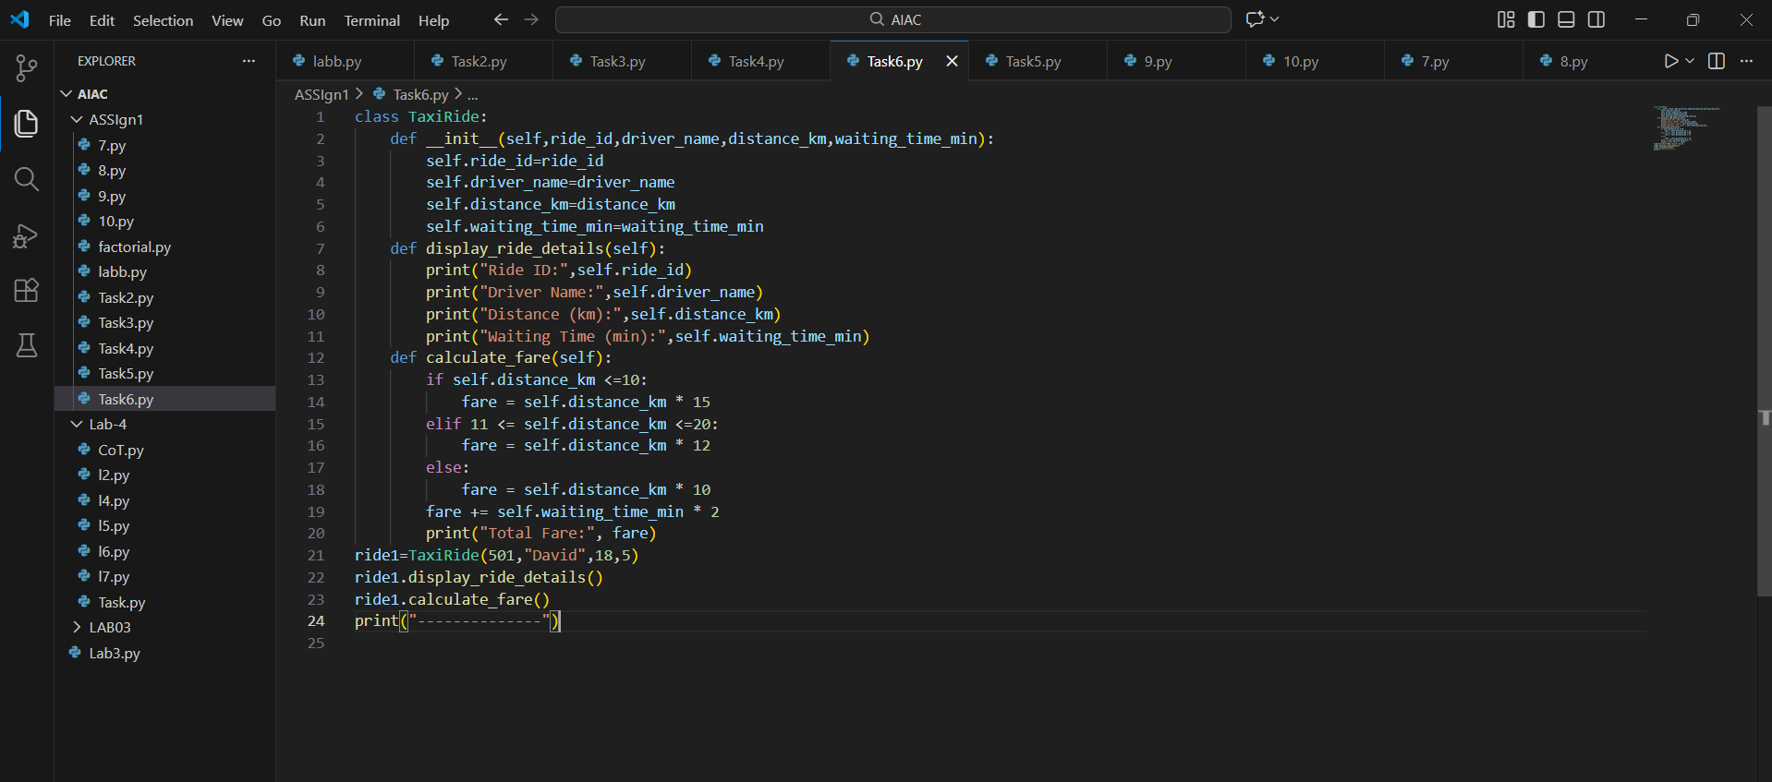
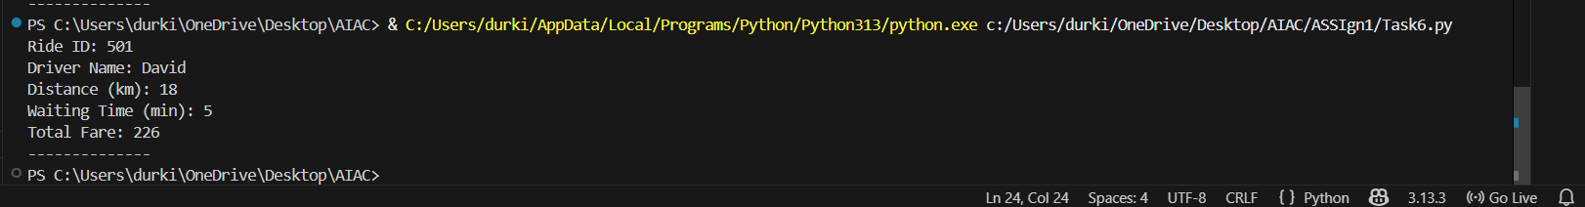
Task 7:
Statistics_sub(student report)
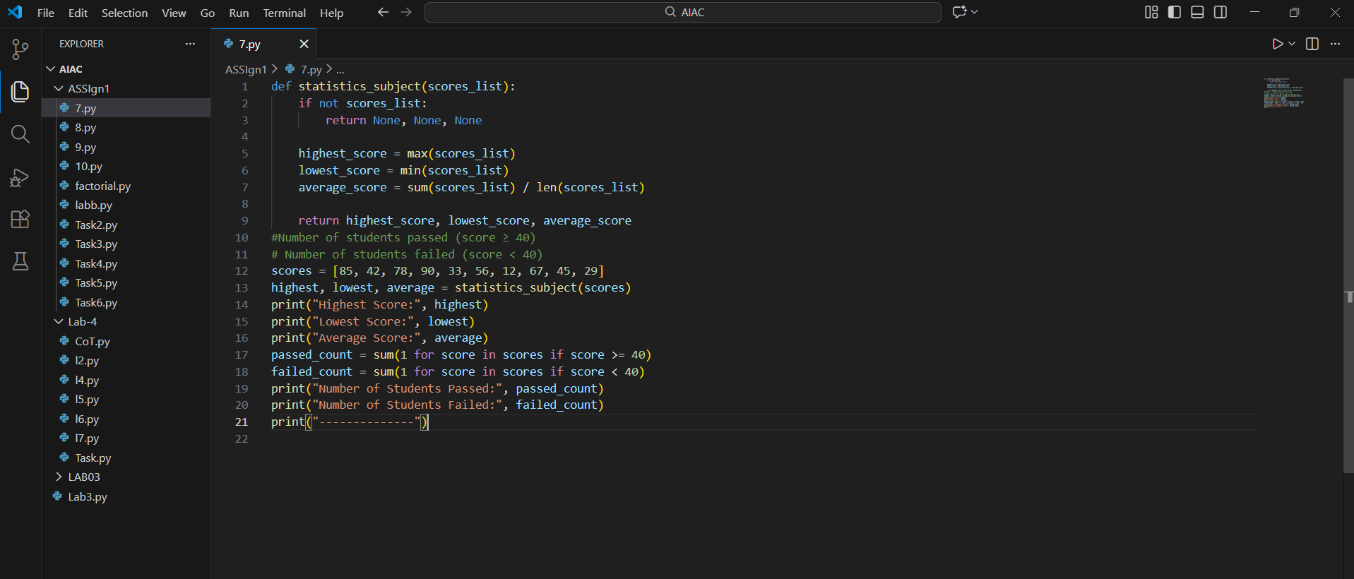
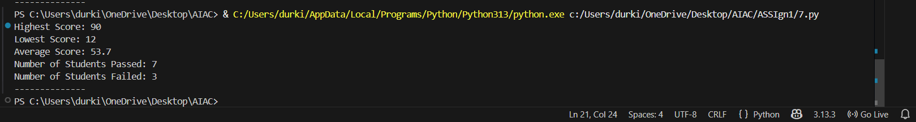

Task 8:
Prime number – Naïve approach , optimized
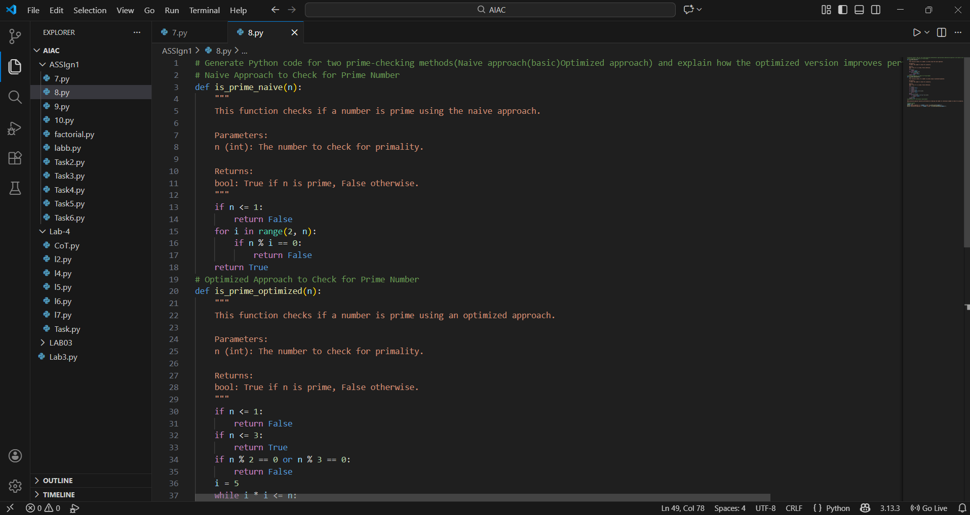
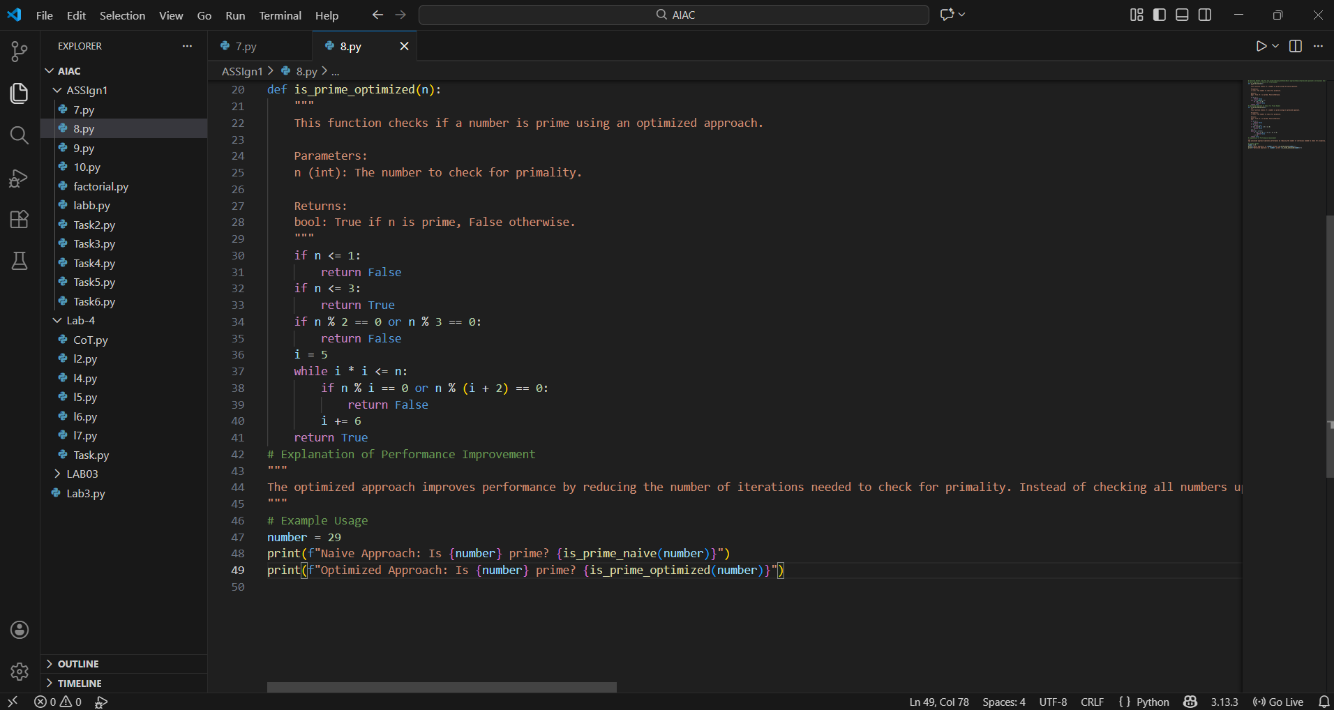
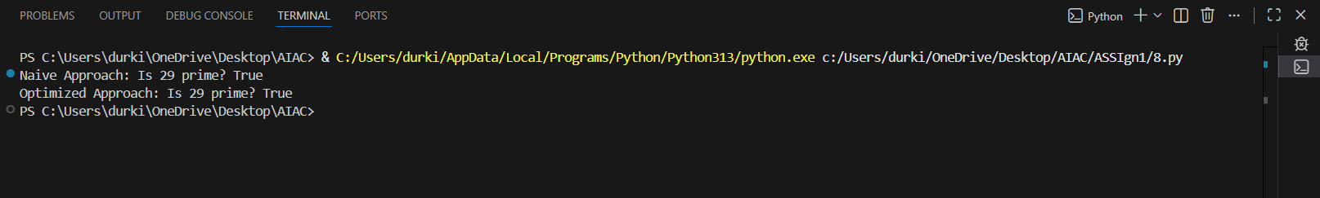
Explanation:
In this, two methods are used to check whether a number is prime: a naïve approach and an optimized approach.
Naïve method:
The naïve method checks divisibility from 2 to n−1, which takes O(n) time and is slow for large numbers.
Optimized method:
The optimized method checks divisibility only up to √n, reducing the time complexity to O(√n).
This optimization improves performance while maintaining transparency in the algorithm design.

Task 9:
Fibonacci series using recursion
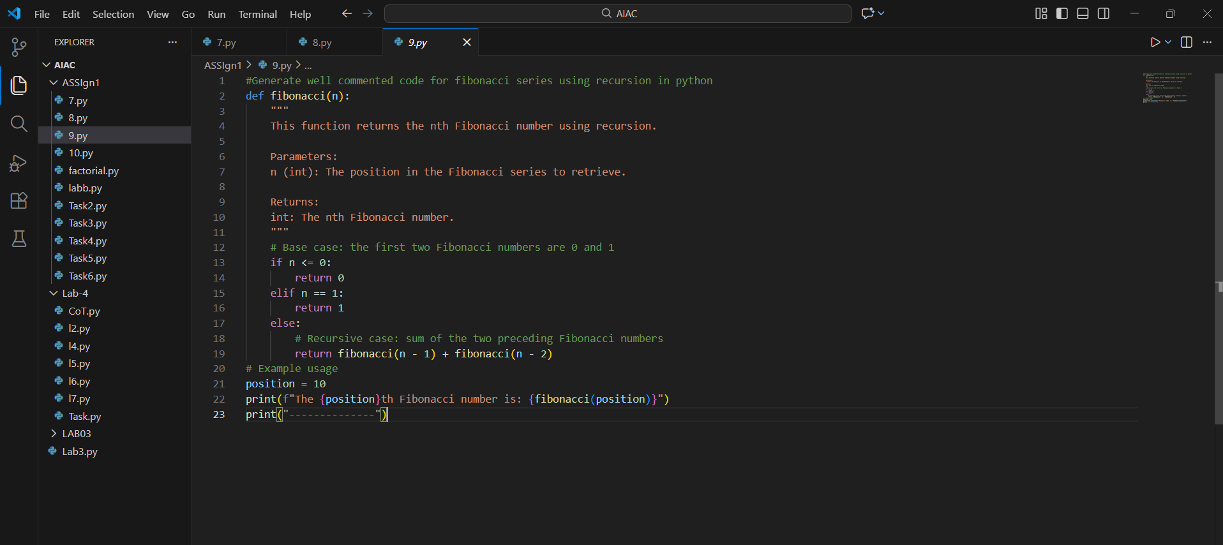
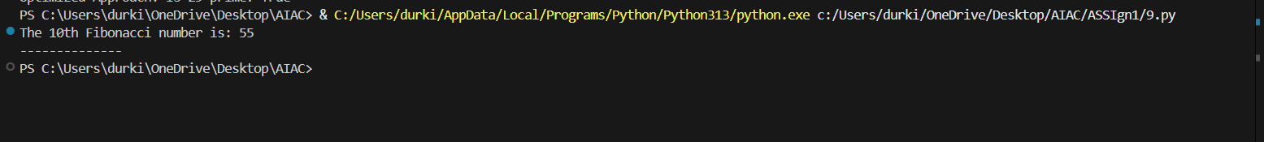

Task 10:
Divide number
