AIAC-ASSIGNMENT-11.2
NAME:J.Varshitha
BATCH : 32
HNO:2303A52413
Task Description #1 – Stack Implementation
Task: Use AI to generate a Stack class with push, pop, peek, and is_empty
methods.
Sample Input Code:
class Stack:
pass
Expected Output:
• A functional stack implementation with all required methods and
docstrings.
# generate a python code to demonstrate stack and its operations
class Stack:
def __init__(self):
self.items = []

def is_empty(self):
return len(self.items) == 0

def push(self, item):
self.items.append(item)

def pop(self):
if not self.is_empty():
return self.items.pop()
else:
raise IndexError("pop from empty stack")

def peek(self):
if not self.is_empty():
return self.items[-1]
else:
raise IndexError("peek from empty stack")

def size(self):
return len(self.items)

# example
stack = Stack()
stack.push(1)
stack.push(2)
stack.push(3)
print(stack.peek()) # Output: 3
print(stack.size()) # Output: 3
print(stack.pop()) # Output: 3
print(stack.pop()) # Output: 2
print(stack.is_empty()) # Output: False

Task Description #2 – Queue Implementation
Task: Use AI to implement a Queue using Python lists.
Sample Input Code:
class Queue:
pass
Expected Output:
• FIFO-based queue class with enqueue, dequeue, peek, and size
methods.
# generate a python code to demonstrate queue and its operations
class Queue:
def __init__(self):
self.items = []

def is_empty(self):
return len(self.items) == 0

def enqueue(self, item):
self.items.append(item)

def dequeue(self):
if not self.is_empty():
return self.items.pop(0)
else:
raise IndexError("dequeue from empty queue")

def peek(self):
if not self.is_empty():
return self.items[0]
else:
raise IndexError("peek from empty queue")

def size(self):
return len(self.items)
#example
queue = Queue()
queue.enqueue(1)
queue.enqueue(2)
queue.enqueue(3)
print(queue.peek()) # Output: 1
print(queue.size()) # Output: 3
print(queue.dequeue()) # Output: 1
print(queue.dequeue()) # Output: 2
print(queue.is_empty()) # Output: False

Task Description #3 – Linked List
Task: Use AI to generate a Singly Linked List with insert and display
methods.
Sample Input Code:
class Node:
pass
class LinkedList:
pass
Expected Output:
• A working linked list implementation with clear method
documentation.
# generate a python code to demonstrate linked list and its operations
class Node:
def __init__(self, data):
self.data = data
self.next = None
class LinkedList:
def __init__(self):
self.head = None

def is_empty(self):
return self.head is None

def append(self, data):
new_node = Node(data)
if self.is_empty():
self.head = new_node
return
last_node = self.head
while last_node.next:
last_node = last_node.next
last_node.next = new_node

def delete(self, key):
current_node = self.head
previous_node = None
while current_node and current_node.data != key:
previous_node = current_node
current_node = current_node.next
if current_node is None:
return # Key not found
if previous_node is None:
self.head = current_node.next # Deleting the head node
else:
previous_node.next = current_node.next # Bypass the node to delete

def search(self, key):
current_node = self.head
while current_node:
if current_node.data == key:
return True
current_node = current_node.next
return False

def size(self):
count = 0
current_node = self.head
while current_node:
count += 1
current_node = current_node.next
return count
# example
linked_list = LinkedList()
linked_list.append(1)
linked_list.append(2)
linked_list.append(3)
print(linked_list.search(2)) # Output: True
print(linked_list.size()) # Output: 3
linked_list.delete(2)
print(linked_list.search(2)) # Output: False
print(linked_list.size()) # Output: 2

Task Description #4 – Binary Search Tree (BST)
Task: Use AI to create a BST with insert and in-order traversal methods.
Sample Input Code:
class BST:
pass
Expected Output:
• BST implementation with recursive insert and traversal methods.
# generate a python code to demonstrate binary search tree and its operations
class TreeNode:
def __init__(self, key):
self.left = None
self.right = None
self.val = key
class BinarySearchTree:
def __init__(self):
self.root = None

def insert(self, key):
if self.root is None:
self.root = TreeNode(key)
else:
self._insert_recursively(self.root, key)

def _insert_recursively(self, node, key):
if key < node.val:
if node.left is None:
node.left = TreeNode(key)
else:
self._insert_recursively(node.left, key)
else:
if node.right is None:
node.right = TreeNode(key)
else:
self._insert_recursively(node.right, key)

def search(self, key):
return self._search_recursively(self.root, key)

def _search_recursively(self, node, key):
if node is None:
return False
if node.val == key:
return True
elif key < node.val:
return self._search_recursively(node.left, key)
else:
return self._search_recursively(node.right, key)

def inorder_traversal(self):
return self._inorder_traversal_recursively(self.root)

def _inorder_traversal_recursively(self, node):
res = []
if node:
res = self._inorder_traversal_recursively(node.left)
res.append(node.val)
res = res + self._inorder_traversal_recursively(node.right)
return res
# example
bst = BinarySearchTree()
bst.insert(5)
bst.insert(3)
bst.insert(7)
print(bst.search(3)) # Output: True
print(bst.search(4)) # Output: False
print(bst.inorder_traversal()) # Output: [3, 5, 7]

Task Description #5 – Hash Table
Task: Use AI to implement a hash table with basic insert, search, and
delete methods.
Sample Input Code:
class HashTable:
pass
Expected Output:
• Collision handling using chaining, with well-commented methods.
# generate a python code to demonstrate hash table and its operations
class HashTable:
def __init__(self):
self.table = {}

def insert(self, key, value):
self.table[key] = value

def delete(self, key):
if key in self.table:
del self.table[key]

def search(self, key):
return self.table.get(key, None)

def size(self):
return len(self.table)
# example
hash_table = HashTable()
hash_table.insert("name", "Alice")
hash_table.insert("age", 30)
print(hash_table.search("name")) # Output: Alice
print(hash_table.size()) # Output: 2
hash_table.delete("age")
print(hash_table.search("age")) # Output: None
print(hash_table.size()) # Output: 1

Task Description #6 – Graph Representation
Task: Use AI to implement a graph using an adjacency list.
Sample Input Code:
class Graph:
pass
Expected Output:
• Graph with methods to add vertices, add edges, and display
connections.
# generate a python code to demonstrate graph and its operations
class Graph:
def __init__(self):
self.graph = {}

def add_edge(self, u, v):
if u not in self.graph:
self.graph[u] = []
if v not in self.graph:
self.graph[v] = []
self.graph[u].append(v)
self.graph[v].append(u) # For undirected graph

def bfs(self, start):
visited = set()
queue = [start]
while queue:
vertex = queue.pop(0)
if vertex not in visited:
print(vertex, end=' ')
visited.add(vertex)
queue.extend(set(self.graph[vertex]) - visited)

def dfs(self, start, visited=None):
if visited is None:
visited = set()
if start not in visited:
print(start, end=' ')
visited.add(start)
for neighbor in self.graph[start]:
self.dfs(neighbor, visited)

# example
graph = Graph()
graph.add_edge(0, 1)
graph.add_edge(0, 2)
graph.add_edge(1, 2)
graph.add_edge(2, 0)
graph.add_edge(2, 3)
print("Breadth-First Search starting from vertex 2:")
graph.bfs(2) # Output: 2 0 3 1
print("\nDepth-First Search starting from vertex 2:")
graph.dfs(2) # Output: 2 0 1 3

Task Description #7 – Priority Queue
Task: Use AI to implement a priority queue using Python’s heapq
module.
Sample Input Code:
class PriorityQueue:
pass
Expected Output:
• Implementation with enqueue (priority), dequeue (highest priority),
and display methods.
# generate a python code to demonstrate priority queue and its operations
import heapq
class PriorityQueue:
def __init__(self):
self.elements = []

def is_empty(self):
return not self.elements

def put(self, item, priority):
heapq.heappush(self.elements, (priority, item))

def get(self):
return heapq.heappop(self.elements)[1]

def peek(self):
return self.elements[0][1] if self.elements else None

def size(self):
return len(self.elements)
# example
priority_queue = PriorityQueue()
priority_queue.put("task1", 2)
priority_queue.put("task2", 1)
print(priority_queue.peek()) # Output: task2
print(priority_queue.size()) # Output: 2
print(priority_queue.get()) # Output: task2
print(priority_queue.get()) # Output: task1

Task Description #8 – Deque
Task: Use AI to implement a double-ended queue using
collections.deque.
Sample Input Code:
class DequeDS:
pass
Expected Output:
• Insert and remove from both ends with docstrings.
# generate a python code to demonstrate deque and its operations
class Deque:
def __init__(self):
self.items = []

def is_empty(self):
return len(self.items) == 0

def add_front(self, item):
self.items.insert(0, item)

def add_rear(self, item):
self.items.append(item)

def remove_front(self):
if not self.is_empty():
return self.items.pop(0)
else:
raise IndexError("remove from empty deque")

def remove_rear(self):
if not self.is_empty():
return self.items.pop()
else:
raise IndexError("remove from empty deque")

def peek_front(self):
if not self.is_empty():
return self.items[0]
else:
raise IndexError("peek from empty deque")

def peek_rear(self):
if not self.is_empty():
return self.items[-1]
else:
raise IndexError("peek from empty deque")

def size(self):
return len(self.items)
# example
deque = Deque()
deque.add_rear(1)
deque.add_rear(2)
deque.add_front(0)
print(deque.peek_front()) # Output: 0
print(deque.peek_rear()) # Output: 2
print(deque.size()) # Output: 3
print(deque.remove_front()) # Output: 0
print(deque.remove_rear()) # Output: 2
print(deque.is_empty()) # Output: False

Task Description #9 Real-Time Application Challenge – Choose the
Right Data Structure
Scenario:
Your college wants to develop a Campus Resource Management System
that handles:
1. Student Attendance Tracking – Daily log of students
entering/exiting the campus.
2. Event Registration System – Manage participants in events with
quick search and removal.
3. Library Book Borrowing – Keep track of available books and their
due dates.
4. Bus Scheduling System – Maintain bus routes and stop
connections.
5. Cafeteria Order Queue – Serve students in the order they arrive.
Student Task:
• For each feature, select the most appropriate data structure from
the list below:
o Stack
o Queue
o Priority Queue
o Linked List
o Binary Search Tree (BST)
o Graph
o Hash Table
o Deque
• Justify your choice in 2–3 sentences per feature.
Feature | Data Structure | Justification
Student Attendance Tracking | Queue | Students enter and exit in order. Queue follows FIFO which perfectly matches attendance logging order.
Event Registration System | Hash Table | Participants can be searched quickly using ID or name. Hash tables provide constant-time lookup.
Library Book Borrowing | Linked List | Books can be added or removed dynamically. Linked list supports flexible insertions and deletions.
Bus Scheduling System | Graph | Bus routes and stops form network connections. Graph represents these relationships efficiently.
Cafeteria Order Queue | Queue | Orders are served in the order students arrive. Queue ensures FIFO processing.

• Implement one selected feature as a working Python program with
AI-assisted code generation.
Expected Output:
• A table mapping feature → chosen data structure → justification.
• A functional Python program implementing the chosen feature
with comments and docstrings.
# generate a python code for bus scheduling system using graph data structure
class Graph:
def __init__(self):
self.graph = {}
def add_edge(self, u, v):
if u not in self.graph:
self.graph[u] = []
if v not in self.graph:
self.graph[v] = []
self.graph[u].append(v)
self.graph[v].append(u) # For undirected graph
def bfs(self, start):
visited = set()
queue = [start]
while queue:
vertex = queue.pop(0)
if vertex not in visited:
print(vertex, end=' ')
visited.add(vertex)
queue.extend(set(self.graph[vertex]) - visited)
def dfs(self, start, visited=None):
if visited is None:
visited = set()
if start not in visited:
print(start, end=' ')
visited.add(start)
for neighbor in self.graph[start]:
self.dfs(neighbor, visited)
# example
bus_schedule = Graph()
bus_schedule.add_edge("Stop A", "Stop B")
bus_schedule.add_edge("Stop A", "Stop C")
bus_schedule.add_edge("Stop B", "Stop D")
bus_schedule.add_edge("Stop C", "Stop D")
print("Bus route from Stop A:")
bus_schedule.bfs("Stop A") # Output: Stop A Stop B Stop C Stop D
print("\nBus route from Stop A (DFS):")
bus_schedule.dfs("Stop A") # Output: Stop A Stop B Stop D Stop C

Task Description #10: Smart Hospital Management System – Data
Structure Selection
A hospital wants to develop a Smart Hospital Management System that
handles:
1. Patient Check-In System – Patients are registered and treated in
order of arrival.
2. Emergency Case Handling – Critical patients must be treated first.
3. Medical Records Storage – Fast retrieval of patient details using
ID.
4. Doctor Appointment Scheduling – Appointments sorted by time.
5. Hospital Room Navigation – Represent connections between
wards and rooms.
Student Task
• For each feature, select the most appropriate data structure from
the list below:
o Stack
o Queue
o Priority Queue
o Linked List
o Binary Search Tree (BST)
o Graph
o Hash Table
o Deque
• Justify your choice in 2–3 sentences per feature.
Feature | Data Structure | Justification
Patient Check-In | Queue | Patients are treated in order of arrival.
Emergency Case Handling | Priority Queue | Critical patients must be treated first.
Medical Records | Hash Table | Fast retrieval using patient ID.
Doctor Appointment Scheduling | BST | Appointments sorted by time efficiently.
Hospital Navigation | Graph | Wards and rooms connected like nodes in a network.

• Implement one selected feature as a working Python program with
AI-assisted code generation.
Expected Output:
• A table mapping feature → chosen data structure → justification.
• A functional Python program implementing the chosen feature
with comments and docstrings.
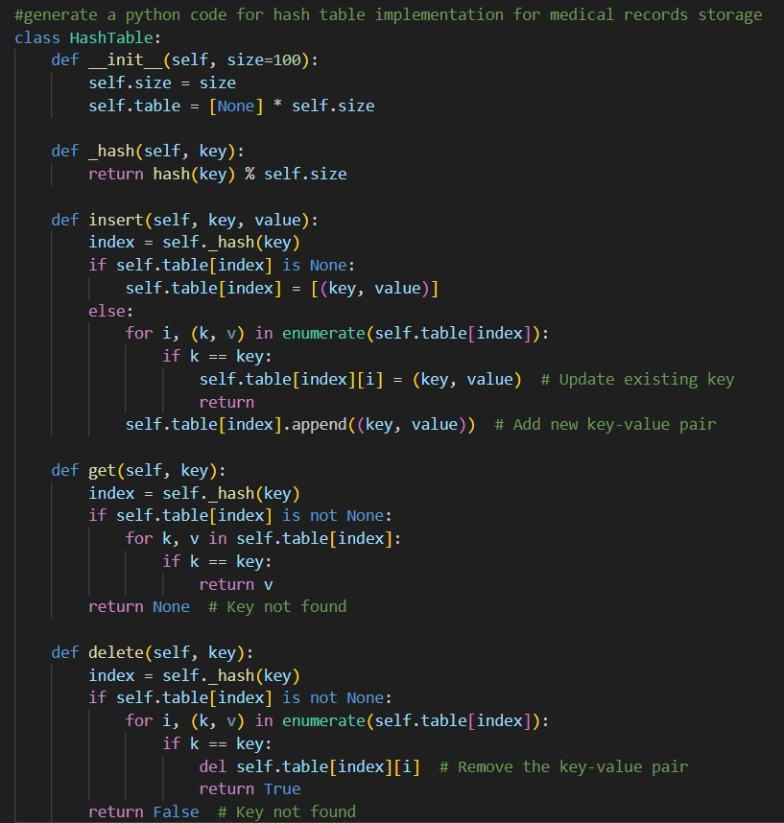
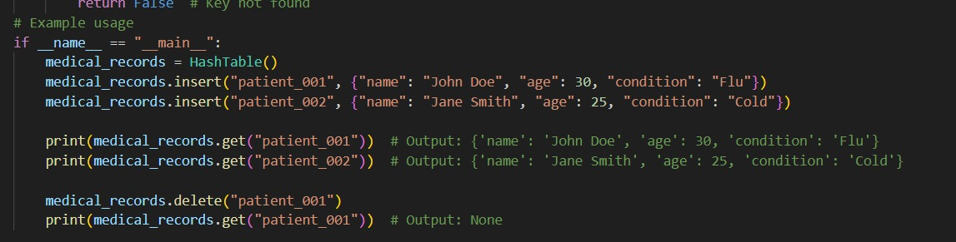
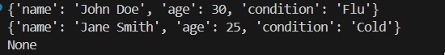
Task Description #11: Smart City Traffic Control System
A city plans a Smart Traffic Management System that includes:
1. Traffic Signal Queue – Vehicles waiting at signals.
2. Emergency Vehicle Priority Handling – Ambulances and fire trucks
prioritized.
3. Vehicle Registration Lookup – Instant access to vehicle details.
4. Road Network Mapping – Roads and intersections connected
logically.
5. Parking Slot Availability – Track available and occupied slots.
Student Task
• For each feature, select the most appropriate data structure from
the list below:
o Stack
o Queue
o Priority Queue
o Linked List
o Binary Search Tree (BST)
o Graph
o Hash Table
o Deque
• Justify your choice in 2–3 sentences per feature.
Feature | Data Structure | Justification
Traffic Signal Queue | Queue | Vehicles wait in arrival order.
Emergency Vehicle Handling | Priority Queue | Ambulances/fire trucks must move first.
Vehicle Registration Lookup | Hash Table | Fast vehicle lookup using registration number.
Road Network Mapping | Graph | Roads and intersections form network connections.
Parking Slot Availability | Hash Table | Quickly check free or occupied slots.

• Implement one selected feature as a working Python program with
AI-assisted code generation.
Expected Output:
• A table mapping feature → chosen data structure → justification.
• A functional Python program implementing the chosen feature
with comments and docstrings.
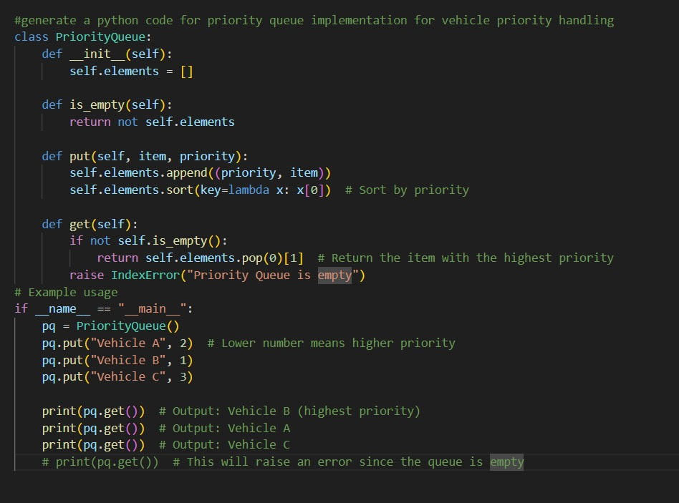
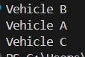
Task Description #12: Smart E-Commerce Platform – Data Structure
Challenge
An e-commerce company wants to build a Smart Online Shopping System
with:
1. Shopping Cart Management – Add and remove products
dynamically.
2. Order Processing System – Orders processed in the order they are
placed.
3. Top-Selling Products Tracker – Products ranked by sales count.
4. Product Search Engine – Fast lookup of products using product ID.
5. Delivery Route Planning – Connect warehouses and delivery
locations.
Student Task
• For each feature, select the most appropriate data structure from
the list below:
o Stack
o Queue
o Priority Queue
o Linked List
o Binary Search Tree (BST)
o Graph
o Hash Table
o Deque
• Justify your choice in 2–3 sentences per feature.
Feature | Data Structure | Justification
Shopping Cart | Linked List | Items can be added or removed dynamically.
Order Processing | Queue | Orders processed in order placed.
Top Selling Products | Priority Queue | Products ranked by sales count.
Product Search | Hash Table | Instant lookup using product ID.
Delivery Route Planning | Graph | Warehouses and delivery points form a network.

• Implement one selected feature as a working Python program with
AI-assisted code generation.
Expected Output:
• A table mapping feature → chosen data structure → justification.
• A functional Python program implementing the chosen feature
with comments and docstrings.
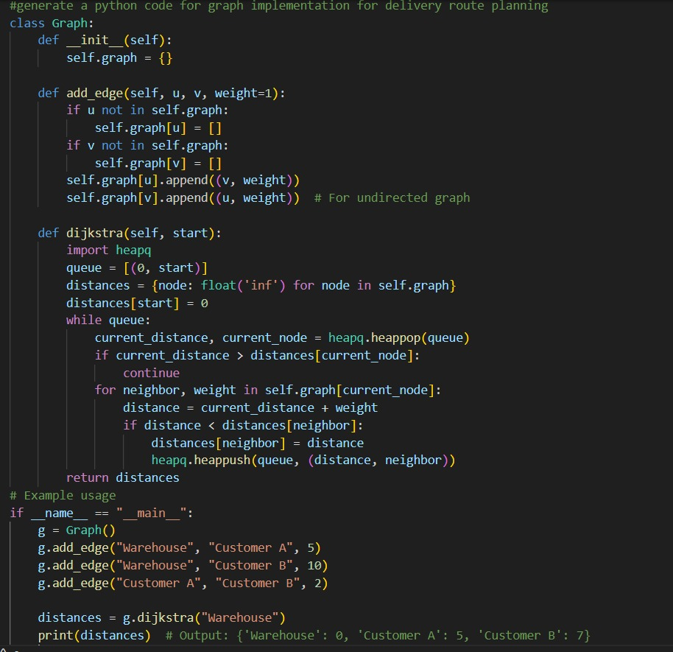

Task Description #14: Smart Banking Management System – Data
Structure Challenge
A bank plans to develop a Smart Banking System that includes:
1. Customer Service Token System – Customers are served in order
of arrival.
2. Loan Approval Priority Handling – High-value or urgent loans
processed first.
3. Account Information Lookup – Fast retrieval of customer details
using Account Number.
4. Transaction History Management – Maintain chronological
transaction records.
5. ATM Network Connectivity – Represent connections between
ATMs across cities.
Student Task:
• For each feature, select the most appropriate data structure from
the list below:
o Stack
o Queue
o Priority Queue
o Linked List
o Binary Search Tree (BST)
o Graph
o Hash Table
o Deque
• Justify your choice in 2–3 sentences per feature.
Feature | Data Structure | Justification
Customer Token System | Queue | Customers served in order of arrival.
Loan Approval Priority | Priority Queue | High-value loans processed first.
Account Lookup | Hash Table | Fast retrieval using account number.
Transaction History | Linked List | Transactions stored sequentially.
ATM Connectivity | Graph | ATMs across cities connected via network.

• Implement one selected feature as a working Python program
with AI-assisted code generation.
Expected Output:
• A table mapping feature → chosen data structure → justification.
• A functional Python program implementing the chosen feature
with comments and docstrings.
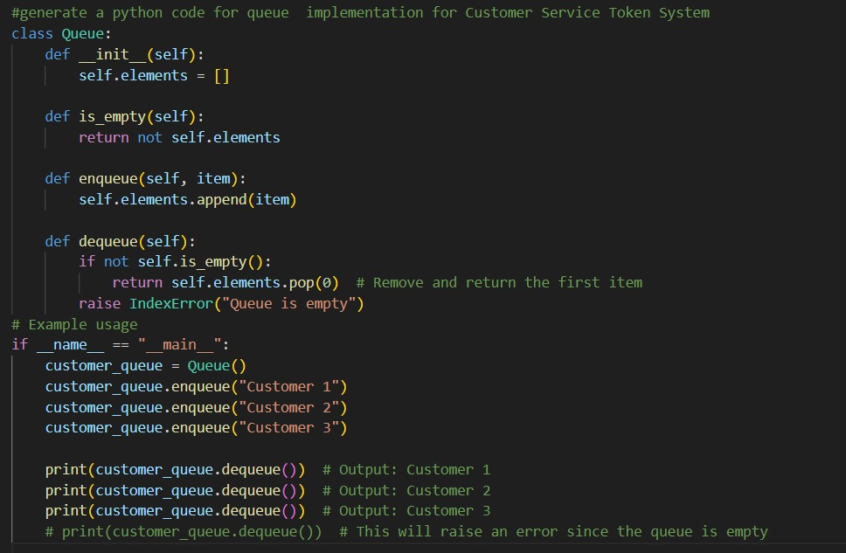
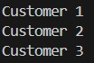
Task Description #15: Online Learning Management System – Data
Structure Selection
An online education platform wants to develop a Learning Management
System that handles:
1. Student Login Authentication – Quick validation of user
credentials.
2. Assignment Submission Queue – Submissions processed in order
of upload.
3. Top Performer Ranking – Rank students based on scores.
4. Course Prerequisite Structure – Represent subject dependencies.
5. Undo Feature in Online Editor – Reverse recent actions.
Student Task:
• Select the most appropriate data structure for each feature from
the given list.
• Justify your selection in 2–3 sentences per feature.
Feature | Data Structure | Justification
Student Login Authentication | Hash Table | Quick username/password lookup.
Assignment Submission | Queue | Submissions processed in order received.
Top Performer Ranking | Priority Queue | Students ranked by highest score.
Course Prerequisites | Graph | Courses depend on other courses.
Undo Feature | Stack | Undo follows LIFO order of actions.

• Implement one selected feature in Python using AI-assisted code
generation.
Expected Output:
• Feature → Data Structure → Justification table.
• Functional Python program with proper documentation.
