ASSIGNMENT 5.1
2303A52413
J.Varshitha
Batch : 32
Task 1:
Employee Data: Create Python code that defines a class named
`Employee` with the following attributes: `empid`, `empname`,
`designation`, `basic_salary`, and `exp`. Implement a method
`display_details()` to print all employee details. Implement another
method `calculate_allowance()` to determine additional allowance
based on experience:
- If `exp > 10 years` → allowance = 20% of `basic_salary`
- If `5 ≤ exp ≤ 10 years` → allowance = 10% of `basic_salary`
- If `exp < 5 years` → allowance = 5% of `basic_salary`
Finally, create at least one instance of the `Employee` class, call the
`display_details()` method, and print the calculated allowance.
Code:
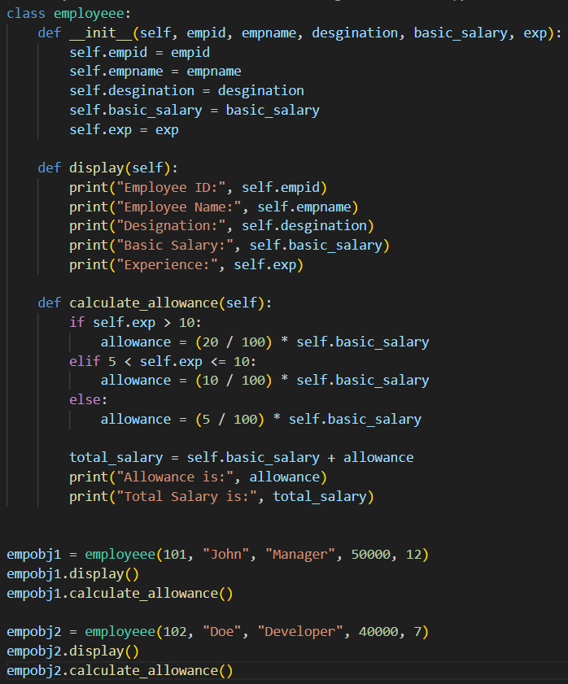
Output:
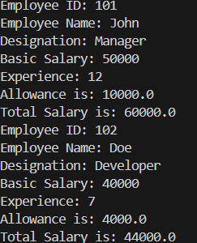
Suggestion:
You should create an Employee class to store employee details like ID, name, designation, salary, and experience.Add a method to display all employee information in a readable format.Implement another method that calculates allowance using conditional statements based on years of experience.Finally, create an object of the class and call both methods to show employee details and allowance.
Task 2:
Electricity Bill Calculation- Create Python code that defines a class
named `ElectricityBill` with attributes: `customer_id`, `name`, and
`units_consumed`. Implement a method `display_details()` to print
customer details, and a method `calculate_bill()` where:
- Units ≤ 100 → ₹5 per unit
- 101 to 300 units → ₹7 per unit
- More than 300 units → ₹10 per unit
Create a bill object, display details, and print the total bill amount
Code:
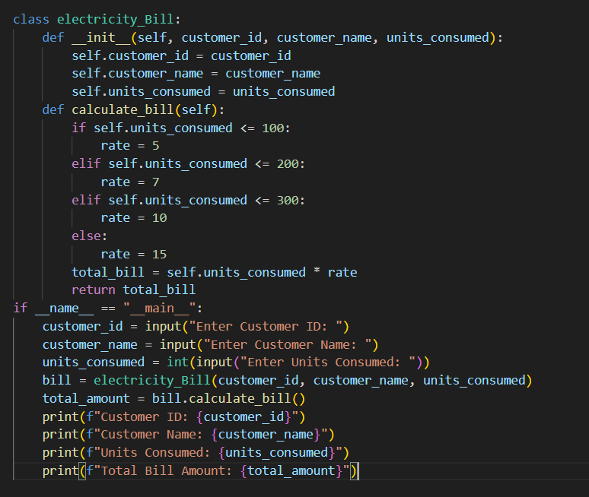
Output:
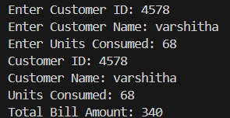
Suggestion:
Create an ElectricityBill class to store customer ID, name, and units consumed.
Use a display_details() method to neatly print the customer information.
Implement a calculate_bill() method with conditional logic to apply different rates based on unit ranges.Finally, create an object of the class and display the total bill amount.

Task 3:
Product Discount Calculation- Create Python code that defines a
class named `Product` with attributes: `product_id`, `product_name`,
`price`, and `category`. Implement a method `display_details()` to
print product details. Implement another method
`calculate_discount()` where:
- Electronics → 10% discount
- Clothing → 15% discount
- Grocery → 5% discount
Create at least one product object, display details, and print the final
price after discount.
Code:
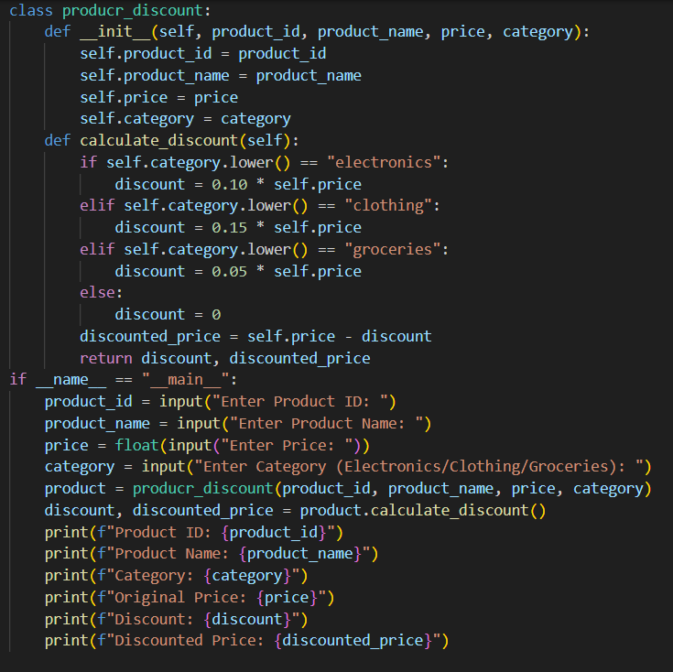
Output:
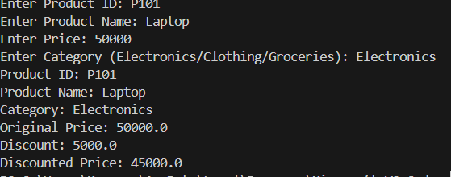

Suggestion:
Create a Product class to store product ID, name, price, and category.
Use a display_details() method to show all product information clearly.
Implement a calculate_discount() method using conditional statements to apply discounts based on the product category.
Finally, create a product object, display its details, and print the final price after applying the discount.

Task 4:
Book Late Fee Calculation- Create Python code that defines a class
named `LibraryBook` with attributes: `book_id`, `title`, `author`,
`borrower`, and `days_late`. Implement a method `display_details()`
to print book details, and a method `calculate_late_fee()` where:
- Days late ≤ 5 → ₹5 per day
- 6 to 10 days late → ₹7 per day
- More than 10 days late → ₹10 per day
Create a book object, display details, and print the late fee
Code:
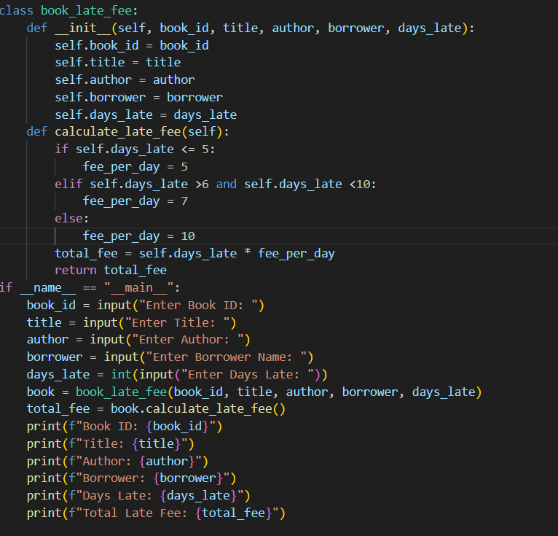

Output:
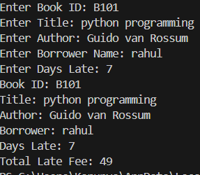

Suggestion:
Create a LibraryBook class to store book details such as ID, title, author, borrower, and days late.Use a display_details() method to neatly print all book information.Implement a calculate_late_fee() method using conditional statements to apply different charges based on the number of late days.
Finally, create a book object, display its details, and print the total late fee.

Task 5:
Student Performance Report - Define a function
`student_report(student_data)` that accepts a dictionary containing
student names and their marks. The function should:
- Calculate the average score for each student
- Determine pass/fail status (pass ≥ 40)
- Return a summary report as a list of dictionaries
Use Copilot suggestions as you build the function and format the
Output
Code:
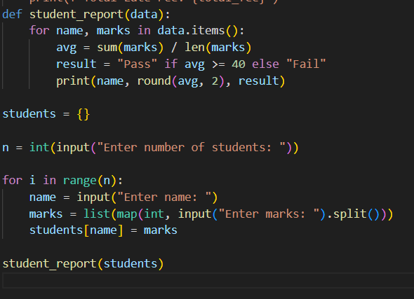
Output:
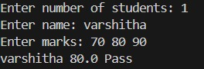
Suggestion:
Create a student_report() function that takes a dictionary of student names and their marks as input.Loop through each student to calculate their average score.Use conditional statements to determine pass or fail based on the average (≥ 40).Store each student’s summary in a list of dictionaries and return it as the final report.
Task 6:
Taxi Fare Calculation-Create Python code that defines a class named
`TaxiRide` with attributes: `ride_id`, `driver_name`, `distance_km`,
and `waiting_time_min`. Implement a method `display_details()` to
print ride details, and a method `calculate_fare()` where:
- ₹15 per km for the first 10 km
- ₹12 per km for the next 20 km
- ₹10 per km above 30 km
- Waiting charge: ₹2 per minute
Create a ride object, display details, and print the total fare.

Code:
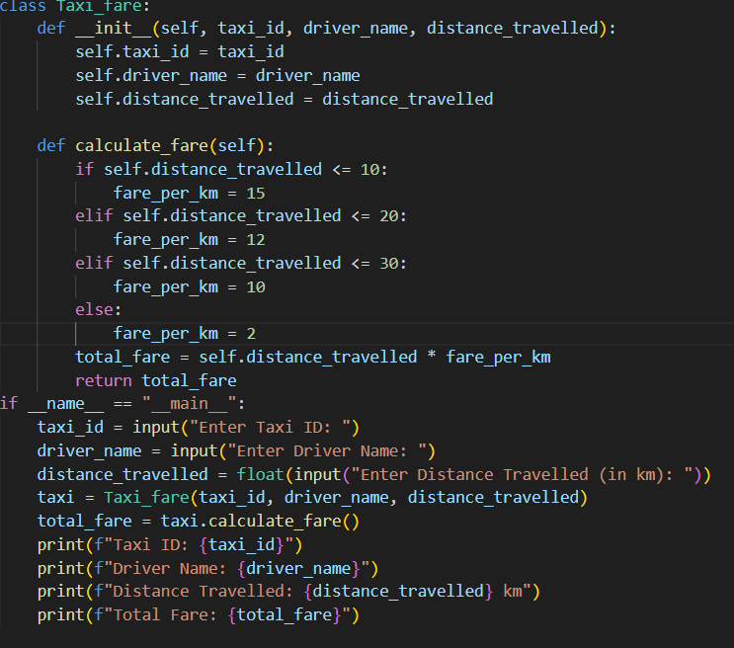
Output:
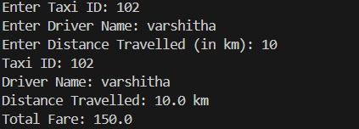
Suggestion:
Create a TaxiRide class to store ride details such as ride ID, driver name, distance traveled, and waiting time.Use a display_details() method to show all ride information clearly.Implement a calculate_fare() method using conditional logic to apply different per-kilometer rates and add waiting charges.
Finally, create a ride object, display its details, and print the total fare amount.

Task 7:
Statistics Subject Performance - Create a Python function
`statistics_subject(scores_list)` that accepts a list of 60 student scores
and computes key performance statistics. The function should return
the following:
- Highest score in the class
- Lowest score in the class
- Class average score
- Number of students passed (score ≥ 40)
- Number of students failed (score < 40)
Allow Copilot to assist with aggregations and logic
Prompt:
Code:
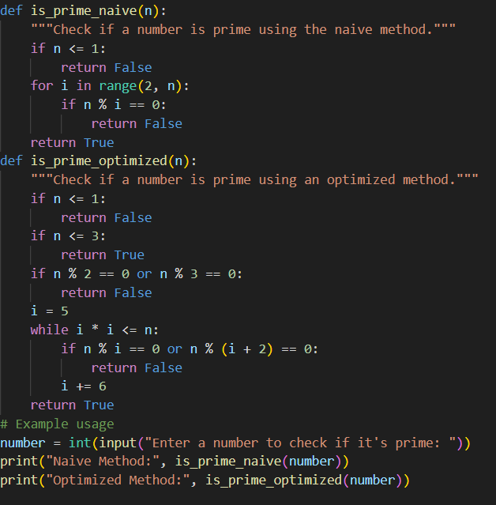

Output:
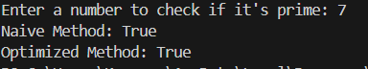

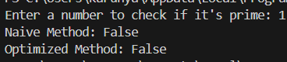
Suggestion:
Create a statistics_subject() function that takes a list of student scores as input.
Use built-in functions like max(), min(), and sum() to compute highest, lowest, and average scores.Apply conditional checks to count how many students passed and failed based on the 40 mark threshold.Return all calculated statistics in a structured format such as a dictionary or tuple.

Task Description #8
(Transparency in Algorithm Optimization)
Task: Use AI to generate two solutions for checking prime numbers:
• Naive approach(basic)
• Optimized approach
Prompt:
“Generate Python code for two prime-checking methods and explain
how the optimized version improves performance.”
Expected Output:
• Code for both methods.
• Transparent explanation of time complexity.
• Comparison highlighting efficiency improvements
Prompt:

Code:
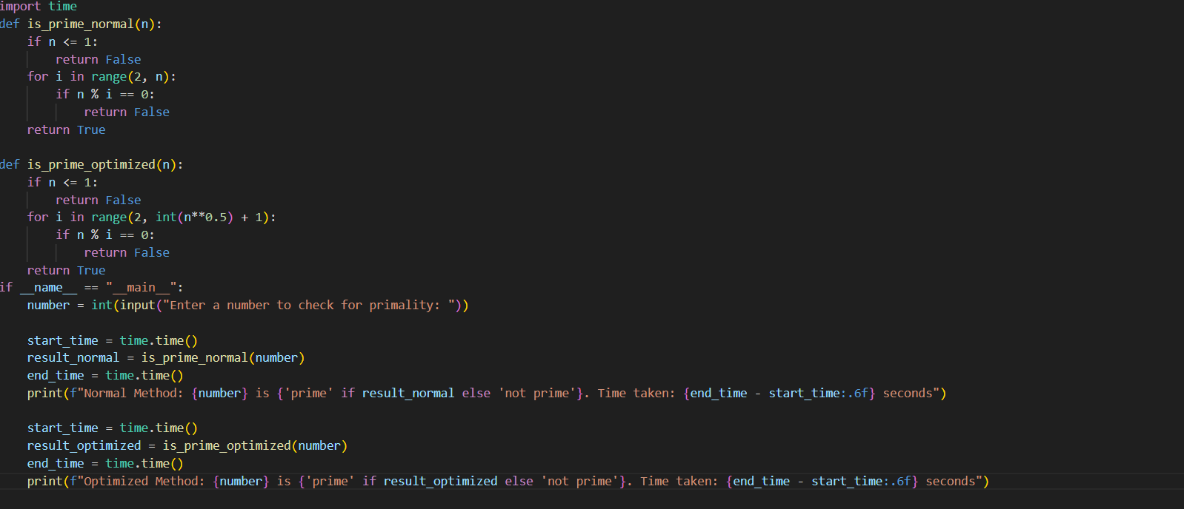
Output:
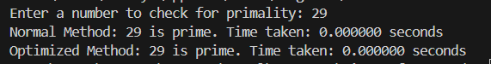
Suggestion:
The naive prime-checking method tests divisibility from 2 up to the number itself, which takes more time.The optimized method only checks divisibility up to the square root of the number.This works because any factor larger than √n must have a smaller matching factor.As a result, the optimized approach reduces unnecessary checks.This makes it much faster and more efficient for large numbers.
Task Description #9
(Transparency in Recursive Algorithms)
Objective: Use AI to generate a recursive function to calculate
Fibonacci numbers.
Instructions:
1. Ask AI to add clear comments explaining recursion.
2. Ask AI to explain base cases and recursive calls.
Expected Output:
• Well-commented recursive code.
• Clear explanation of how recursion works.
• Verification that explanation matches actual execution
Prompt:

Code:
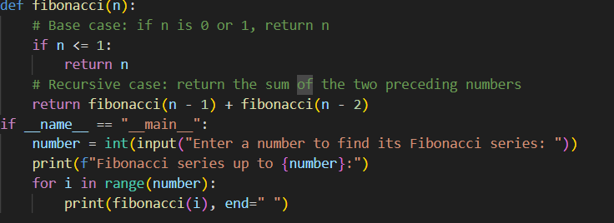
Output:
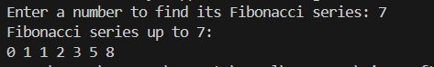
Suggestion:
The recursive Fibonacci function works by calling itself to find earlier Fibonacci values until it reaches base cases like 0 or 1, where the f
unction stops. These base cases prevent infinite recursion and give direct results. Each recursive call solves a smaller version of the same problem, making the logic easy to follow. Clear comments explain how the function moves between calls. The explanation matches actual execution because the function follows the same step-by-step recursive process.

Task Description #10
(Transparency in Error Handling)
Task: Use AI to generate a Python program that reads a file and
processes data.
Prompt:
“Generate code with proper error handling and clear explanations for
each exception.”
Expected Output:
• Code with meaningful exception handling.
• Clear comments explaining each error scenario
• Validation that explanations align with runtime behavior.
Prompt:

Code:
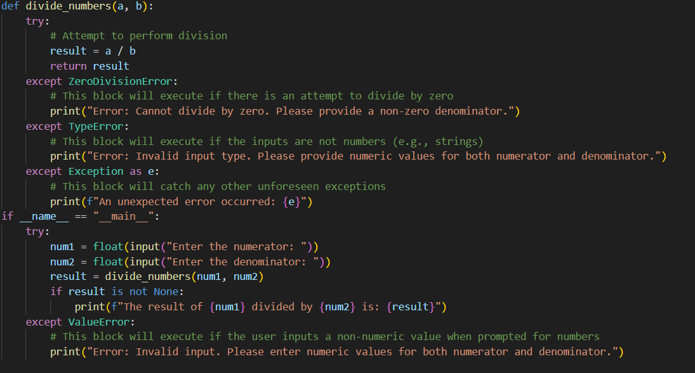
Output:
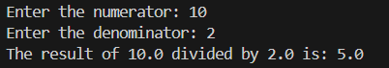
Suggestion:
The program reads and processes a file using proper error handling to manage common issues like missing files or incorrect data formats. Each exception includes a clear message that explains the cause of the error in simple terms. Comments in the code describe when and why each error might occur. This prevents the program from crashing and makes debugging easier. The explanation matches the actual runtime behavior because errors are handled exactly where they occur.

