AI Assisted Coding
ASSIGNMENT-4.1
Name:J.Varshitha
HT No: 2303A52413
Batch:32
QUESTION-1:
Zero-Shot Prompting (Basic Lab Task)
Task:
Write a Python function that classifies a given text as Spam or Not
Spam using zero-shot prompting.
Steps:
1. Construct a prompt without any examples.
2. Clearly specify the output labels.
3. Display only the predicted label.
Input:
"Congratulations! You have won a free lottery ticket."
Expected Output:
Spam
PROMPT:
Generate a python program that Identify’s the given text into Spam or Not Spam. Display the output as only Spam or Not Spam and take input from user.
CODE:
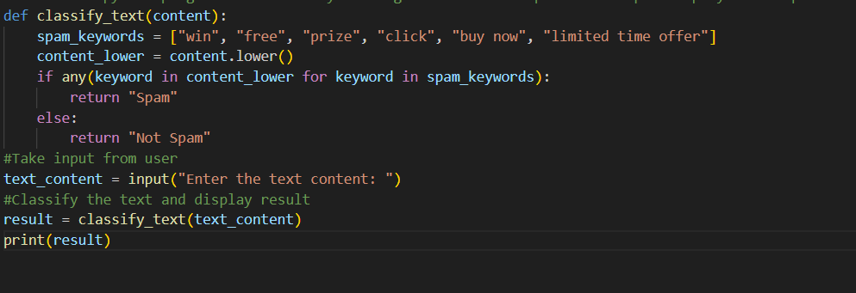
OUTPUT:
EXPLANATION:
The program takes a text message from the user and converts it to lowercase.It checks whether the message contains any common spam words or not.If any spam word is found, it prints spam otherwise, it prints not spam.

QUESTION-2
One-Shot Prompting (Emotion detection)
Task:
Write a Python program that detects the emotion of a sentence using one-shot prompting.
Emotions: [‘happy', 'sad', 'angry', 'excited', 'nervous', ’neutral’]
Steps:
1. Provide one labeled example inside the prompt.
2. Take a sentence as input.
3. Print the predicted emotion
PROMPT:
classify the emotions of a given sentence
Emotions: Happy, Sad, Angry,neutral
EXAMPLE:"I played and enjoyed a lot today"
Emotion:Happy
display the output as only emotion
Take the input from the user.
CODE:
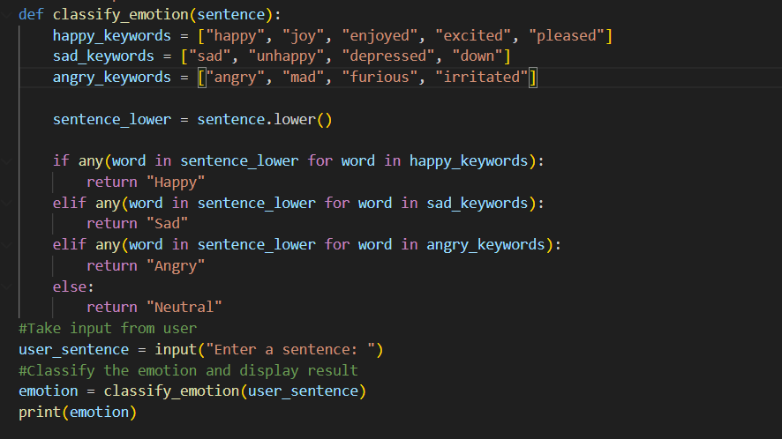
OUTPUT:
EXPLANATION:
The program takes a sentence from the user and converts it to lowercase so emotion words can be matched easily.It checks the sentence for happy, sad, or angry keywords and returns the corresponding emotion.If none of the emotion words are found, it classifies the sentence as Neutral and prints only the emotion.

QUESTION-3
Few-Shot Prompting (Student Grading Based on Marks)
Task:
Write a Python program that predicts a student’s grade based on
marks using few-shot prompting.
Grades:
['A', 'B', 'C', 'D', 'F']
Grading Criteria (to be inferred from examples):
• 90–100 → A
• 80–89 → B
• 70–79 → C
• 60–69 → D
• Below 60 → F
PROMPT:
classify the grades of students based on their marks
Grades: A: 90-100
B: 80-89
C: 70-79
D: 60-69
F: below 60
display the output as only grade
Take the input from the user.
CODE:
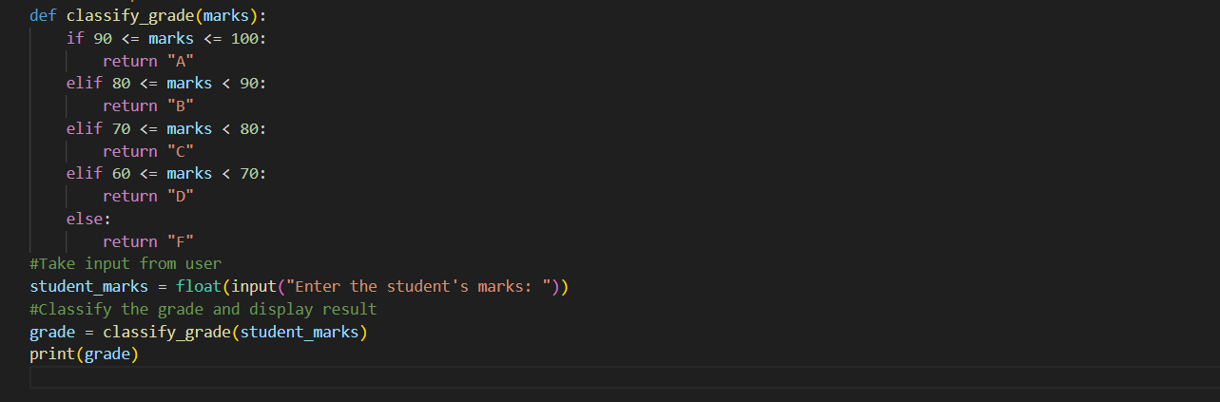
OUTPUT:
EXPLANATION:
The program takes the student’s marks as input and compares them with predefined score ranges.Based on where the marks fall, it assigns the correct grade from A to F.Finally, it prints only the grade as the output.

QUESTION-4
Multi-Shot Prompting (Indian Zodiac Sign Prediction using
Month Name)
Task:
Write a Python program that predicts a person’s Indian Zodiac sign(Rashi) based on the month of birth (month name) using multi-shot prompting.
Indian Zodiac Order (Simplified Month-Based Model):
The Indian Zodiac cycle starts in March with Mesha and follows this order:
March → Mesha
April → Vrishabha
May → Mithuna
June → Karka
July → Simha
August → Kanya
September → Tula
October → Vrischika
November → Dhanu
December → Makara
January → Kumbha
February → Meena
PROMPT:
Generate a Python program that predicts a person’s Indian Zodiac sign based on the month of birth
Example:
March → Mesha
April → Vrishabha
May → Mithuna
June → Karka
July → Simha
August → Kanya
September → Tula
October → Vrischika
November → Dhanu
December → Makara
January → Kumbha
February → Meena
Display the output as only Zodiac sign
Take the input from the user
CODE:
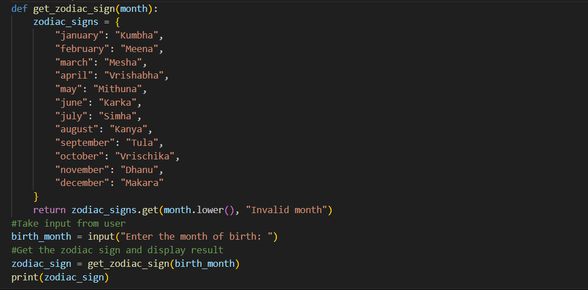
OUTPUT:
EXPLANATION:
The program asks the user for their birth month and converts it to lowercase to avoid case-sensitive errors.It looks up the corresponding Indian Zodiac sign from a predefined dictionary.Finally, it prints only the Zodiac sign.

QUESTION-5
Result Analysis Based on Marks
Task:
Write a Python program that determines whether a student Passes or Fails based on marks using Chain-of-Thought (CoT) prompting.
Result Categories:
['Pass', 'Fail']
PROMPT:
predict whether a student is pass or fail based on their marks
Display the output as only Pass or Fail
Take the input from the user
CODE:
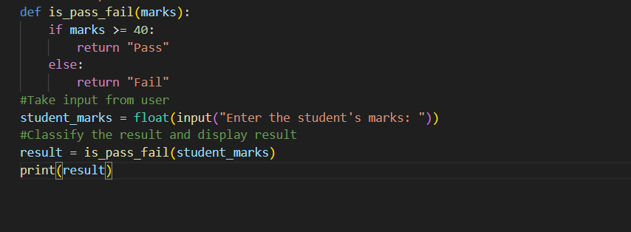
OUTPUT:
EXPLANATION:
The program takes the student’s marks as input and checks whether they are 40 or above.If the condition is true, it returns Pass; otherwise, it returns Fail.Finally, it prints only the result based on the marks entered.

QUESTION-6
Voting Eligibility Check (Chain-of-Thought Prompting)
Task:
Write a Python program that determines whether a person is eligible to vote using Chain-of-Thought (CoT) prompting.
PROMPT:
Determine whether a person is eligible to vote or not
Display the output as only Eligible or Not Eligible
The minimum age to vote is 18
The person must be a citizen of India
Take the input from the user
CODE:
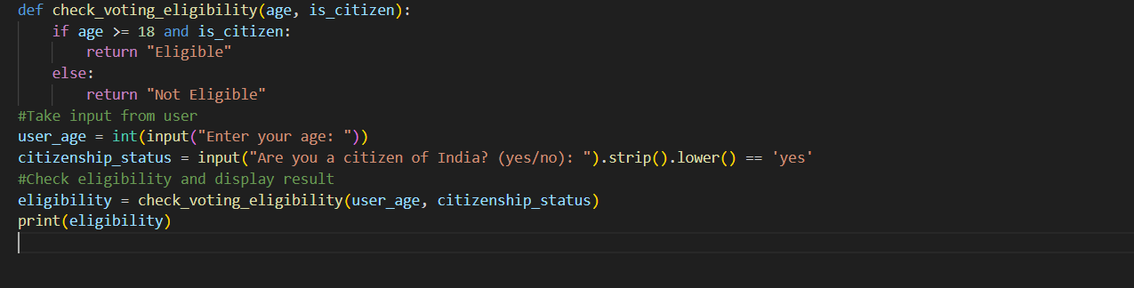
OUTPUT:
EXPLANATION:
The program takes the user’s age and citizenship status as input.It checks whether the user is 18 or older and an Indian citizen.If both conditions are satisfied, it prints Eligible otherwise, it prints Not Eligible.

QUESTION-7
Prompt Chaining (String Processing – Palindrome Names)
Task:
Write a Python program that uses the prompt chaining technique to identify palindrome names from a list of student names.
PROMPT:
Generate a list of student names
check Whether the names are palindrome or not
display the names which are palindrome
CODE:
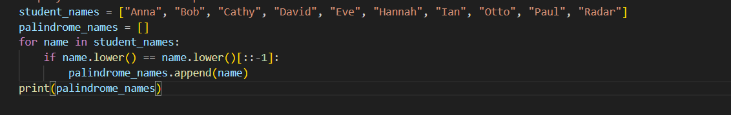
OUTPUT:
EXPLANATION:
The program starts with a list of student names and checks each name one by one.It converts each name to lowercase and compares it with its reverse to see if it reads the same forwards and backwards.Names that are palindromes are collected in a new list and printed as the final output.
QUESTION-8
Prompt Chaining (String Processing – Word Length Analysis)
Task:
Write a Python program that uses prompt chaining to
analyze a list of words. In the first prompt, generate a list of words.
In the second prompt, traverse the list and calculate the length of each word. In the third prompt, use the output of the previous step to determine whether each word is Short (length less than 5) or Long (length greater than or equal to 5), and display the result for each word.
PROMPT:
Generate a list of the palindrome names from previous output
Now traverse the list and calculate the length of each word
Now classify the words as short or long
if length<5 : short
if length>=5 : long
display the output as name:short/long
And display output as short or long for each word
CODE:
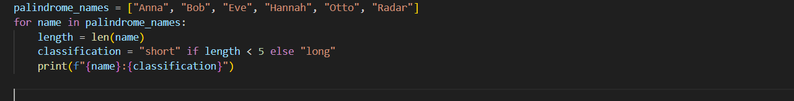
OUTPUT:
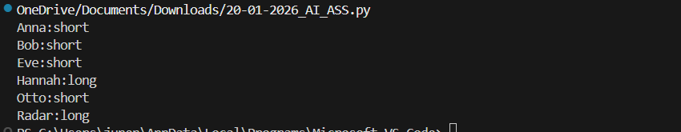
EXPLANATION:
The program goes through each palindrome name in the list and calculates the length of the word.Based on the length, it classifies the name as short (less than 5 characters) or long (5 or more characters).Finally, it prints each name along with its classification in the format name:short/long.

