AI ASSISTED CODING

ASSIGNMENT-2.3
2303A52413
BATCH-32

TASK-1
Task 1: Word Frequency from Text File
scenario:
You are analyzing log files for keyword frequency.
Task:
Use Gemini to generate Python code that reads a text file and counts word frequency, then explains the code.
Expected Output:
  - Working code
  - Explanation
  - Screenshot

Prompt:

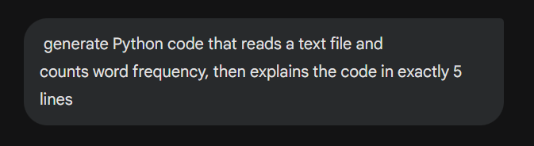

Code:
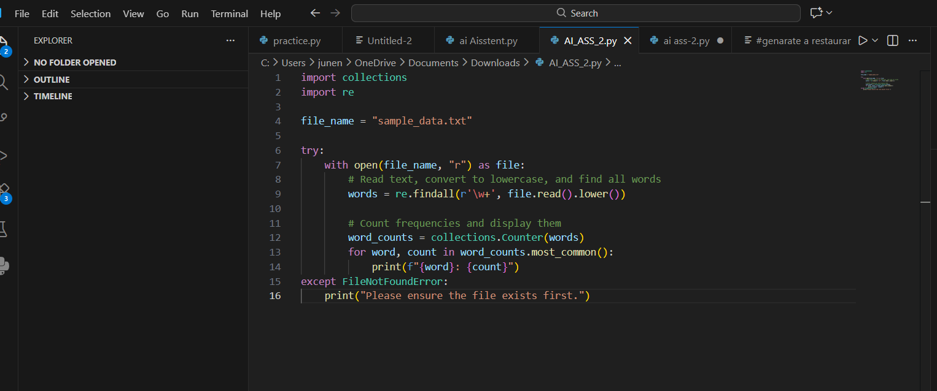

Output:

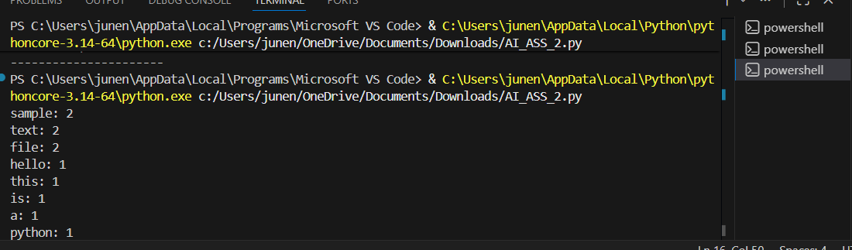
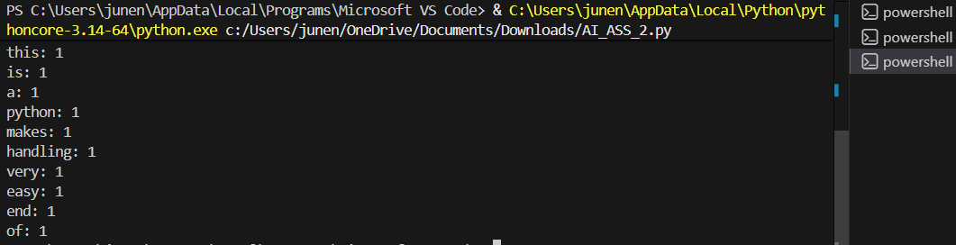

Explanation:

This program reads a text file and splits the content into words. Each word is stored in a dictionary where the key is the word and the value is its count. If a word appears again, its count is increased. Finally, the program prints how many times each word appears in the file. This helps in analyzing text data and finding frequently used words.
Task 2 :
Task 2: File Operations Using Cursor AI
Scenario:
You are automating basic file operations
Task:
Use Cursor AI to generate a program that:
Creates a text file
Writes sample text
Reads and displays the content
Expected Output:
  - Functional code
  - Cursor AI screenshots

Prompt:
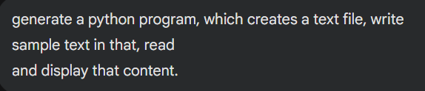
Code:
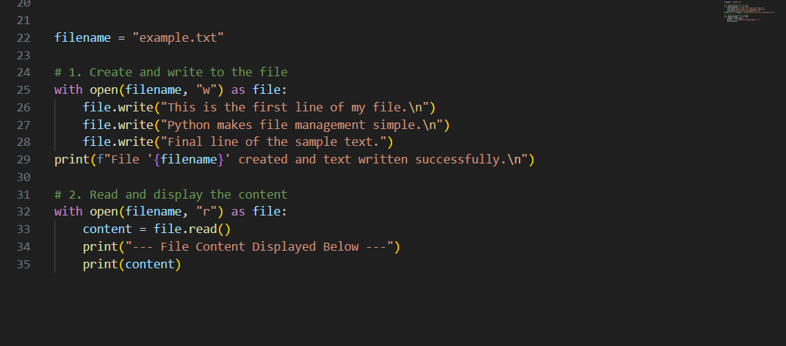

Output:
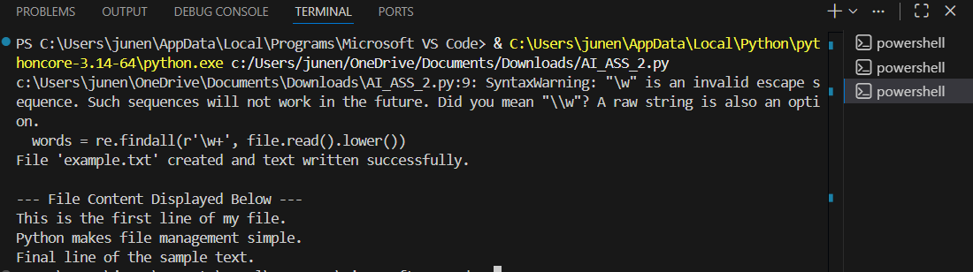

Explanation:
This program demonstrates basic file operations in Python. First, a text file named example.txt is created in write mode and sample text is written into it. The file is then closed to save the data. Next, the same file is opened in read mode, and its content is read and displayed on the screen. This helps in understanding how files are created, written, and read using Python.

Task3:
Task 3: CSV Data Analysis
Scenario:
You are processing structured data from a CSV file.
Task:
Use Gemini in Colab to read a CSV file and calculate mean, min, and max.
Expected Output:
  - Correct output
  - Screenshot

Prompt:

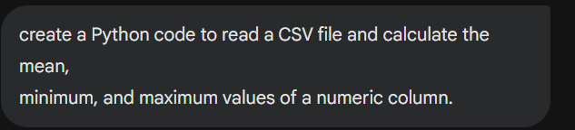

Code:

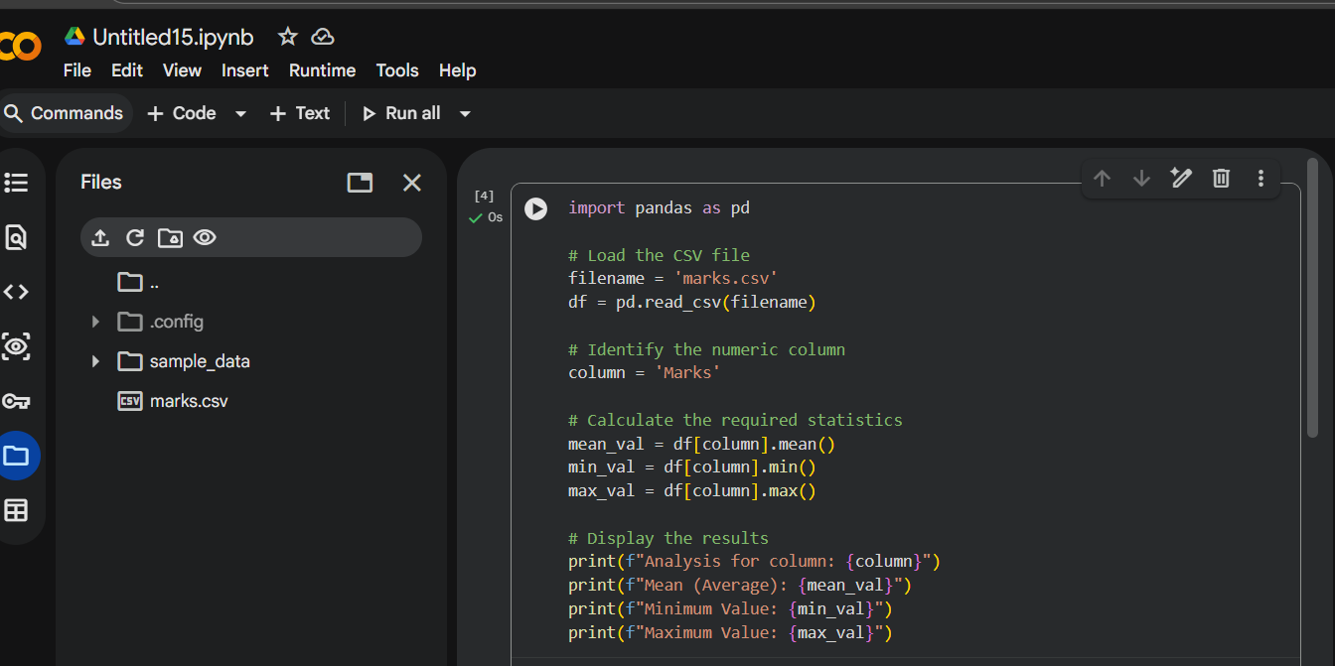

Output:

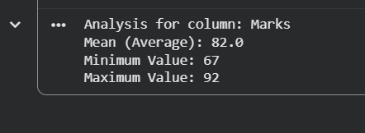

Explanation:

This program uses the Pandas library to read a CSV file in Google Colab. The CSV file contains numeric data in a column named “Marks”. After reading the file, the program calculates the mean, minimum, and maximum values using built-in Pandas functions. Finally, the calculated results are printed, making it easy to analyze structured data.

Task 4:

Sorting Lists Manual vs Built-in Scenario:
You are reviewing algorithm choices for efficiency.
Task:
Use Gemini to generate:
Bubble sort
Python’s built-in sort()
Compare both implementations.

Prompt:

Bubble sort:

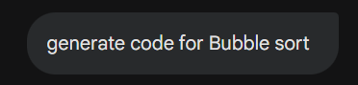
Python’s built in sort:

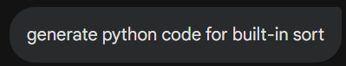

Code:

Bubble sort:

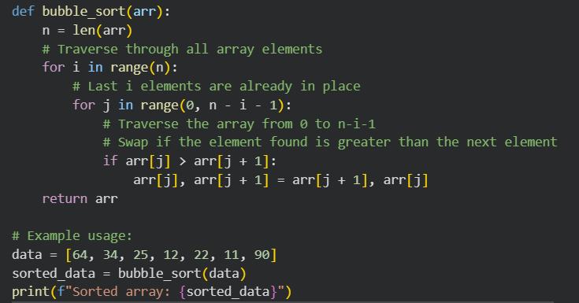

Python’s built in sort:

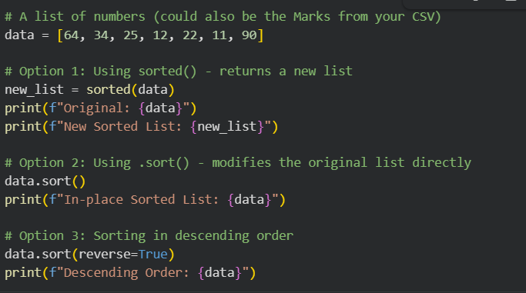

Output:

Bubble sort:

Python’s built in sort:

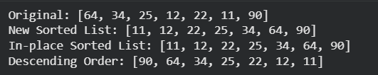

Explanation:
Bubble sort is a manual sorting algorithm that compares adjacent elements and swaps them repeatedly, which makes it easy to understand but slow for large lists. Python’s built-in sort() method is highly optimized and much faster because it uses an efficient algorithm internally. Therefore, bubble sort is useful for learning concepts, while the built-in sort is preferred for real applications.

