AI Assisted Coding
ASSIGNMENT-1.2
Name:J.Varshitha
HT No:2303A52413
Batch:32
Question 1:
Task 1:
AI-Generated Logic Without Modularization (Factorial without Functions)
Scenario You are building a small command-line utility for a startup intern onboarding task. The program is simple and must be written quickly without modular design.
Task Description Use GitHub Copilot to generate a Python program that computes a mathematical product-based value (factorial-like logic) directly in the main execution flow, without using any user-defined functions.
• Constraint:
Do not define any custom function
Logic must be implemented using loops and variables only
Prompt:
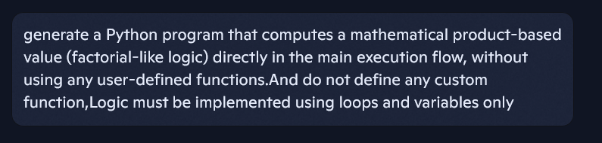
Code Screenshot:
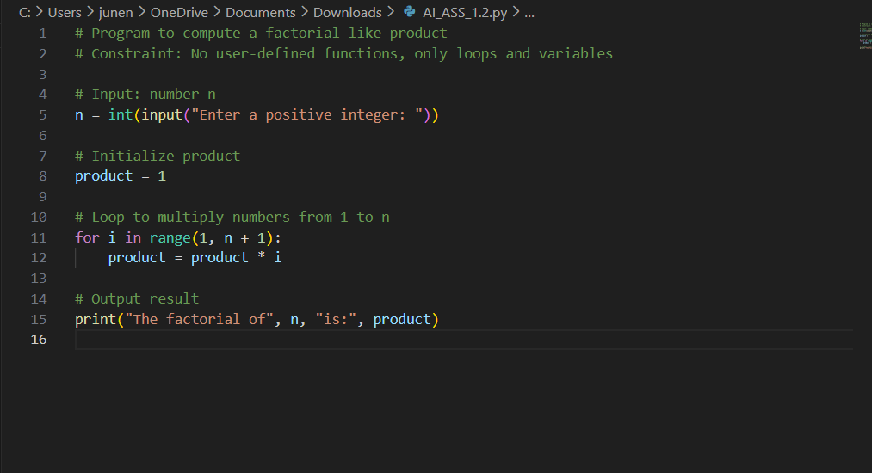
Output(O/P):
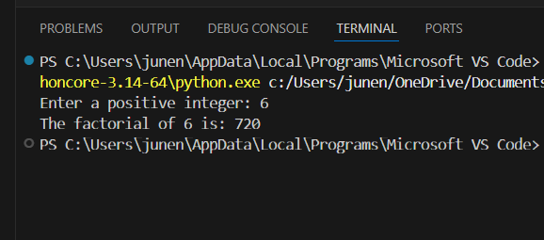
Copilot Suggestions:
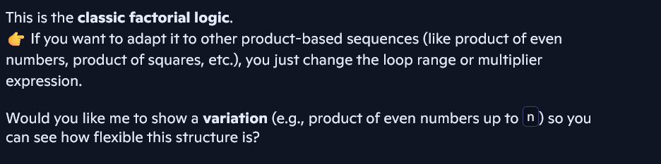
Explanation:
Copilot proved valuable for beginners by instantly providing accurate logic from the given instructions.It saved time by offering a ready-to-use solution instead of writing everything manually.The code it produced reflected good practices, including handling inputs and special cases.It also minimized the chances of syntax issues and logical errors during coding.Altogether, Copilot made programming simpler, quicker, and more efficient.

Question 2:
Scenario Your team lead asks you to review AI-generated code before committing it to a shared repository.
Task Description Analyze the code generated in Task 1 and use Copilot again to:
Reduce unnecessary variables
Improve loop clarity
Enhance readability and efficiency
Hint: Prompt Copilot with phrases like
“optimize this code”,
“simplify logic”, or
“make it more readable”
Prompt:
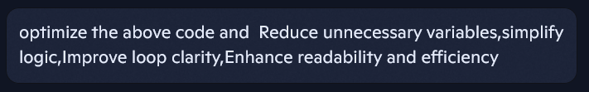
Code Screenshot:
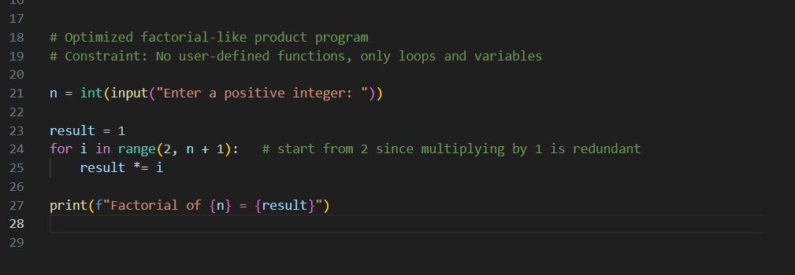

Output(O/P):
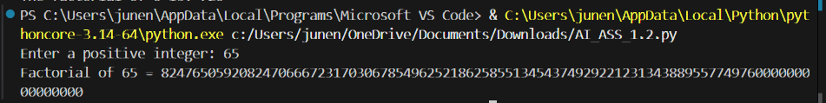
Copilot Suggestions:
Explanation:
Optimized the code in minimal number of lines and short variable names.

Question 3:
Scenario: The same logic now needs to be reused in multiple scripts.
Task Description Use GitHub Copilot to generate a modular version of the program by:
Creating a user-defined function
Calling the function from the main block
Constraints:
Use meaningful function and variable names
Include inline comments (preferably suggested by Copilot)

Prompt:
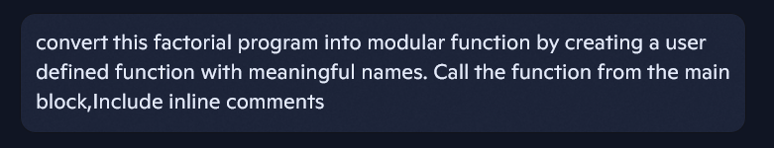
Code Screenshot:
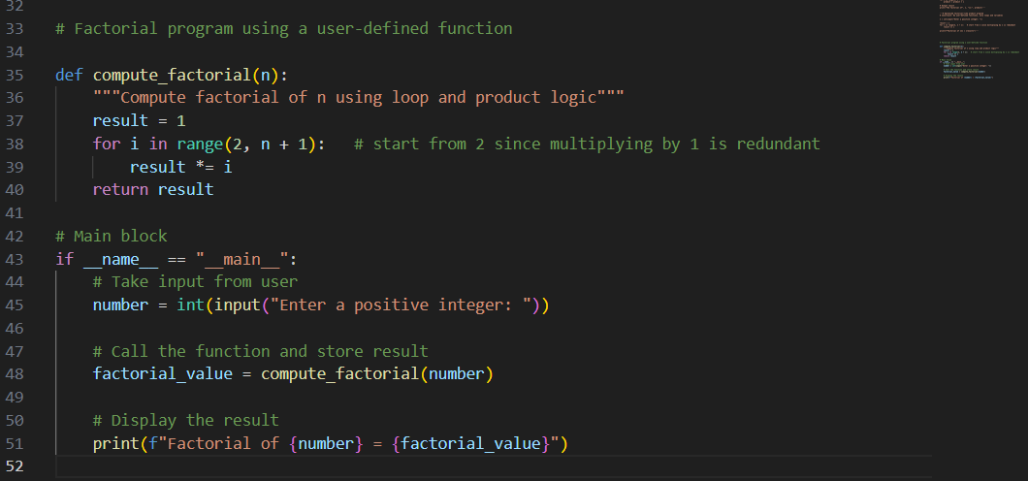
Output(O/P):
Copilot Suggestions:
Explanation:
This structure makes the program easier to maintain, reuse, and extend.

Question 4:
Scenario As part of a code review meeting, you are asked to justify design choices.
Task Description Compare the non-function and function-based Copilot-generated programs on the following criteria:
Logic clarity
Reusability
Debugging ease
Suitability for large projects
AI dependency risk

Explanation:

Criteria | Non-Function Program | Function-Based Program
Logic clarity | Simple and direct; beginners can easily follow the loop and variable updates. | Clear separation of concerns; the factorial logic is encapsulated in a named function, improving readability.
Reusability | Limited; logic is tied to the main block and cannot be reused elsewhere without copy-pasting. | High; the function can be reused in other scripts, imported into modules, or extended for variations.
Debugging ease | Debugging requires scanning the entire main block; harder to isolate issues if code grows. | Easier; errors can be traced to the function, and unit tests can be written specifically for it.
Suitability for large projects | Poor; inline logic becomes messy and unmanageable as complexity increases. | Strong; modular design scales well, supports maintainability, and aligns with best practices in large projects.
AI dependency risk | Higher; developers may rely on AI to regenerate similar inline logic repeatedly instead of reusing code. | Lower; once the function is defined, developers can confidently reuse it without repeatedly asking AI.

Question 5:
Scenario:
Your mentor wants to test how well AI understands different computational paradigms.
Task Description:
Prompt Copilot to generate:
An iterative version of the logic A recursive version of the same logic Constraints:
Both implementations must produce identical outputs Students must not manually write the code first.

Prompt 1:

Code:
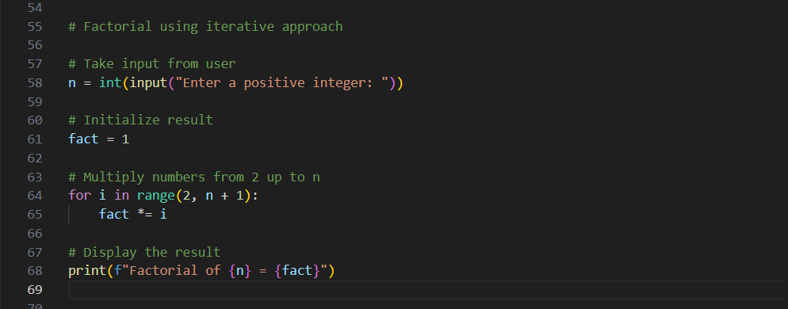
Output:
Copilot Suggestions:

Prompt 2:

Code:
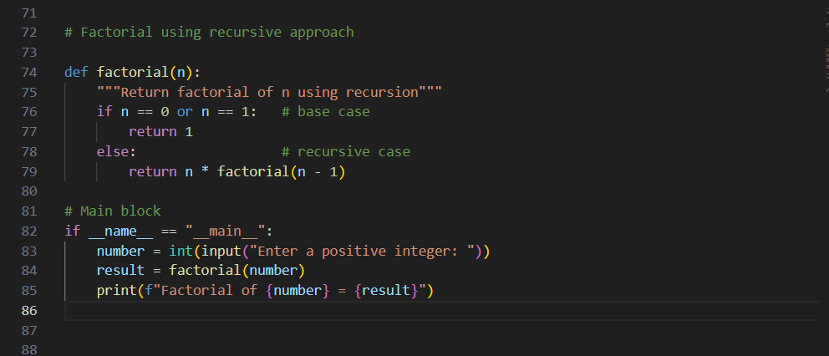
Output:
Copilot Suggestions:

Iterative version:
This iterative approach is efficient, avoids recursion depth limits, and is easy to debug.

Recursive version:
This recursive version is elegant and concise, but for very large n, the iterative approach is safer because recursion depth in Python is limited.

