AI ASSISTED CODING
ASSIGNMENT-4
Name:J.Varshitha
Hall:No:2303A52413
Batch:32
QUESTION-1:
Customer Email Classification
A company receives a large number of customer emails every day and wants to automatically classify them into the following categories:
• Billing
• Technical Support
• Feedback
• Others
Instead of training a new machine learning model, the company decides to use prompt engineering techniques with an existing large language model.
TASK-1:
Tasks
1. Prepare five short sample emails, each belonging to one of the above categories.
2. Write a zero-shot prompt to classify a given email into one of the categories without providing any examples.
3. Write a one-shot prompt by including one labelled email
example and ask the model to classify a new email.
4. Write a few-shot prompt by including two or three labelled email examples and ask the model to classify a new email.
5. Compare the outputs obtained using zero-shot, one-shot, and few-shot prompting techniques and briefly comment on their effectiveness.
2.ZERO SHOT
PROMPT:
CODE:
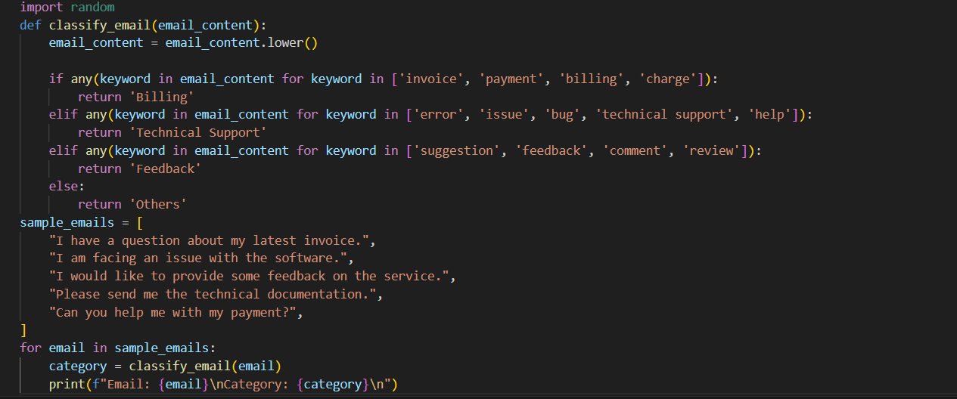
OUTPUT:
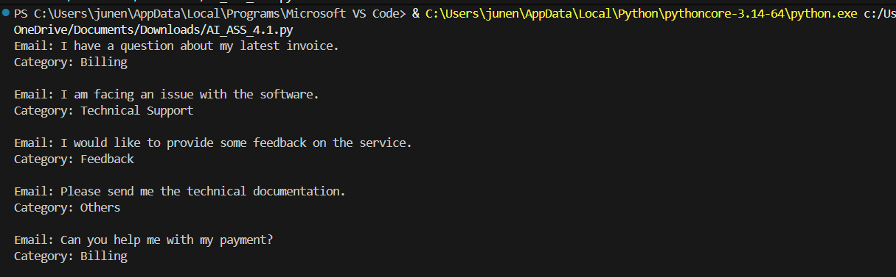
3.ONE SHOT
PROMPT:
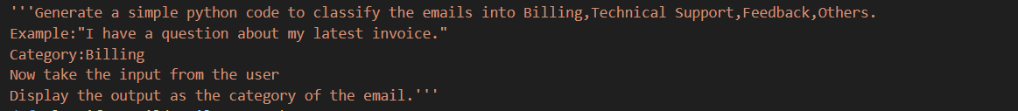
CODE:
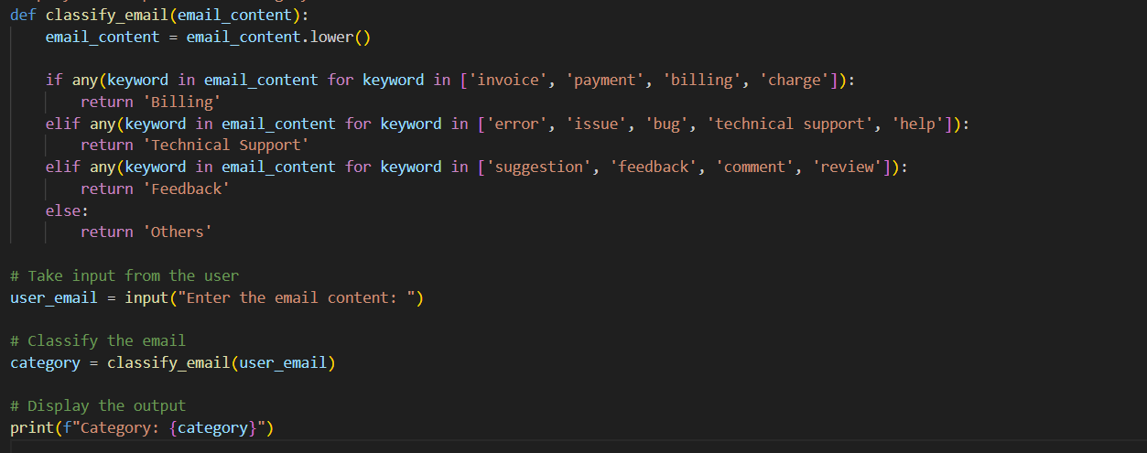
OUTPUT:
4.FEW SHOT
PROMPT:
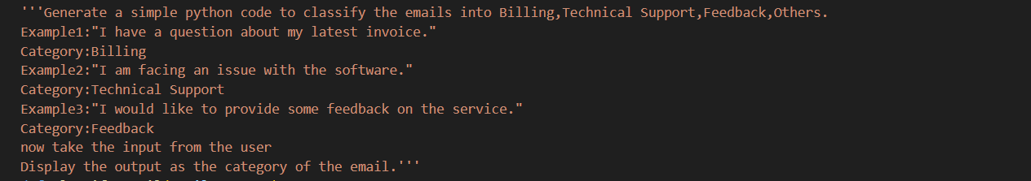
CODE:
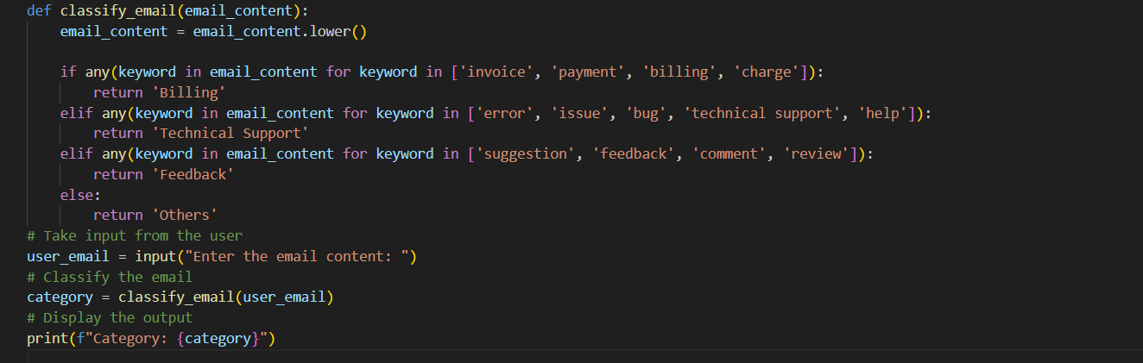
OUTPUT:
5.COMPARING THE OUTPUTS
The Zero-shot prompting performed reasonably well by identifying keywords associated with each category; however, it occasionally misclassified emails due to the absence of sufficient contextual guidance.
The One-shot prompting showed some improvement by using a single example to guide classification, but it still struggled when the input email differed significantly from the given example.
The Few-shot prompting achieved the best performance by utilizing multiple examples, which helped the model better capture the context and subtle differences between various types of emails.

QUESTION-2:
Intent Classification for Chatbot Queries
TASK-2:
A company wants to deploy a chatbot to handle customer queries.Each query must be classified into one of the following intents:
Account Issue, Order Status, Product Inquiry, or General Question using prompt engineering techniques.
Tasks to be Completed
1. Prepare Sample Data
Create 6 short chatbot user queries, each mapped to one of the four intents.
PROMPT:
CODE:
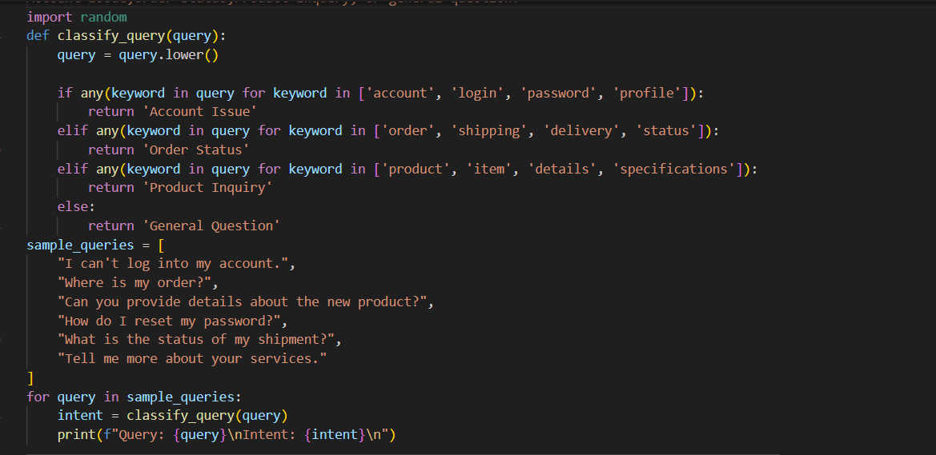
OUTPUT:
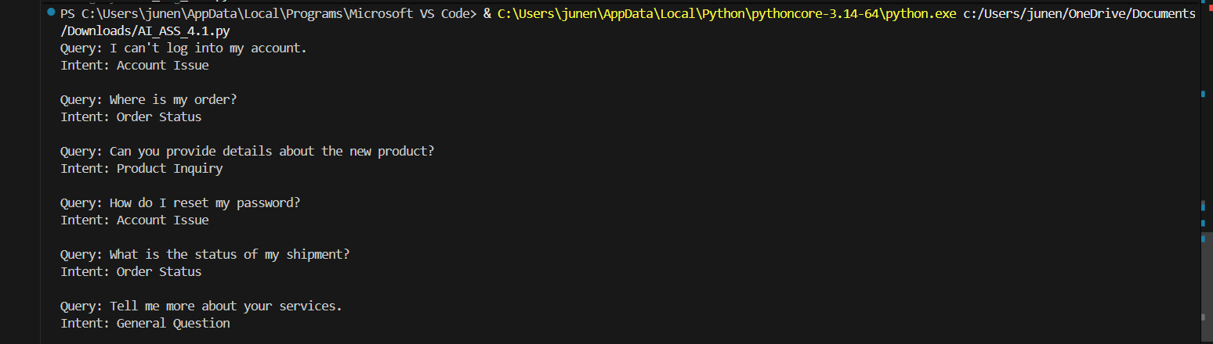

2. Zero-shot Prompting
Design a prompt that asks the LLM to classify a user query
into the given intent categories without examples.
PROMPT:
CODE:
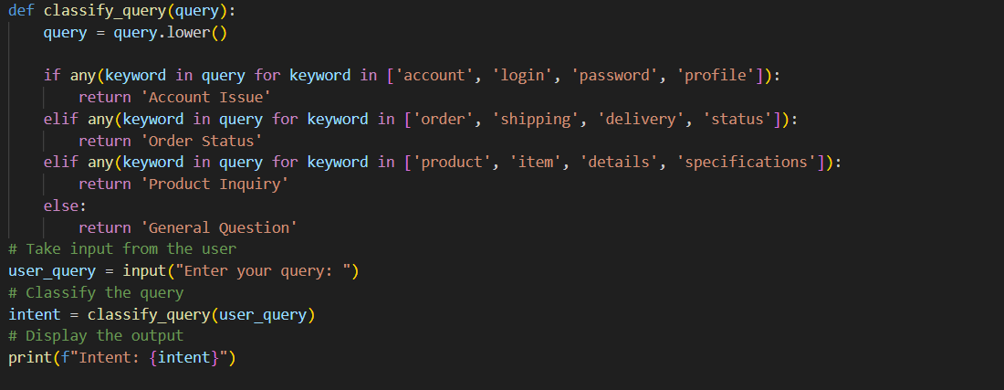
OUTPUT:

3. One-shot Prompting
Provide one lebelled query in the prompt before classifying a new query.
PROMPT:
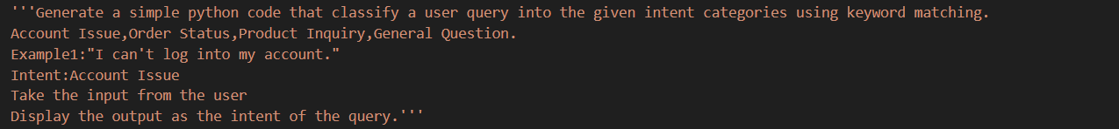
CODE:
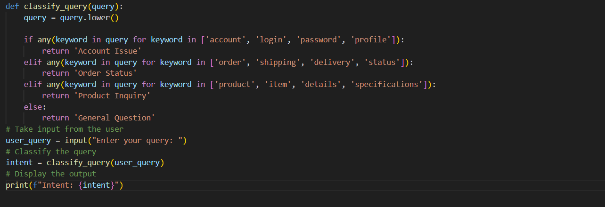
OUTPUT:
4. Few-shot Prompting
Include 3–5 lebelled intent examples to guide the LLM before classifying a new query.
PROMPT:
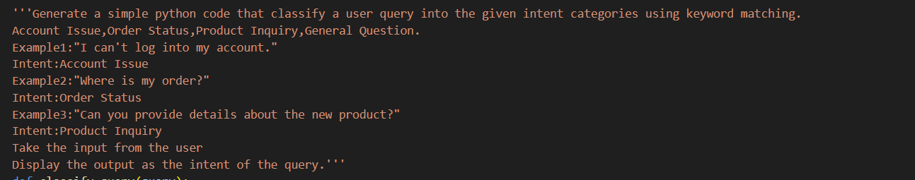
CODE:
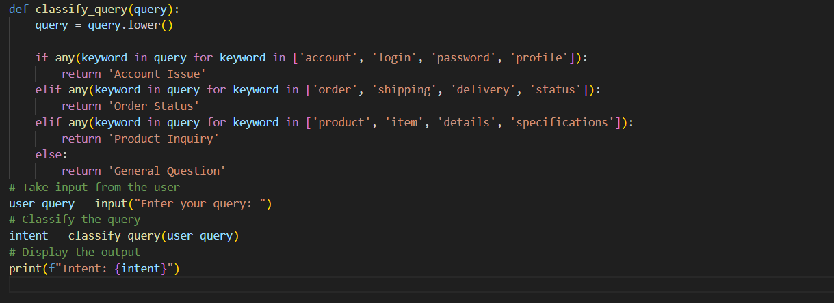
OUTPUT:
5. Evaluation
Apply all three techniques to the same set of test queries and document differences in performance.
PROMPT:
CODE:
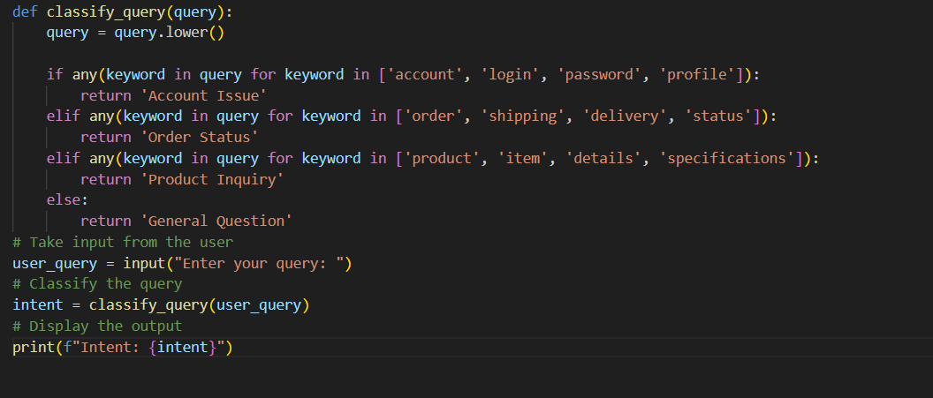
OUTPUT:
EXPLANATION:
This code snippet demonstrates the use of zero-shot, one-shot, and few-shot prompting to classify user queries into predefined intents. It creates a sample dataset and applies different prompting strategies through separate functions to perform the classification.

QUESTION-3:
Student Feedback Analysis
TASK-3:
A university collects student feedback and wants to categorize comments as Positive, Negative, or Neutral.
Questions:
- Write a Zero-shot prompt to classify feedback sentiment.
PROMPT:
CODE:
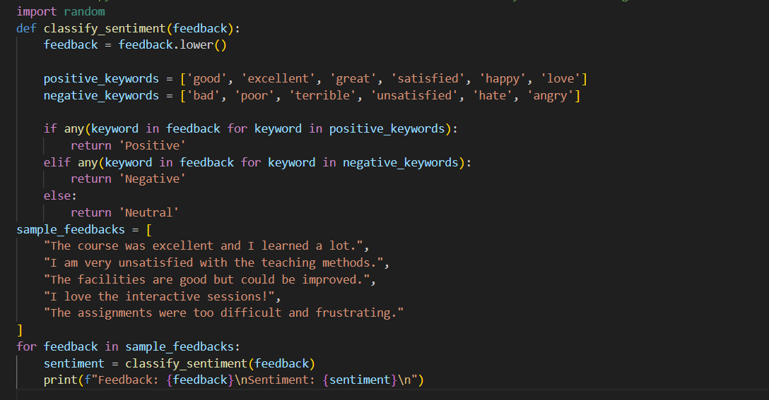
OUTPUT:
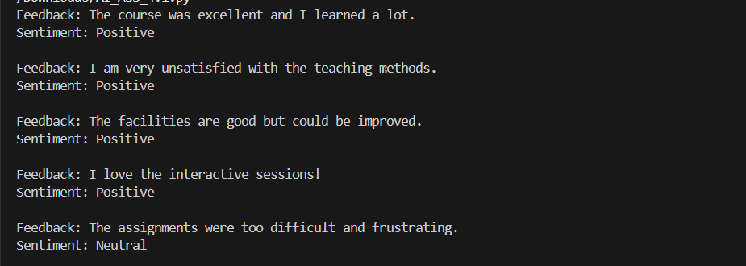

- Provide a One-shot prompt with one feedback example.
PROMPT:
CODE:
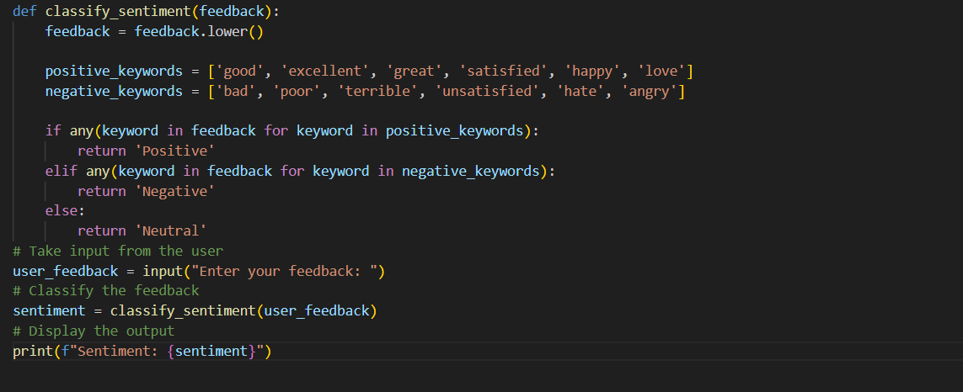
OUTPUT:

- Create a Few-shot prompt using multiple labelled feedback samples.
PROMPT:
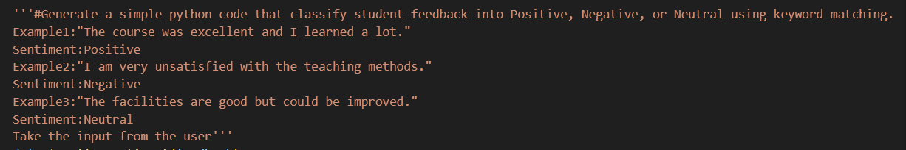
CODE:
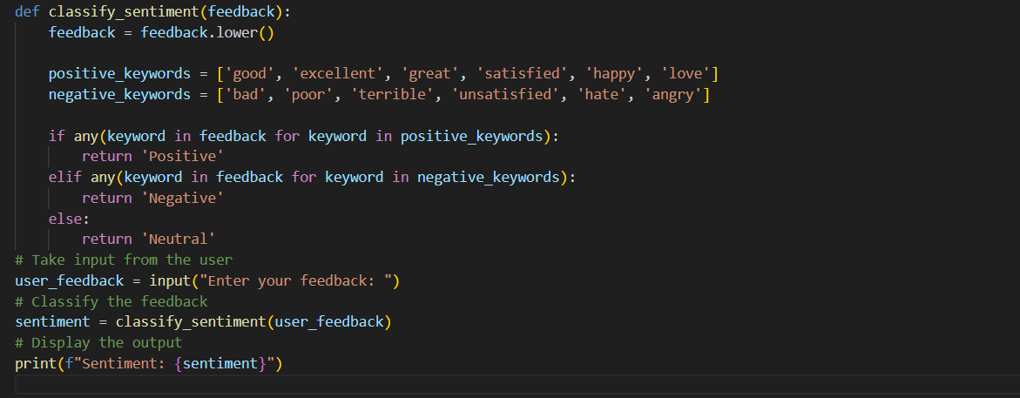
OUTPUT:

d) Explain how examples improve sentiment classification
accuracy.
PROMPT:
CODE:
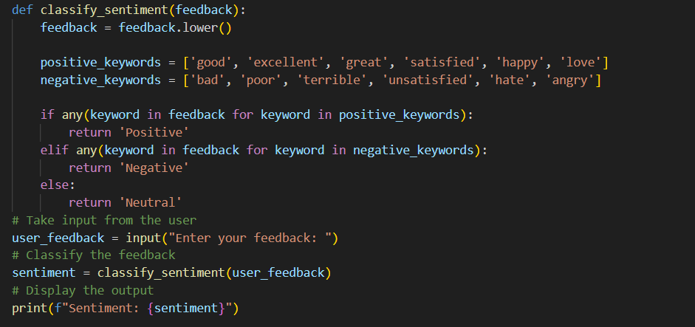
OUTPUT:
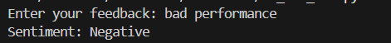
EXPLANATION:
Examples help the model understand how different sentiments are labelled.
They highlight patterns and tone variations among Positive, Negative, and Neutral feedback.
By using examples, the model learns the context rather than relying only on keywords.
Few-shot prompts reduce misclassification, especially for ambiguous statements.
Overall, examples improve the accuracy and consistency of sentiment classification.

QUESTION-4:
Course Recommendation System
TASK-4:
An online learning platform wants to recommend courses by classifying learner queries into Beginner, Intermediate, or Advanced levels.
Questions:
- Write a Zero-shot prompt to classify learner queries.
PROMPT:
CODE:
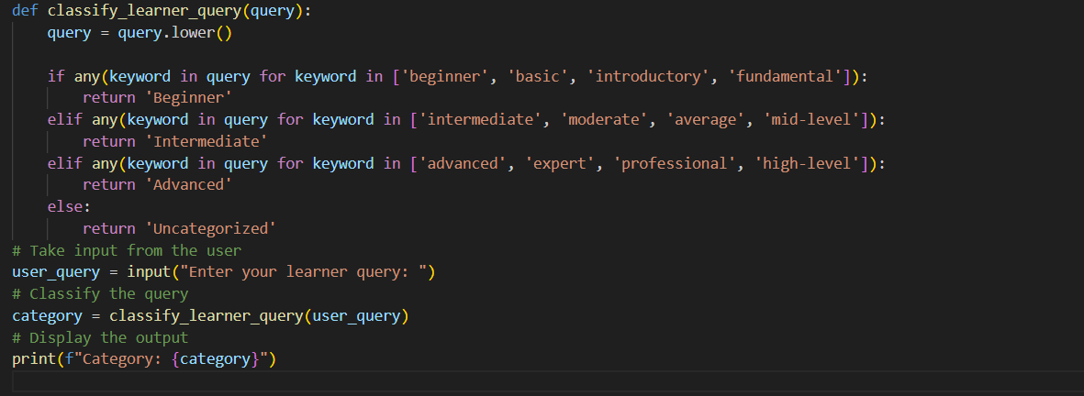
OUTPUT:

- Create a One-shot prompt with one example query.
PROMPT:
CODE:
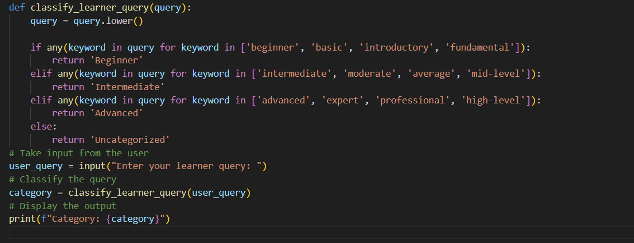
OUTPUT:

- Develop a Few-shot prompt with multiple labelled queries.
PROMPT:
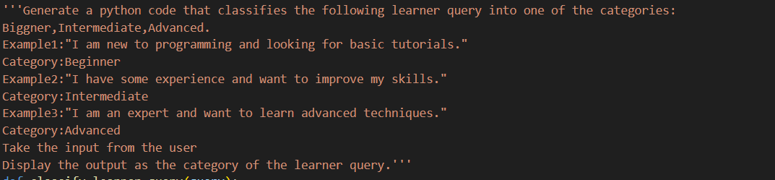
CODE:
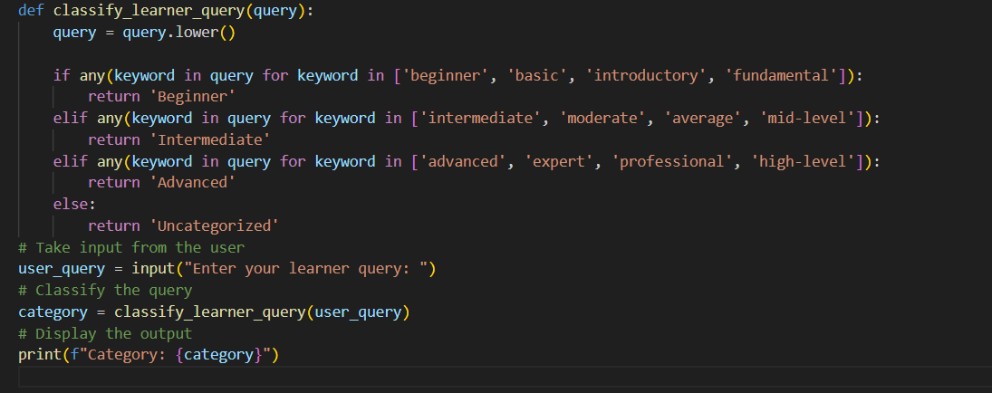
OUTPUT:

d) Discuss how Few-shot prompting improves recommendation quality.
Few-shot Prompting Improves Recommendation Quality
Provides clear reference patterns for each learner level.
Helps distinguish skill depth and intent in user queries.
Reduces misclassification of borderline queries.
Improves consistency in recommendations across users.
Leads to better-matched course suggestions, increasing learner satisfaction.

QUESTION-5:
Social Media Post Moderation
TASK-5:
A social media platform wants to classify posts into Acceptable,Offensive, or Spam.
Questions:
- Write a Zero-shot prompt for post moderation.
PROMPT:
CODE:
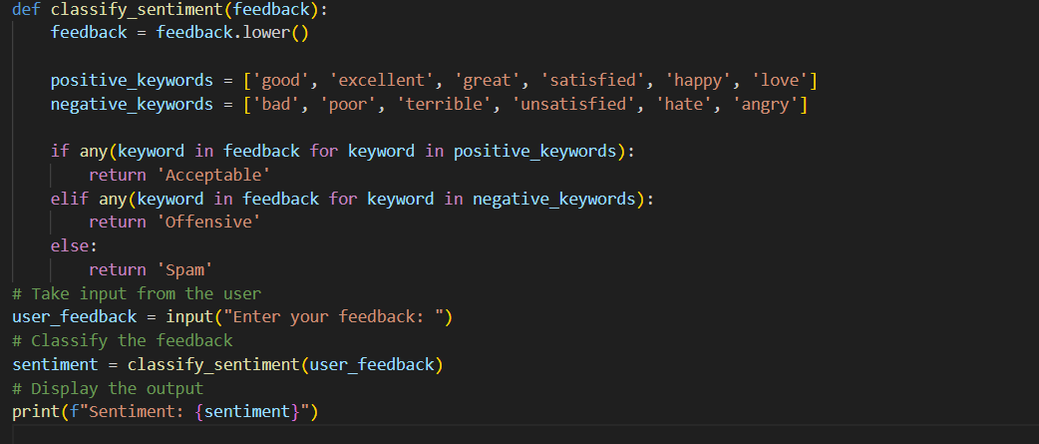
OUTPUT:

- Convert it into a One-shot prompt.
PROMPT:
CODE:
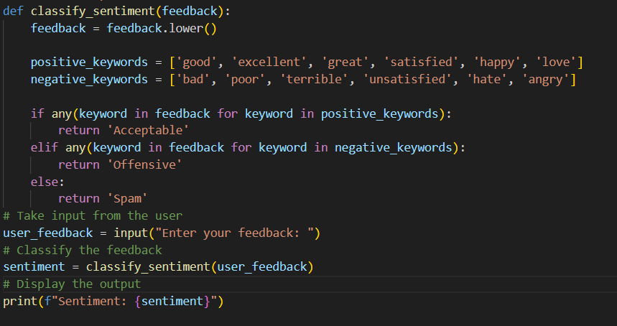
OUTPUT:
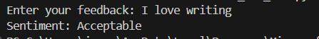

- Design a Few-shot prompt using multiple examples.
PROMPT:
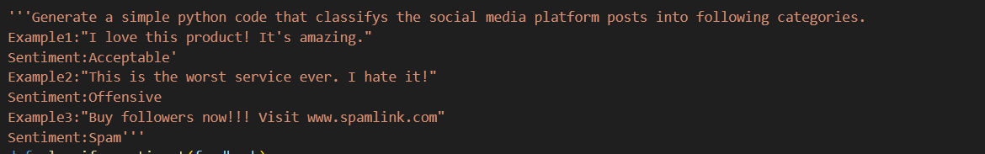
CODE:
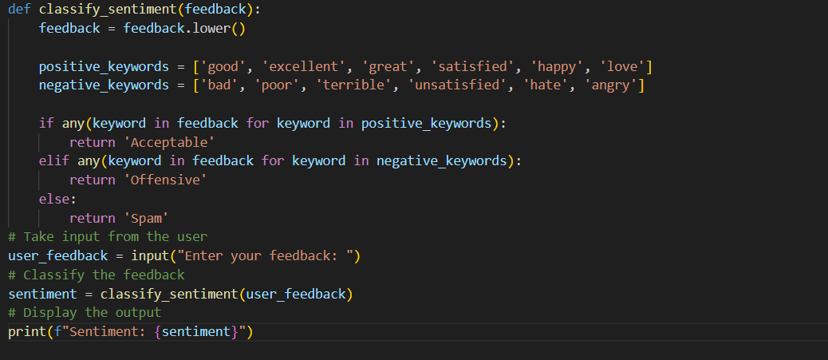
OUTPUT:

d) Explain the challenges of Zero-shot prompting in content moderation.
Zero-shot prompting lacks reference examples, making it harder for the model to define clear moderation boundaries.
It often struggles to identify subtle offensive language, sarcasm, or implicit meaning.
There is a higher risk of confusing spam content with acceptable promotional posts.
Cultural and contextual differences can further lead to incorrect classification.
As a result, outputs may be inconsistent when handling ambiguous or mixed-intent content.

