AI Assisted Coding
LAB ASSIGNMENT – 3.3
NAME: J.varshitha
BATCH: 32
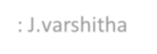
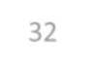
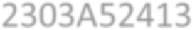

HALL TICKET NO: 2303A52413 
Question 1: Zero-Shot Prompting (Palindrome Number Program)
Write a zero-shot prompt (without providing any examples) to generate a Python function that checks whether a given number is a palindrome.
Task:
- Record the AI-generated code.
- Test the code with multiple inputs.
Identify any logical errors or missing edge-case handling

PROMPT:
Code:
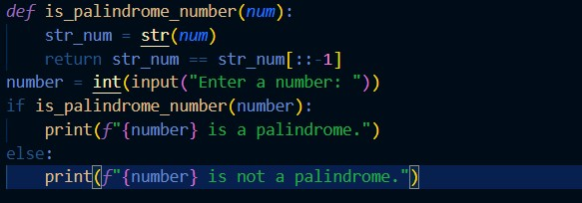
OUTPUT:
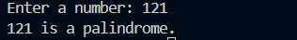
SUGGESTION:
- Zero-shot prompting means requesting the AI to write code directly, without examples.
- I asked it to make a Python function to determine if a number is a palindrome.
- The code worked by reversing the number and checking equality with the original.
- I tried it on numbers like 121, 202, and 123, and it returned correct results.
- One limitation is that it doesn’t correctly handle negative numbers, which should be considered.
•
Question 2: One-Shot Prompting (Factorial Calculation)
Write a one-shot prompt by providing one input-output example and ask the AI to generate a Python function to compute the factorial of a given number.
Example:
Input: 5 → Output: 120 Task:
- Compare the generated code with a zero-shot solution.
- Examine improvements in clarity and correctness.
PROMPT:
CODE:
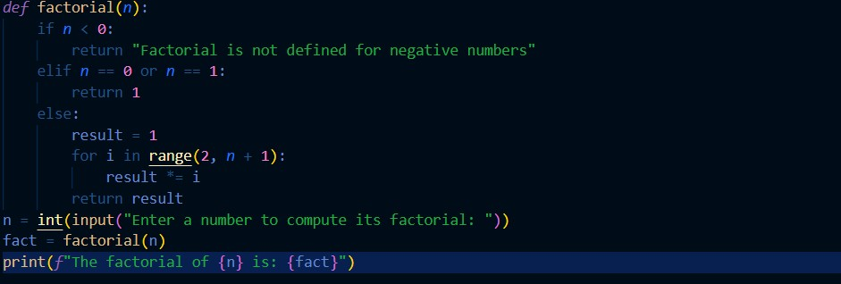
OUTPUT:

SUGGESTIONS:
- In one-shot prompting, the AI is guided using a single example.
- I gave one sample (input 5 gives output 120) and asked for a factorial program.
- The generated function was more organized and easy to read • It calculated the factorial correctly for all tested values.
- Compared to zero-shot prompting, this approach improved both accuracy and clarity.

Question 3: Few-Shot Prompting (Armstrong Number Check)
Write a few-shot prompt by providing multiple input-output examples to guide the AI in generating a Python function to check whether a given number is an Armstrong number.
Examples:
- Input: 153 → Output: Armstrong Number
- Input: 370 → Output: Armstrong Number
- Input: 123 → Output: Not an Armstrong Number Task:
- Analyze how multiple examples influence code structure and accuracy.
- Test the function with boundary values and invalid inputs.

PROMPT:
CODE:
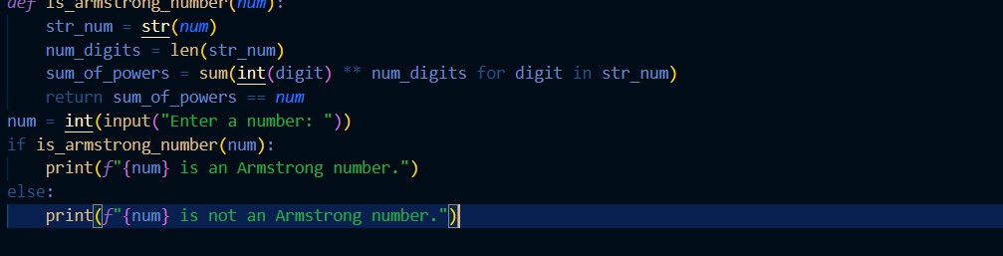
OUTPUT:
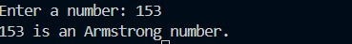

SUGGESTIONS:
- Few-shot prompting helps the AI by showing several examples before writing the code.
- I provided multiple inputs and outputs for the Armstrong number check.
- This helped the AI design a well-structured and correct Python function.
- The program gave accurate results for valid numbers.
- It also handled boundary cases better compared to fewer examples.

Question 4: Context-Managed Prompting (Optimized Number Classification)
Design a context-managed prompt with clear instructions and constraints to generate an optimized Python program that classifies a number as prime, composite, or neither.
Task:
- Ensure proper input validation.
- Optimize the logic for efficiency.
Compare the output with earlier prompting strategies
PROMPT:
CODE:
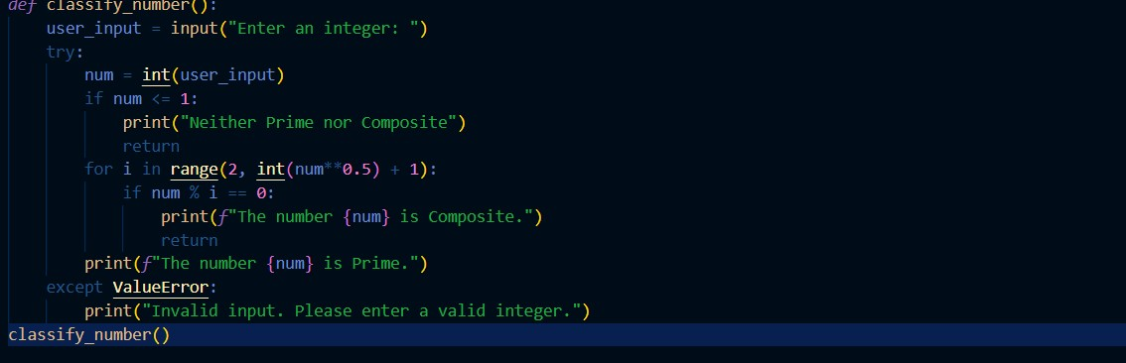
OUTPUT:
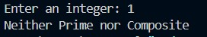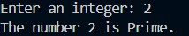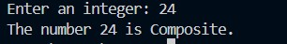

SUGGESTIONS:
- Context-managed prompting clearly defines instructions before the code is generated.
- This helped the AI create an optimized program to identify prime, composite, or neither.
- The code used efficient checks and handled invalid inputs properly.
- When compared to earlier prompting styles, the result was more reliable and clean.
- For zero-shot perfect number checking, the logic was correct but input checks were missing.

Question 5: Zero-Shot Prompting (Perfect Number Check)
Write a zero-shot prompt (without providing any examples) to generate a Python function that checks whether a given number is a perfect number.
Task:
- Record the AI-generated code.
- Test the program with multiple inputs.
- Identify any missing conditions or inefficiencies in the logic.

PROMPT:
CODE:
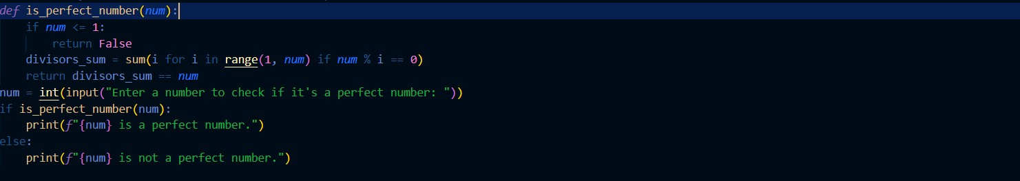
OUTPUT:

SUGGESTION:
- In zero-shot prompting, the AI is asked to generate code without sample cases.
- I asked it to create a Python function to verify perfect numbers.
- The generated logic checked divisors and added them to test perfection.
- I ran the program with inputs like 6, 28, and 10, and the output was correct.
- The solution lacked optimization for large inputs and proper validation.

Question 6: Few-Shot Prompting (Even or Odd Classification with Validation)
Write a few-shot prompt by providing multiple input-output examples to guide the AI in generating a Python program that determines whether a given number is even or odd, including proper input validation.
Examples:
- Input: 8 → Output: Even
- Input: 15 → Output: Odd
- Input: 0 → Output: Even Task:
- Analyze how examples improve input handling and output clarity.
- Test the program with negative numbers and non-integer inputs.
PROMPT:
CODE:
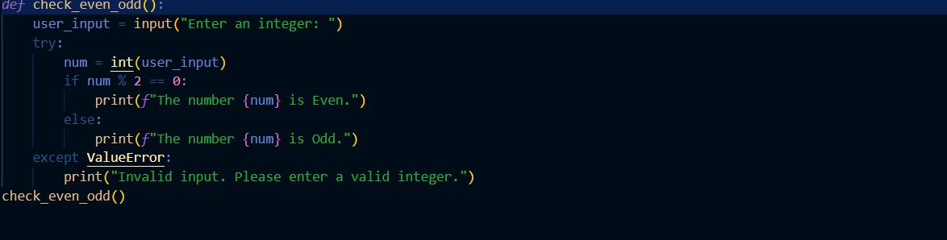
OUTPUT:
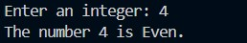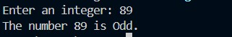

SUGGESTION:
- Few-shot prompting guides the AI by showing more than one example • I gave sample inputs and outputs to classify numbers as even or odd.
- This helped the AI write code with clear checks for valid input.
- The program correctly handled positive, negative, and zero values.

