AI ASSISTED CODING

ASSIGNMENT 16.3
Name:J.Varshitha
HT No:2303A52413
Batch:32

Task 1 – Hospital Management Database
Task:
Create schema and queries for a Hospital Management System.
Instructions:
- Tables: Doctors, Patients, Appointments.
- Use AI to define constraints (unique IDs, valid dates).
- Generate queries:
- List all appointments for a specific doctor.
- Retrieve patient history by patient ID.
- Count total patients treated by each doctor.
Expected Output:
- Normalized schema and SQL queries with joins.

Prompt:

Create SQLite schema for Doctors, Patients, Appointments with PK, FK, constraints.
Write queries:
- appointments by doctor
- patient history by id
- patient count per doctor
Use JOINs.
Code:
--Drop tables if they exist
DROP TABLE IF EXISTS Appointments;
DROP TABLE IF EXISTS Doctors;
DROP TABLE IF EXISTS Patients;

-- Create Doctors table
CREATE TABLE Doctors (
doctor_id INTEGER PRIMARY KEY,
name TEXT NOT NULL,
specialty TEXT NOT NULL
);

-- Create Patients table
CREATE TABLE Patients (
patient_id INTEGER PRIMARY KEY,
name TEXT NOT NULL,
date_of_birth DATE NOT NULL
);
-- Create Appointments table
CREATE TABLE Appointments (
appointment_id INTEGER PRIMARY KEY,
doctor_id INTEGER NOT NULL,
patient_id INTEGER NOT NULL,
appointment_date DATE NOT NULL,
FOREIGN KEY (doctor_id) REFERENCES Doctors(doctor_id),
FOREIGN KEY (patient_id) REFERENCES Patients(patient_id)
);

--- Insert sample data into Doctors
INSERT INTO Doctors (name, specialty) VALUES ('Dr. Smith', 'Cardiology');
INSERT INTO Doctors (name, specialty) VALUES ('Dr. Johnson', 'Neurology');
INSERT INTO Doctors (name, specialty) VALUES ('Dr. Lee', 'Pediatrics');
--- Insert sample data into Patients
INSERT INTO Patients (name, date_of_birth) VALUES ('Alice Brown', '1980-05-15');
INSERT INTO Patients (name, date_of_birth) VALUES ('Bob Green', '1990-08-22');
INSERT INTO Patients (name, date_of_birth) VALUES ('Charlie White', '2000-12-01');
-- Insert sample data into Appointments
INSERT INTO Appointments (doctor_id, patient_id, appointment_date) VALUES (1, 1, '2023-10-15');
INSERT INTO Appointments (doctor_id, patient_id, appointment_date) VALUES (1, 2, '2023-10-16');
INSERT INTO Appointments (doctor_id, patient_id, appointment_date) VALUES (2, 1, '2023-10-17');

-- Query: Appointments by doctor
SELECT d.name AS doctor_name, a.appointment_date, p.name AS patient_name
FROM Appointments a
JOIN Doctors d ON a.doctor_id = d.doctor_id
JOIN Patients p ON a.patient_id = p.patient_id
ORDER BY d.name, a.appointment_date;
-- Query: Patient history by id
SELECT p.name AS patient_name, p.date_of_birth, d.name AS doctor_name, a.appointment_date
FROM Patients p
JOIN Appointments a ON p.patient_id = a.patient_id
JOIN Doctors d ON a.doctor_id = d.doctor_id
WHERE p.patient_id = 1
ORDER BY a.appointment_date;
-- Query: Patient count per doctor
SELECT d.name AS doctor_name, COUNT(a.patient_id) AS patient_count
FROM Doctors d
LEFT JOIN Appointments a ON d.doctor_id = a.doctor_id
GROUP BY d.doctor_id, d.name;

Output:
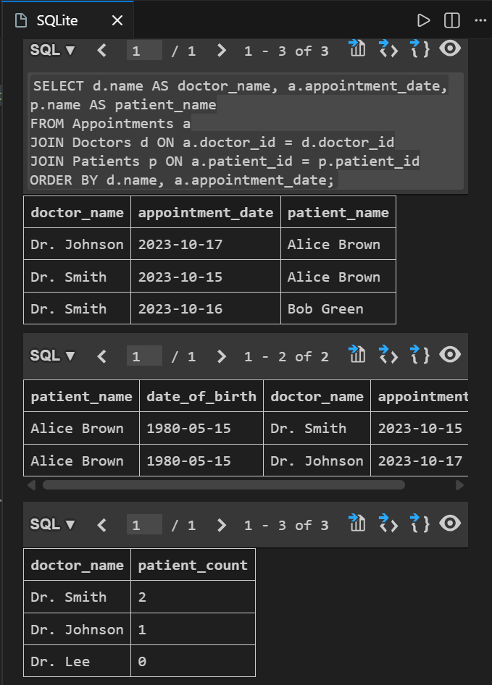

Explanation:
- Doctors, Patients, and Appointments tables are created with primary and foreign keys to maintain relationships.
- Appointments table connects doctors and patients.
- JOIN is used to combine data from multiple tables.
- Queries fetch doctor appointments, patient history, and total patients per doctor.

Task 2 – Real-Time Application: Online Shopping Database
Scenario:
Design a database for an E-commerce platform.
Requirements:
- Tables: Users, Products, Orders, OrderDetails.
- Generate queries to:
- Retrieve all orders by a user.
- Find the most purchased product.
- Calculate total revenue in a given month.
- AI should also suggest normalization improvements and query optimization.
Expected Output:
- Complete schema with relationships + SQL queries for analytics.

Prompt:

Create SQLite schema for Users, Products, Orders, OrderDetails with PK, FK.

Write queries:
- orders by user
- most purchased product
- monthly revenue

Suggest indexing.
Code:

--Drop tables if they exist
DROP TABLE IF EXISTS OrderDetails;
DROP TABLE IF EXISTS Orders;
DROP TABLE IF EXISTS Products;
DROP TABLE IF EXISTS Users;

-- Create tables
CREATE TABLE Users (
UserID INTEGER PRIMARY KEY,
UserName TEXT NOT NULL,
Email TEXT NOT NULL UNIQUE
);
CREATE TABLE Products (
ProductID INTEGER PRIMARY KEY,
ProductName TEXT NOT NULL,
Price REAL NOT NULL
);
CREATE TABLE Orders (
OrderID INTEGER PRIMARY KEY,
UserID INTEGER,
OrderDate DATE,
FOREIGN KEY (UserID) REFERENCES Users(UserID)
);
CREATE TABLE OrderDetails (
OrderDetailID INTEGER PRIMARY KEY,
OrderID INTEGER,
ProductID INTEGER,
Quantity INTEGER,
FOREIGN KEY (OrderID) REFERENCES Orders(OrderID),
FOREIGN KEY (ProductID) REFERENCES Products(ProductID)
);
-- Insert sample data
INSERT INTO Users (UserName, Email) VALUES ('Alice', 'alice@example.com'), ('Bob', 'bob@example.com');
INSERT INTO Products (ProductName, Price) VALUES ('Laptop', 1000.00), ('Mouse', 25.00);
INSERT INTO Orders (UserID, OrderDate) VALUES (1, '2023-01-15'), (2, '2023-01-16');
INSERT INTO OrderDetails (OrderID, ProductID, Quantity) VALUES (1, 1, 1), (1, 2, 2), (2, 2, 1);

-- Queries
-- Orders by user
SELECT u.UserName, o.OrderID, o.OrderDate
FROM Users u
JOIN Orders o ON u.UserID = o.UserID
WHERE u.UserID = 1; -- Replace with desired UserID
-- Most purchased product
SELECT p.ProductName, SUM(od.Quantity) AS TotalQuantity
FROM Products p
JOIN OrderDetails od ON p.ProductID = od.ProductID
GROUP BY p.ProductID
ORDER BY TotalQuantity DESC
LIMIT 1;
-- Monthly revenue
SELECT strftime('%Y-%m', o.OrderDate) AS Month, SUM(p.Price * od.Quantity) AS Revenue
FROM Orders o
JOIN OrderDetails od ON o.OrderID = od.OrderID
JOIN Products p ON od.ProductID = p.ProductID
GROUP BY Month
ORDER BY Month;
-- Indexing suggestions
CREATE INDEX idx_orders_user_id ON Orders(UserID);
CREATE INDEX idx_order_details_order_id ON OrderDetails(OrderID);
CREATE INDEX idx_order_details_product_id ON OrderDetails(ProductID);
CREATE INDEX idx_products_price ON Products(Price);
-- Validate indexes
PRAGMA index_list('Orders');
PRAGMA index_list('OrderDetails');
PRAGMA index_list('Products');
PRAGMA index_info('idx_orders_user_id');
PRAGMA index_info('idx_order_details_order_id');
PRAGMA index_info('idx_order_details_product_id');
PRAGMA index_info('idx_products_price');-

Output:
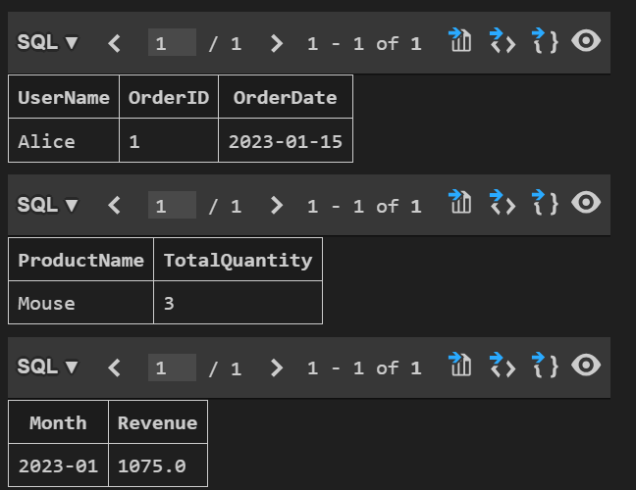

Explanation:
- Users, Products, Orders, and OrderDetails tables are created and normalized.
- OrderDetails removes redundancy by storing product quantities separately.
- JOIN and aggregate functions are used for analytics queries.
- Indexes are added to improve query performance.

Index Validation:
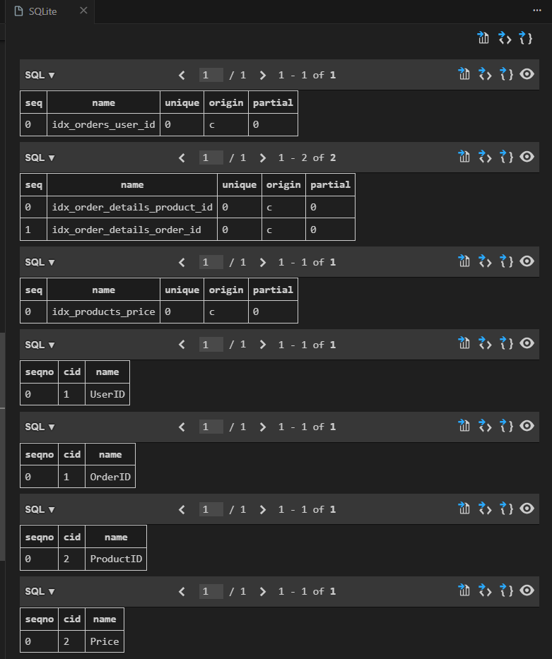

Task 3 – Library Database
Task:
Design schema for a Library Management System.
Instructions:
- Tables: Books, Members, Loans.
- Use AI to suggest indexing strategy for faster queries.
- Generate queries:
- Retrieve all books currently issued.
- Find overdue books (loan date > 30 days).
- Count the number of books loaned by each member.
Expected Output:
- Schema + SQL queries demonstrating joins and conditions.
Prompt:

Create SQLite schema for Books, Members, Loans with PK, FK.

Write queries:
- currently issued books
- overdue books (>30 days)
- books count per member

Suggest indexes.
Code:
-- Create tables
CREATE TABLE Books (
BookID INTEGER PRIMARY KEY,
Title TEXT NOT NULL,
Author TEXT NOT NULL,
PublishedYear INTEGER
);
CREATE TABLE Members (
MemberID INTEGER PRIMARY KEY,
Name TEXT NOT NULL,
JoinDate DATE
);
CREATE TABLE Loans (
LoanID INTEGER PRIMARY KEY,
BookID INTEGER,
MemberID INTEGER,
LoanDate DATE,
ReturnDate DATE,
FOREIGN KEY (BookID) REFERENCES Books(BookID),
FOREIGN KEY (MemberID) REFERENCES Members(MemberID)
);

-- Insert sample data
INSERT INTO Books (Title, Author, PublishedYear) VALUES
('The Great Gatsby', 'F. Scott Fitzgerald', 1925),
('To Kill a Mockingbird', 'Harper Lee', 1960),
('1984', 'George Orwell', 1949);
INSERT INTO Members (Name, JoinDate) VALUES
('Alice Johnson', '2020-01-15'),
('Bob Smith', '2021-06-10'),
('Charlie Brown', '2019-11-05');
INSERT INTO Loans (BookID, MemberID, LoanDate, ReturnDate) VALUES
(1, 1, '2023-01-10', NULL),
(2, 2, '2023-02-20', '2023-03-01'),
(3, 3, '2023-01-05', NULL);

-- Query: currently issued books
SELECT b.Title, m.Name, l.LoanDate
FROM Loans l
JOIN Books b ON l.BookID = b.BookID
JOIN Members m ON l.MemberID = m.MemberID
WHERE l.ReturnDate IS NULL;
-- Query: overdue books (>30 days)
SELECT b.Title, m.Name, l.LoanDate
FROM Loans l
JOIN Books b ON l.BookID = b.BookID
JOIN Members m ON l.MemberID = m.MemberID
WHERE l.ReturnDate IS NULL AND julianday('now') - julianday(l.LoanDate) > 30;
-- Query: books count per member
SELECT m.Name, COUNT(l.LoanID) AS BooksCount
FROM Members m
LEFT JOIN Loans l ON m.MemberID = l.MemberID
GROUP BY m.MemberID;
-- Suggested indexes
CREATE INDEX idx_loans_bookid ON Loans(BookID);
CREATE INDEX idx_loans_memberid ON Loans(MemberID);
CREATE INDEX idx_loans_loandate ON Loans(LoanDate);
CREATE INDEX idx_loans_returndate ON Loans(ReturnDate);

Output:
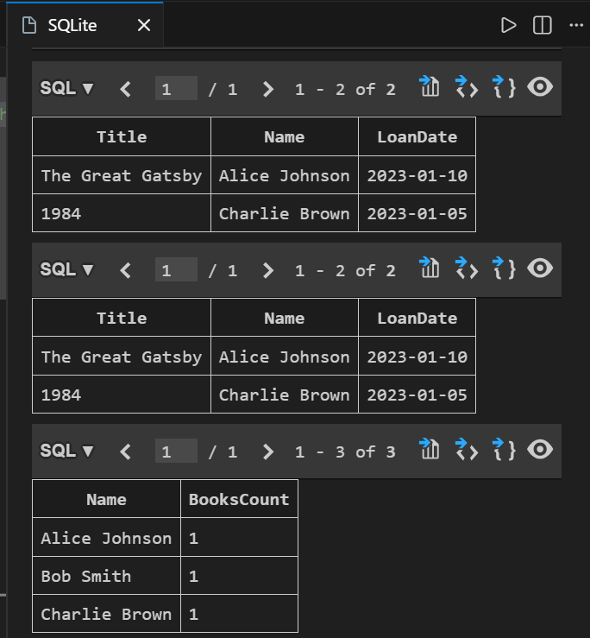

Explanation:
- Books, Members, and Loans tables are linked using foreign keys.
- Loans table tracks issued and returned books.
- Queries use JOIN and conditions to find issued and overdue books.
- Indexes help speed up search operations.
Task 4: Optimize Queries
Instructions:
- Use AI tools to analyze query efficiency.
- Optimize inefficient queries using joins, indexes, or reducing subqueries.
- Test optimized queries for correctness.
Starter Code Example:
-- Original query
SELECT * FROM Books WHERE author_id IN (SELECT author_id FROM Authors WHERE country='UK');
-- Optimized query
SELECT b.*
FROM Books b
JOIN Authors a ON b.author_id = a.author_id
WHERE a.country = 'UK';
Expected Output:
- Both queries return the same result: all books written by UK authors.
- Optimized query performs faster for larger datasets.

Prompt:
Optimize this query using JOIN:

SELECT * FROM Books WHERE author_id IN
(SELECT author_id FROM Authors WHERE country='UK');
Code:
-- Create tables
CREATE TABLE Authors (
AuthorID INTEGER PRIMARY KEY,
Name TEXT NOT NULL,
Country TEXT NOT NULL
);
CREATE TABLE Books (
BookID INTEGER PRIMARY KEY,
Title TEXT NOT NULL,
AuthorID INTEGER,
PublishedYear INTEGER,
FOREIGN KEY (AuthorID) REFERENCES Authors(AuthorID)
);
-- Insert sample data
INSERT INTO Authors (Name, Country) VALUES
('J.K. Rowling', 'UK'),
('George Orwell', 'UK'),
('F. Scott Fitzgerald', 'USA');
INSERT INTO Books (Title, AuthorID, PublishedYear) VALUES
('Harry Potter and the Sorcerer''s Stone', 1, 1997),
('1984', 2, 1949),
('The Great Gatsby', 3, 1925);
-- Original query
SELECT * FROM Books WHERE AuthorID IN
(SELECT AuthorID FROM Authors WHERE Country='UK');
-- Optimized query using JOIN
SELECT b.*
FROM Books b
JOIN Authors a ON b.AuthorID = a.AuthorID
WHERE a.Country = 'UK';

Output:
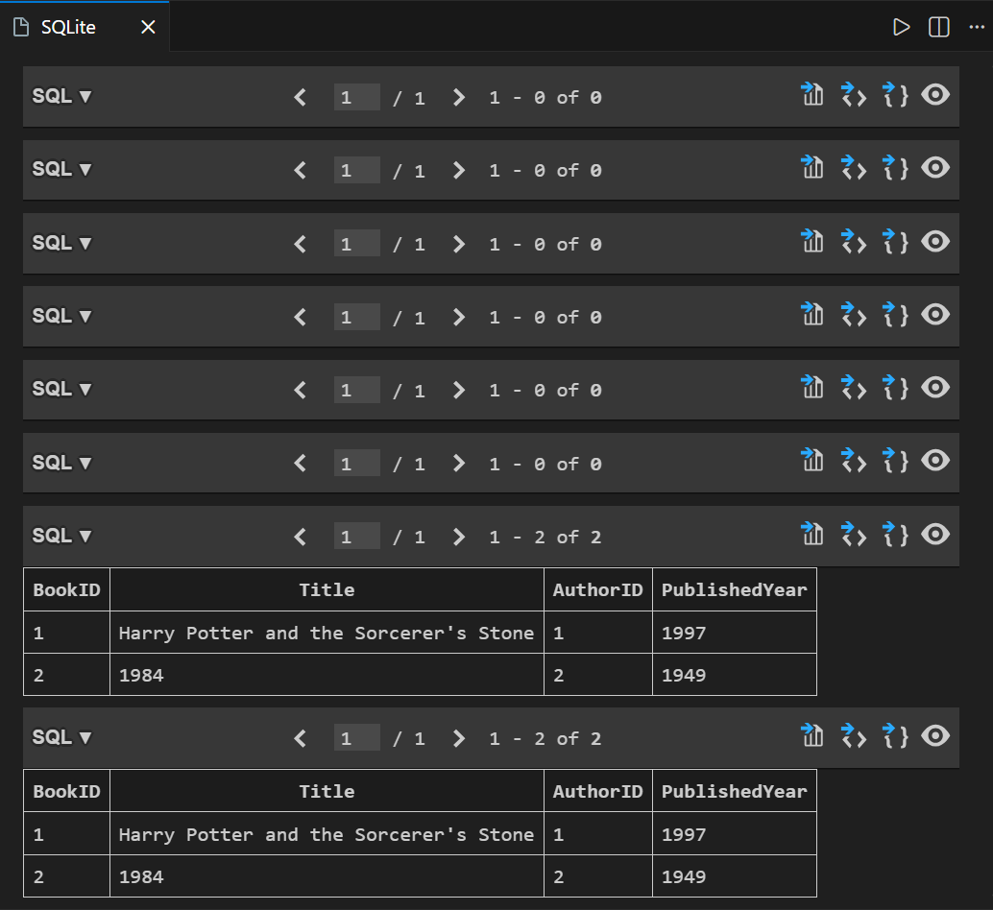

Explanation:
- Original query uses subquery which is slower for large data.
- Optimized query uses JOIN to directly match tables.
- JOIN improves performance and reduces execution time.
- Both queries give same result but optimized one is faster.

Task 5: University Course Registration
Scenario:
SR University needs a course registration system for students enrolling in different courses under faculty supervision.
- Use Copilot to design schema tables: Students, Courses, Faculty, and Registrations.
- Define relationships:
- Each student can register for multiple courses.
- Each course is taught by a faculty member.
- Write SQL queries to:
- List all students enrolled in a specific course.
- Find faculty members teaching more than 2 courses.
- Retrieve courses with the highest number of registrations.
Prompt:

Create SQLite schema for Students, Courses, Faculty, Registrations with relationships.

Write queries:
- students in a course
- faculty teaching >2 courses
- most registered courses
Use JOINs.

Code:
-- Drop tables if they exist
DROP TABLE IF EXISTS Registrations;
DROP TABLE IF EXISTS Students;
DROP TABLE IF EXISTS Courses;
DROP TABLE IF EXISTS Faculty;

-- Create tables
CREATE TABLE Faculty (
faculty_id INTEGER PRIMARY KEY,
name TEXT NOT NULL
);
CREATE TABLE Courses (
course_id INTEGER PRIMARY KEY,
course_name TEXT NOT NULL,
faculty_id INTEGER,
FOREIGN KEY (faculty_id) REFERENCES Faculty(faculty_id)
);
CREATE TABLE Students (
student_id INTEGER PRIMARY KEY,
name TEXT NOT NULL
);
CREATE TABLE Registrations (
registration_id INTEGER PRIMARY KEY,
student_id INTEGER,
course_id INTEGER,
FOREIGN KEY (student_id) REFERENCES Students(student_id),
FOREIGN KEY (course_id) REFERENCES Courses(course_id)
);

-- Sample data insertion
INSERT INTO Faculty (name) VALUES ('Dr. Smith'), ('Dr. Johnson'), ('Dr. Lee');
INSERT INTO Courses (course_name, faculty_id) VALUES ('Math 101', 1), ('Math 103', 1), ('History 201', 2), ('Science 301', 3), ('Math 102', 1), ('History 202', 2), ('Science 302', 3);
INSERT INTO Students (name) VALUES ('Alice'), ('Bob'), ('Charlie');
INSERT INTO Registrations (student_id, course_id) VALUES (1, 1), (1, 2), (2, 1), (3, 3);
INSERT INTO Registrations (student_id, course_id) VALUES (2, 3), (3, 1), (3, 2);

-- Query: students in a course
SELECT s.name AS student_name, c.course_name
FROM Students s
JOIN Registrations r ON s.student_id = r.student_id
JOIN Courses c ON r.course_id = c.course_id
WHERE c.course_name = 'Math 101';

-- Query: faculty teaching >2 courses
SELECT f.name AS faculty_name, COUNT(c.course_id) AS course_count
FROM Faculty f
JOIN Courses c ON f.faculty_id = c.faculty_id
GROUP BY f.faculty_id, f.name
HAVING COUNT(c.course_id) > 2;

-- Query: most registered courses
SELECT c.course_name, COUNT(r.registration_id) AS registration_count
FROM Courses c
JOIN Registrations r ON c.course_id = r.course_id
GROUP BY c.course_id, c.course_name
ORDER BY registration_count DESC
LIMIT 1;

Output:
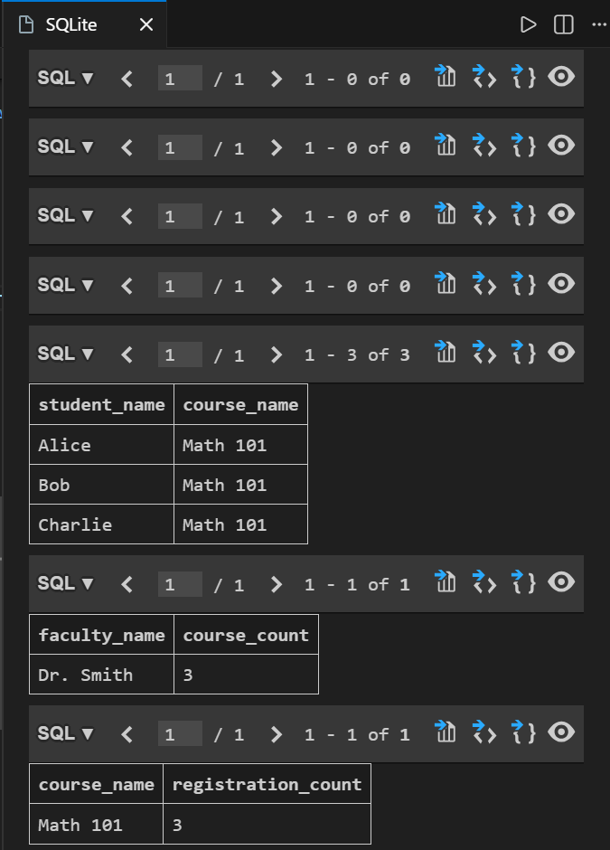

Explanation:
- Students, Courses, Faculty, and Registrations tables are created with relationships.
- The registrations table handles many-to-many relationships between students and courses.
- JOIN is used to retrieve combined data.
- Aggregate functions help find faculty load and popular courses.

