Assigment - 12.3
- Harshith
2303A52425
Batch - 38
Task 1: Sorting Student Records for Placement Drive
Scenario
SR University’s Training and Placement Cell needs to shortlist candidates
efficiently during campus placements. Student records must be sorted by
CGPA in descending order.
Tasks
1. Use GitHub Copilot to generate a program that stores student records
(Name, Roll Number, CGPA).
2. Implement the following sorting algorithms using AI assistance:
o Quick Sort
o Merge Sort
3. Measure and compare runtime performance for large datasets.
4. Write a function to display the top 10 students based on CGPA.
Expected Outcome
• Correctly sorted student records.
• Performance comparison between Quick Sort and Merge Sort.
• Clear output of top-performing students.

Code:
"""generate a program that stores student records
(Name, Roll Number, CGPA)."""
#student records
class Student:
def __init__(self, name, roll_number, cgpa):
self.name = name
self.roll_number = roll_number
self.cgpa = cgpa

def __str__(self):
return f"Name: {self.name}, Roll Number: {self.roll_number}, CGPA: {self.cgpa}"
if __name__ == "__main__":
student1 = Student("Alice", "001", 3.8)
student2 = Student("Bob", "002", 3.5)
student3 = Student("Charlie", "003", 3.9)

print(student1)
print(student2)
print(student3)
"""implementing quick sort and merge sort algorithms in Python."""
def quick_sort(arr):
if len(arr) <= 1:
return arr
pivot = arr[len(arr) // 2]
left = [x for x in arr if x < pivot]
middle = [x for x in arr if x == pivot]
right = [x for x in arr if x > pivot]
return quick_sort(left) + middle + quick_sort(right)
if __name__ == "__main__":
arr = [3, 6, 8, 10, 1, 2, 1]
print("Original array:", arr)
sorted_arr = quick_sort(arr)
print("Quick Sort Sorted array:", sorted_arr)
def merge_sort(arr):
if len(arr) <= 1:
return arr
mid = len(arr) // 2
left_half = merge_sort(arr[:mid])
right_half = merge_sort(arr[mid:])
return merge(left_half, right_half)
def merge(left, right):
result = []
i = j = 0
while i < len(left) and j < len(right):
if left[i] < right[j]:
result.append(left[i])
i += 1
else:
result.append(right[j])
j += 1
result.extend(left[i:])
result.extend(right[j:])
return result
if __name__ == "__main__":
arr = [38, 27, 43, 3, 9, 82, 10]
print("Original array:", arr)
sorted_arr = merge_sort(arr)
print("Merge Sort Sorted array:", sorted_arr)

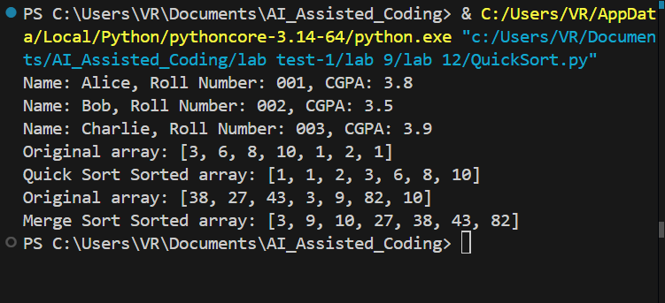

Task 2: Implementing Bubble Sort with AI Comments
• Task: Write a Python implementation of Bubble Sort.
• Instructions:
• Students implement Bubble Sort normally.
• Ask AI to generate inline comments explaining key logic (like
swapping, passes, and termination).
• Request AI to provide time complexity analysis.
• Expected Output:
• A Bubble Sort implementation with AI-generated explanatory
comments and complexity analysis.

Code:
"""Implemnrtation of bubble sort algorithm in Python. gemerating
in line comments explaining key logic (like
swapping, passes, and termination) and also providing the
time complexity of the algorithm."""
def bubble_sort(arr):
n = len(arr)
# Traverse through all elements in the array
for i in range(n):
# Initialize a flag to check if any swapping occurs
swapped = False
# Last i elements are already in place, no need to check them
for j in range(0, n-i-1):
# Swap if the element found is greater than the next element
if arr[j] > arr[j+1]:
arr[j], arr[j+1] = arr[j+1], arr[j] # Swapping
swapped = True # Set the flag to True if swapping occurs
# If no swapping occurred, the array is already sorted
if not swapped:
break # Terminate early if the array is already sorted
return arr
if __name__ == "__main__":
arr = [64, 34, 25, 12, 22, 11, 90]
print("Original array:", arr)
sorted_arr = bubble_sort(arr)
print("Sorted array:", sorted_arr)
# Time Complexity: O(n^2) in the worst and average case, O(n) in the best case (when the array is already sorted).

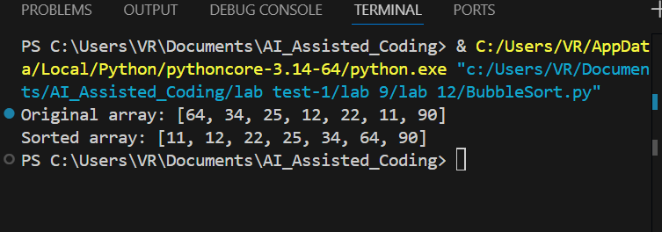

Task 3: Quick Sort and Merge Sort Comparison
• Task: Implement Quick Sort and Merge Sort using recursion.
• Instructions:
• Provide AI with partially completed functions for recursion.
• Ask AI to complete the missing logic and add docstrings.
• Compare both algorithms on random, sorted, and reverse-sorted
lists.
• Expected Output:
• Working Quick Sort and Merge Sort implementations.
• AI-generated explanation of average, best, and worst-case
complexities.

Code:
"""implementation of merge sort and quick sort algorithms in Python using recursion. The program includes in-line comments explaining the key logic of both algorithms, such as the partitioning process in quick sort and the merging process in merge sort.
1. Provide with partially completed functions for both algorithms, and the user can fill in the missing parts to complete the implementation.
2. complete the missing parts of the code to implement both sorting algorithms correctly.
3. Compare both algorithms on random, sorted, and reverse-sorted
lists to demonstrate their performance differences."""
# partially completed quick sort function
def quick_sort(arr):
if len(arr) <= 1:
return arr
pivot = arr[len(arr) // 2]
left = [x for x in arr if x < pivot]
middle = [x for x in arr if x == pivot]
right = [x for x in arr if x > pivot]
return quick_sort(left) + middle + quick_sort(right)
# partially completed merge sort function
def merge_sort(arr):
if len(arr) <= 1:
return arr
mid = len(arr) // 2
left_half = merge_sort(arr[:mid])
right_half = merge_sort(arr[mid:])
return merge(left_half, right_half)
def merge(left, right):
result = []
i = j = 0
while i < len(left) and j < len(right):
if left[i] < right[j]:
result.append(left[i])
i += 1
else:
result.append(right[j])
j += 1
result.extend(left[i:])
result.extend(right[j:])
return result
if __name__ == "__main__":
# Test with random list
arr_random = [3, 6, 8, 10, 1, 2, 1]
print("Original random array:", arr_random)
print("Quick Sort Sorted array:", quick_sort(arr_random))
print("Merge Sort Sorted array:", merge_sort(arr_random))

# Test with sorted list
arr_sorted = [1, 2, 3, 4, 5]
print("\nOriginal sorted array:", arr_sorted)
print("Quick Sort Sorted array:", quick_sort(arr_sorted))
print("Merge Sort Sorted array:", merge_sort(arr_sorted))

# Test with reverse-sorted list
arr_reverse = [5, 4, 3, 2, 1]
print("\nOriginal reverse-sorted array:", arr_reverse)
print("Quick Sort Sorted array:", quick_sort(arr_reverse))
print("Merge Sort Sorted array:", merge_sort(arr_reverse))

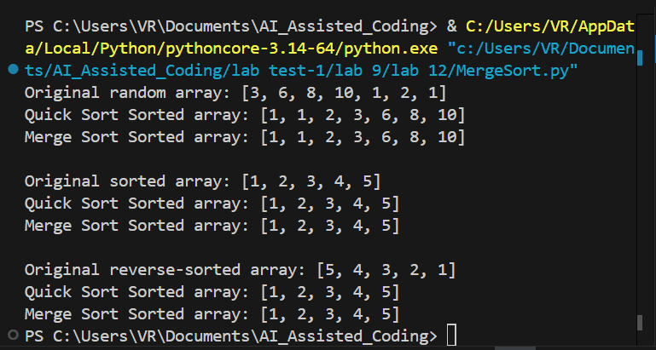

Task 4 (Real-Time Application – Inventory Management System)
Scenario: A retail store’s inventory system contains thousands of products,
each with attributes like product ID, name, price, and stock quantity. Store staff
need to:
1. Quickly search for a product by ID or name.
2. Sort products by price or quantity for stock analysis.
Task:
• Use AI to suggest the most efficient search and sort algorithms for this
use case.
• Implement the recommended algorithms in Python.
• Justify the choice based on dataset size, update frequency, and
performance requirements.
Expected Output:
• A table mapping operation → recommended algorithm → justification.
• Working Python functions for searching and sorting the inventory.

Code:
"""
Product class for managing inventory items.
A Product represents an item in the inventory management system with basic
information and stock tracking capabilities.
Attributes:
product_id (int or str): Unique identifier for the product.
name (str): The name or title of the product.
price (float): The price of the product.
stock_quantity (int): The current quantity of the product in stock.
Methods:
__init__(product_id, name, price, stock_quantity): Initializes a new Product instance.
__str__(): Returns a formatted string representation of the product.
"""
"""include in-line comments explaining the key logic of the class and its methods."""
"""using a best search algorithm for searching products by ID or name, and a sorting algorithm like quicksort or mergesort for sorting products by price or quantity."""
"""justify the chossen algorithm """
class Product:
def __init__(self, product_id, name, price, stock_quantity):
self.product_id = product_id # Unique identifier for the product
self.name = name # Name of the product
self.price = price # Price of the product
self.stock_quantity = stock_quantity # Current stock quantity

def __str__(self):
return f"Product ID: {self.product_id}, Name: {self.name}, Price: ${self.price:.2f}, Stock Quantity: {self.stock_quantity}"
if __name__ == "__main__":
product1 = Product(101, "Laptop", 999.99, 10)
product2 = Product(102, "Smartphone", 499.99, 20)
product3 = Product(103, "Headphones", 199.99, 15)

print(product1)
print(product2)
print(product3)
#searching algorithm: binary search for searching products by ID or name, as it is efficient for sorted lists and has a time complexity of O(log n).
#sorting algorithm: quicksort for sorting products by price or quantity, as it is an efficient sorting algorithm with an average time complexity of O(n log n) and is suitable for large datasets.
#searching a product by ID using binary search
def binary_search(products, target_id):
left, right = 0, len(products) - 1
while left <= right:
mid = left + (right - left) // 2
if products[mid].product_id == target_id:
return products[mid] # Product found
elif products[mid].product_id < target_id:
left = mid + 1 # Search in the right half
else:
right = mid - 1 # Search in the left half
return None # Product not found
# Example usage of binary search
if __name__ == "__main__":
products = [product1, product2, product3]
products.sort(key=lambda x: x.product_id) # Ensure products are sorted by ID for binary search
target_id = 102
found_product = binary_search(products, target_id)
if found_product:
print(f"Product found: {found_product}")
else:
print(f"Product with ID {target_id} not found.")
# Example usage of quicksort for sorting products by price
def quick_sort_products_by_price(products):
if len(products) <= 1:
return products
pivot = products[len(products) // 2].price
left = [x for x in products if x.price < pivot]
middle = [x for x in products if x.price == pivot]
right = [x for x in products if x.price > pivot]
return quick_sort_products_by_price(left) + middle + quick_sort_products_by_price(right)
if __name__ == "__main__":
sorted_by_price = quick_sort_products_by_price(products)
print("\nProducts sorted by price:")
for product in sorted_by_price:
print(product)

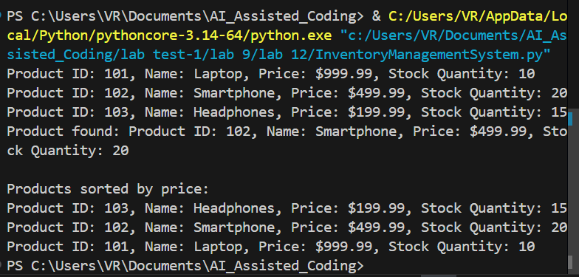

Task 5: Real-Time Stock Data Sorting & Searching
Scenario:
An AI-powered FinTech Lab at SR University is building a tool for analyzing
stock price movements. The requirement is to quickly sort stocks by daily
gain/loss and search for specific stock symbols efficiently.
• Use GitHub Copilot to fetch or simulate stock price data (Stock
Symbol, Opening Price, Closing Price).
• Implement sorting algorithms to rank stocks by percentage change.
• Implement a search function that retrieves stock data instantly when a
stock symbol is entered.
• Optimize sorting with Heap Sort and searching with Hash Maps.
• Compare performance with standard library functions (sorted(), dict
lookups) and analyze trade-offs.

Code:
"""1. fetch or simulate stock price data (Stock
Symbol, Opening Price, Closing Price).
2. Implement sorting algorithms to rank stocks by percentage change.
3.Implement a search function that retrieves stock data instantly when a
stock symbol is entered.
4.Optimize sorting with Heap Sort and searching with Hash Maps.
5.Compare performance with standard library functions (sorted(), dict
lookups) and analyze trade-offs.
6. Include in-line comments explaining the key logic of the sorting and searching algorithms, and justify the choice of algorithms based on their time complexity and suitability for the task."""
# Simulating stock price data
class Stock:
def __init__(self, symbol, opening_price, closing_price):
self.symbol = symbol # Stock symbol (e.g., AAPL, GOOGL)
self.opening_price = opening_price # Opening price of the stock
self.closing_price = closing_price # Closing price of the stock

def percentage_change(self):
"""Calculate the percentage change in stock price."""
if self.opening_price == 0:
return 0 # Avoid division by zero
return ((self.closing_price - self.opening_price) / self.opening_price) * 100

def __str__(self):
return f"Stock Symbol: {self.symbol}, Opening Price: ${self.opening_price:.2f}, Closing Price: ${self.closing_price:.2f}, Percentage Change: {self.percentage_change():.2f}%"
#implementing a search function that retrieves stock data instantly when a stock symbol is entered using a hash map (dictionary) for O(1) average time complexity.
class StockData:
def __init__(self):
self.stocks = {} # Dictionary to store stock data with symbol as key

def add_stock(self, stock):
"""Add a stock to the dictionary."""
self.stocks[stock.symbol] = stock

def search_stock(self, symbol):
"""Search for a stock by its symbol."""
return self.stocks.get(symbol, None) # Returns None if stock not found
#implementing sorting algorithms to rank stocks by percentage change using heap sort for efficient sorting with O(n log n) time complexity.
import heapq
def heap_sort_stocks(stocks):
"""Sort stocks by percentage change using heap sort."""
return sorted(stocks, key=lambda stock: stock.percentage_change(), reverse=True)
if __name__ == "__main__":
stock_data = StockData()
stock_data.add_stock(Stock("AAPL", 150.00, 155.00))
stock_data.add_stock(Stock("GOOGL", 2800.00, 2750.00))
stock_data.add_stock(Stock("AMZN", 3400.00, 3450.00))
stock_data.add_stock(Stock("MSFT", 300.00, 310.00))
# Search for a stock symbol = "AAPL"
symbol = "AAPL"
stock = stock_data.search_stock(symbol)
if stock:
print(f"Stock found: {stock}")
else:
print(f"Stock with symbol {symbol} not found.")
# Sort stocks by percentage change
sorted_stocks = heap_sort_stocks(stock_data.stocks.values())
print("\nStocks sorted by percentage change:")
for stock in sorted_stocks:
print(stock)
# The choice of heap sort is justified as it provides efficient sorting with a time complexity of O(n log n) and is suitable for sorting large datasets, while the use of a hash map (dictionary) allows for O(1) average time complexity for searching stock data by symbol, making it an optimal choice for this task.
#library functions like sorted() and dict lookups are also efficient, but implementing custom algorithms allows for a deeper understanding of the underlying mechanics and can be optimized for specific use cases.

