AI ASSISSTANT CODING ASSIGNMENT -2.2

P.Harshith 2303A52425 BATCH- 38

Lab 2: Exploring Additional AI Coding Tools beyond Copilot – Gemini (Colab) and Cursor AI
Task 1: Cleaning Sensor Data
- Scenario:
- You are cleaning IoT sensor data where negative values are invalid.
- Task:
Use Gemini in Colab to generate a function that filters out all negative numbers from a list.
- Expected Output:
- Before/after list
- Screenshot of Colab execution
PROMPT:
write a python code to extract all the negative numbers from a user given list of numbers and show the new list which contains no negative numbers

Code :
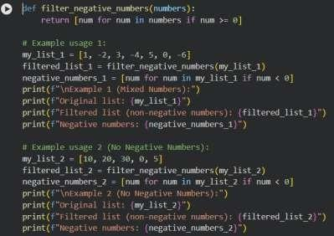

Output:
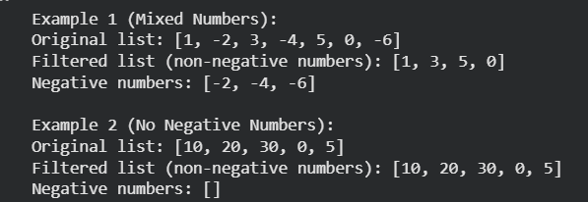

Explanation :
This program takes a list of numbers from the user and checks which of them are negative.
The user first enters several numbers separated by spaces. This input is taken as a string and then converted into a list of decimal numbers using the split() and float() functions inside a try block. If the user enters anything other than numbers, the program shows an error message and uses an empty list.
After that, the program uses list comprehension to find all the negative numbers in the list. It also creates another list that contains only non-negative numbers, meaning zero and positive values.
At the end, the program displays the original list, the negative numbers, and the list after removing all negative values.

Task 2: String Character Analysis
- Scenario:
You are building a text-analysis feature.

Task:
Use Gemini to generate a Python function that counts vowels, consonants, and digits in a string.
- Expected Output:
- Working function
- Sample inputs and outputs
PROMPT: write a python code that counts vowels, consonants and digits in a string

Code & output:

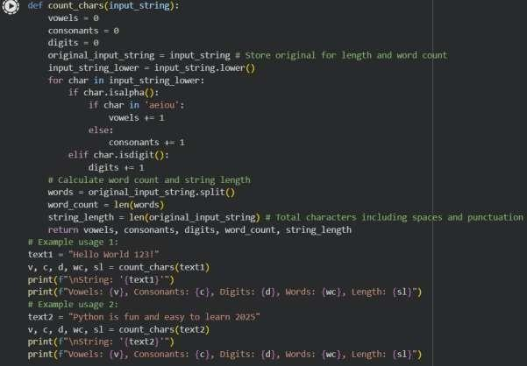
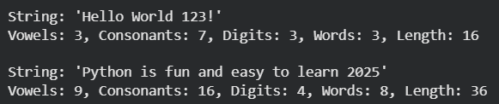

Explanation:
This program is used to count vowels, consonants, and digits in a given string.
A function called count_chars is created, which takes a string as input. Inside the function, the program checks each character one by one. If the character is a letter, it checks whether it is a vowel or a consonant and increases the count accordingly. If the character is a number, the digit count is increased.
After checking all the characters, the function returns the total number of vowels, consonants, and digits.
In the program, two example strings are given. The function is called for each string and the results are printed.

Task 3: Palindrome Check – Tool Comparison
- Scenario:
You must decide which AI tool is clearer for string logic.
- Task: Generate a palindrome-checking function using Gemini and Copilot, then compare the results.

Expected Output:
- Side-by-side code comparison
- Observations on clarity and structure
PROMPT: write a python code for palindrome checker by user input

Code & output:

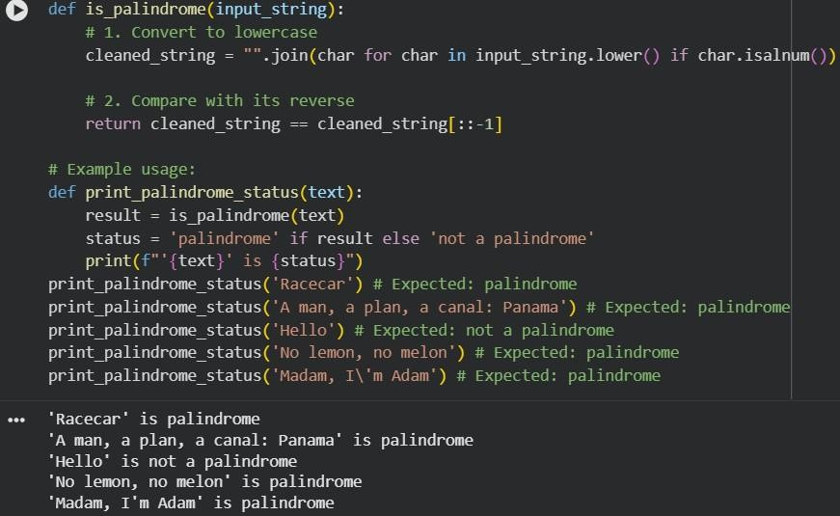

Explanation:
This program checks whether a given string is a palindrome.
The function removes spaces and converts the string to lowercase, then compares it with its reverse. If both are the same, it returns True; otherwise, it returns False.

Task 4: Code Explanation Using AI
- Scenario:
You are reviewing unfamiliar code written by another developer.

Task:
Ask Gemini to explain a Python function (prime check OR palindrome check) line by line.

Expected Output:
- Code snippet
- AI explanation
- Student comments on understanding
PROMPT: write a python code for Python function (prime check) line by line.

Code & Output:

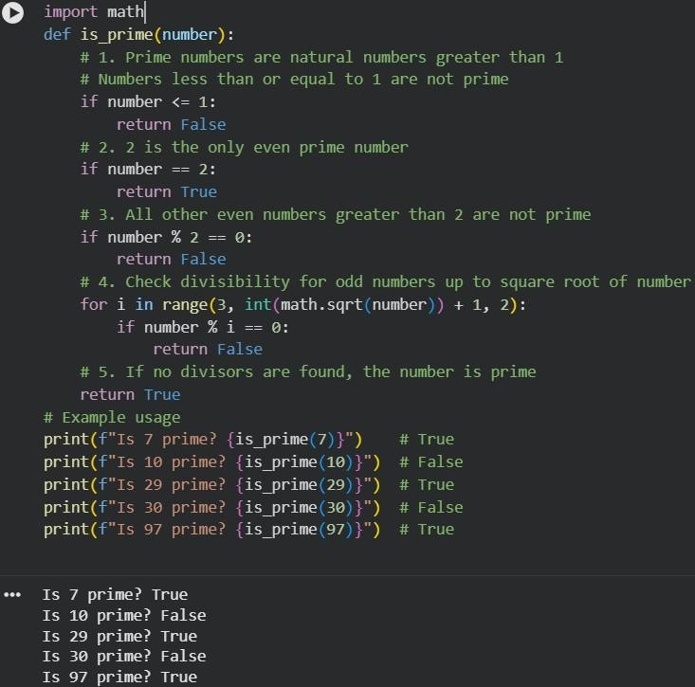

Explanation:
This program checks whether a given number is a prime number.
The function is_prime first removes numbers less than or equal to 1. It then checks special cases like 2 and even numbers. For the remaining odd numbers, it checks divisibility from 3 up to the square root of the number. If no divisor is found, the number is considered prime.

