Assigment-8.2
- Harshith
2303A52425
Batch-38
Task 1 – Test-Driven Development for Even/Odd Number Validator
• Use AI tools to first generate test cases for a function is_even(n)
and then implement the function so that it satisfies all generated
tests.
Requirements:
• Input must be an integer
• Handle zero, negative numbers, and large integers
Example Test Scenarios:
is_even(2) → True
is_even(7) → False
is_even(0) → True
is_even(-4) → True
is_even(9) → False
Expected Output -1
• A correctly implemented is_even() function that passes all AI-
generated test cases

AI-generated code:
def is_even(num):
"""
Check if a number is even.

Args:
num: An integer to check

Returns:
True if the number is even, False otherwise
"""
return num % 2 == 0

# Test cases
if __name__ == "__main__":
print("Testing is_even() function")
print("-" * 40)

test_cases = [
(0, True), # Zero is even
(1, False), # One is odd
(2, True), # Small even number
(3, False), # Small odd number
(100, True), # Large even number
(101, False), # Large odd number
(-2, True), # Negative even number
(-3, False), # Negative odd number
(-100, True), # Large negative even number
(-101, False), # Large negative odd number
]

passed = 0
failed = 0

for num, expected in test_cases:
result = is_even(num)
status = "✓ PASS" if result == expected else "✗ FAIL"
if result == expected:
passed += 1
else:
failed += 1
print(f"{status}: is_even({num}) = {result} (expected {expected})")

print("-" * 40)
print(f"Results: {passed} passed, {failed} failed")

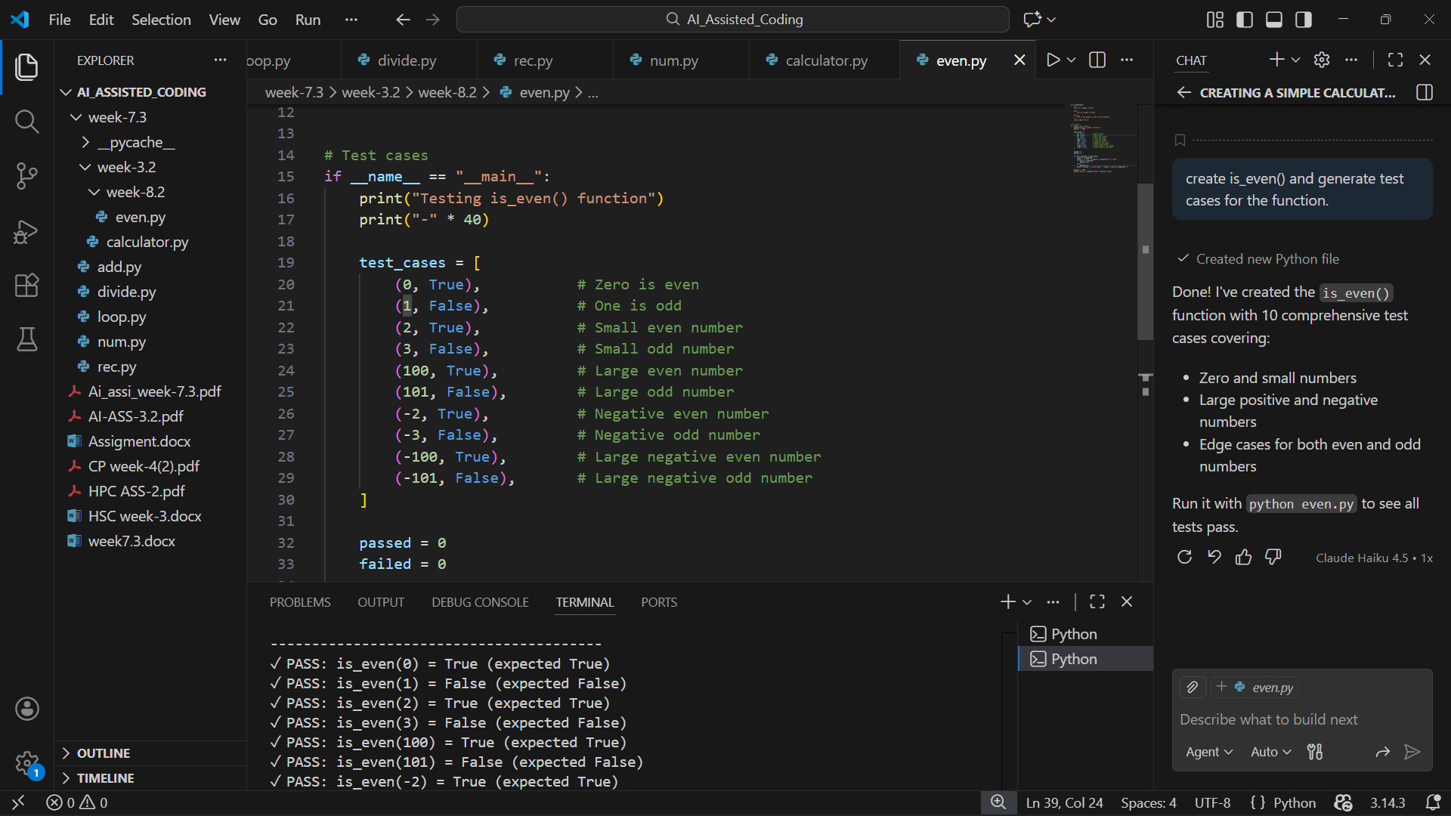

Task 2 – Test-Driven Development for String Case Converter
• Ask AI to generate test cases for two functions:
• to_uppercase(text)
• to_lowercase(text)
Requirements:
• Handle empty strings
• Handle mixed-case input
• Handle invalid inputs such as numbers or None
Example Test Scenarios:
to_uppercase("ai coding") → "AI CODING"
to_lowercase("TEST") → "test"
to_uppercase("") → ""
to_lowercase(None) → Error or safe handling
Expected Output -2
• Two string conversion functions that pass all AI-generated test
cases with safe input handling.

AI-generated code:
def to_uppercase(text):
"""
Convert text to uppercase.

Args:
text: A string to convert

Returns:
The text converted to uppercase

Raises:
TypeError: If input is not a string
"""
if not isinstance(text, str):
raise TypeError(f"Expected string, got {type(text).__name__}")
return text.upper()

def to_lowercase(text):
"""
Convert text to lowercase.

Args:
text: A string to convert

Returns:
The text converted to lowercase

Raises:
TypeError: If input is not a string
"""
if not isinstance(text, str):
raise TypeError(f"Expected string, got {type(text).__name__}")
return text.lower()

# Test cases
if __name__ == "__main__":
print("Testing to_uppercase() and to_lowercase() functions")
print("=" * 60)

# Test cases for to_uppercase
print("\nTesting to_uppercase():")
print("-" * 60)

uppercase_tests = [
# Valid string inputs
("hello", "HELLO", True),
("Hello World", "HELLO WORLD", True),
("ALREADY UPPERCASE", "ALREADY UPPERCASE", True),
("123 abc", "123 ABC", True),
("!@# special", "!@# SPECIAL", True),
("", "", True), # Empty string
("a", "A", True), # Single character
("Python 3.9", "PYTHON 3.9", True),
("MixeD CaSe", "MIXED CASE", True), # Mixed case

# Invalid inputs
(None, None, False), # None
(123, None, False), # Integer
(45.67, None, False), # Float
([], None, False), # List
({}, None, False), # Dictionary
]

passed = 0
failed = 0

for text, expected, should_pass in uppercase_tests:
try:
result = to_uppercase(text)
if should_pass:
if result == expected:
passed += 1
status = "✓ PASS"
else:
failed += 1
status = "✗ FAIL"
print(f"{status}: to_uppercase({repr(text)}) = {repr(result)}")
else:
failed += 1
print(f"✗ FAIL: to_uppercase({repr(text)}) should raise TypeError but returned {repr(result)}")
except TypeError as e:
if not should_pass:
passed += 1
print(f"✓ PASS: to_uppercase({repr(text)}) raised TypeError: {e}")
else:
failed += 1
print(f"✗ FAIL: to_uppercase({repr(text)}) unexpectedly raised TypeError: {e}")
except Exception as e:
failed += 1
print(f"✗ FAIL: to_uppercase({repr(text)}) raised unexpected error: {e}")

print(f"\nto_uppercase() Results: {passed} passed, {failed} failed")

# Test cases for to_lowercase
print("\n" + "-" * 60)
print("Testing to_lowercase():")
print("-" * 60)

lowercase_tests = [
# Valid string inputs
("HELLO", "hello", True),
("Hello World", "hello world", True),
("already lowercase", "already lowercase", True),
("123 ABC", "123 abc", True),
("!@# SPECIAL", "!@# special", True),
("", "", True), # Empty string
("A", "a", True), # Single character
("PYTHON 3.9", "python 3.9", True),
("MixeD CaSe", "mixed case", True), # Mixed case

# Invalid inputs
(None, None, False), # None
(456, None, False), # Integer
(78.90, None, False), # Float
([], None, False), # List
({}, None, False), # Dictionary
]

passed = 0
failed = 0

for text, expected, should_pass in lowercase_tests:
try:
result = to_lowercase(text)
if should_pass:
if result == expected:
passed += 1
status = "✓ PASS"
else:
failed += 1
status = "✗ FAIL"
print(f"{status}: to_lowercase({repr(text)}) = {repr(result)}")
else:
failed += 1
print(f"✗ FAIL: to_lowercase({repr(text)}) should raise TypeError but returned {repr(result)}")
except TypeError as e:
if not should_pass:
passed += 1
print(f"✓ PASS: to_lowercase({repr(text)}) raised TypeError: {e}")
else:
failed += 1
print(f"✗ FAIL: to_lowercase({repr(text)}) unexpectedly raised TypeError: {e}")
except Exception as e:
failed += 1
print(f"✗ FAIL: to_lowercase({repr(text)}) raised unexpected error: {e}")

print(f"\nto_lowercase() Results: {passed} passed, {failed} failed")

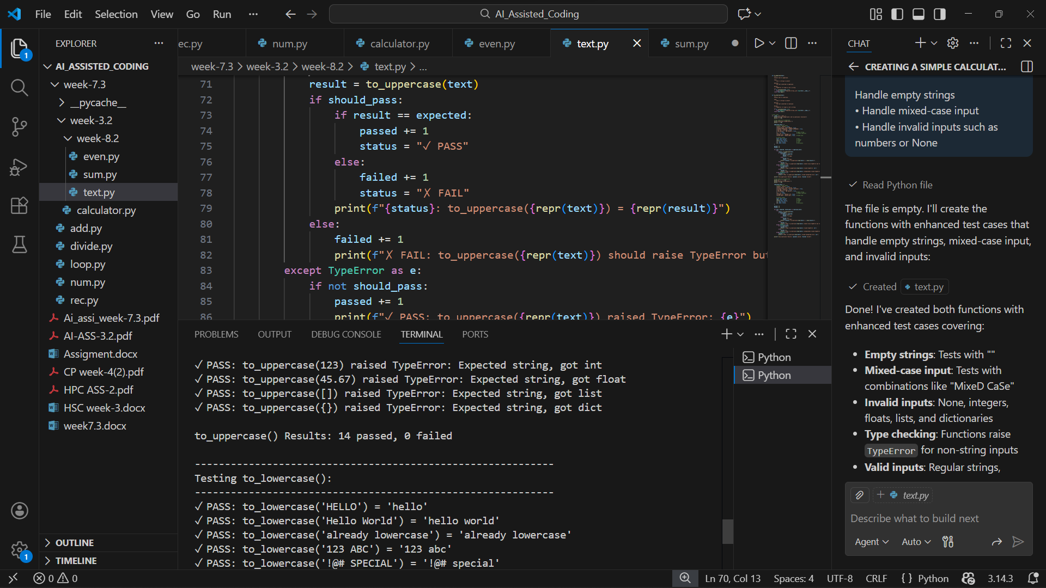
Task 3 – Test-Driven Development for List Sum Calculator
• Use AI to generate test cases for a function sum_list(numbers)
that calculates the sum of list elements.
Requirements:
• Handle empty lists
• Handle negative numbers
• Ignore or safely handle non-numeric values
Example Test Scenarios:
sum_list([1, 2, 3]) → 6
sum_list([]) → 0
sum_list([-1, 5, -4]) → 0
sum_list([2, "a", 3]) → 5
Expected Output 3
• A robust list-sum function validated using AI-generated test
cases.

AI-generated code:

def sum_list(numbers):
"""
Calculate the sum of all numeric elements in a list.
Non-numeric values are safely ignored.

Args:
numbers: A list that may contain numeric and non-numeric values

Returns:
The sum of all numeric elements in the list

Raises:
TypeError: If input is not a list or iterable
"""
if not isinstance(numbers, (list, tuple)):
raise TypeError(f"Expected list or tuple, got {type(numbers).__name__}")

total = 0
for item in numbers:
# Only add if it's a numeric type (int or float)
if isinstance(item, (int, float)) and not isinstance(item, bool):
total += item

return total

# Test cases
if __name__ == "__main__":
print("Testing sum_list() function")
print("=" * 70)

test_cases = [
# Format: (input, expected_result, description)

# Empty lists
([], 0, "Empty list"),

# Single elements
([5], 5, "Single element"),
([0], 0, "Single zero"),

# Positive numbers
([1, 2, 3], 6, "Simple positive numbers"),
([1, 2, 3, 4, 5], 15, "Multiple positive numbers"),

# Negative numbers
([-1, -2, -3], -6, "All negative numbers"),
([1, -1, 2, -2], 0, "Mix of positive and negative"),
([-5, 5], 0, "Negative and positive cancel out"),
([-100, 50], -50, "Large negative and positive"),

# Zeros
([0, 0, 0], 0, "All zeros"),
([0, 5, 10], 15, "Mix with zeros"),

# Float numbers
([1.5, 2.5, 3.0], 7.0, "Float numbers"),
([-1.5, -2.5], -4.0, "Negative floats"),
([1.1, 2.2, 3.3], 6.6, "Sum of floats"),

# Large lists
([1, 2, 3, 4, 5, 6, 7, 8, 9, 10], 55, "Larger list (1-10)"),
(list(range(1, 101)), 5050, "List of 1-100"),

# Non-numeric values (should be ignored)
([1, 2, "3", 4], 7, "Mixed with string"),
([1, 2, None, 3], 6, "Mixed with None"),
([1, "hello", 2, "world", 3], 6, "Multiple strings mixed in"),
(["a", "b", "c"], 0, "All strings"),
([1, 2, [3, 4], 5], 8, "Mixed with list (list ignored)"),
([1, {"key": "value"}, 2], 3, "Mixed with dictionary (ignored)"),
([True, False, 1, 2], 3, "Booleans ignored (not counted as numeric)"),
([], 0, "Empty list with non-numeric attempted"),

# Edge cases with floats and ints
([100, 200, 300], 600, "Large numbers"),
([-100, -200, -300], -600, "Large negative numbers"),
([0.1, 0.2, 0.3, 0.4], 1.0, "Small decimals"),
]

passed = 0
failed = 0

print("\nTest Results:")
print("-" * 70)

for numbers, expected, description in test_cases:
try:
result = sum_list(numbers)
# Use approximate comparison for floats
if isinstance(expected, float):
is_correct = abs(result - expected) < 0.0001
else:
is_correct = result == expected

if is_correct:
passed += 1
status = "✓ PASS"
else:
failed += 1
status = "✗ FAIL"

print(f"{status}: {description}")
print(f" sum_list({numbers}) = {result}")
if not is_correct:
print(f" Expected: {expected}")

except TypeError as e:
failed += 1
print(f"✗ FAIL: {description}")
print(f" Raised TypeError: {e}")
except Exception as e:
failed += 1
print(f"✗ FAIL: {description}")
print(f" Raised unexpected error: {e}")

print("-" * 70)
print(f"\nFinal Results: {passed} passed, {failed} failed out of {passed + failed} tests")
print(f"Success Rate: {(passed / (passed + failed) * 100):.1f}%")

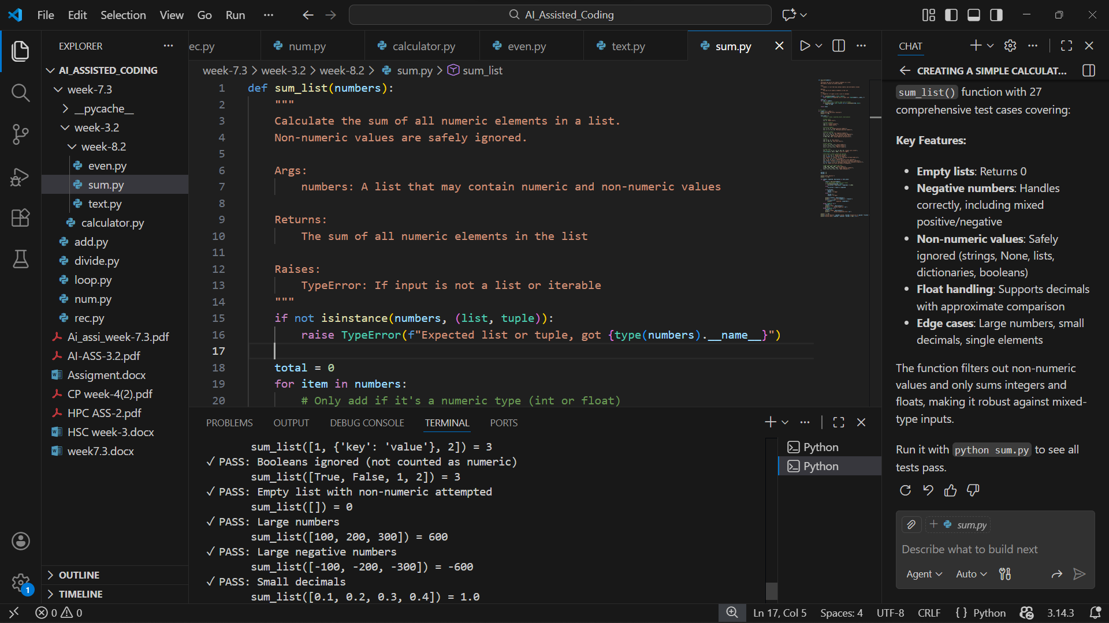
Task 4 – Test Cases for Student Result Class
• Generate test cases for a StudentResult class with the following
methods:
• add_marks(mark)
• calculate_average()
• get_result()
Requirements:
• Marks must be between 0 and 100
• Average ≥ 40 → Pass, otherwise Fail
Example Test Scenarios:
Marks: [60, 70, 80] → Average: 70 → Result: Pass
Marks: [30, 35, 40] → Average: 35 → Result: Fail
Marks: [-10] → Error
Expected Output -4
• A fully functional StudentResult class that passes all AI-
generated test

AI-generated code:
class StudentResult:
"""
A class to manage student marks and calculate results.
"""

def __init__(self):
"""Initialize an empty list of marks."""
self.marks = []

def add_marks(self, mark):
"""
Add a mark to the student's record.

Args:
mark: A numeric mark to add (must be between 0 and 100)

Raises:
ValueError: If mark is not between 0 and 100
TypeError: If mark is not a number
"""
# Type check
if not isinstance(mark, (int, float)) or isinstance(mark, bool):
raise TypeError(f"Mark must be a number, got {type(mark).__name__}")

# Range check
if mark < 0 or mark > 100:
raise ValueError(f"Mark must be between 0 and 100, got {mark}")

self.marks.append(mark)

def calculate_average(self):
"""
Calculate the average of all marks.

Returns:
The average mark, or 0 if no marks have been added
"""
if len(self.marks) == 0:
return 0
return sum(self.marks) / len(self.marks)

def get_result(self):
"""
Get the result (Pass/Fail) based on average.
Pass: Average >= 40
Fail: Average < 40

Returns:
"Pass" if average >= 40, "Fail" otherwise
"""
average = self.calculate_average()
return "Pass" if average >= 40 else "Fail"

# Test cases
if __name__ == "__main__":
print("Testing StudentResult class")
print("=" * 70)

test_cases = [
# Format: (description, marks_to_add, expected_average, expected_result, should_fail)

# Valid cases - Pass
("Example 1: High marks [60, 70, 80]", [60, 70, 80], 70.0, "Pass", False),
("Passing with average 40", [40, 40, 40], 40.0, "Pass", False),
("Passing with average 50", [40, 50, 60], 50.0, "Pass", False),
("Perfect marks [100, 100, 100]", [100, 100, 100], 100.0, "Pass", False),
("Single passing mark", [85], 85.0, "Pass", False),

# Valid cases - Fail
("Example 2: Low marks [30, 35, 40]", [30, 35, 40], 35.0, "Fail", False),
("Failing with average 39.9", [35, 40, 44], 39.666666, "Fail", False),
("All zeros [0, 0, 0]", [0, 0, 0], 0.0, "Fail", False),
("Single failing mark [25]", [25], 25.0, "Fail", False),
("Mix of low marks", [10, 20, 30], 20.0, "Fail", False),

# Edge cases
("No marks added", [], 0.0, "Fail", False),
("Single mark at boundary 40", [40], 40.0, "Pass", False),
("Single mark below 40", [39], 39.0, "Fail", False),
("Float marks [45.5, 50.5]", [45.5, 50.5], 48.0, "Pass", False),
("Float marks failing [30.5, 35.5]", [30.5, 35.5], 33.0, "Fail", False),

# Invalid cases - should raise errors
("Negative mark [-10]", [-10], None, None, True),
("Mark over 100 [105]", [105], None, None, True),
("Mark at -1", [-1], None, None, True),
("Mark at 101", [101], None, None, True),
("String as mark", ["50"], None, None, True),
("None as mark", [None], None, None, True),
("Boolean as mark", [True], None, None, True),
]

passed = 0
failed = 0

print("\nTest Results:")
print("-" * 70)

for description, marks_to_add, expected_average, expected_result, should_fail in test_cases:
try:
student = StudentResult()

# Add marks
for mark in marks_to_add:
student.add_marks(mark)

# Calculate results
average = student.calculate_average()
result = student.get_result()

if should_fail:
# Test should have raised an error but didn't
failed += 1
print(f"✗ FAIL: {description}")
print(f" Expected error but got: Average={average}, Result={result}")
else:
# Check results
average_correct = abs(average - expected_average) < 0.01
result_correct = result == expected_result

if average_correct and result_correct:
passed += 1
print(f"✓ PASS: {description}")
print(f" Average: {average:.2f}, Result: {result}")
else:
failed += 1
print(f"✗ FAIL: {description}")
print(f" Got - Average: {average:.2f}, Result: {result}")
print(f" Expected - Average: {expected_average}, Result: {expected_result}")

except (ValueError, TypeError) as e:
if should_fail:
passed += 1
print(f"✓ PASS: {description}")
print(f" Correctly raised {type(e).__name__}: {e}")
else:
failed += 1
print(f"✗ FAIL: {description}")
print(f" Unexpected error: {type(e).__name__}: {e}")

except Exception as e:
failed += 1
print(f"✗ FAIL: {description}")
print(f" Unexpected error: {type(e).__name__}: {e}")

print("-" * 70)
print(f"\nFinal Results: {passed} passed, {failed} failed out of {passed + failed} tests")
print(f"Success Rate: {(passed / (passed + failed) * 100):.1f}%")

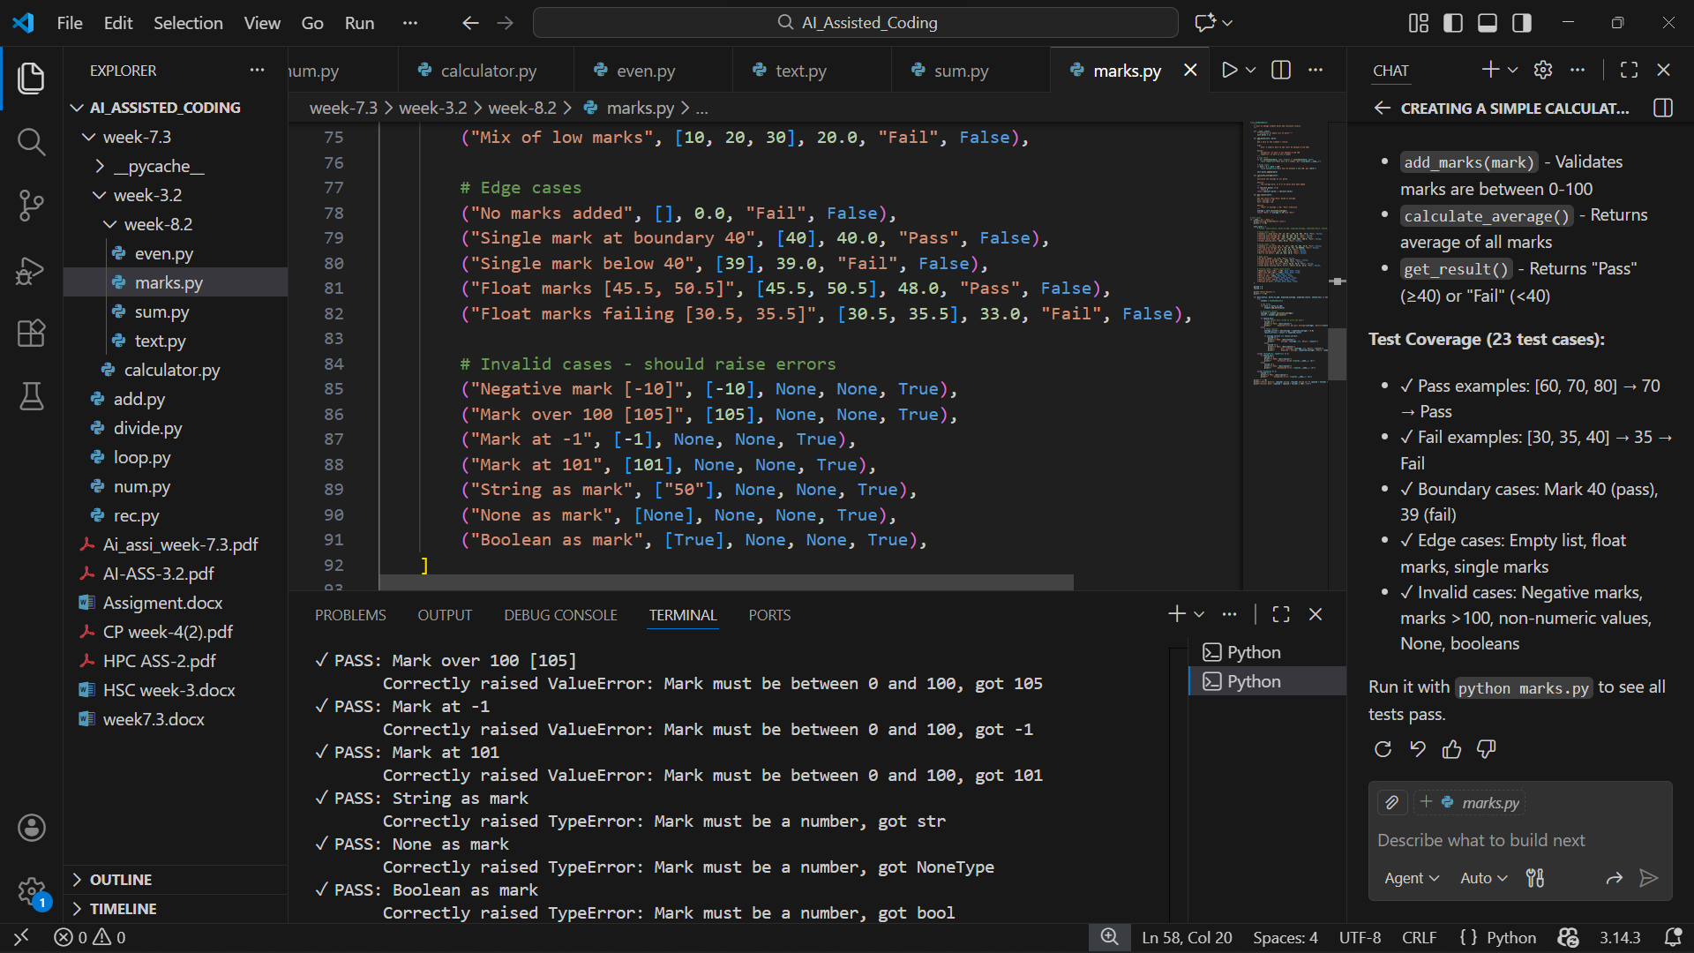
Task 5 – Test-Driven Development for Username Validator
Requirements:
• Minimum length: 5 characters
• No spaces allowed
• Only alphanumeric characters
Example Test Scenarios:
is_valid_username("user01") → True
is_valid_username("ai") → False
is_valid_username("user name") → False
is_valid_username("user@123") → False
Expected Output 5
A username validation function that passes all AI-generated test cases.

AI-generated code:
def is_valid_username(username):
"""
Validate a username based on specific requirements.

Requirements:
• Minimum length: 5 characters
• No spaces allowed
• Only alphanumeric characters (letters and digits)

Args:
username: The username string to validate

Returns:
True if username is valid, False otherwise

Raises:
TypeError: If username is not a string
"""
# Type check
if not isinstance(username, str):
raise TypeError(f"Username must be a string, got {type(username).__name__}")

# Check minimum length
if len(username) < 5:
return False

# Check for spaces
if ' ' in username:
return False

# Check if only alphanumeric characters
if not username.isalnum():
return False

return True

# Test cases
if __name__ == "__main__":
print("Testing is_valid_username() function")
print("=" * 70)

test_cases = [
# Format: (username, expected_result, description)

# Valid usernames
("user01", True, "Valid: Letters and digits (6 chars)"),
("abcde", True, "Valid: Exactly 5 characters"),
("admin123", True, "Valid: 8 characters with letters and digits"),
("user2024", True, "Valid: Typical username format"),
("alice", True, "Valid: All letters, exactly 5 chars"),
("bob123", True, "Valid: All letters and digits (6 chars)"),
("test12345", True, "Valid: Long alphanumeric username"),
("A1B2C3", True, "Valid: Mixed case letters and digits"),
("12345", True, "Valid: All digits, exactly 5 chars"),
("username123", True, "Valid: Typical long username"),

# Invalid - Too short
("ai", False, "Invalid: Too short (2 chars)"),
("test", False, "Invalid: Too short (4 chars)"),
("user", False, "Invalid: Exactly 4 characters"),
("123", False, "Invalid: Too short (3 chars)"),
("ab", False, "Invalid: Too short (2 chars)"),
("", False, "Invalid: Empty string"),

# Invalid - Contains spaces
("user name", False, "Invalid: Contains space in middle"),
("user 01", False, "Invalid: Space between chars"),
("user ", False, "Invalid: Trailing space"),
(" user", False, "Invalid: Leading space"),
(" ", False, "Invalid: Only spaces"),

# Invalid - Contains special characters
("user@123", False, "Invalid: Contains @ symbol"),
("user.name", False, "Invalid: Contains period"),
("user-name", False, "Invalid: Contains hyphen"),
("user_123", False, "Invalid: Contains underscore"),
("user#456", False, "Invalid: Contains hash"),
("user!name", False, "Invalid: Contains exclamation"),
("user$789", False, "Invalid: Contains dollar sign"),
("user&name", False, "Invalid: Contains ampersand"),
("user*123", False, "Invalid: Contains asterisk"),
("user(name)", False, "Invalid: Contains parentheses"),
("user[123]", False, "Invalid: Contains brackets"),
("user/name", False, "Invalid: Contains slash"),
("user\\name", False, "Invalid: Contains backslash"),
("user'name", False, "Invalid: Contains apostrophe"),
("user\"name", False, "Invalid: Contains quote"),
("user:name", False, "Invalid: Contains colon"),
("user;name", False, "Invalid: Contains semicolon"),
("user,name", False, "Invalid: Contains comma"),

# Edge cases - Type errors
(None, None, "Invalid: None type"),
(123, None, "Invalid: Integer type"),
(45.67, None, "Invalid: Float type"),
([], None, "Invalid: List type"),
({}, None, "Invalid: Dictionary type"),
]

passed = 0
failed = 0

print("\nTest Results:")
print("-" * 70)

for username, expected, description in test_cases:
try:
result = is_valid_username(username)

if expected is None:
# Should have raised an error
failed += 1
print(f"✗ FAIL: {description}")
print(f" Expected error but got: {result}")
else:
if result == expected:
passed += 1
status = "✓ PASS"
else:
failed += 1
status = "✗ FAIL"

print(f"{status}: {description}")
if result != expected:
print(f" Got: {result}, Expected: {expected}")

except TypeError as e:
if expected is None:
passed += 1
print(f"✓ PASS: {description}")
print(f" Correctly raised TypeError: {e}")
else:
failed += 1
print(f"✗ FAIL: {description}")
print(f" Unexpected TypeError: {e}")

except Exception as e:
failed += 1
print(f"✗ FAIL: {description}")
print(f" Unexpected error: {type(e).__name__}: {e}")

print("-" * 70)
print(f"\nFinal Results: {passed} passed, {failed} failed out of {passed + failed} tests")
print(f"Success Rate: {(passed / (passed + failed) * 100):.1f}%")

# Summary of requirements
print("\n" + "=" * 70)
print("Username Validation Requirements:")
print(" • Minimum length: 5 characters")
print(" • No spaces allowed")
print(" • Only alphanumeric characters (A-Z, a-z, 0-9)")
print("=" * 70)

