Assigment-9.2
- Harshith
2303A52425
Batch-38
Task Description -1 (Documentation – Function Summary
Generation)
Task:
Use AI to generate concise functional summaries for each Python
function in a given script.
Instructions:
• Provide a Python script to the AI.
• Ask the AI to write a short summary describing the purpose of
each function.
• Ensure summaries are brief and technically accurate.
• Do not include code implementation details.
Expected Output -1:
A Python script where each function contains a clear and concise
summary explaining its purpose.

Code:
#factorial
def factorial(n): # function definition
"""
Calculate the factorial of a non-negative integer.

Args:
n (int): A non-negative integer for which to calculate the factorial.

Returns:
int: The factorial of n (n!).

Raises:
RecursionError: If n is negative or very large, causing stack overflow.

Examples:
>>> factorial(0)
1
>>> factorial(5)
120
>>> factorial(1)
1
"""
if n == 0: # base case for factorial of 0
return 1 # return 1 for factorial of 0
else: # recursive case for factorial of n greater than 0
return n * factorial(n-1) # return n multiplied by factorial of n-1
""" The factorial function calculates the factorial of a non-negative integer n.
The factorial of n (denoted as n!) is the product of all positive integers less than or equal to n.
The function uses recursion to compute the factorial. If n is 0, it returns 1
as the base case. For n greater than 0, it returns n multiplied by the factorial of n-1."""
# Example
if __name__ == "__main__":
print(factorial(5))

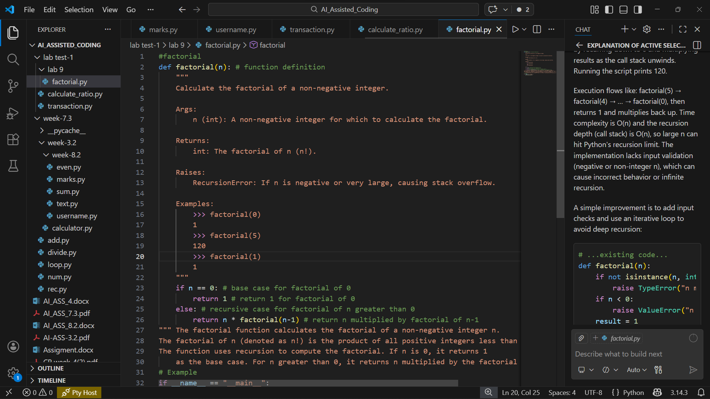

Task Description -2 (Documentation – Logical Explanation for
Conditions and Loops)
Task:
Use AI to document the logic behind conditional statements and loops in
a Python program.
Instructions:
• Provide a Python program without comments.
• Instruct AI to explain only decision-making logic and loop
behavior.
• Skip basic syntax explanations.
Expected Output -2:
Python code with clear explanations describing the logic of conditions
and loops.

Code:\
#fibonacci.py
def fibonacci(n): # function definition
if n < 0: # check for negative input
raise ValueError("Input must be a non-negative integer.") # raise an error for negative input

if n == 0: # base case for fibonacci of 0
return 0 # return 0 for fibonacci of 0
elif n == 1: # base case for fibonacci of 1
return 1 # return 1 for fibonacci of 1
else: # recursive case for fibonacci of n greater than 1
return fibonacci(n-1) + fibonacci(n-2) # return the sum of fibonacci of n-1 and fibonacci of n-2
""" The fibonacci function calculates the nth Fibonacci number using recursion. The Fibonacci sequence is defined as follows:
- F(0) = 0 (base case)
- F(1) = 1 (base case)
- F(n) = F(n-1) + F(n-2) for n > 1 (recursive case)
The function checks for negative input and raises a ValueError if the input is invalid. For valid inputs, it computes the Fibonacci number recursively by summing the two preceding Fibonacci numbers until it reaches the base cases. """
# Example
if __name__ == "__main__":
print(fibonacci(10)) # Output: 55, which is the 10th Fibonacci number.

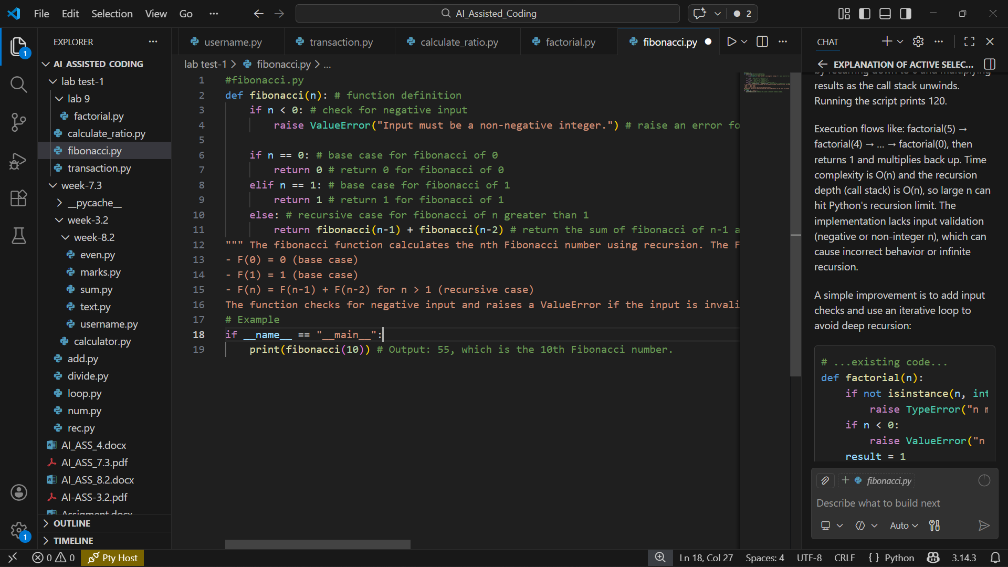

Task Description -3 (Documentation – File-Level Overview)
Task:
Use AI to generate a high-level overview describing the functionality of
an entire Python file.
Instructions:
• Provide the complete Python file to AI.
• Ask AI to write a brief overview summarizing the file’s purpose
and functionality.
• Place the overview at the top of the file.
Expected Output -3:
A Python file with a clear and concise file-level overview at the
Beginning

Code:
#Armstrong.py
"""An Armstrong number (also known as a narcissistic number) is a number
that is equal to the sum of its own digits each raised to the power of
the number of digits. For example, 153 is an Armstrong number
because 1^3 + 5^3 + 3^3 = 153. The function is_armstrong_number
checks if a given non-negative integer is an Armstrong number.
It first converts the number to a string to easily access each digit,
calculates the number of digits, and then computes the sum of each digit
raised to the power of the number of digits. Finally, it compares"""
def is_armstrong_number(num):
if not isinstance(num, int) or num < 0:
raise ValueError("Input must be a non-negative integer.")

num_str = str(num)
num_digits = len(num_str)

armstrong_sum = sum(int(digit) ** num_digits for digit in num_str)

return armstrong_sum == num
# Example
if __name__ == "__main__":
test_numbers = [0, 1, 153, 370, 371, 407, 9474, 9475]

for number in test_numbers:
if is_armstrong_number(number):
print(f"{number} is an Armstrong number.") # Output: 0, 1, 153, 370, 371, 407, and 9474 are Armstrong numbers, while 9475 is not.
else:
print(f"{number} is not an Armstrong number.")

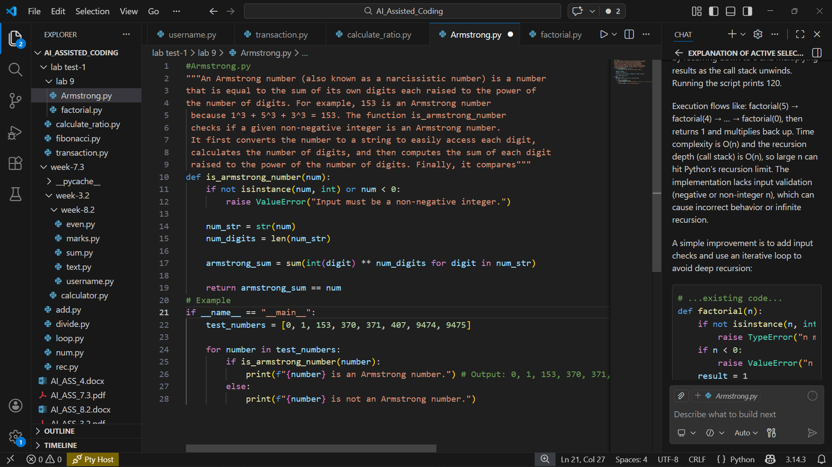

Task Description -4 (Documentation – Refine Existing
Documentation)
Task:
Use AI to improve clarity and consistency of existing documentation in
Python code.
Instructions:
• Provide Python code containing basic or unclear comments.
• Ask AI to rewrite the documentation to improve clarity and
consistency.
• Ensure technical meaning remains unchanged.
Expected Output -4:
Python code with refined and improved documentation that is clear and
consistent.

Code:
"""Simple factorial utility.

This module provides a recursive implementation of the factorial function.

The `factorial` function expects a non-negative integer. For values outside
that domain the behavior is undefined and may raise a `RecursionError` as
the recursion depth is exceeded.

Example:
>>> factorial(5)
120
"""

def factorial(n):
"""Return the factorial of a non-negative integer.

Args:
n (int): A non-negative integer whose factorial is to be computed.

Returns:
int: The factorial of ``n`` (that is, n!).

Raises:
RecursionError: If ``n`` is negative or so large that Python's
recursion limit is exceeded.

Notes:
This implementation uses simple recursion and therefore has O(n)
time complexity and O(n) recursion depth. For very large ``n``, an
iterative implementation is recommended to avoid recursion limits.
"""
if n == 0:
return 1
else:
return n * factorial(n - 1)

if __name__ == "__main__":
print(factorial(5))

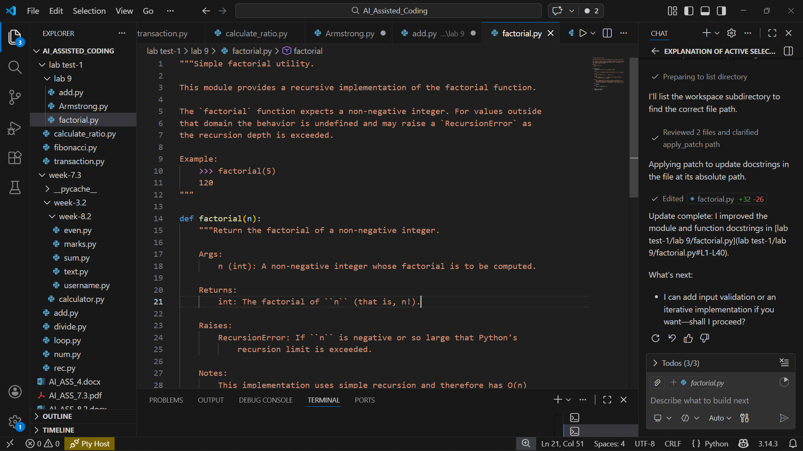
Task Description -5 (Documentation – Prompt Detail Impact Study)
Task:
Study the impact of prompt detail on AI-generated documentation
quality.
Instructions:
Create two prompts: one brief and one detailed.
• Use both prompts to document the same Python function.
• Compare the generated outputs.
Expected Output -5:
A comparison table highlighting differences in completeness, clarity, and
accuracy of documentation.

Code:
''' Add two numbers'''
def add(num1, num2):
return num1 + num2
# Example
if __name__ == "__main__":
print(add(5, 3)) # Output: 8, which is the sum of 5 and 3.

""" Add two numbers suc that differentiate between numeric and non-numeric inputs,
and handle potential overflow issues.
The add function takes two inputs, num1 and num2, and returns their sum.
It first checks if both inputs are numeric (either integers or floats) and
raises a TypeError if they are not. Then, it attempts to perform the addition and
checks for potential overflow by comparing the result with the maximum representable float value.
If an overflow is detected, it raises an OverflowError. Finally, if all checks pass, it returns"""
def add(num1, num2):
if not isinstance(num1, (int, float)) or not isinstance(num2, (int, float)):
raise TypeError("Both inputs must be numbers.")

result = num1 + num2

# Check for overflow (this is a simple check and may not cover all cases)
if result > float('inf') or result < float('-inf'):
raise OverflowError("The result of the addition is too large to handle.")

return result
# Example
if __name__ == "__main__":
try:
print(add(5, 3)) # Output: 8
print(add(1e308, 1e308)) # This will raise an OverflowError
except Exception as e:
print(f"Error: {e}")

