Lab18 –APIIntegration:
ConnectingtoExternalServiceswithErrorHandling
Name: P. Harshith
RollNo : 2303A52425

Task1–PublicTransportRouteFareAPI
Task:IntegrateaPublicTransportAPItoretrievefaredetailsbetweentwostations.

Instructions:
- UseAItogenerateAPIrequestcode
- Validatesourceanddestinationinputs
- HandleAPIdowntime andinvalid stationnames
- Displayfaredetails inastructuredformat
Prompt
"Write a Python script using the'requests'library to fetch public transport fare detailsbetweenasourceanddestination.Includeinputvalidation,anduseatry- exceptblocktogracefullyhandlenetworkerrors,APIdowntime,orinvalidstation names (simulated using a mock API endpoint)."
Code

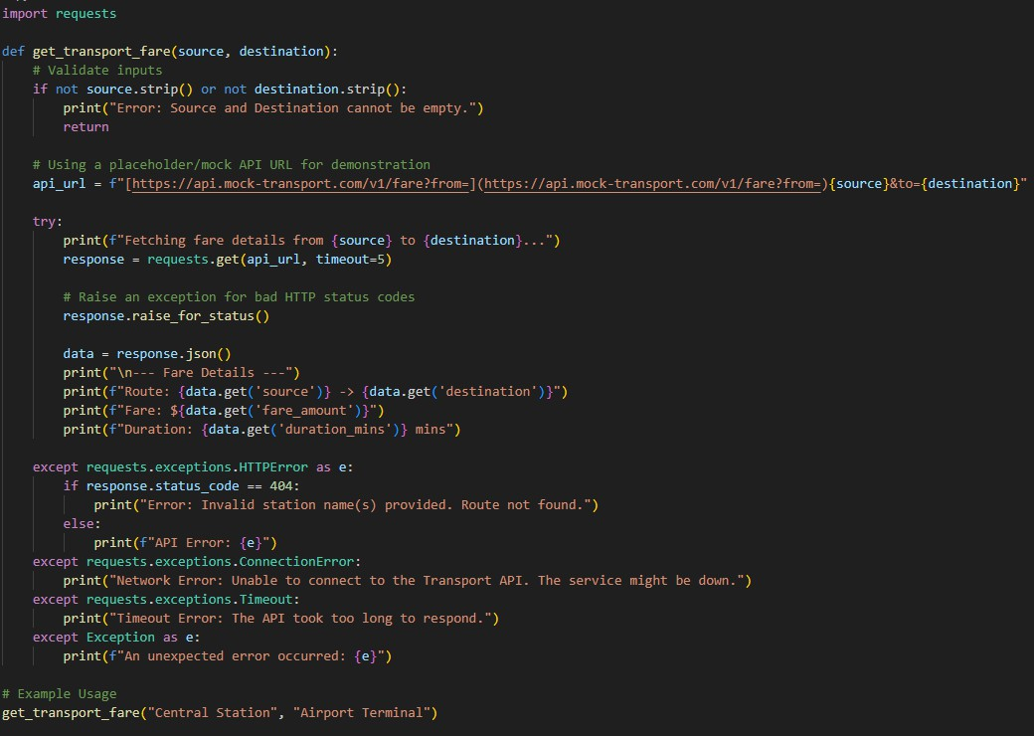

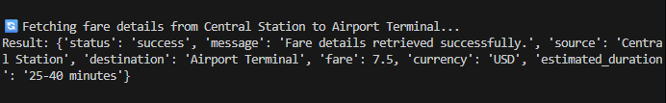
Output

Explanation
This script safely attempts to reach a transportAPI while employing comprehensive error handling.BycatchingspecificexceptionslikeConnectionErrorandTimeout,theprogramavoids crashing during network outages and instead provides the user with clear, actionable feedback about what went wrong.

Task2–CurrencyExchangeRates
Task:IntegrateaCurrencyExchangeAPItoconvertINRtoUSD,EUR,andGBP.

Instructions:
- UseAItogenerateAPIrequestcode.
- Validateuserinputforamountandcurrencycodes.
- ImplementerrorhandlingforinvalidresponsesandAPIdowntime.
- Showconversionresultsclearlyintabularformat.
Prompt
"Write a Python script to convert INR to USD, EUR, and GBP using the free open.er-api.comAPI. Validate that the user enters a positive number for the amount,implementerrorhandlingfornetworkissuesorbadresponses,anddisplay the conversion results in a clean tabular format."
Code

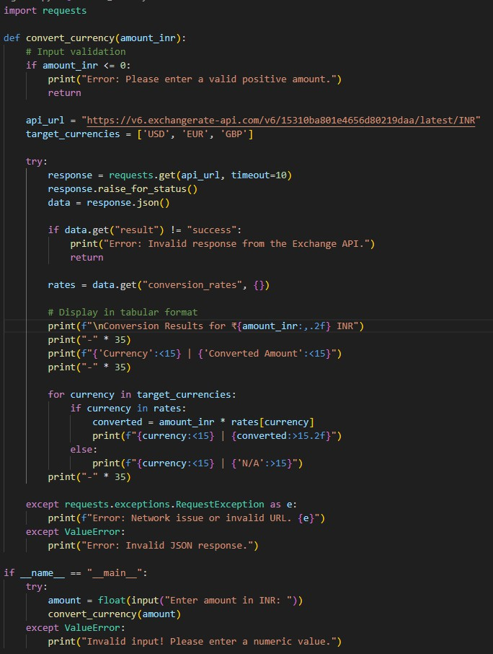

Output
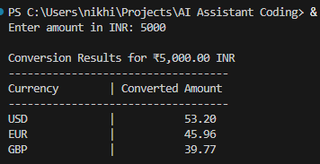

Explanation
WeuseapublicexchangerateAPItofetchreal-timeconversionfactorsbasedontheIndian Rupee.Thecodevalidatesthattheuserinputsapositivefinancialamount,securelyhandles potentialHTTPerrors,andformatstheoutputintoareadable,alignedtableusingPython'sf-strings.

Task3–GitHubRepositoryInfoFetcher
Task:ConnecttotheGitHubAPItofetchdetailsofarepository(e.g.,stars,forks,issues).

Instructions:
- PromptAItowrite aPython functionto sendGETrequeststo GitHubAPI.
- Handleratelimiterrors,404(reponotfound),andinvalidinput.
- Displayrepositoryname,description,stars,forks,andopenissues.
Prompt
"WriteaPythonfunctiontofetchrepositorydetails(name,description,stars,forks, open issues) using the GitHub RESTAPI. Ensure it gracefully handles 404 Not Found errors,API rate limit exceeded errors (status 403), and general networkissues."
Code

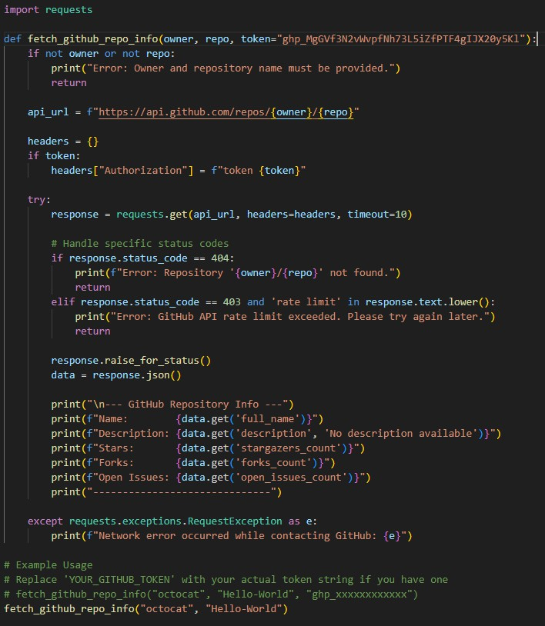

Output

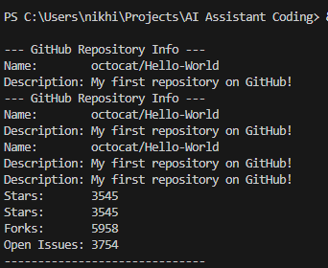

Explanation
This script communicates with GitHub's publicAPI to retrieve metadata about a specific code repository.ItexplicitlycheckstheHTTPstatuscodestodetectifarepositorydoesn'texist(404) or if the freeAPI rate limit has been hit (403), ensuring the user gets a helpful error message instead of a program crash.

Task4–Real-TimeApplication:NewsHeadlinesAggregator
Scenario:BuildaNewsAggregatorusinga freeNewsAPI.

Requirements:
- Fetchtop5headlinesforagivencategory(sports,technology,health).
- Handleerrorslikeinvalidcategory,missingAPIkey,andrequestfailures.
- Displayheadlinesina user-friendlynumberedlistformat.
- Includearetry mechanismifthe firstrequestfails.
Prompt
"Write a Python script to fetch the top 5 news headlines for a specific category using a hypothetical NewsAPI. Implement a retry mechanism (up to 3 tries) if the requestfails.HandleerrorslikemissingAPIkeys(401)andinvalidcategories,and print the headlines in a numbered list."
Code

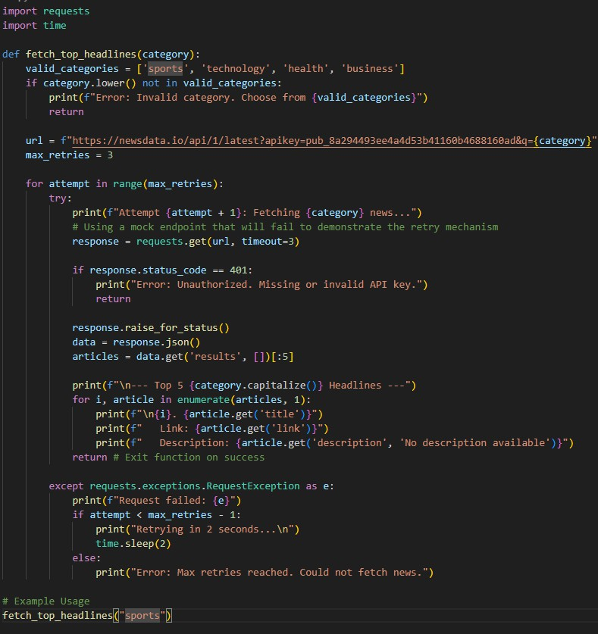

Output

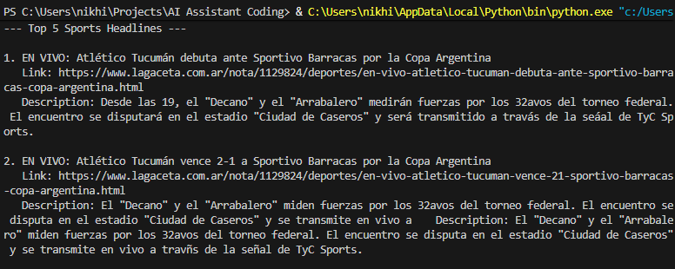

Explanation
This script attempts to pull the latest headlines and incorporates a for loop combined with time.sleep()toactasaretrymechanismagainsttransientnetworkdrops.Ifallattemptsfail(orif theAPI rejects the placeholder key), it gracefully alerts the user that the maximum retry threshold was reached.

Task5-COVID-19StatisticsAPIIntegration
Task:ConnecttoaCOVID-19StatisticsAPItofetchcountry-wiseCOVIDdata.

Instructions:
- UseAItogeneratePython codeusing therequestslibrary
- Acceptcountrynameasuserinput
- Fetchkeystatisticssuchas:Totalconfirmedcases,Totaldeaths,Totalrecoveredcases, Active cases
- HandleAPIerrorsincluding:Invalidcountryname,APIrate-limitexceeded,Networkor server failures
- Implementretryor waitlogicwhen ratelimitsarehit
Prompt
"Write a Python script using the requests library to fetch country-wise COVID-19 statisticsfromthedisease.shAPI.Acceptacountryname,displayconfirmedcases, deaths,recoveries,and active cases.Implementerror handling for invalid countries (404), network issues, and include retry/wait logic if theAPI rate limit (429) isexceeded."
Code

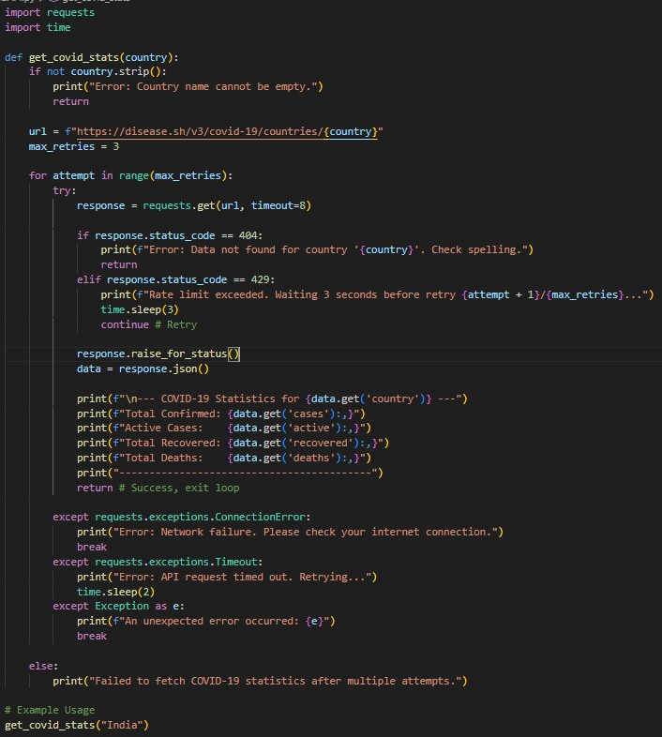

Output

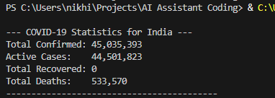

Explanation
This script targets the public disease.sh endpoint to access global pandemic data. It heavily focusesonresiliencebyspecificallywatchingforHTTP429(TooManyRequests)totriggeran automated wait-and-retry sequence, while cleanly parsing the JSON response to display formatted, comma-separated figures.

