Lab19–CodeTranslation:Converting Between Programming Languages
Name: P. Harshith
Roll No: 2303A52425

Task1–PythontoC++Conversion
Task:TranslateasimplePythonclassintoC++usingAIassistance.

Instructions:
- PromptAItoconvertaPythonclassrepresentingaStudentwithattributesandmethods into equivalent C++ code
- Ensureproperhandlingof:Constructors,Datatypes,Accessspecifiers
- Compileandrunbothversionstoverifyoutputconsistency
Prompt
"Convert a simple Python Student class (which has'name'and'age'attributes initializedinaninitmethod,andadisplay()method)intoequivalentC++code. EnsureyouuseproperC++constructors,explicitdatatypes,andaccessspecifiers like'public'. Include a main function to test it."
Code(C++)

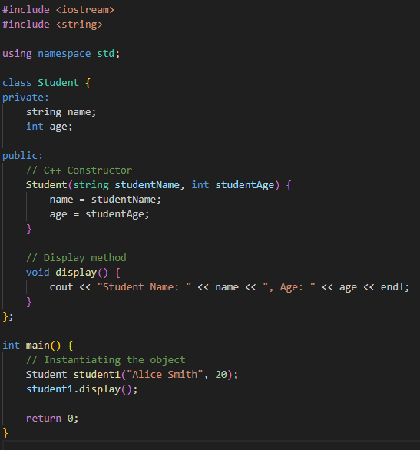

Output

StudentName:AliceSmith,Age:20
Explanation
TheAIsuccessfullymappedPython'sinitconstructortoaparameterizedC++constructor and replaced Python's dynamic typing with explicit C++ types like std::string and int. It also correctly applied public and private access specifiers, a concept heavily enforced in C++ but

largelyhandledimplicitlyinPython.

Task2–JavatoPythonFunctionConversion
Task:ConvertaJavamethodthatcheckswhetheranumberisprimeintoPython.

Instructions:
- AskAItotranslateaJavaisPrime()methodintoPython
- Testthefunctionwithmultipleinputs
- EnsurethePythonversionfollowsPythonicsyntaxandlogic
Prompt
"Translate a standard Java isPrime(int n) method into Python. Ensure the resulting codefollowsPythonicsyntax(likeusingrange),handlesedgecases(numbersless than 2), and test the function with a few sample integer inputs."
Code
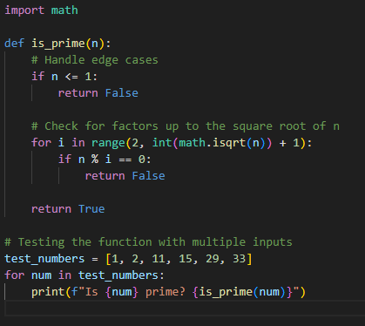

Output
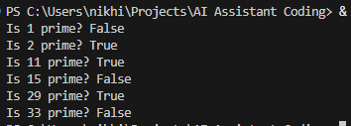

Explanation
TheAI effectively translated Java's verbose for loop and static type declarations into Python's highlyreadablefor...inrange(...)syntax.Theunderlyingmathematicallogicremainsperfectly intact, utilizing the square root optimization to ensure the checking process remains highlyefficient.

Task3–PseudocodetoPythonImplementation
Task:TranslateagivenpseudocodealgorithmintoPythonusingAI.

Instructions:
- ProvideAIwithpseudocodeforsorting numbers(e.g.,bubblesortorselectionsort)
- AskAItoconvertitinto executablePythoncode
- Validatecorrectnessusingsampleinputlists
Prompt
"Translate the standard Bubble Sort algorithm pseudocode into an executable Python function. The function should sort a list of numbers in place. Validate its correctnessbysortingasampleinputlistandprintingthebeforeandafterstates."
Code

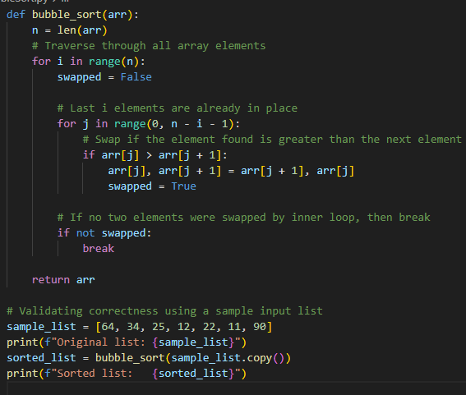

Output
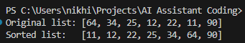

Explanation
TheAIcorrectlyinterpretedabstractpseudocodeloopsandconditionalsintoconcretePython syntax. It also cleverly utilized Python's simultaneous assignment feature (arr[j], arr[j+1] = arr[j+1], arr[j]), completely eliminating the need for a temporary variable usually found in standard sorting pseudocode.

Task4–SQLtoPandasQuery
Task:TranslateaSQLqueryintoaPandasDataFrameoperationinPython.

Instructions:
- ProvideAIwithaSQLquery(e.g.,SELECTname,salaryFROMemployeesWHERE salary>50000).
- AskAItogenerate equivalentPandascode.
- TestthegeneratedcodeonasampleDataFrame.
Prompt
"TranslatethefollowingSQLqueryintoaPandasDataFrameoperation:SELECT name, salary FROM employees WHERE salary>50000. Provide sample mock data for the'employees'DataFrame to test and display the result."
Code
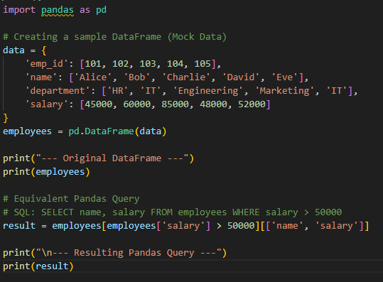

Output

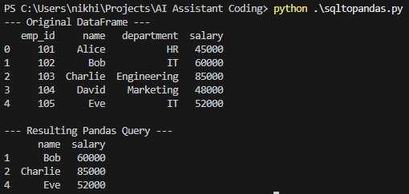

Explanation
TheAI elegantly translated the declarative SQL WHERE clause into boolean array indexing in pandas(employees['salary']>50000).Itthenchainedacolumnselectionlist([['name','salary']]) to accurately replicate the specific projection behavior of the SQL SELECT statement.

Task5–Real-TimeApplication:AlgorithmTranslation Across Languages
Scenario:Acompanymaintainsalgorithmswrittenindifferentprogramminglanguages.

Instructions:
- UseAItotranslateaselectedalgorithmbetweentwoprogramminglanguages(e.g., Converting a Python searching algorithm into C)
- Executeandtestbothversions
- Documenttranslationchallengessuchas:Syntaxdifferences,Librarysupport,Memorymanagement
Prompt
"TranslateaPythoniterativeBinarySearchalgorithmintoC.Providethecomplete Ccode,testitwithasamplesortedarray,andincludecommentsdocumentingthe translation challenges specifically regarding syntax differences, lack of library support, and memory management in C vs Python."
Code(C)

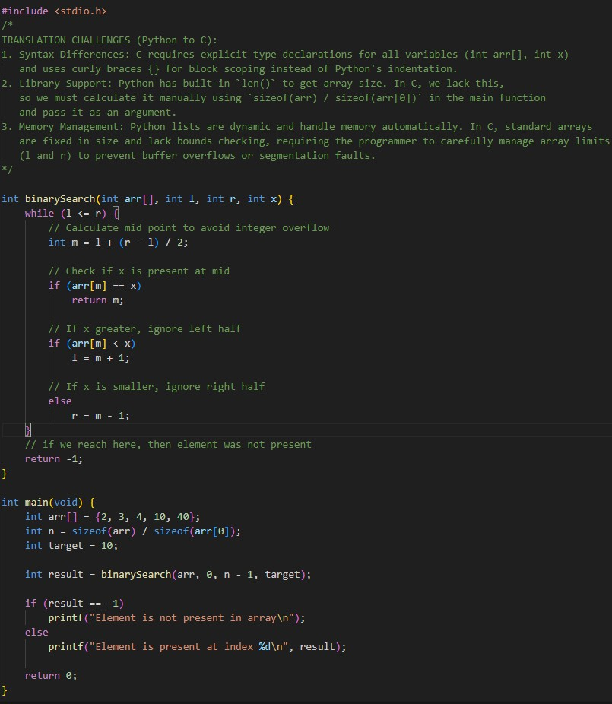

Output
—----Elementis presentatindex3 —----
Explanation

Moving from Python to C highlighted significant structural differences; C demanded strict variable typing and manual block delineations using curly braces. Furthermore, because C arraysaren'tobjectswithmetadatalikePythonlists,thealgorithmrequiredthearraysizetobe manually computed and passed around to prevent dangerous memory-access errors.

