Assigment- 5

- Harshith
2303A52425
Batch-38

Task 1: Privacy and Data Security in AI-Generated Code Scenario
AI tools can sometimes generate insecure authentication logic. Task Description
Use an AI tool to generate a simple login system in Python. Analyze the generated code to check:
- Whether credentials are hardcoded
- Whether passwords are stored or compared in plain text
- Whether insecure logic is used
Expected Output
- AI-generated login code import hashlib
class LoginSystem:
def init (self):
self.users = {}

def register(self, username, password):
if username in self.users:
return False, "Username already exists." # Hash the password for security
hashed_password = hashlib.sha256(password.encode()).hexdigest() self.users[username] = hashed_password
return True, "Registration successful."

def login(self, username, password):
if username not in self.users:
return False, "Username not found."

hashed_password = hashlib.sha256(password.encode()).hexdigest() if self.users[username] == hashed_password:
return True, "Login successful." else:

return False, "Incorrect password."

def display_users(self):
print("\nCurrent Registered Users:") if not self.users:
print("No users registered yet.")
for username, hashed_password in self.users.items():
print(f"Username: {username}, Hashed Password: {hashed_password[:10]}...") # Show first 10 chars of hash

if name == ' main ':
login_system = LoginSystem()
print("--- Welcome to the Simple Login System ---") # Registration examples
print("\n--- Registration ---")
success, message = login_system.register("alice", "password123") print(f"Alice registration: {message}")
success, message = login_system.register("bob", "securepass") print(f"Bob registration: {message}")
success, message = login_system.register("alice", "anotherpass") # Try to register existing user
print(f"Alice re-registration: {message}") login_system.display_users()
# Login examples print("\n--- Login ---")
success, message = login_system.login("alice", "password123") print(f"Alice login with correct password: {message}")
success, message = login_system.login("bob", "wrongpass") print(f"Bob login with incorrect password: {message}")
success, message = login_system.login("charlie", "newuserpass") print(f"Charlie login (non-existent user): {message}")
success, message = login_system.login("bob", "securepass") print(f"Bob login with correct password: {message}")

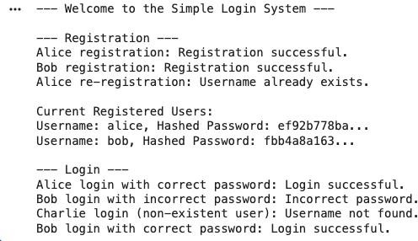
Identification of security risks

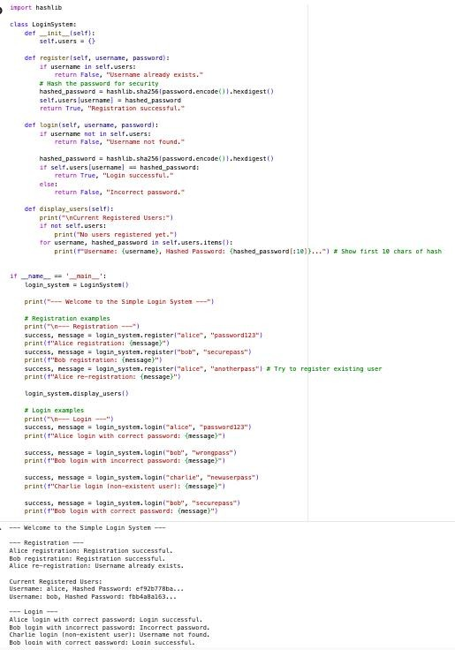
Security Risk Analysis of the Login System
login
register
LoginSystem

Based on the analysis of the
class, particularly the
and
methods,

here are the identified security vulnerabilities:
- Lack of Password Salting: While is used to hash passwords, there is
hashlib.sha256
no salt implemented. This makes the system vulnerable to rainbow table attacks. An attacker with access to the hashed passwords could use precomputed hash tables to find the original passwords, especially for common passwords.
- Username Enumeration: The error messages returned by the method are
login
different for a non-existent username ("Username not found") versus an incorrect password for a valid username ("Incorrect password"). This allows an attacker to

enumerate valid usernames present in the system, which is the first step in many attack scenarios.
- Brute-Force Attack Vulnerability: There are no mechanisms in place to prevent or mitigate brute-force attacks. An attacker could repeatedly try different passwords for a given username without any rate limiting or account lockout, eventually guessing the correct password.
- No Input Validation/Password Policy: The system does not enforce any password complexity requirements (e.g., minimum length, use of special characters, numbers). This allows users to set weak passwords, making them easier to guess. Similarly, there's no validation for usernames.
- Storage of Passwords (via dictionary): The system stores user data,
self.users
including hashed passwords, in a simple in-memory dictionary. While this is acceptable for a simple demonstration, in a real-world application, this would need to be a secure database. The in-memory storage means data is lost when the application

restarts. More critically, if the application is compromised, the could be directly accessed.
self.users
Revised secure version of the code import hashlib
import os

class LoginSystem:
def init (self):
self.users = {}

def register(self, username, password):
if username in self.users:
return False, "Username already exists."
# Basic password policy: minimum length of 8 characters if len(password) < 8:
return False, "Password must be at least 8 characters long."

# Generate a unique salt for each user
salt = os.urandom(16).hex() # 16-byte random salt, converted to hex string # Concatenate salt with password before hashing
# Ensure consistent encoding for both salt and password salted_password = (salt + password).encode('utf-8') hashed_password = hashlib.sha256(salted_password).hexdigest() # Store both the salt and the hashed password self.users[username] = (salt, hashed_password)
return True, "Registration successful." def login(self, username, password):
dictionary

if username not in self.users:
# Prevent username enumeration by returning a generic error return False, "Invalid username or password."
# Retrieve the stored salt and hashed password
stored_salt, stored_hashed_password = self.users[username]
# Concatenate the retrieved salt with the provided password and hash it salted_input_password = (stored_salt + password).encode('utf-8') hashed_input_password = hashlib.sha256(salted_input_password).hexdigest() # Compare the newly generated hash with the stored hash
if hashed_input_password == stored_hashed_password: return True, "Login successful."
else:
# Return a generic error for incorrect password as well return False, "Invalid username or password."
def display_users(self):
print("\nCurrent Registered Users:") if not self.users:
print("No users registered yet.")
for username, (salt, hashed_password) in self.users.items(): print(f"Username: {username}, Salt: {salt[:8]}..., Hashed Password:
{hashed_password[:10]}...") # Show first 8 chars of salt and 10 of hash

if name == ' main ':
login_system = LoginSystem()
print("--- Welcome to the Simple Login System (Improved Security) ---") # Registration examples
print("\n--- Registration ---")
success, message = login_system.register("alice", "password123") print(f"Alice registration: {message}")
success, message = login_system.register("bob", "securepass") print(f"Bob registration: {message}")
# Test password policy
success, message = login_system.register("charlie", "short") print(f"Charlie registration (short password): {message}")

success, message = login_system.register("alice", "anotherpass") # Try to register existing user
print(f"Alice re-registration: {message}") login_system.display_users()
# Login examples print("\n--- Login ---")
success, message = login_system.login("alice", "password123") print(f"Alice login with correct password: {message}")
success, message = login_system.login("bob", "wrongpass") print(f"Bob login with incorrect password: {message}")
success, message = login_system.login("charlie", "newuserpass") # Non-existent user print(f"Charlie login (non-existent user): {message}")
# Try to login with short password (this should fail as charlie wasn't registered) success, message = login_system.login("charlie", "short")
print(f"Charlie login (non-existent user with short pass attempt): {message}")

success, message = login_system.login("bob", "securepass") print(f"Bob login with correct password: {message}")

Brief explanation of improvements

Improvements Made to Enhance Security:
1.

Password Salting Implementation:
2.
- Change: A unique, randomly generated salt (os.urandom(16).hex()) is now created for each user during registration.
- Before: Passwords were hashed directly using without salting.
hashlib.sha256
- Impact: This prevents rainbow table attacks. Even if an attacker obtains the database of hashed passwords, they cannot use precomputed tables to reverse the hashes, as each hash is unique due to the unique salt. This significantly increases the effort required for an attacker to crack passwords.
3.

Prevention of Username Enumeration:
4.

- Change: The method now returns a single, generic error message
login
("Invalid username or password.") regardless of whether the username does not exist or the password for an existing username is incorrect.
- Before: The system provided distinct error messages: "Username not found." for non-existent users and "Incorrect password." for valid users with wrong passwords.
- Impact: This prevents attackers from easily determining which usernames are valid within the system. By obscuring the existence of a username, it makes it harder for attackers to target valid accounts for brute-force or other credential- stuffing attacks.
5.

Basic Password Policy Enforcement:

6.

- Change: During registration, the password length (e.g., 8 characters).
register

method now enforces a minimum

- Before: There was no password policy, allowing users to set weak or short passwords.
- Impact: This encourages users to create stronger passwords, making them more resilient to brute-force attacks and dictionary attacks. While this is a basic policy, it's a fundamental step towards better password hygiene.
7.

Secure Storage of Salt and Hashed Password:
8.

- Change: Both the unique salt and the hashed password are now stored together
as a tuple for each user.
(salt, hashed_password)
- Before: Only the hashed password was stored.
- Impact: Storing the salt with the hash is crucial because the salt is necessary to re-hash a user's input password during login for comparison. It ensures that the salting mechanism is properly utilized for authentication.

Task 2: Bias Detection in AI-Generated Decision Systems Scenario
AI systems may unintentionally introduce bias. Task Description
Use AI prompts such as:
- “Create a loan approval system”
- Vary applicant names and genders in prompts Analyze whether:
- The logic treats certain genders or names unfairly
- Approval decisions depend on irrelevant personal attributes

Suggest methods to reduce or remove bias. Expected Output
- Python code generated by AI
class LoanApprovalSystem:
def init (self):
# Define basic approval thresholds and rules self.MIN_CREDIT_SCORE = 600
self.MIN_INCOME_FOR_LOAN_AMOUNT_RATIO = 0.3 # income should be at least 30% of loan amount

def evaluate_loan(self, credit_score, income, loan_amount, employment_status): # Rule 1: Credit score must meet the minimum requirement
if credit_score < self.MIN_CREDIT_SCORE:
return "Rejected", "Reason: Credit score too low."

# Rule 2: Income must be sufficient relative to the loan amount
# For simplicity, we'll say income must be at least 30% of the loan amount if income < loan_amount * self.MIN_INCOME_FOR_LOAN_AMOUNT_RATIO:
return "Rejected", "Reason: Insufficient income relative to loan amount."

# Rule 3: Employment status must be 'employed' if employment_status.lower() != 'employed':
return "Rejected", "Reason: Applicant is not employed."

# If all rules are passed, approve the loan return "Approved", "Reason: All criteria met."

if name == ' main ':
loan_system = LoanApprovalSystem()

print("--- Loan Application Evaluation ---")

# Sample Applicant 1: Should be Approved applicant1 = {
"credit_score": 720,
"income": 60000,
"loan_amount": 100000, "employment_status": "employed"
}
decision, reason = loan_system.evaluate_loan(**applicant1) print(f"\nApplicant 1 (Credit: {applicant1['credit_score']}, Income:
${applicant1['income']:.2f}, Loan: ${applicant1['loan_amount']:.2f}, Employment:
{applicant1['employment_status']}): {decision} - {reason}")

# Sample Applicant 2: Rejected (Low Credit Score) applicant2 = {
"credit_score": 550,
"income": 70000,
"loan_amount": 150000, "employment_status": "employed"
}
decision, reason = loan_system.evaluate_loan(**applicant2) print(f"\nApplicant 2 (Credit: {applicant2['credit_score']}, Income:
${applicant2['income']:.2f}, Loan: ${applicant2['loan_amount']:.2f}, Employment:
{applicant2['employment_status']}): {decision} - {reason}")

# Sample Applicant 3: Rejected (Insufficient Income) applicant3 = {
"credit_score": 680,
"income": 20000,
"loan_amount": 100000, "employment_status": "employed"
}
decision, reason = loan_system.evaluate_loan(**applicant3) print(f"\nApplicant 3 (Credit: {applicant3['credit_score']}, Income:
${applicant3['income']:.2f}, Loan: ${applicant3['loan_amount']:.2f}, Employment:
{applicant3['employment_status']}): {decision} - {reason}")

# Sample Applicant 4: Rejected (Unemployed) applicant4 = {
"credit_score": 650,
"income": 50000,
"loan_amount": 80000, "employment_status": "unemployed"
}
decision, reason = loan_system.evaluate_loan(**applicant4) print(f"\nApplicant 4 (Credit: {applicant4['credit_score']}, Income:
${applicant4['income']:.2f}, Loan: ${applicant4['loan_amount']:.2f}, Employment:
{applicant4['employment_status']}): {decision} - {reason}")

# Sample Applicant 5: Approved (Edge case for income ratio) applicant5 = {
"credit_score": 600,
"income": 30000,
"loan_amount": 100000, "employment_status": "employed"

}
decision, reason = loan_system.evaluate_loan(**applicant5) print(f"\nApplicant 5 (Credit: {applicant5['credit_score']}, Income:
${applicant5['income']:.2f}, Loan: ${applicant5['loan_amount']:.2f}, Employment:
{applicant5['employment_status']}): {decision} - {reason}")

