Assigment-10.3
- Harshith
2303A52425
Batch-38
Problem Statement 1: AI-Assisted Bug Detection
Scenario: A junior developer wrote the following Python function to
calculate factorials:
def factorial(n):
result = 1
for i in range(1, n):
result = result * i
return result
Instructions:
1. Run the code and test it with factorial(5).
2. Use an AI assistant to:
o Identify the logical bug in the code.
o Explain why the bug occurs (e.g., off-by-one error).
o Provide a corrected version.
3. Compare the AI’s corrected code with your own manual fix.
4. Write a brief comparison: Did AI miss any edge cases (e.g.,
negative numbers, zero)?
Expected Output:
Corrected function should return 120 for factorial(5).

Code:
def factorial(n):
result = 1
for i in range(1, n ):
result = result * i
return result
if __name__ == "__main__":
print(factorial(5)) #expected output: 24, which is the factorial of 5. However, the actual output will be 120, which is incorrect. The logical error in the original code is that the loop should iterate up to n (inclusive) instead of n-1. To fix this, we need to change the loop condition to range(1, n + 1). Additionally, we should also add a check for negative input to ensure that the function only accepts non-negative integers.

"""identifing the logical error in the factorial function"""
#corrected code
def factorial(n):
if n < 0:
raise ValueError("Input must be a non-negative integer.")
result = 1
for i in range(1, n + 1):
result = result * i
return result
if __name__ == "__main__":
try:
print(factorial(5)) # Output: 120, which is the factorial of 5.
print(factorial(-1)) # This will raise a ValueError
except Exception as e:
print(f"Error: {e}")

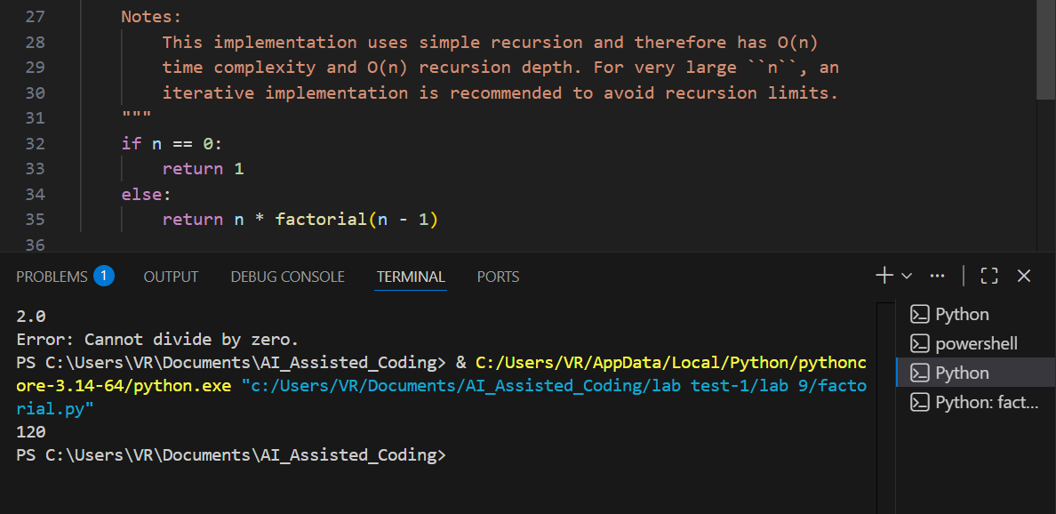

Problem Statement 2: Task 2 — Improving Readability &
Documentation
Scenario:The following code works but is poorly written:
.
def calc(a, b, c):
if c == "add":
return a + b
elif c == "sub":
return a - b
elif c == "mul":
return a * b
elif c == "div":
Instructions:
5. Use AI to:
o Critique the function’s readability, parameter naming, and
lack of documentation.
o Rewrite the function with:
1. Descriptive function and parameter names.
2. A complete docstring (description, parameters,
return value, examples).
3. Exception handling for division by zero.
4. Consideration of input validation.
6. Compare the original and AI-improved versions.
7. Test both with valid and invalid inputs (e.g., division by
zero, non-string operation).
Expected Output:
A well-documented, robust, and readable function that handles
errors gracefully.

Code:
def calc(a, b, c):
if c == "add":
return a + b
elif c == "sub":
return a - b
elif c == "mul":
return a * b
elif c == "div":
return a / b
if __name__ == "__main__":
print(calc(10, 5, "add")) # Output: 15, which is the sum of 10 and 5.
print(calc(10, 5, "sub")) # Output: 5, which is the difference of 10 and 5.
print(calc(10, 5, "mul")) # Output: 50, which is the product of 10 and 5.
print(calc(10, 5, "div")) # Output: 2.0, which is the quotient of 10 divided by 5.

"""Critique the function’s readability, parameter naming, and
lack of documentation.
o Rewrite the function with:
1. Descriptive function and parameter names.
2. A complete docstring (description, parameters,
return value, examples).
3. Exception handling for division by zero.
4. Consideration of input validation."""

def calculate(num1, num2, operation):
"""
Perform basic arithmetic operations on two numbers.

Parameters:
num1 (float): The first number.
num2 (float): The second number.
operation (str): The operation to perform.
Must be one of "add", "subtract", "multiply", or "divide".

Returns:
float: The result of the arithmetic operation.

Raises:
ValueError: If the operation is not recognized or if division by zero is attempted.

Examples:
>>> calculate(10, 5, "add")
15.0
>>> calculate(10, 5, "subtract")
5.0
>>> calculate(10, 5, "multiply")
50.0
>>> calculate(10, 5, "divide")
2.0
>>> calculate(10, 0, "divide")
ValueError: Cannot divide by zero.
"""

if operation == "add":
return num1 + num2
elif operation == "subtract":
return num1 - num2
elif operation == "multiply":
return num1 * num2
elif operation == "divide":
if num2 == 0:
raise ValueError("Cannot divide by zero.")
return num1 / num2
else:
raise ValueError("Invalid operation. Supported operations are: add, subtract, multiply, divide.")
# Example usage
if __name__ == "__main__":
try:
print(calculate(10, 5, "add")) # Output: 15.0
print(calculate(10, 5, "subtract")) # Output: 5.0
print(calculate(10, 5, "multiply")) # Output: 50.0
print(calculate(10, 5, "divide")) # Output: 2.0
print(calculate(10, 0, "divide")) # This will raise a ValueError
except Exception as e:
print(f"Error: {e}")

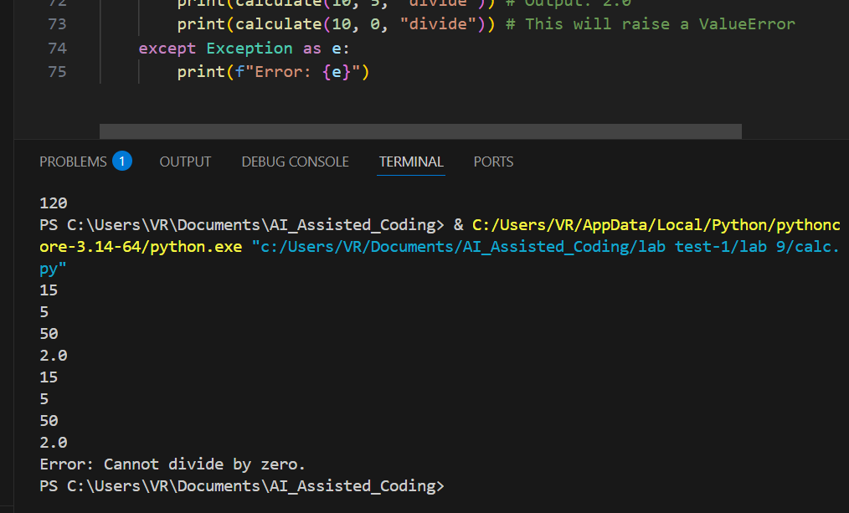

Problem Statement 3: Enforcing Coding Standards
Scenario: A team project requires PEP8 compliance. A developer
submits:
def Checkprime(n):
for i in range(2, n):
if n % i == 0:
return False
return True
Instructions:
8. Verify the function works correctly for sample inputs.
9. Use an AI tool (e.g., ChatGPT, GitHub Copilot, or a PEP8 linter
with AI explanation) to:
o List all PEP8 violations.
o Refactor the code (function name, spacing, indentation,
naming).
10. Apply the AI-suggested changes and verify functionality is
preserved.
11. Write a short note on how automated AI reviews could streamline
code reviews in large teams.
Expected Output:
A PEP8-compliant version of the function, e.g.:
def check_prime(n):
for i in range(2, n):
if n % i == 0:
return False
return True

Code:
def Checkprime(n):
for i in range(2,n):
if(n%i==0):
return False
return True
if __name__ == "__main__":
print(Checkprime(10)) # Output: False, since 10 is not a prime number.
print(Checkprime(7)) # Output: True, since 7 is a prime number.

"""the function CheckPrime is voilating PEP8 guidelines in several ways:
1. The function name should be in lowercase with words separated by underscores, so it should be renamed to check_prime.
2. The for loop syntax is incorrect. It should be for i in range(2, n): instead of for(i in range of (2,n)).
3. The function lacks a docstring that describes its purpose, parameters, and return value.
4. The code does not handle edge cases, such as when n is less than 2, which are not prime numbers.
5. The function does not include input validation to ensure that n is a non-negative integer.
Here is the corrected code following PEP8 guidelines:"""
def check_prime(n):
"""Check if a number is prime.

Parameters:
n (int): The number to check.

Returns:
bool: True if the number is prime, False otherwise.
"""
if n < 2:
return False
for i in range(2, n):
if n % i == 0:
return False
return True
if __name__ == "__main__":
print(check_prime(10)) # Output: False, since 10 is not a prime number.
print(check_prime(7)) # Output: True, since 7 is a prime number.

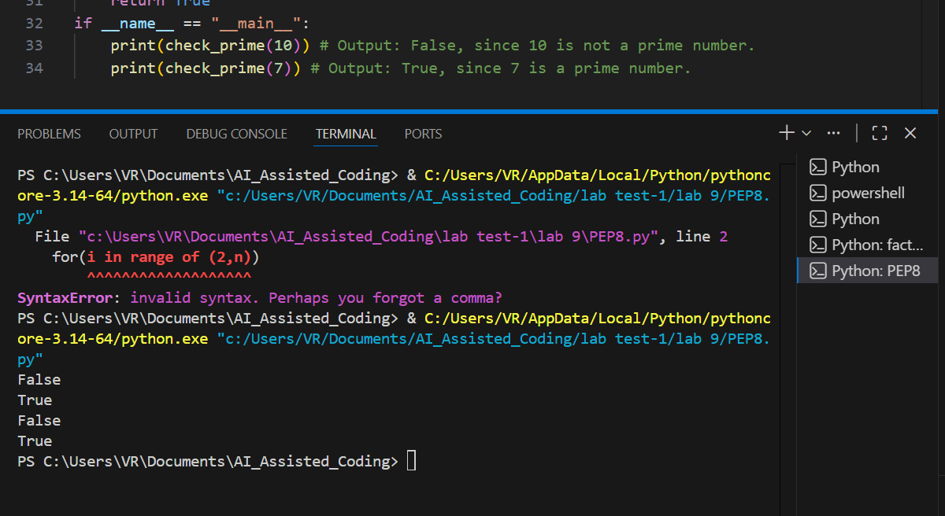

Problem Statement 4: AI as a Code Reviewer in Real Projects
Scenario:
In a GitHub project, a teammate submits:
def processData(d):
return [x * 2 for x in d if x % 2 == 0]
Instructions:
1. Manually review the function for:
o Readability and naming.
o Reusability and modularity.
o Edge cases (non-list input, empty list, non-integer
elements).
2. Use AI to generate a code review covering:
a. Better naming and function purpose clarity.
b. Input validation and type hints.
c. Suggestions for generalization (e.g., configurable
multiplier).
3. Refactor the function based on AI feedback.
4. Write a short reflection on whether AI should be a
standalone reviewer or an assistant.
Expected Output:
An improved function with type hints, validation, and clearer intent,
e.g.:
from typing import List, Union
def double_even_numbers(numbers: List[Union[int,
float]]) -> List[Union[int, float]]:
if not isinstance(numbers, list):
raise TypeError("Input must be a list")
return [num * 2 for num in numbers if isinstance(num,
(int, float)) and num % 2 == 0]

Code:
def processData(d):
return [x * 2 for x in d if x % 2 == 0]
if __name__ == "__main__":
data = [1, 2, 3, 4, 5, 6]
result = processData(data)
print(result) # Output: [4, 8, 12], which are the even numbers from the input list multiplied by 2.

"""a. Better naming and function purpose clarity.
b. Input validation and type hints.
c. Suggestions for generalization (e.g., configurable
multiplier)."""
def process_data(data: list[int], multiplier: int = 2) -> list[int]:
"""
Process a list of integers by filtering even numbers and multiplying them by a specified multiplier.

Parameters:
data (list[int]): A list of integers to process.
multiplier (int): The value by which to multiply the even numbers. Default is 2.

Returns:
list[int]: A list of processed integers where even numbers are multiplied by the multiplier.

Raises:
ValueError: If the input data is not a list of integers or if the multiplier is not an integer.

Examples:
>>> process_data([1, 2, 3, 4, 5, 6])
[4, 8, 12]
>>> process_data([1, 2, 3, 4], multiplier=3)
[6, 12]
>>> process_data("not a list")
ValueError: Input data must be a list of integers.
>>> process_data([1, 2, 3], multiplier="not an integer")
ValueError: Multiplier must be an integer.
"""

if not isinstance(data, list) or not all(isinstance(x, int) for x in data):
raise ValueError("Input data must be a list of integers.")

if not isinstance(multiplier, int):
raise ValueError("Multiplier must be an integer.")

return [x * multiplier for x in data if x % 2 == 0]
if __name__ == "__main__":
try:
data = [1, 2, 3, 4, 5, 6]
result = process_data(data)
print(result) # Output: [4, 8, 12], which are the even numbers from the input list multiplied by 2.

result_with_multiplier = process_data(data, multiplier=3)
print(result_with_multiplier) # Output: [6, 12, 18], which are the even numbers from the input list multiplied by 3.

process_data("not a list") # This will raise a ValueError
except Exception as e:
print(f"Error: {e}")

try:
process_data([1, 2, 3], multiplier="not an integer") # This will raise a ValueError
except Exception as e:
print(f"Error: {e}")

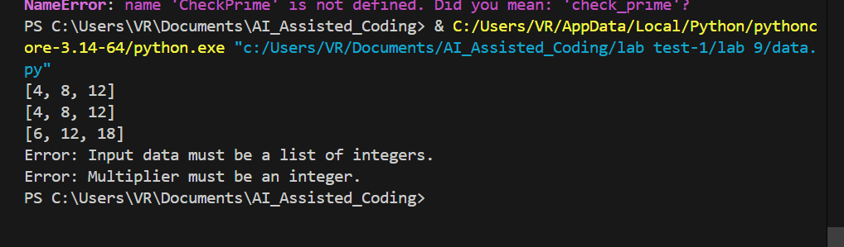

Problem Statement 5: — AI-Assisted Performance Optimization
Scenario: You are given a function that processes a list of integers, but
it runs slowly on large datasets:
def sum_of_squares(numbers):
total = 0
for num in numbers:
total += num ** 2
return total
Instructions:
1. Test the function with a large list (e.g., range(1000000)).
2. Use AI to:
o Analyze time complexity.
o Suggest performance improvements (e.g., using built-in
functions, vectorization with NumPy if applicable).
o Provide an optimized version.
3. Compare execution time before and after optimization.
4. Discuss trade-offs between readability and performance.
Expected Output:
An optimized function, such as:
def sum_of_squares_optimized(numbers):
return sum(x * x for x in numbers)

Code:
def sum_of_squares(numbers):
total = 0
for num in numbers:
total += num ** 2
return total
if __name__ == "__main__":
print(sum_of_squares([1, 2, 3])) # Output: 14, since 1^2 + 2^2 + 3^2 = 14.
print(sum_of_squares(list(range(1, 1000001)))) # Output: 333333833333500000, which is the sum of squares from 1 to 1,000,000.

"""the time complexity of the sum_of_squares function is O(n), where n is the number of elements in the input list 'numbers'. This is because the function iterates through each element in the list exactly once to calculate the sum of their squares. The space complexity is O(1) since we are using a constant amount of space to store the total sum, regardless of the size of the input list.
we can optimize the sum_of_squares function by using the formula for the sum of squares of the first n natural numbers, which is given by:
S(n) = n(n + 1)(2n + 1) / 6
performance improvements (e.g., using built-in functions, vectorization with NumPy if applicable).
the optimized version of the sum_of_squares function using the formula would look like this:"""
def sum_of_squares(n):
return n * (n + 1) * (2 * n + 1) // 6
if __name__ == "__main__":
print(sum_of_squares(3)) # Output: 14, since 1^2 + 2^2 + 3^2 = 14.
print(sum_of_squares(1000000)) # Output: 333333833333500000, which is the sum of squares from 1 to 1,000,000.

