Assigment - 13.2
- Harshith
2303A52425
Batch no. : 38
Task Description -1 (Refactoring – Eliminating Repetitive Logic)
• Task: Use AI-assisted coding techniques to restructure a Python
program that performs repeated calculations, transforming it into
a reusable and maintainable design.
Instructions:
• Ask AI to locate repeated computations within the program.
• Encapsulate repeated logic into reusable functions.
• Verify that program output remains unchanged after refactoring.
• Add proper docstrings to all defined functions.
Sample Code:
length = 8
width = 4
print("Area:", length * width)
print("Perimeter:", 2 * (length + width))
length = 12
width = 6
print("Area:", length * width)
print("Perimeter:", 2 * (length + width))
Expected Output:
A refactored Python script that uses a single reusable function to
compute area and perimeter without repeating code.

Code:

length = 8
"""
Calculate and display the area and perimeter of a rectangle.
Args:
length (float): The length of the rectangle.
width (float): The width of the rectangle.
Returns:
None
Examples:
>>> print_rectangle_properties(8, 4)
Area: 32
Perimeter: 24
>>> print_rectangle_properties(12, 6)
Area: 72
Perimeter: 36
"""
width = 4
print("Area:", length * width)
print("Perimeter:", 2 * (length + width))
length = 12
width = 6
print("Area:", length * width)
print("Perimeter:", 2 * (length + width))

"""locate repeated code and refactor it into a function to improve code reusability and maintainability."""
def print_rectangle_properties(length, width):
print("Area:", length * width)
print("Perimeter:", 2 * (length + width))

print_rectangle_properties(8, 4)
print_rectangle_properties(12, 6)

Output:

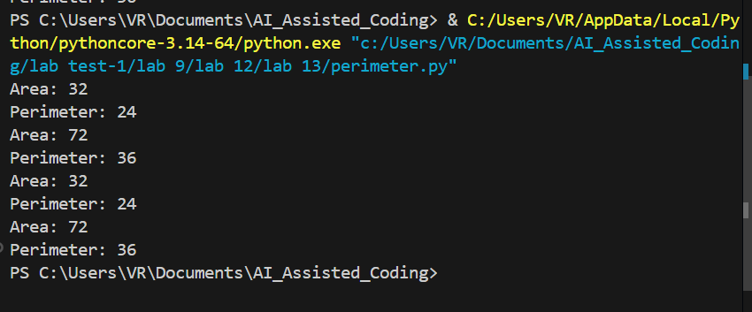

Task Description -2 (Refactoring – Modularizing Inline
Calculations)
• Task: Use AI to refactor a Python script by extracting repeated
inline calculations into reusable and well-documented functions.
Instructions:
• Identify repeated calculation patterns in the code.
• Convert them into reusable functions.
• Ensure readability and proper documentation.
Sample Code:
amount = 1000
discount = amount * 0.10
final_amount = amount - discount
print("Final Amount:", final_amount)
amount = 2000
discount = amount * 0.10
final_amount = amount - discount
print("Final Amount:", final_amount)
Expected Output:
A modular Python program that uses a reusable function to compute
final amounts for different inputs.

Code:
amount = 1000
discount = amount * 0.10
final_amount = amount - discount
print("Final Amount:", final_amount)
amount = 2000
discount = amount * 0.10
final_amount = amount - discount
print("Final Amount:", final_amount)

"""• Identify repeated calculation patterns in the code.
• Convert them into reusable functions.
• Ensure readability and proper documentation for the functions."""
def calculate_final_amount(amount):
"""Calculate the final amount after applying a 10% discount.

Args:
amount (float): The original amount before discount.

Returns:
float: The final amount after applying the discount.
"""
discount = amount * 0.10
return amount - discount

print("Final Amount:", calculate_final_amount(1000))
print("Final Amount:", calculate_final_amount(2000))

Output:
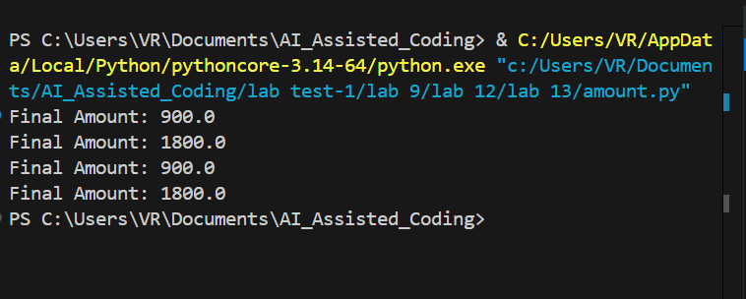

Task Description -3 (Refactoring – Improving Loop and
Conditional Performance)
• Task: Apply AI-based suggestions to enhance the performance of
Python code that relies on nested loops and repeated conditional
checks.
Instructions:
• Use AI to recommend more efficient data structures or logic
simplifications.
• Replace inefficient constructs while preserving program behavior.
• Compare execution efficiency before and after refactoring.
Sample Code:
students = ["Anil", "Bhavya", "Charan", "Divya"]
check_list = ["Charan", "Esha", "Bhavya"]
for name in check_list:
exists = False
for student in students:
if name == student:
exists = True
if exists:
print(name, "found")
else:
print(name, "not found")
Expected Output:
An optimized Python program that performs faster lookups using
efficient logic, along with execution performance comparison.

Code:
students = ["Anil", "Bhavya", "Charan", "Divya"]
check_list = ["Charan", "Esha", "Bhavya"]
for name in check_list:
exists = False
for student in students:
if name == student:
exists = True
if exists:
print(name, "found")
else:
print(name, "not found")

"""make the code more efficient and readable by using a function to check for the presence of names in the students list."""
def check_name(name, students):
"""Check if a name exists in the students list.

Args:
name (str): The name to check for.
students (list): The list of student names.

Returns:
bool: True if the name exists in the list, False otherwise.
"""
return name in students
students = ["Anil", "Bhavya", "Charan", "Divya"]
check_list = ["Charan", "Esha", "Bhavya"]
for name in check_list:
if check_name(name, students):
print(name, "found")
else:
print(name, "not found")

Output:

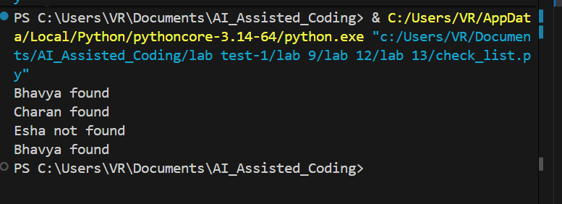

Task Description -4 (Refactoring – Replacing Hardcoded Values
with Constants)
• Task: Utilize AI assistance to improve maintainability by
replacing hardcoded numerical values with named constants.
Instructions:
• Detect hardcoded numeric values used directly in expressions.
• Define descriptive constants at the beginning of the program.
• Update calculations to use these constants without changing
results.
Sample Code:
print("Simple Interest:", (1000 * 2 * 5) / 100)
print("Simple Interest:", (2000 * 2 * 5) / 100)
Expected Output:
A revised Python program using constants such as RATE and TIME for
clearer and maintainable calculations..

Code:

print("Simple Interest:", (1000 * 2 * 5) / 100)
print("Simple Interest:", (2000 * 2 * 5) / 100)

"""Calculate simple interest for different principal amounts, rates, and time periods. declare a function to compute simple interest and use it to calculate the interest for various scenarios.
and also declare the attributes of the function in the docstring for better understanding."""
def calculate_simple_interest(principal, rate, time):
"""Calculate simple interest based on the formula: (P * R * T) / 100.

Args:
principal (float): The initial amount of money.
rate (float): The annual interest rate (in percentage).
time (float): The time the money is invested for (in years).

Returns:
float: The calculated simple interest.
"""
return (principal * rate * time) / 100
print("Simple Interest:", calculate_simple_interest(1000, 5, 2))
print("Simple Interest:", calculate_simple_interest(2000, 5, 2))

Output:
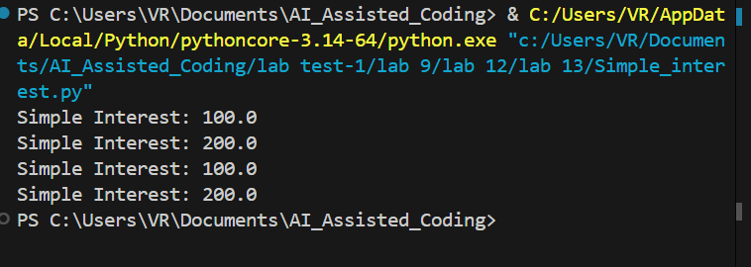

Task Description -5 (Re factoring – Enhancing Variable Naming
and Code Clarity)
• Task: Apply AI tools to improve code readability by renaming
unclear variables and adding meaningful comments..
Instructions:
• Replace non-descriptive variable names with meaningful
identifiers.
• Add inline comments where the logic may be unclear.
• Ensure program output remains the same.
Sample Code:
x = 50
y = 30
z = x + y
print(z)
Expected Output:
A Python program with clear variable names and explanatory comments
that improve readability without altering functionality.

Code:
x = 50
y = 30
z = x + y
print(z)
"""• Replace non-descriptive variable names with meaningful
identifiers.
• Add inline comments where the logic may be unclear.
• Ensure program output remains the same."""
def add_numbers(num1, num2):
"""Add two numbers and return the result.

Args:
num1 (float): The first number to be added.
num2 (float): The second number to be added.

Returns:
float: The sum of the two numbers.
"""
return num1 + num2

result = add_numbers(50, 30)
print(result)

Output:

