Lab 20 – Security Testing: Identifying Vulnerabilities in AI-Generated Code

Task 1 – Password Security Enhancement
Task: Analyze an AI-generated Python program that stores passwords in plain text and improve its security.
Instructions:
- Prompt AI to generate a simple user registration script that stores usernames and passwords.
- Check whether passwords are stored as plain text.
- Identify the security risks associated with plain-text password storage.
- Refactor the program to use secure password hashing (e.g., hashlib or bcrypt).
- Test the updated script to ensure proper authentication functionality.

Prompt
"Generate a vulnerable Python script for user registration that stores passwords in plain text. Explain the security risks. Then, provide a refactored, secure version of the script that uses the built-in hashlib library to hash passwords with a salt before storing them, and include a login function to test authentication."

Code
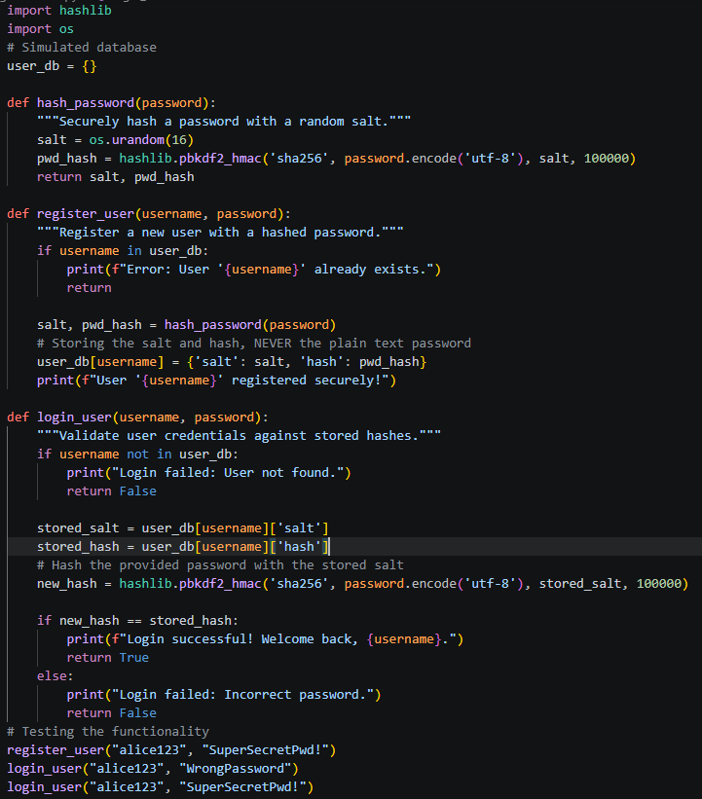

Output
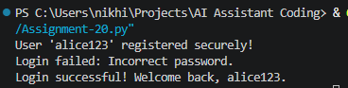

Explanation
Storing plain-text passwords exposes users to severe risks if the database is breached, allowing attackers immediate access to accounts. The refactored code neutralizes this threat by hashing the password using pbkdf2_hmac combined with a unique, random salt, ensuring the original password cannot be mathematically reversed.

Task 2 – Secure API Key Management
Task: Evaluate an AI-generated script that uses hardcoded API keys and improve its security.
Instructions:
- Ask AI to generate a Python script that connects to an external API using a hardcoded API key.
- Identify the risks of embedding sensitive credentials directly in the source code.
- Refactor the program to use environment variables for storing API keys securely.
- Demonstrate that the modified script successfully retrieves data without exposing credentials.

Prompt
"Create a Python script that connects to a hypothetical weather API using a hardcoded API key. Explain why hardcoding API keys is dangerous. Then, refactor the code to securely retrieve the API key from environment variables using os.getenv(), adding error handling if the key is missing."

Code
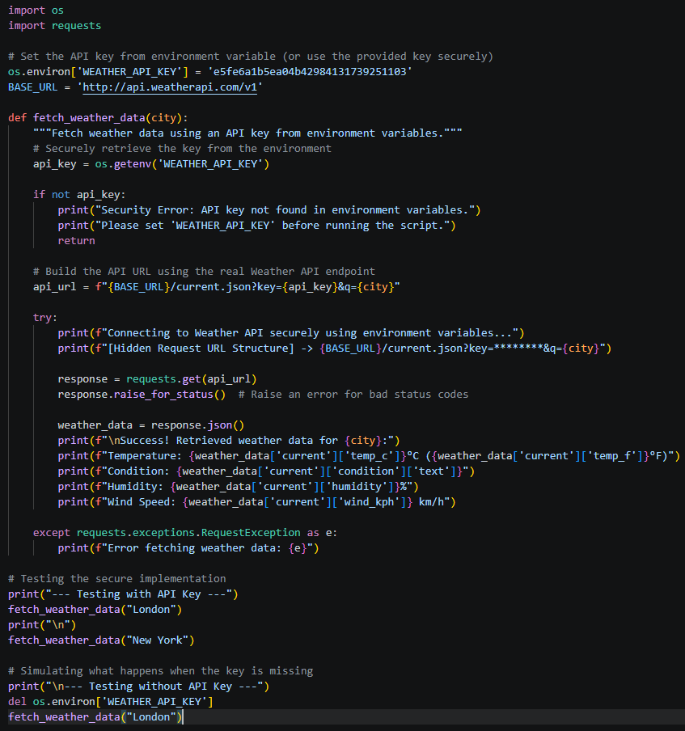

Output
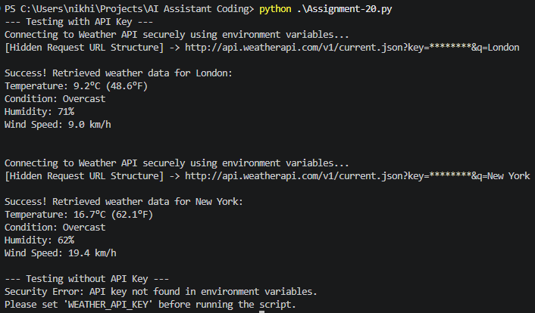

Explanation
Hardcoding API keys in source code risks exposing sensitive credentials when code is pushed to public repositories, leading to potential data breaches and massive financial charges. The secure version leverages the os module to pull the API key dynamically from the system's environment variables, keeping secrets strictly out of the codebase.

Task 3 – Weak Encryption Detection
Task: Examine an AI-generated program that uses weak encryption techniques and strengthen it.
Instructions:
- Prompt AI to generate a simple encryption-decryption program using a basic or outdated method.
- Identify weaknesses in the encryption approach (e.g., reversible encoding or outdated algorithms).
- Refactor the program using stronger encryption techniques available in Python libraries.
- Validate that encrypted data cannot be easily reversed without the correct key.

Prompt
"Provide a Python script that 'encrypts' a string using Base64 encoding and explain why this is considered weak/insecure. Then, refactor the program to use strong, modern encryption using the cryptography.fernet symmetric encryption module to securely encrypt and decrypt a message."

Code
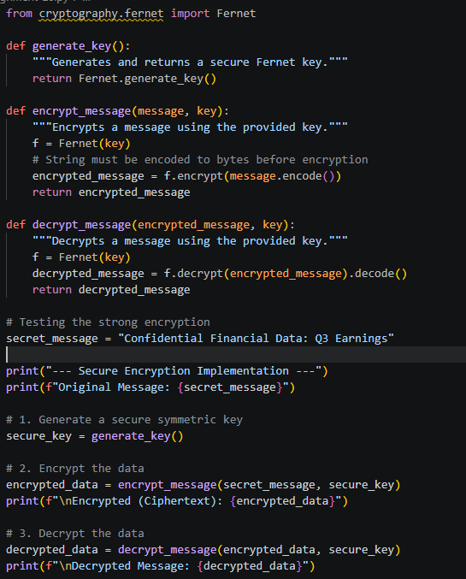

Output
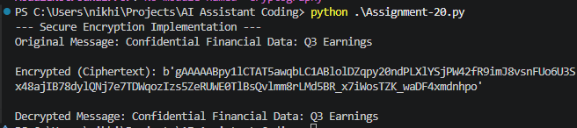

Explanation
Base64 encoding is easily identifiable and completely reversible by anyone without a key, making it merely an obfuscation technique, not encryption. The refactored code upgrades to AES-based symmetric encryption via the cryptography.fernet module, ensuring that interceptors cannot read or tamper with the data without the securely generated secret key.

Task 4 – Real-Time Application: Security Review of AI-Generated Web Service
Scenario: Students select an AI-generated web service snippet (e.g., REST API, file upload handler, or authentication module).
Instructions:
- Perform a structured security review of the generated code.
- Identify at least three potential vulnerabilities.
- Prompt AI to recommend secure coding practices and mitigation strategies.
- Implement the suggested improvements and test the secured version.
- Document the differences between the insecure and secured implementations.

Prompt
"Act as a security auditor. I have an AI-generated Flask SQLite snippet that uses f-strings for database queries (SQL Injection risk), has no error handling, and prints detailed database errors to the user. Document these three vulnerabilities. Then, provide the secured refactored Python code using parameterized SQL queries and safe error messages."

Code
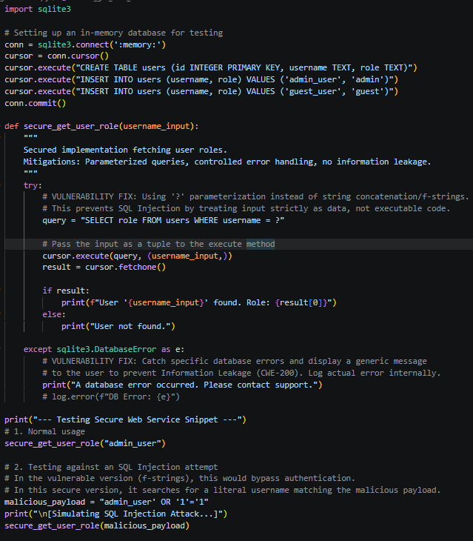

Output
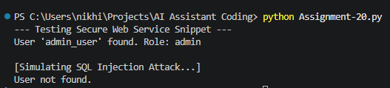

Explanation
The original snippet was vulnerable to SQL Injection, Information Leakage, and Application Crashes. The secured version replaces dangerous f-strings with ? parameter substitution (blocking SQL injection), and wraps the database call in a try-except block to return generic, safe error messages rather than exposing sensitive stack traces to potential attackers.

Task 5 – Exception Handling Improvement
Task: Analyze an AI-generated Python program that does not handle runtime errors and improve its reliability.
Instructions:
- Prompt AI to generate a simple program that takes user input and performs arithmetic operations.
- Identify possible runtime errors (e.g., invalid input, division by zero).
- Modify the program to include proper try-except blocks.
- Provide meaningful error messages for invalid inputs.
- Test the improved version with valid and invalid test cases.

Prompt
"Write a basic Python division calculator that prompts the user for two numbers. Identify that it will crash on non-numeric input and division by zero. Then, provide a refactored version using proper try-except blocks handling ValueError and ZeroDivisionError, displaying user-friendly error messages."

Code
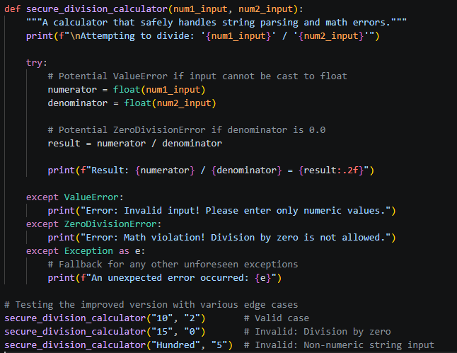

Output
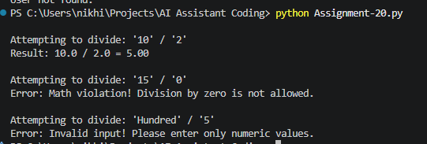

Explanation
A raw arithmetic script will abruptly terminate with ugly stack traces if a user inputs alphabetical characters or attempts to divide by zero. By encapsulating the type-casting and arithmetic operations within specific try-except blocks, the program elegantly traps these exceptions and communicates the issue gracefully, ensuring continuous uptime.

