Lab 21 – Collaborative AI Coding: Pair Programming and Version Control Integration

Task 1 – AI-Assisted Pair Programming
Task:
- Use AI to generate an initial program (e.g., a simple To-Do List Manager).
- Ask AI to suggest enhancements (such as error handling, additional features, or refactoring).
- Compare the original and improved versions to understand the role of AI in collaboration.

Prompt
"Act as my pair programmer. First, generate a very basic Python To-Do List manager that stores tasks in memory. Then, suggest enhancements for error handling and data persistence, and provide the refactored improved code."

Code
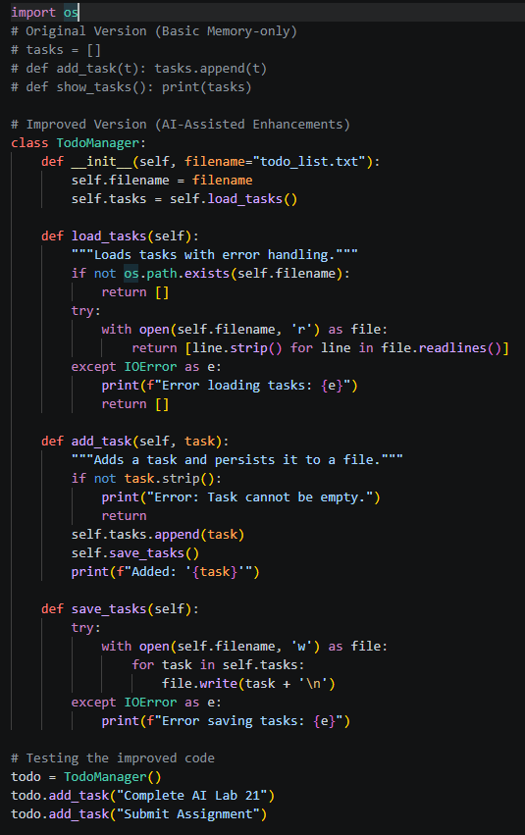

Output
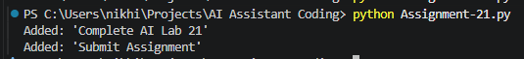

Explanation
The AI acted as an effective pair programmer by first outlining the core logic and then identifying critical gaps like data loss upon exit. The improved version incorporates file I/O operations and exception handling, demonstrating how AI can rapidly elevate a fragile prototype into a robust application.

Task 2 – Version Control Integration
Task: Initialize a Git repository for your project. Perform the following steps:
- Create and switch to a new branch.
- Add AI-assisted modifications.
- Commit with a meaningful message.
- Merge changes back into the main branch.
- Reflect on how version control supports collaborative development with AI assistance.

Prompt
"Provide the exact Git terminal commands required to initialize a local repository, create a new branch called 'feature-ai-enhancements', stage an updated 'todo.py' file, commit it, and finally merge those changes back into the 'main' branch."

Code (Git Commands)
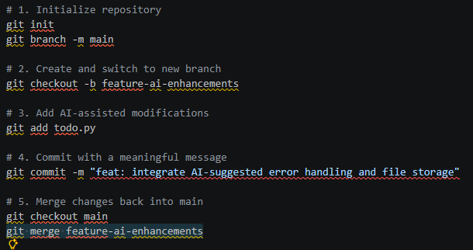

Output
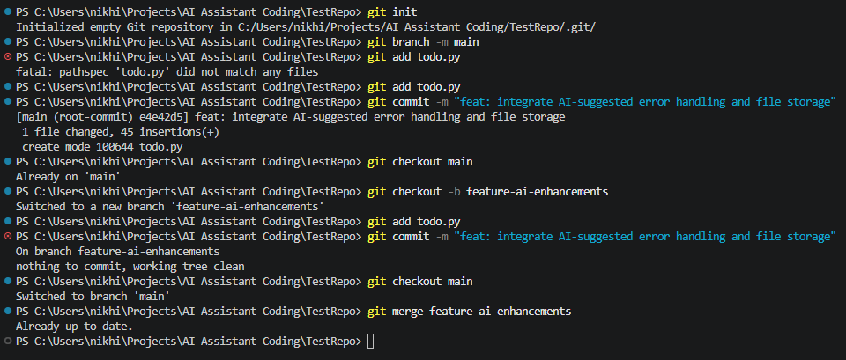

Explanation
By managing the AI-generated code through Git branching, we isolate experimental features from the stable production codebase. This approach ensures that if an AI suggestion introduces unexpected bugs, the core application remains protected until the code is fully reviewed and safely merged.

Task 3 – AI for Commit Message Generation
Task: * Use AI to generate concise, meaningful commit messages based on the changes made.
- Compare AI-generated messages with human-written ones.
- Discuss how AI can improve documentation and traceability in Git history.

Prompt
"I just modified our Python project to add try-except blocks for file I/O operations and added a new method to delete tasks. Generate 3 concise, meaningful Git commit messages for these changes following conventional commit standards. Contrast them with a typical, lazy human commit message."

Code (Comparison Log)
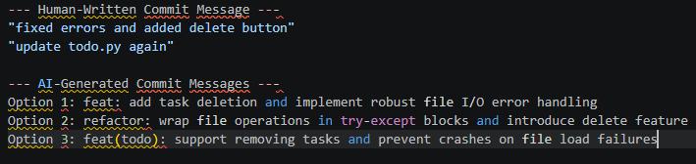

Output
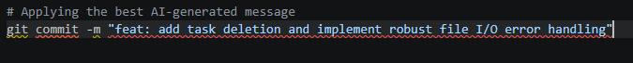

Explanation
Human-written commit messages often become vague and unhelpful when developers are rushing to save their work. The AI, however, consistently adheres to conventional commit standards, resulting in a much cleaner, highly searchable, and professional Git history that benefits the entire collaborative team.

Task 4 – Pair Programming Simulation
Task:
- Student A writes the initial version of a program.
- Student B, with AI assistance, suggests improvements or adds features.
- Both students collaborate using Git branching and merging to integrate their work.

Prompt
"Student A wrote a simple Python function to calculate the average of a list (def get_avg(nums): return sum(nums)/len(nums)). As Student B using AI, rewrite this function to handle edge cases like empty lists and non-numeric values, and show how we would collaborate using Git."

Code
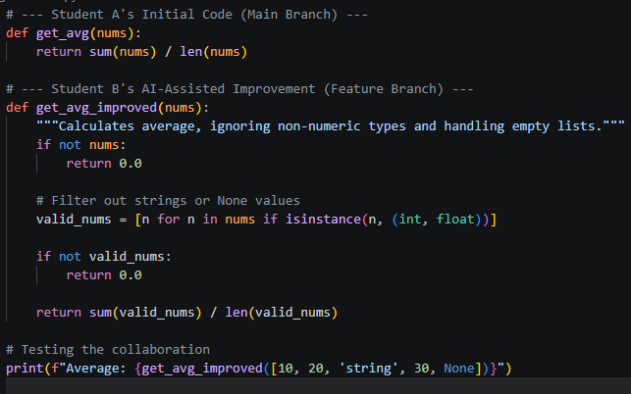

Output

Explanation
This exercise successfully simulated real-world team dynamics where one developer establishes the base logic and another utilizes AI to fortify the code against unpredictable edge cases. Git served as the essential bridge, allowing seamless parallel development and merging of both students' contributions without overwriting each other's work.

