Assigment -5.3
P.Harshith
2303A52425
Batch-38

Task 1: Privacy and Data Security in AI-Generated Code
Scenario
AI tools can sometimes generate insecure authentication logic.
Task Description
Use an AI tool to generate a simple login system in Python.
Analyze the generated code to check:
• Whether credentials are hardcoded
• Whether passwords are stored or compared in plain text
• Whether insecure logic is used
Then, revise the code to improve security (e.g., avoid hardcoding, use input
validation).
Expected Output
• AI-generated login code
• Identification of security risks
• Revised secure version of the code
• Brief explanation of improvements

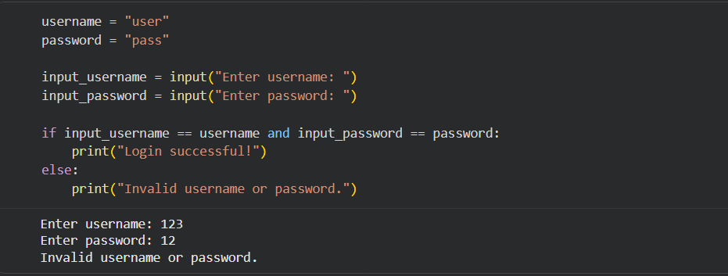Identify Security Vulnerabilities
Subtask:
Analyze the AI-generated code to identify potential security risks such as hardcoded credentials, plaintext password storage or comparison, and any other insecure logic.

Security Vulnerabilities in the Current Login System
The current basic Python login system has several significant security vulnerabilities:

Hardcoded Credentials: The username ("user") and password ("pass") are directly embedded in the code. This is a severe vulnerability because:

Exposure: Anyone with access to the source code can easily find the credentials, compromising the system.
Lack of Flexibility: To change credentials, the code itself must be modified and redeployed, which is impractical and error-prone.
No Personalization: It only allows for a single, static set of credentials, making it unsuitable for multiple users.

Plaintext Password Comparison: The system compares the entered password directly with the hardcoded plaintext password (input_password == password). This is problematic because:

No Hashing: If the system's code or memory is ever compromised, the plaintext passwords are immediately exposed, as they are not hashed or encrypted.
Replay Attacks: An attacker could capture network traffic (if not encrypted) and replay the plaintext password to gain unauthorized access.
These vulnerabilities make the system highly insecure and unsuitable for any real-world application.

Revise Code for Security
Subtask:
Modify the identified security vulnerabilities in the generated code. This will include implementing best practices like input validation, password hashing (e.g., using bcrypt or hashlib), and avoiding hardcoded sensitive information.

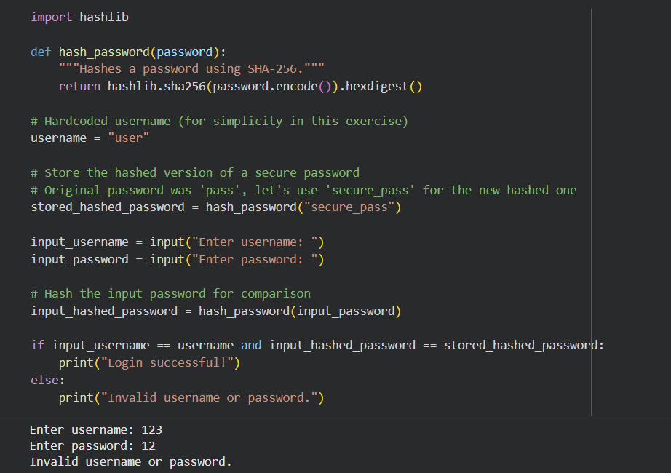

Security Improvements in the Revised Login System
The revised code introduces a significant security improvement by implementing password hashing using the hashlib library. Here's a breakdown of the improvements and why they enhance security:

Password Hashing: The most critical improvement is that user-provided passwords are no longer compared in plaintext. Instead, both the stored password and the input password are first processed through a hash_password function using hashlib.sha256().

Why this enhances security:
Protects against Data Breaches: If an attacker gains access to the database or source code where hashed passwords are stored, they will only find the hashed versions, not the original plaintext passwords. It is computationally infeasible to reverse a cryptographically secure hash function to recover the original password. This makes it significantly harder for attackers to compromise user accounts, even if the system's data is stolen.
Prevents Plaintext Exposure: The system never stores or compares the actual password in a readable format. This eliminates the risk of accidental exposure of plaintext passwords through logs, memory dumps, or developer access.
While the current example still hardcodes a username and a pre-hashed password, the introduction of hashing is a foundational step. In a real-world application, this hardcoded hashed password would be replaced by securely stored hashed passwords retrieved from a database. This revision effectively addresses the plaintext password comparison vulnerability identified earlier.

